Target Users

The target user group consists of people regularly buy food at supermarkets and want to know more information about their purchases. There are two categories of these people: the younger generation aged 16-30 and the parental figures aged 20-50 as described in the brainstorm. They like eating all types of food, but they generally try to stay healthy, go for organic produce, and are aware of sustainability and environmental issues. Also, they are tech-savvy as their Internet use is regular enough to navigate around various web applications without much trouble, and they own a smartphone for the mobile version of the app. These users are middle to upper class people who are financially stable and educated with college degrees or in pursuit of one. In addition, they live in urban neighborhoods with access to a wide variety of different supermarkets.

Test subjects were chosen from grocery shoppers at Yasai Market. All subjects fall into the young generation of the target user group description.

The first subject, a 20-year-old male Cal undergraduate student, was shopping with a friend. He made purchase decisions based on information on the package, and the price of the item. He did not seem to prioritize purchasing environmentally friendly products, instead focusing on cost-effectiveness.

The second subject, a 26-year-old Cal graduate student, was on a semi-regular trip to the store. She was highly focused on efficiency, picking up groceries that she buys regularly and paying little attention to the information on each item. When the application was mentioned, she began to consider environmental issues with her purchases, but she noted that she would still buy some products, regardless of its impacts.

The third subject, a 21-year-old nonstudent, was much more careful with his selection of items.

Problem and Solution Overview

Buyers would like to know where their food is coming from and who is actually making it besides the store that is displaying it. There are a couple of reasons behind their curiosity. For one, it is to ensure the supermarket is being honest with the customers. Producers can easily use false advertisement and mislead consumers to buy their products by marking it as organic or "natural". Another reason is because of health issues. They want to know that the food is as fresh and organic as possible. Finally, there is a lacking of human-to-human interaction at supermarkets. Consumers want to know that their purchases are going towards supporting local economies, and understand how their money is affecting various communities around the world.

Our solution would work as follows. Once the user has bought all of their food, they can go to their profile on this application and look at their past receipts containing the items they have bought. They can then click on one of their products and see a company profile with all the data our application has on it. This profile would include things such as the farmer’s name, family history, size of establishment, number of employees, types of goods produced, pictures of the farm/plant/establishment, pictures of the employees, soil conditions, use of pesticides, etc. By distinguishing facts about the truly organic and sustainable growers, customers now know for sure that they are supporting sustainable and organic providers.

We are also thinking of making a solution running on mobile platforms in the future. The difference between this and the web application would be the process of accessing this information. Instead of going through past receipts when they have left the supermarket, users scan the food bar codes as they are shopping to fetch the data and load the company profile onto their screen as before.

Contextual Inquiry - Interview Descriptions

**Procedure:**

*Setting:* Yasai Produce on college (across from Safeway), approached those aged 18-30 (appeared young) and asked to follow them through their buying experience and then asked following questions. What we witnessed: Followed and noted actions for first half of their shopping experience. When picking groceries people rely on few guidelines.

1. Is the produce fresh/ripe/how ripe to decide how many to buy (opportunistic qualities)
2. What are they planning on making for meals in the next few days (planned)
3. Users rely on lots of touching and contact with the product
4. Those that buy packaged foods often look at ingredients, grade quality and other distinguishing features (especially comparing like products)

*Interfacing with the product:* For the second half of their time we handed them cardboard representations of the application (one for each state/action) we went through the process twice for each participant, one for a product that had appealing traits (locally grown, organic, etc) and one that was rated low and had a recommendation for an alternative.

**Studies:**

Jerry, 20-year-old Caucasian Male, Cal student doing weekend shopping with a friend Jerry made his decisions with a friend, they made team decisions based on what they read on the package and pricing. When using the application, Jerry didn’t need to ask his friend to compare things with him and he actually took substantially less time in making a decision because the application was able to provide him with all of the information he needed to feel “educated” enough to make a decision. He also like the receipt review idea that would allow him to compare his purchases with those of his friends and he could find new recommended products with those who could not come along with him on his grocery runs. He also gave us the idea to have a quick “to buy list” so that friends could pick up groceries for one another. Thanks!

Margaret, 26-year-old Asian Female, Grad student on semi-regular grocery run to Yasai (she usually just goes to Safeway across the street but in this case she only needed produce) Margaret was all business and used a succinct grocery list to pick exactly what she needed for the next 3 days. She didn’t really care much about reading the package and we found out that she was buying the regular groceries that she always got. Once we introduced the web application she immediately began to question her buying habits (especially when buying something that was rated low on the “Origin” scale). With such easy to see information she was able to stay up to date on news relating to the products she was using (ex. The dairy farm that produced her yogurt was cited for unclean and unfit living environment for the cattle). However there was a noticeable slow down in her shopping efficiency. When we asked her if the slow down is worth the “directed influence and ability to make an educated purchase” she said “It depends”. Taking a picture of the barcode takes just about a couple of seconds but that is an unnecessary time sink for some, the possibility of NFC could make it better though. She liked how pertinent data was available immediately and that other data (farm history and personal story etc) could be looked up if she wanted. Her time is valuable and some products she is GOING to buy… regardless of most information. Her use for the application would be more for exploring new products and checking in for unknown facts/customer feedback. The receipt review was an interesting idea to her though, she wouldn’t mind taking time to look at her “purchase journal” and see the faces of those whom she supported through her purchases and use this in a social environment to find recommended products and compare her environmental friendliness with those around her.

Craig, 21-year-old Asian Male, non-student on weekly visit to Yasai Craig didn’t check his produce or other goods that he bought but that was because he already built a loyalty to those specific products and he blindly trusted the quality of Yasai produce. The application intrigued him and he felt that it was an interesting addition to the shopping experience and he realized that he was buying much more than just groceries. He loved the idea of on demand information that could help him feel comfortable with his purchases and give reason and meaning to every dollar spent. It seems that his understanding of a dollar was much more humble and appreciative than the other two participants which seemed to make him care more about what he was buying. He felt that the time to pull out his phone, snap a picture and wait for content loading was worth the knowledge gained. He is a possible outlier within our target audience because he did not have any concern with time spent looking up each product… the other two mentioned time spent pulling out phone and using app as a possible deterrent for general users.. and I would agree with that assumption He also liked the idea of viewing past purchases online and sharing content with friends. Craig has the time and interest to review his purchase history and learn from spending reports/trends to learn how to buy more sustainable and support local growers.

Task Analysis Questions

**1. Who is going to use system?**

The people who are going to use this system regularly buy food at supermarkets and want to know more information about their purchases. There are two categories of these people: the younger generation aged 16-30 and the parental figures aged 20-50 as described in the brainstorm. They like eating all types of food, but they generally try to stay healthy, go for organic produce, and are aware of sustainability and environmental issues. Also, they are tech-savvy as their Internet use is regular enough to navigate around various web applications without much trouble, and they own a smartphone for the mobile version of the app. These users are middle to upper class people who are financially stable and educated with college degrees or in pursuit of one. In addition, they live in urban neighborhoods with access to a wide variety of different supermarkets.

**2. What tasks do they now perform?**

Users now choose what food to buy based on a few things. They use what they see in the supermarkets, including the physical food, tags showing a brief description and price, nutrition facts on the boxes, etc. They also reflect on their past experiences with the same or similar types of produce, as well as what they hear from others and what they read online and in books/magazines. They also choose based on taste; some people buy organic products because they feel that it tastes better than non-organic products. Commonly made dishes are another basis for what groceries to buy.

**3. What tasks are desired?**

We would like for users to be able to choose their purchases based on details from the food’s actual source instead of relying on themselves and other entities to provide this information. With our application, users can purchase groceries, then go home and check the site to see where all of their groceries came from. This will ensure that they know the behind-the-scenes of the food’s making, and not be left in the dark about any questions they may have on their produce. We want our users to learn more about the food they buy through our application and make better purchase decisions based on the information. We also want the users to interact with each other on our site to create a community that promotes sustainability. They will be able to do this through sharing vendor recommendations and ratings.

**4. How are the tasks learned?**

These tasks are learned through experience and continued usage of the app. However, the app is mostly intuitive and simple to use already. After users log in to their profile, past receipts will be in the middle of the screen. Choosing a receipt will then reveal the foods from that purchase, which they can then easily select and read about. Consequently, they will build more awareness of their purchases, which will lead to more careful selection of groceries at stores. We want to trigger their curiosity and have them constantly coming back to the site after each grocery run to check for information on their purchases. Eventually, users will move from post-purchase checks to pre-purchase checks, using our mobile version of the site to scan bar codes and find out if a product they want to buy is sustainable or not.

**5. Where are the tasks performed?**

The tasks can be performed wherever they have Internet and a computer. Ideally though, these will be done at home or in some other private environment, as there sometimes may be videos available. The best time to access the app would be right after the grocery shopping so users can return items as soon as possible if necessary. For mobile usage, the app would be used in the supermarket while users are buying produce since they just scan the product barcode to get the information.

**6. What’s the relationship between user & data?**

Users have access to any data in the database pertaining to the particular food they are looking at. They can also make the data more personable by favoriting foods, getting recommendations for similar foods, and customizing seasonal recipes from ingredients they have bought or should buy. Users also contribute data through their feedback on food items and vendors, which other users can use as reference as well.

**7. What other tools does the user have?**

Other tools that the user may have are a shopping list, smartphone, home pc, laptop, books/magazines on food nutrition, and newspapers with ads and discounts for the supermarket. There are also some mobile and web applications that search for stores that sell sustainably grown or organic produce. However, none of them are as personalized or as interactive as our application. We want to eliminate the need for users to go through all of these different resources to search for information on their food by allowing users to access this application through their home computer, laptop, or smartphone.

**8. How do users communicate with each other?**

Users communicate with each other by sharing their favorite foods/farmers/markets via a social media website like Facebook, as well as through the ability to rate and leave feedback on the produce/farmer/market.

**9. How often are the tasks performed?**

The tasks are usually performed during and/or after the buying the produce. Since people buy their groceries every couple of weeks, the app will probably be used two or three weeks at a time. However, they may perform the tasks more often for various reasons, such as updating their comments and feedback.

**10. What are the time constraints on the tasks?**

People going to the supermarket usually are in a hurry. They want to get what they want as soon as possible. Thus, the mobile version will need to run its database queries in a matter of seconds to not frustrate the users and become detrimental to the shopping experience. However, since people at home have more time, there is no immediate need for the web application to provide information as quickly as possible. But the site should still be easy to navigate so that users can browse through as much information as they would like to.

**11. What happens when things go wrong?**

For technical errors, the application will redirect the users back to wherever they were previously and generate bug reports, which we will respond to. One way that the mobile site can respond to a crash or a connection time-out is to show a list of general tips for how to choose groceries, so that users can still have some information to base their purchase on. If the food isn’t in the database, then the users will unfortunately not be able to get the desired details. They can, however, file a suggestion on adding this particular product for the future. This is also a way of communicating with the app creators (us) when technical difficulties and problems with the user interface arise, the other ways being by conventional means of communication like the phone, email, social media sites, etc.

Analysis of Tasks

**Easy:** Sign in and reach personal home page

**Easy:** Browse news on local markets, organic industry, and general notifications targeted at those trying to live healthy and sustainably

* just look through condensed news feed on home page

**Moderate:** Viewing purchase history and review of vendors (farms that you bought from)

* browse past receipts by date, items purchased, or other specifications

**Moderate:** Scanning barcodes of specific goods

* for mobile use the user will need to scan the product barcode and receive fetched data

**Hard:** Sharing favorite vendors or markets with friends

* find a vendor that you want to support and then using Facebook or Twitter invite friends
* need to know how to utilize both Origin site and the social media site

**Hard:** Finding seasonal recipes with ingredients from local markets/ private vendors

* lots of options, need to scroll through to find something appealing and available
* eventually this could be calculated based on preferences

Interface Design

**LANDING PAGE:** This page has been kept simple on purpose in order to direct users to a useful outcome as soon as possible. There is a button for mobile users to click in order to engage mobile resolution and ready camera to take a barcode picture (we think this is possible to do through a web application). There is then a simple log in field and a sign up button to keep things extremely simple. The sign up button is large and grabs attention so that new/unfamiliar users will be able to jump right to it.  
[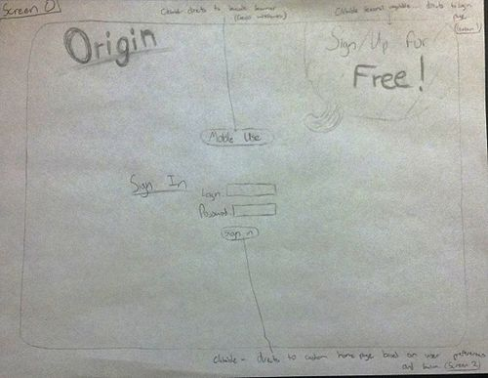](http://bid.berkeley.edu/cs160-fall12/index.php/File:0.jpg) [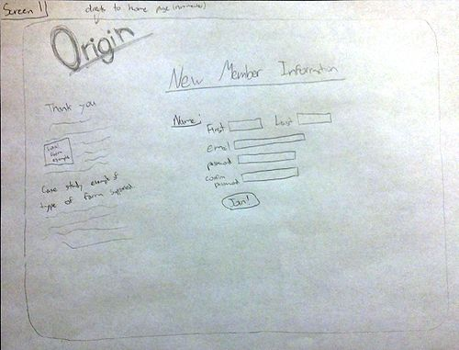](http://bid.berkeley.edu/cs160-fall12/index.php/File:1.jpg)

**HOME PAGE:** The user home page is the central location for news, trivia, and updates on their favorite foods and topics that they care about (sustainability, organic foods, small-scale farms, etc). Again, we are keeping it simple and displaying a slideshow with articles and pictures that can be paused to read further or clicked on to follow to original link. There is also notifications at the top right of the page (note that they will only be present on the home page since the average user will not spend much time elsewhere in the application) and ways of connecting/posting interesting articles or recipes to facebook or twitter.

Clicking on PURCHASE HISTORY, FAVORITE SUPPLIERS, or RECIPES is covered in the below sections.

[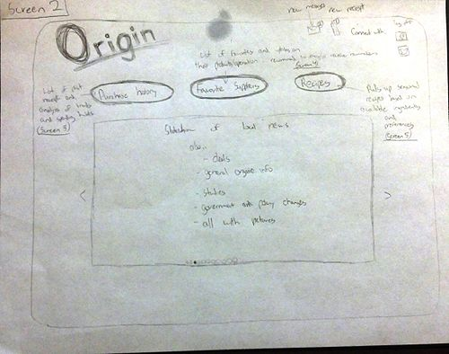](http://bid.berkeley.edu/cs160-fall12/index.php/File:2.jpg)

**After selecting "Purchase history"':** Purchase history brings up an immediate report for your last receipt. There are simple sorting arguments on the left to find a desired purchase quickly. Once a user clicks on VIEW REPORT the new report will be refreshed on the page. There will be a receipt summary which is basically just a copy of the original receipt, along with a CO2 calculator (could be expanded to include the "Origin Rating"). A key part of this page is the sliding display of suppliers at the bottom. This will include a linked image to the producer's site or Origin profile along with a condensed thank you and personal message from the owner/farmer.

[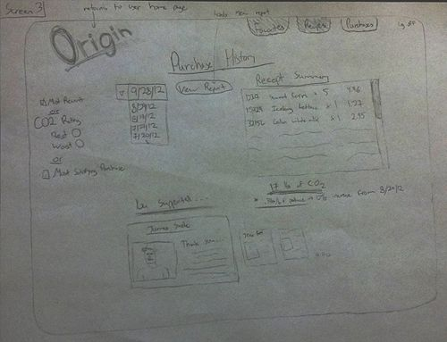](http://bid.berkeley.edu/cs160-fall12/index.php/File:3.jpg)

**After selecting "Favorite Suppliers"':** After clicking on RECOMMENDATIONS you are directed to a scrollable page that includes your favorite suppliers and updates on each (i.e. new products, family news, personal statements, and other general news). From here you can see what products they have in the market at any given time as well as what they will be offering in the future (harvest dates, etc). You will also be able to recommend your favorites to others through facebook or directly to their Origin account, simply by clicking on the RECOMMEND button to the right of the supplier summary.

[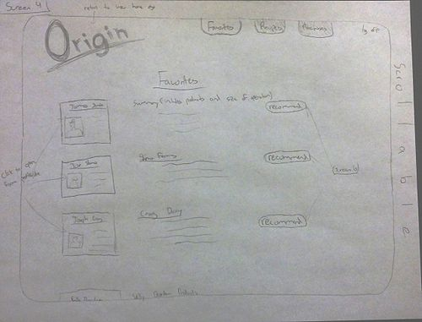](http://bid.berkeley.edu/cs160-fall12/index.php/File:4.jpg) [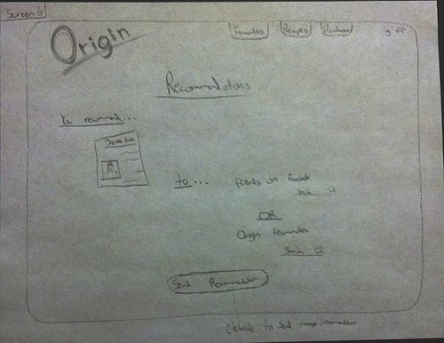](http://bid.berkeley.edu/cs160-fall12/index.php/File:6.jpg)

**After selecting "Recipes"':** Recipes is another extremely useful aspect of the Origin site. There are two options here... One is to enter ingredients that you want to use and allow that combination to define what recipes are suggested and the second option is to find seasonal dishes based on what is available locally at a given point in time. These recipes will add more "flavor" to a user's life by mixing things up and suggesting new things that they may end up liking. The seasonal selection is a slideshow of pictures, ingredients, and cooking instructions so that the user can quickly scan through to see if there is anything worth trying. For the pick-your-own ingredients option, the user must click the COOK button after entering ingredients and up will pop another page (page 7). This is another slideshow of recipes using the key ingredients specified. The recipes will be rated and presented based on ratings. Eventually we would like to have users enter recipes to be voted upon and approved based on a stringent user approval ratio.

[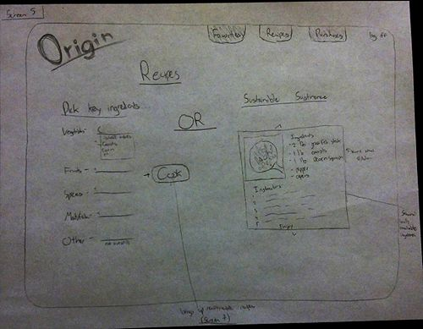](http://bid.berkeley.edu/cs160-fall12/index.php/File:5.jpg) [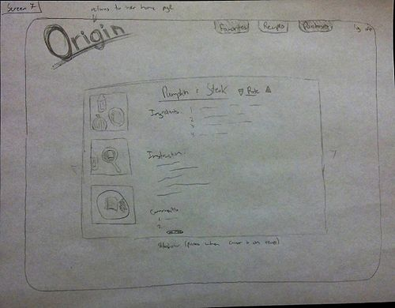](http://bid.berkeley.edu/cs160-fall12/index.php/File:7.jpg)

**TASK 1, New user browsing the site for vendors:** When a new user visits the home page, they will immediately see a feed of common sustainability topics and information about vendors. From there, they can explore the various articles and read about vendors in the area. The detailed information on each vendor includes their store information, so the user can check that if he wishes to pay a visit. [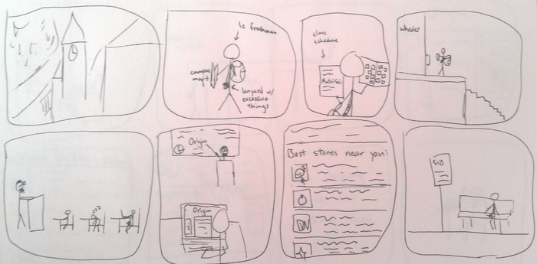](http://bid.berkeley.edu/cs160-fall12/index.php/File:G19_task_1.png)

**TASK 2, Finding information on recent purchases:** When a user logs in, he can click on "Purchase History." The app will load information about items that he recently purchased and display a general overview, with links to the supplier's sites and indicators that show whether the items are sustainable, organic, etc. The user can click on an item to get further information on the item and its supplier, and possibly add it to his fridge. [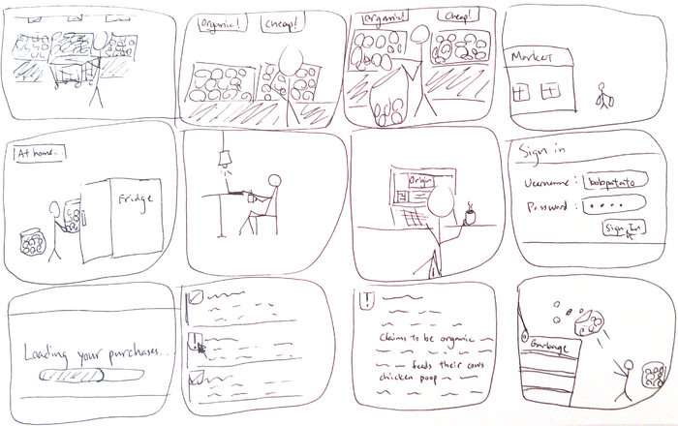](http://bid.berkeley.edu/cs160-fall12/index.php/File:G19_task_2.png)

**TASK 3, Looking up and saving recipes (Steps are in order left to right, top to bottom):** If you are an existing user, you can simply log in (top left screen) and click "Generate recipes" (on the top right screen). Then, the user can rifle through the book and click on a recipe to select it (on the middle left screen). Once the recipe is selected, as displayed in the middle right screen, to mark it as his favorite, the user simply drags the page onto the fridge door (as illustrated in the bottom left screen). The user gets feedback that the page is "stored" because it will appear as a page on a magnet clip on the fridge door. For easy access of favorite recipes, the user only simply has to click on that page (on the magnet clip), from any screen where the closed fridge door is present. [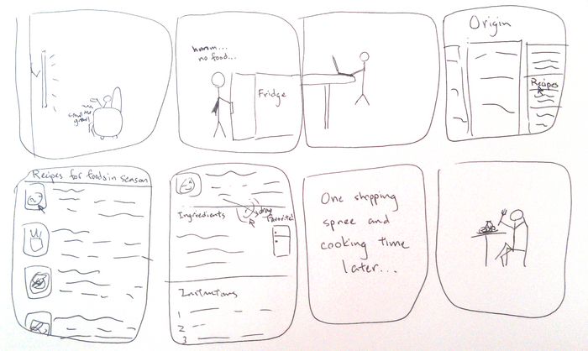](http://bid.berkeley.edu/cs160-fall12/index.php/File:G19_task_3.png)

Analysis of Approach

There are several ways how our application takes advantage of the affordances of web applications. First, the World Wide Web allows people to easily access a vast amount of information. We are hosting a large database of food details and want users to be able to access this data in a simple manner, so a web application would be the perfect solution. In addition, updating this information through a web framework language such as Ruby on Rails is pretty straightforward. A single web browser also provides you the ability to refer to many different webpages at once. Since there are a lot of different kinds of food labels on the market, it is possible for the users to get into situations like not having enough knowledge or understanding the meaning of a certain technical term when looking up the information about these organic/sustainable foods. Looking up these terms is now easy as you can open up multiple tabs and easily switch from the information page and the term definition page. Plus, web applications can be run on most of the browsers, so users do not have to worry about whether the application will be supported if they want to use it on other devices. In other words, a web application has a large flexibility because of its operating system independence.

Another approach we had was a mobile platform. The main pro behind this is that users can find out the produce details when they first see the produce during their shopping experience rather than waiting to find a computer to see it in a web browser. It is a simple functionality of scanning the bar code to access the information. However, there are a few cons. While it is convenient to search for and look at many different terminologies on web browsers, it is the exact opposite with mobile devices since they usually have small screens. Switching between web pages becomes a hassle as you have to use the touch screen functionality to zoom out of the current page and zoom in to the new page. Lastly, support of mobile applications vary by platform (i.e. Android or iOS), so there have to be multiple instances of the application written in different code to run on both an iPhone and an Android.