Problem and solution overview

Here is the consumer pain that Origin aims to resolve, buyers want to know more about the product they are buying (ex. location of origin, worker’s rights, chemicals used, etc.) but there are few resources to help users find this information in a convenient manner. This problem can be further specified to foods and consumables because for a few reasons. For one, users are curious to know whether or not supermarkets are being honest with customers. Producers can easily use false advertising and mislead consumers to buy their products by marking it as organic or "natural". Another reason is because of health concerns. Consumers want to know that the food is as fresh and organic as possible. Finally, there is a lacking of human-to-human interaction at supermarkets. Consumers want to know that their purchases are going towards supporting local economies, and understand how their money is affecting various communities around the world. Our solution would work as follows. Once the user has bought all of their food, they can go to their profile on this application and look at their past receipts containing the items they have bought. They can then click on one of their products and see a company profile with additional data points of interest. This profile would include things such as the farmer’s name, family history, size of establishment, number of employees, types of goods produced, pictures of the farm/plant/establishment, pictures of the employees, soil conditions, use of pesticides, etc. By distinguishing facts about the truly organic and sustainable growers, customers can begin to make educated decisions and truly manipulate what happens in the world by directing the flow of money.

Target user group

The target user group consists of people regularly buy food at supermarkets and want to know more information about their purchases. There are two categories at play here: the younger generation aged 16-30 and the parental figures aged 20-50. They like eating all types of food, but they generally try to stay healthy, go for organic produce, and are aware of sustainability and environmental issues. Also, they are tech-savvy, meaning that their Internet use is regular enough to navigate around various web applications without much trouble. These users are middle to upper class people who are financially stable and educated with college degrees or in pursuit of one. In addition, they live in urban neighborhoods with access to a wide variety of products being offered at varying locations. In practice we ended up testing our product with young, Caucasian males primarily and most had financial stability that would, in theory, make them stronger candidates for using an application that distinguishes between goods based on metrics other than price. We did test our hypothesis on a few middle-aged individuals from varying backgrounds and feedback was also positive. However, a concern that our team has always considered is the major limiting factor of financial stability and/or prioritization of responsible consumerism.

Tasks

**Easy: View News from the Feed**

Browse news on local markets, organic industry, and general notifications targeted at those trying to live healthy and sustainably. Click any article to expand to the full story.

* The user must sign in or sign up and will then be automatically dropped off on the home page
* From there they can click on the news articles that are rotated through
* Click on a given article picture/title and the user will be moved to the news article page
* The user can navigate back to the home page when finished

**Medium: Navigate to an Item Profile**

* To get here the user must go from my account to receipts
* Then to gain further information on an item they must click on it on the digital copy of the receipt
* From here they are redirected to a supplier profile page that also holds information on their products (more information on the item of interest though)
* They can recommend the product/ supplier from this page
* To return to the receipts page they must click the respective button located at the top right of the page

**Hard: Comment on an Item and Recommend to a Friend**

* From the "My Account" page or the "Receipts" page
* Click on item or supplier of choice if available or navigate to purchase or recommendations
* Find item/supplier to recommend and click the recommend button
* In the case of a recipe the user must search through the carousel object to find a recipe of interest and then recommend from there
* Recommendations can be completed through connecting with a social network such as Facebook or Twitter
* The other option is for the user to specify an email and send a recommendation directly from there (this email will also include an offer to join the Origin community and hopefully will help to expand the user base)

By using these three tasks, we can test all of the most important functions of our website. Therefore we can make sure that each function works well and know users’ reaction of the function. Secondly, we test the part we are uncertain about, such as the information listed on the receipt page, to get their feedback about it. In addition, the three tasks are sequential, which can tell us which page, which element confuses the user to continue.

Design Evolution

Overall Flow

The changes that occurred between the different design phases were very much representative of what we were taught in class. For example, our very first assignment pertaining to Origin was just simple sketches and undeveloped ideas that were being thrown around at the time. The lack of formality during this phase really allowed us to continue evolving through the next couple of stages.

Our low-fidelity testing is where the vast majority of our development happened. This is the stage where drawings became code and we could really start to get a grasp as to how much we would be able to handle this semester and what were some possible milestones to reach for in the future. The testing and amount of user feedback early in this stage was vital in the production of a well expressed and fully-developed application. The contextual inquiry assignment helped to verify hypotheses and reignite interest in possible features that had originally been cast away by doubt and fear of failure. The greatest takeaway at this junction in our design process was the importance of early user feedback. "Survey soon and survey often" became our motto once we realized the amount of work it would entail to begin implementation of the features we were considering. Even user feedback on the sketches helped to define what our first, most basic prototype looked like. We kept our UI simple and clear of possible distractions that would take attention away from the actual functionality of our application.

Finally, our pilot usability study and now our final version becomes more about polishing off less-noticeable blemishes and making sure that the flow of work from task to task is smooth and stimulating for our users. There were not as many changes as I thought there would be for this final iteration but I guess that it makes sense (and aligns with what we have learned in class) because the majority of large changes happen at the beginning when there is little time invested in the actual UI and features are more of concepts then actual implementation.

Biggest Changes

Our home page actually ended up looking more similar to the original sketch than it did to the intermediate prototypes. I think the reasoning for the news feed on the original sketch was to keep the home page interesting and fill it with something entertaining. On the other hand, the reasoning for NOT including the news feed on the low-fidelity prototypes was that we could possibly do something else and it didn't seem logical to invest time into developing a feature that we were unsure about. We also decided to get away from inclusion of Facebook, Twitter, Youtube and other name-brand social media sites on our homepage because there is no purpose for them to be on this page! We only need those mediums for sharing content, this led us to simplify the design by removing the site icons on our homepage while still retaining their existence on the recommendation page.

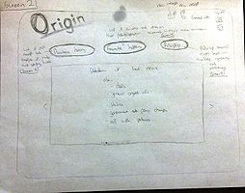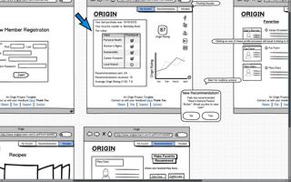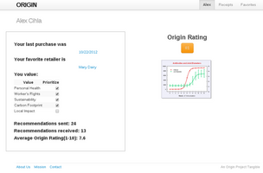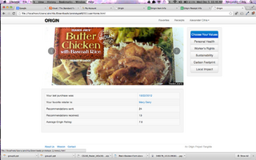

The purchase history/ receipt archive was simplified from our sketch to a more relaxed design with a lot less information and confusing selection boxes. The final implementation is pretty close to our original mock-up less the recipes button which we deemed unnecessary for this particular release of our product. Something else to note about the original sketch is the inclusion of the item profile, which is now a separate page all together. We will go into more detail about that later.

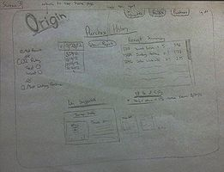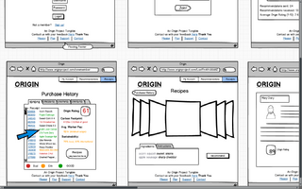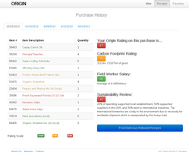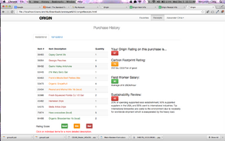

The item profile shown squished in the lower half of the purchase history sketch was something that we saw requiring more attention and was important enough to warrant its own separate page. At first we thought that the best information to show would be the relevant information pertaining to the item as well as a condensed list of who favorited it. However, this idea was born whilst the team was considering the integration of a social network within Origin. As of now we have decided to leave the social networking to Facebook and Twitter (we will still use their viral abilities in spreading content awareness and draw new users in). We had also received much feedback regarding the lacking of some sort of commenting system that would allow user feedback. Many test subjects asked about a comment system and whether or not we were considering implementing one. So, in the end, we decided to eliminate the list of users who favorited a specific item in favor of a comments section and easy rating system so that users can leave immediate feedback through minimal effort. Notice the thumbs-up/down system similar to that of Facebook, we believe that this design will help to induce comfort and familiarity with our site.

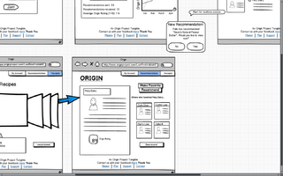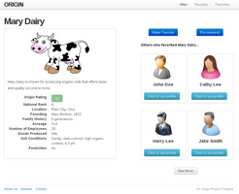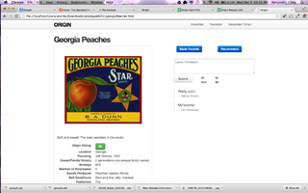

The main change here is the removal of the "Accept" and "Deny" buttons which were going to be used with the idea that Origin was going to become a sort of social site. We have since pivoted towards allowing users to post to Facebook, Twitter, and other popular sites in the future without having to synch accounts or draw any parallels between the two services. We believe that simply sending an email or posting to someones wall will be enough to induce a sufficiently high rate of new traffic.

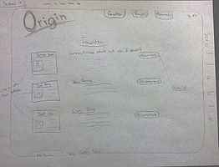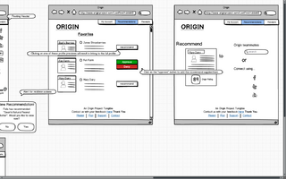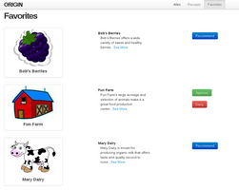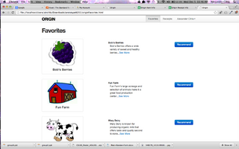

Most Effective Evaluation Technique

The contextual inquiry project was definitely the most influential evaluation technique that we carried out. By using this technique very early on in our process, one could argue that it was really the birthplace of our idea and the reasoning behind why we decided to continue on with our implementation plans with the knowledge that the features were of use and would be solving real-life problems. We were able to begin our visualization of Origin and the creative juices started to churn amongst the team. From here on out we began to hold productive meetings that consisted of aggressive brainstorming and discussion relating to design heuristics for our application.

The fact that this evaluation technique occurred so early in our process made it the absolute foundation from which our creation grew. We were able to focus on big-picture issues and remain creative rather than focusing on implementation of very specific features and handling specific tasks. There was a ton of information to rake through but all of the data was helpful in one way or another. The birds-eye-view approach to the problem was liberating and definitely helped us all to think of possible features (even those that are too complicated for the scope of this class). I would, without a doubt, call our contextual inquiry the most helpful, informative, and influential form of evaluation/testing that we have done all semester.