Introduction and Mission Statement

Origin is a food application that gives users more detailed information on the company profile making their produce, such as the farmer’s name, family history, size of establishment, number of employees, types of goods produced, pictures of the farm/plant/establishment and employees, soil conditions, use of pesticides, etc. The reason behind this application is that buyers would like to know where their food is coming from and who is actually making it besides the store that is displaying it. These people are curious because, for one, they want to be ensured that the supermarket is being honest with the customers. Producers can easily use false advertisement and mislead consumers to buy their products by marking it as organic or "natural". Another reason is because of health issues. They want to know that the food is as fresh and organic as possible. Finally, there is a lacking of human-to-human interaction at supermarkets. Consumers want to know that their purchases are going towards supporting local economies, and understand how their money is affecting various communities around the world. With Origin distinguishing facts about the truly organic and sustainable growers, customers now know for sure that they are supporting sustainable and organic providers. The experiment we are conducting is to interview various people who have just bought groceries from the supermarket and have them try out our prototype of Origin. We will observe them using our application, making sure to ask them questions and note down their feedback on the prototype.

Our mission is to give market shoppers as much information as possible about the background behind the food they buy, help them personalize their produce, and provide a social platform for them to interact with other.

The roles of our team members are as follows:

Prototype

Referring to next 4 screen shots... The first and most simple task here is to create a new account and input the simple requested information (email, password, etc). From here the user can return to the landing page and sign in as a member. These first FOUR pages show sign up and log in. After completing log in the user will be directed to a "My Account" page where they can view their most basic data and preferences. We hope to use this page as a sort of report card for the user so that they can immediately track their trends and get feedback on their most recent status as an Origin member.

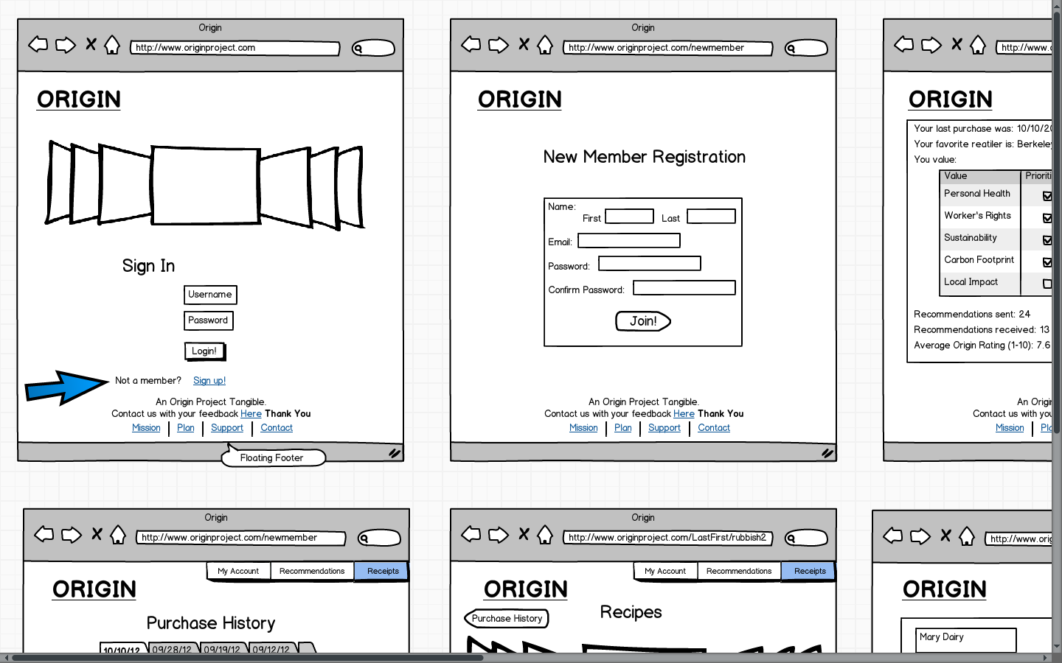

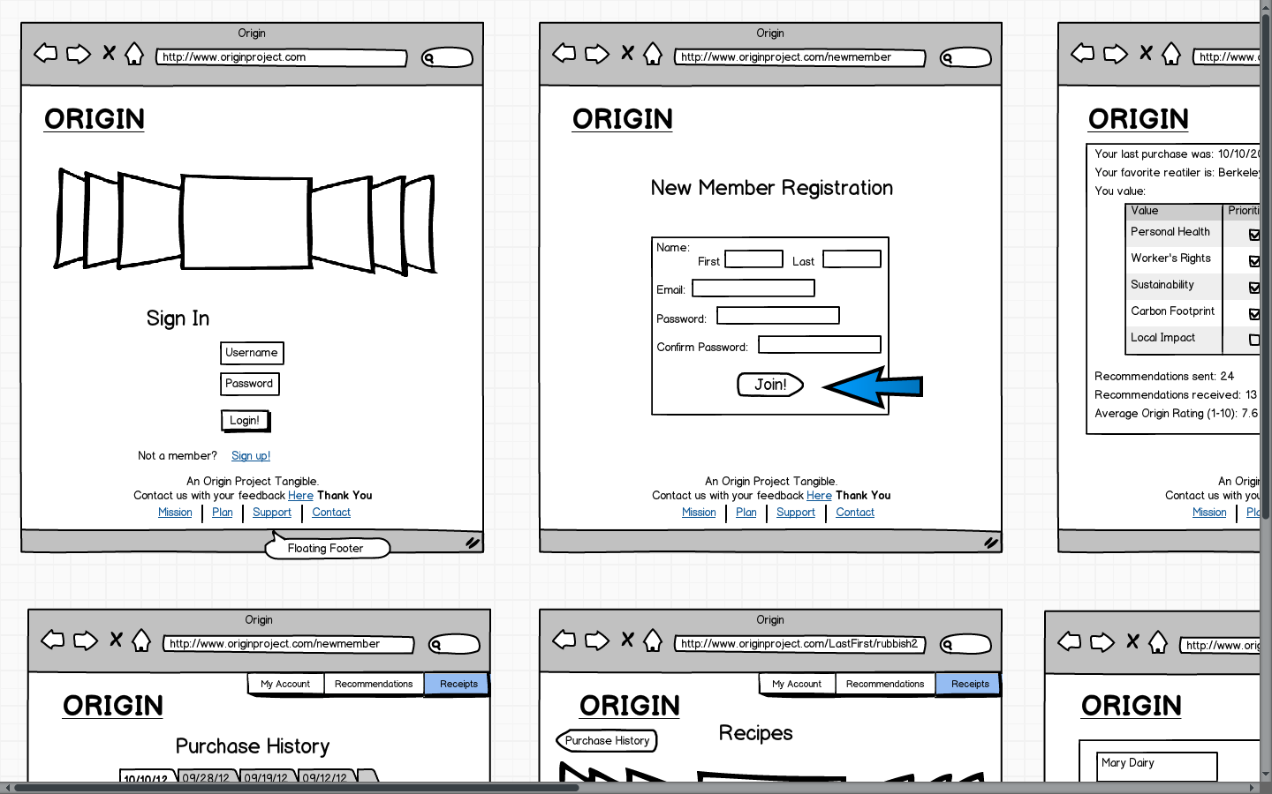

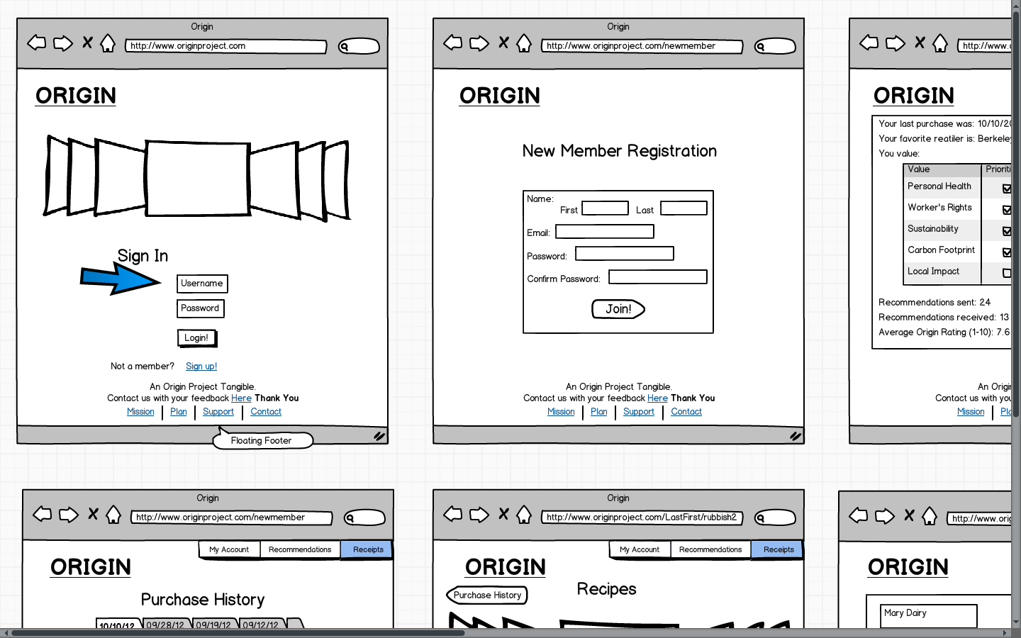

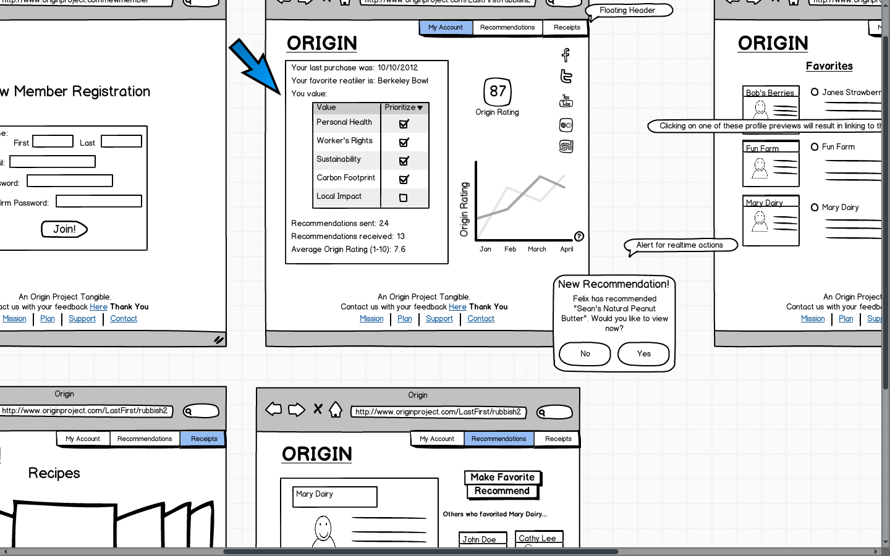

Referring to next screen shot... The home page is where the user sees notifications and is notified of changes to their account, specifically recommendation related. The notification will come in the form of an alert that pops up in real time or at the beginning of a new session.

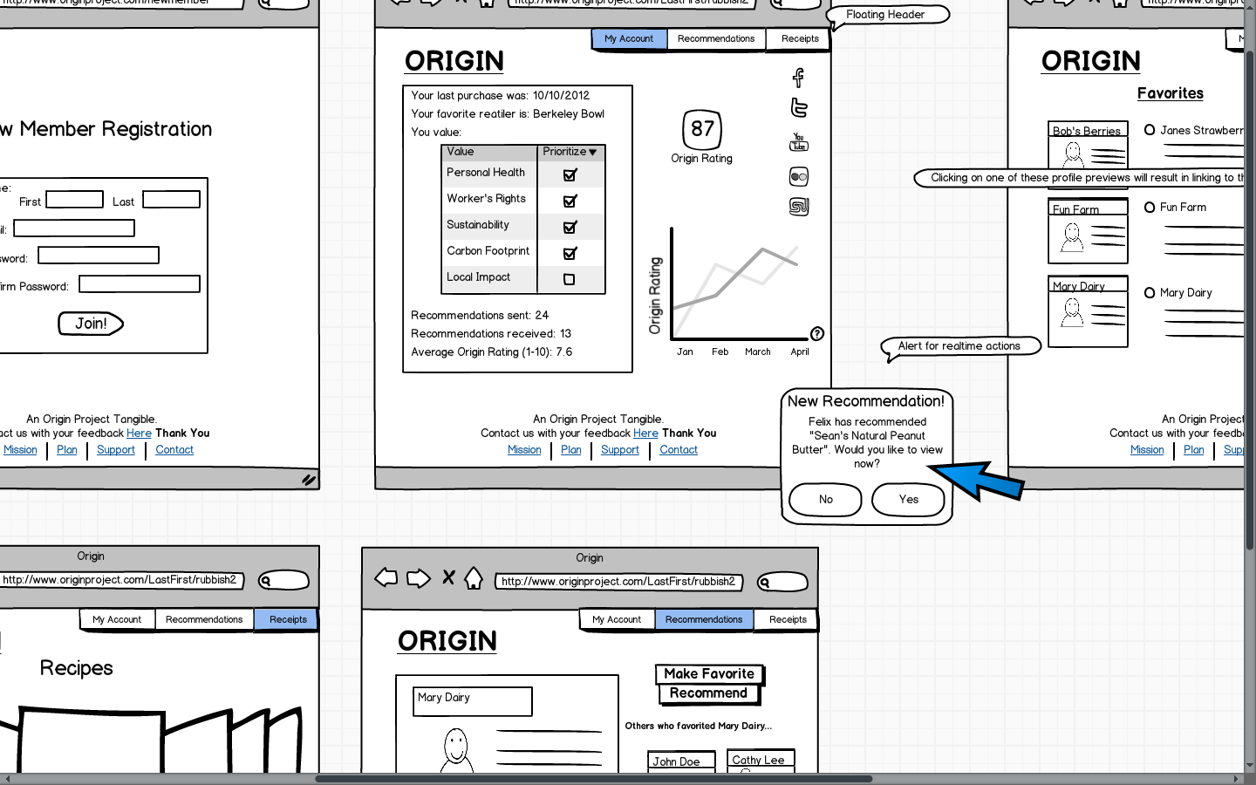

Referring to next screen shot... We will be synching Origin with Facebook and Twitter so that people can connect with their friends via these pre-constructed networks. We also hope to use YouTube,Flickr, and possibly Stumbleupon to post other media and key data in order to spread awareness of the service.

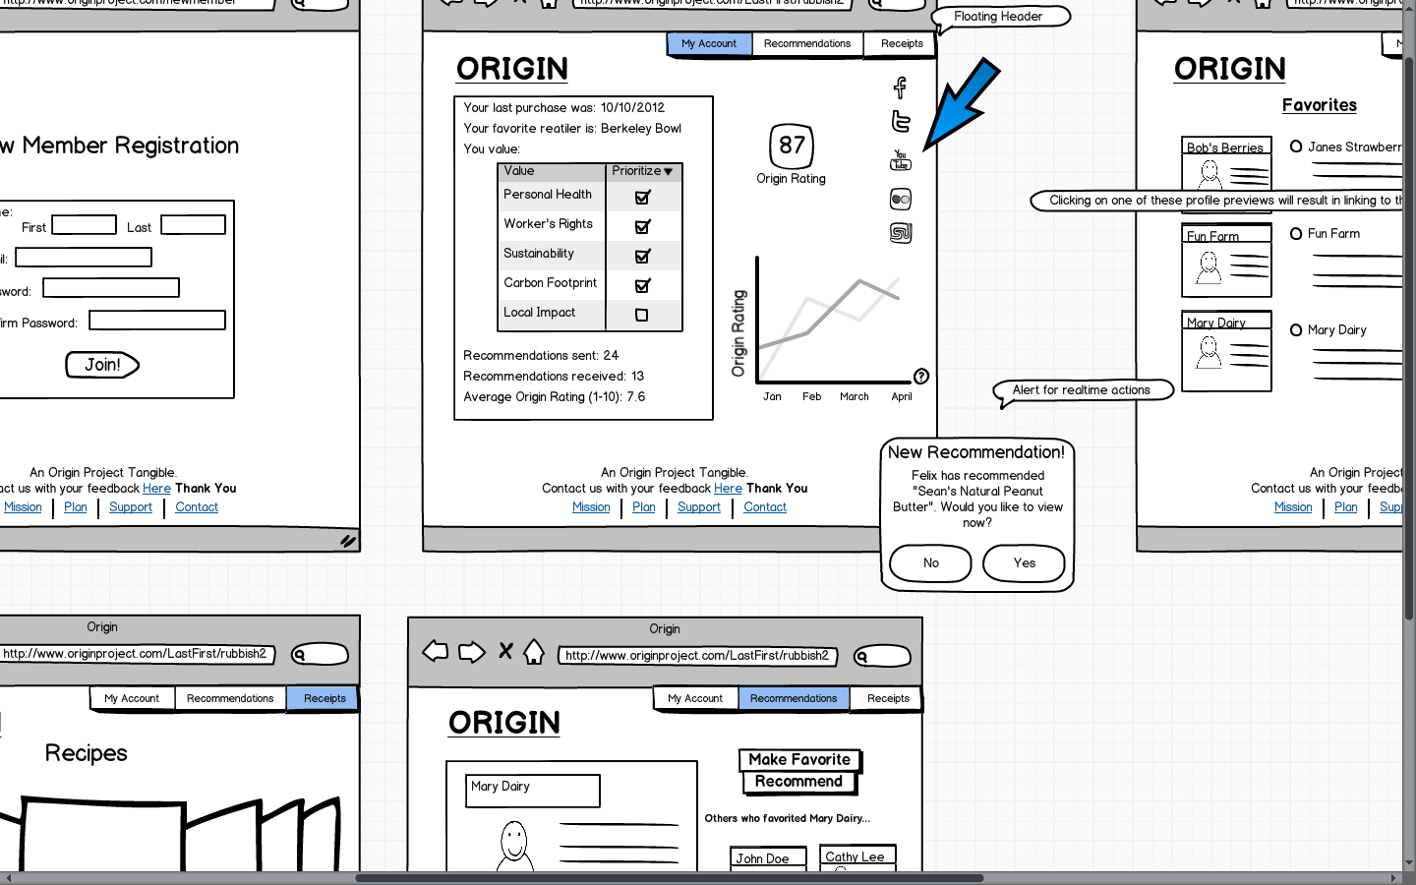

Referring to the next 3 screen shots.... Recommendations can be sent between users via email or preexisting connections on Facebook or Twitter. These recommendations can be approved or denied. The user can choose to click on the profile thumbnail to find more data on the product/supplier or they can trust the recommendation and accept with no research. The recommendations are to add a product/supplier to a list of favorites (as of now we were just going to sort these chronologically) and from here they can be recommended to other users.

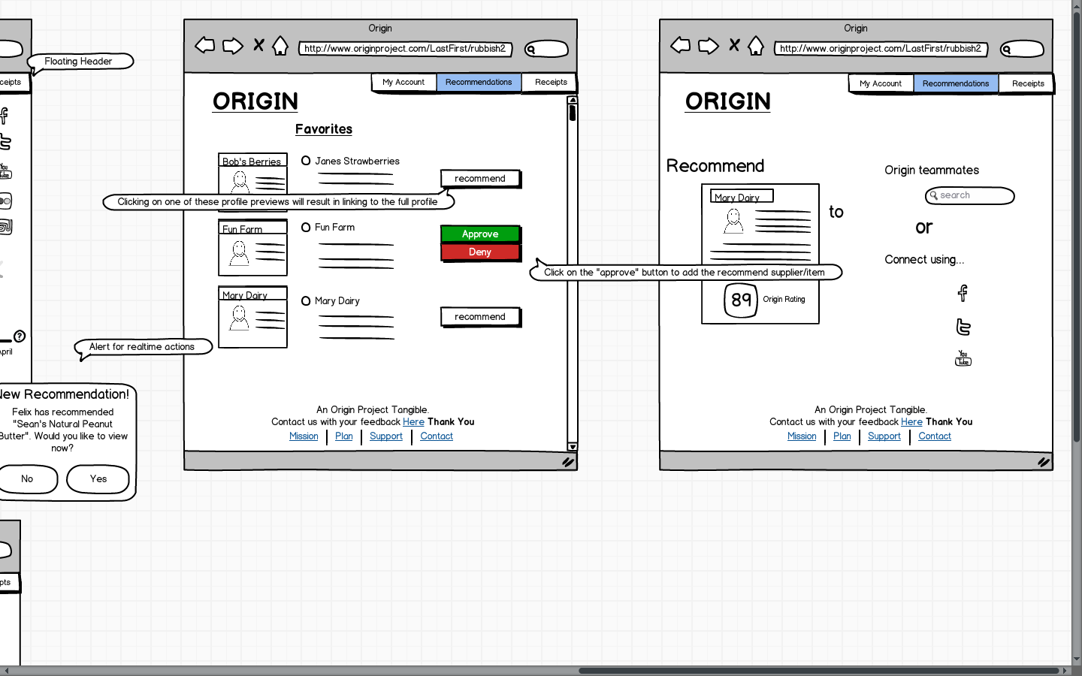

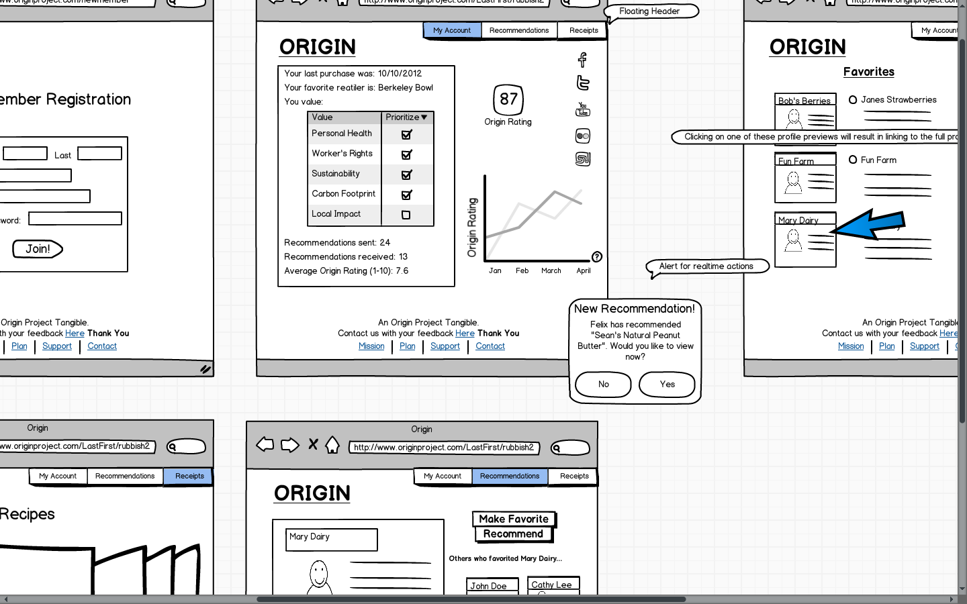

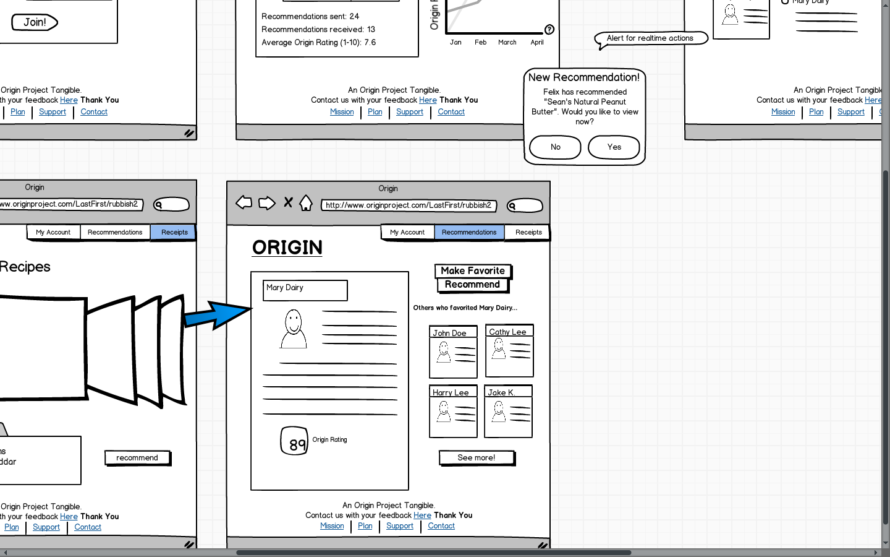

Referring to next 5 screen shots... The user is also able to look through past purchases and see digital copies of their receipts which include links to supplier/product profile pages on items that have been updated into database (we assume that not all products will have profiles due to constantly changing supply of goods). The receipt history is meant to give a quick story on relevant information for the user so that they can break down their overall Origin rating into individual purchases and see how they can change their spending to have certain desired changes (ex. they can start buying from companies that pay their employees above minimum wage...pay a 'livable' wage or maybe base their purchase decision on something carbon footprint related). From the receipt the user can go to a profile and read more about that given product. They can also make recommendations from here.

The user can also find relevant recipes using the ingredients from certain purchases to make a dish. These recipes, similar to products/suppliers can be recommended to others. We hope to also include comments here because of the unanimous user feedback that we got in our experimentation.

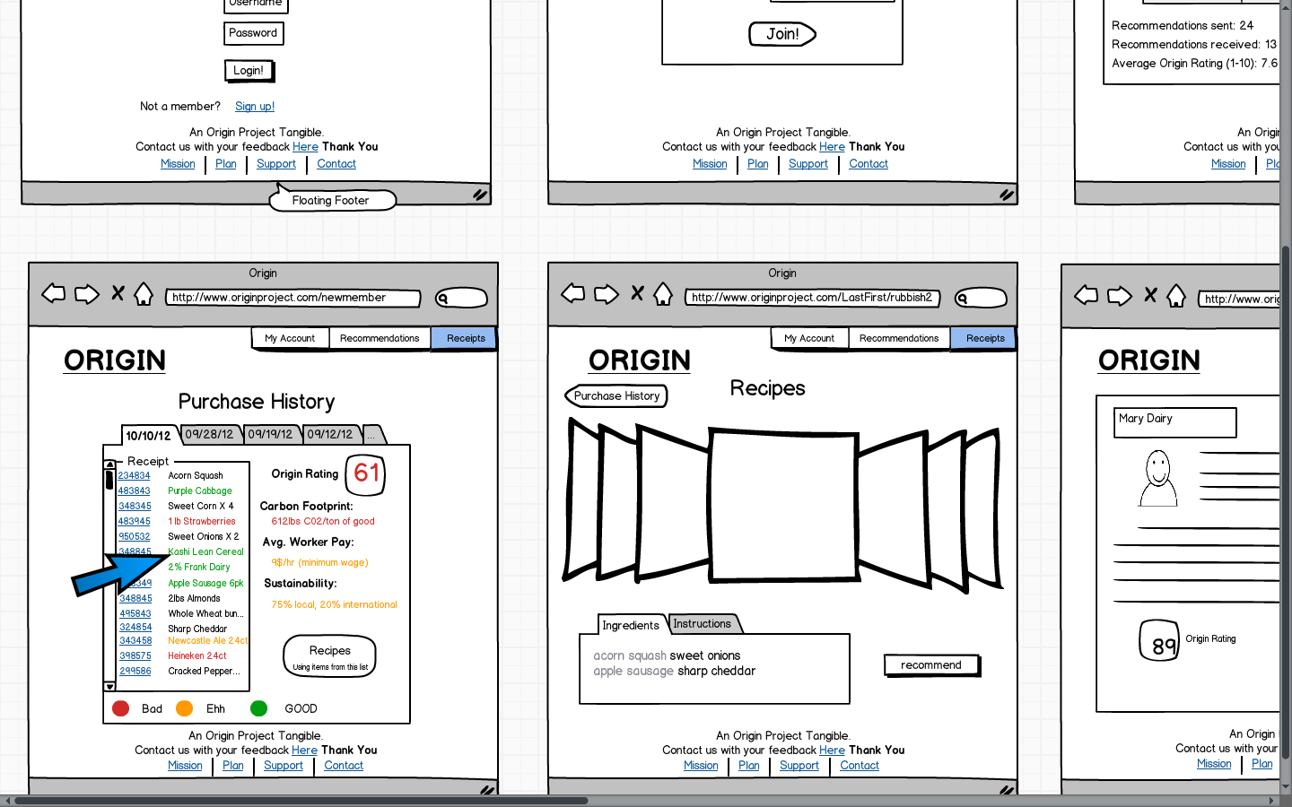

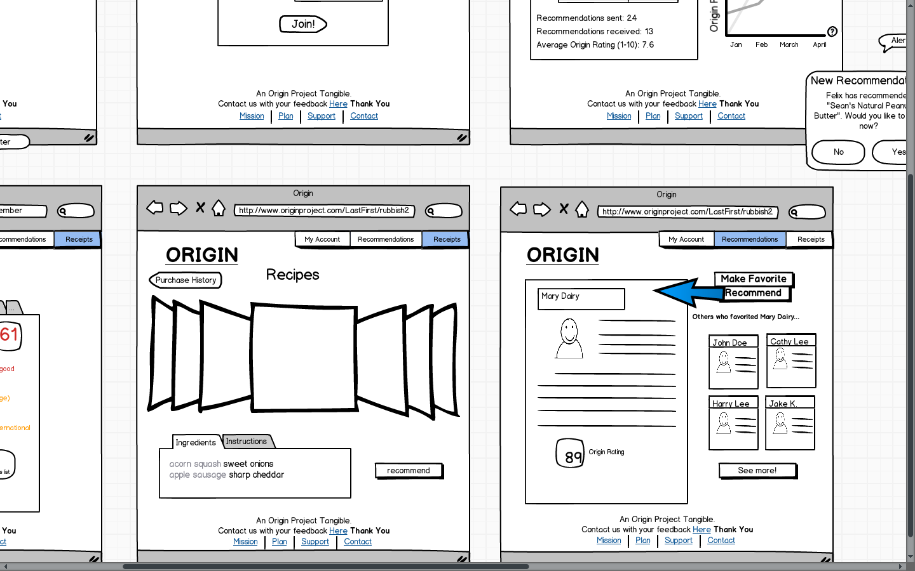

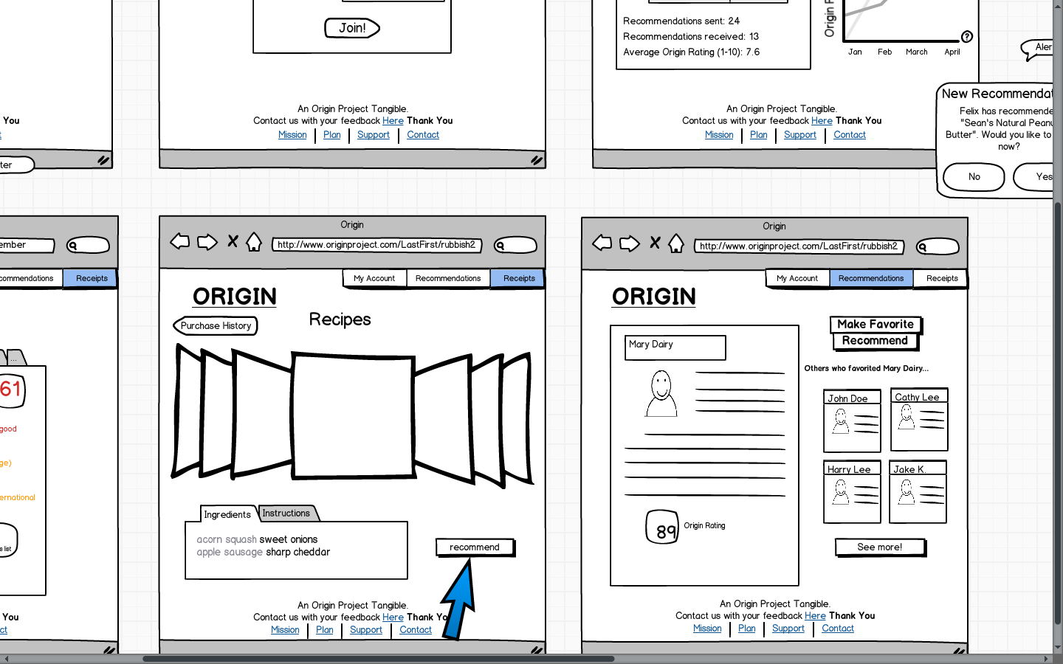

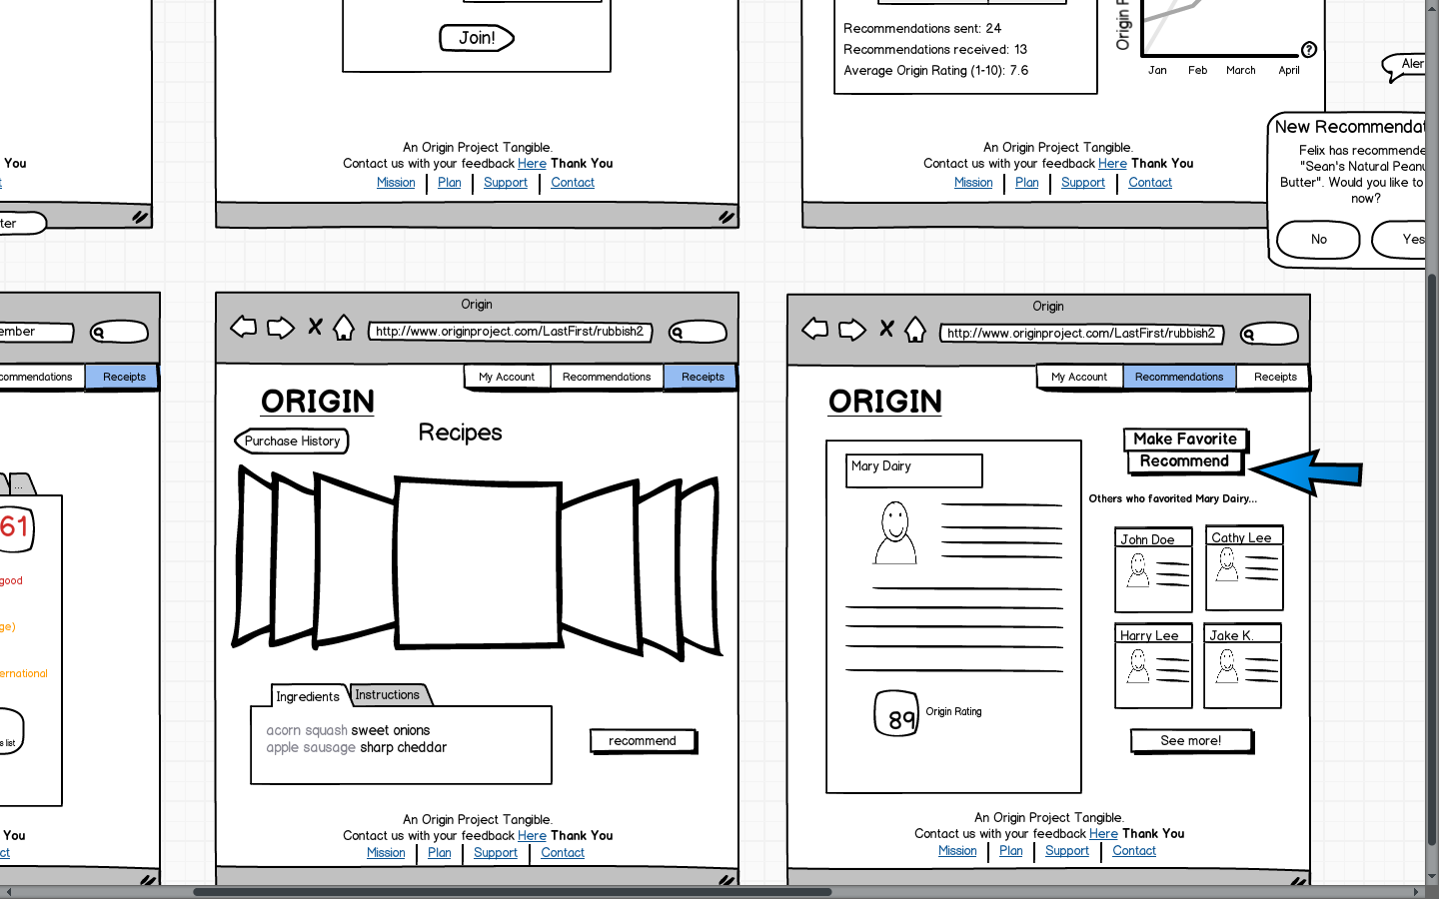

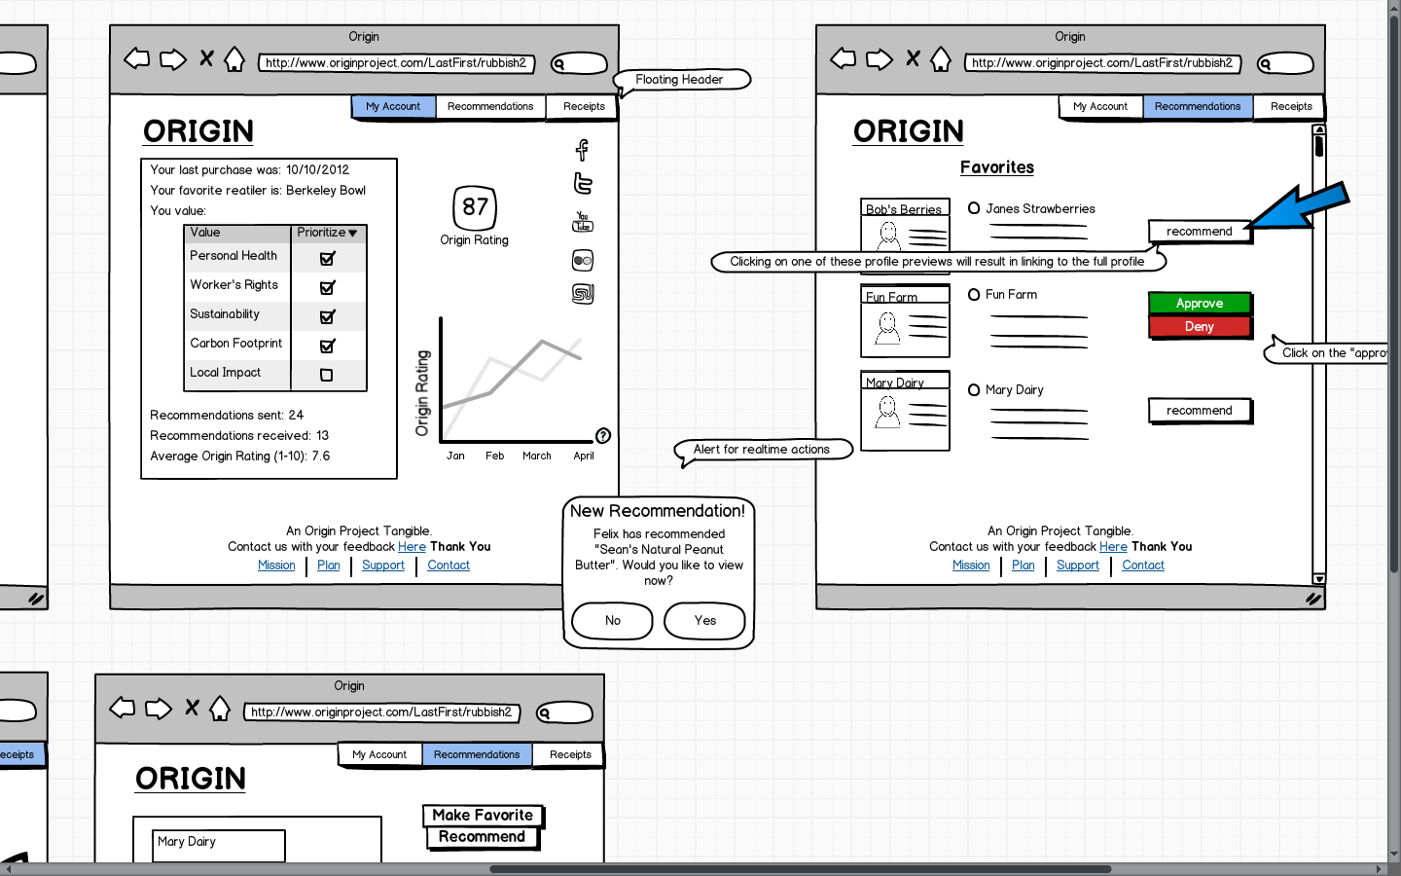

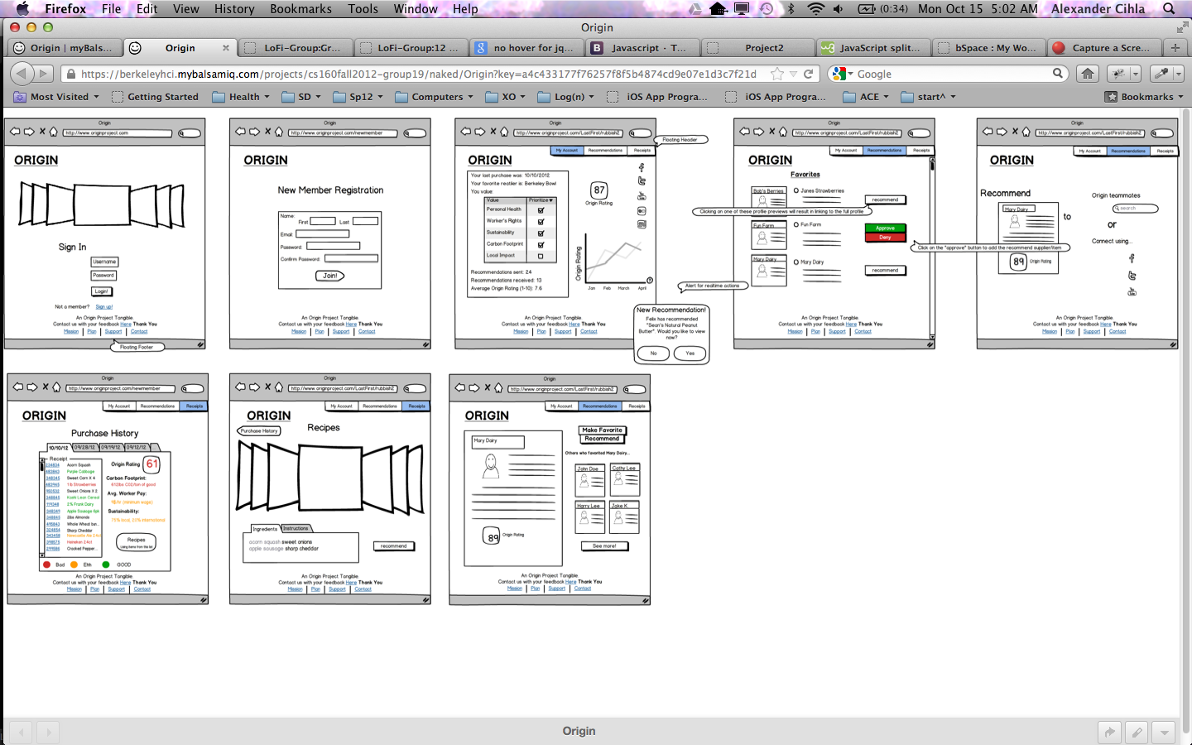

Method

**Participants**

We chose members of the Chi Phi fraternity to partake in our experimentation because we needed young individuals that we could test after they went grocery shopping. Since transitioning from a mobile app we have also pivoted our user group to a younger and socially active community. Since changing our idea to fit into the generalization of web application rather than mobile, the idea is to use the preexisting network on Twitter and Facebook to allow users to share their favorite suppliers and recipes.

Tucker Chambers- Tucker is a third-year architecture major and lives an active lifestyle (lacrosse). He is our outlier in this situation because he does not have a Twitter or Facebook so he would be an isolated user on the site with minimal opportunity to recommend and interface with the Origin community. He will most likely judge the site on purely what it offers outside of the recycling of the social network aspect.

Gabe Kahn- Gabe is a sophomore and very active on Facebook (although he does not tweet). Gabe is one of the few people in the house to have a car and he makes trips to Safeway regularly frequently. It will be interesting to see how he will use the site and decide what kind of value it offers him. Especially since he spends a lot of time and money shopping for food at the same store. We will see what he learns from tools such as purchase history and recommendations of products and recipes.

Ash Sridhar- Ash is a sophomore mechanical engineer student who has both twitter and Facebook, and he uses them often. He also posts images of food and dishes that he has cooked (foodie) so we will see what type of feedback he has fro the social network integration and ability to share this information with his friends at a moments notice. He does not travel to the supermarket that frequently but when he does he usually buys premium goods and likes to read the labels throroughly because he likes to know exactly what he is getting and why he wants to buy it.

**Environment**

We also wanted to test the user in their normal computing environment, like their room or office, because we want to mimic the environment that they would be in when they check Facebook or other social networking sites. It is hard/impossible to get a random person to allow you to follow them home and conduct the test. We simplified the experiment by testing three users who all went on the same shopping trip and shared a similar in-store-experience. The environement will be in their own room or in our downstairs common rom, where they would normal do something like this while they are browsing the web. We grabbed them a couple of hours after their trip so that thtir purchases could still be fresh in their mind. The experiment was done one at a time with a computer, observer, and facilitator looking on and interacting as a system. We used my computer and allowed them to actually control the computer. They would then speak out their actions as well as show it on screen and then the “computer” would briefly interject and change to the appropriate page or take the appropriate action.

**Tasks**

The three tasks that our users will try to accomplish are the following: Log in to view purchase history, locate information about a specific item , and recommend a supplier/item/recipe to a friend.

**Logging in**

1. The user must click the "New Member" button and fill out the form
2. Very straight forward... fill in data... create account... and return to home page to log in
3. Then they will be redirected the "My Account" page which will give a brief summary of their purchase history and spending trends
4. From here they can join through Facebook, Twitter, and/or YouTube
5. A new user will have no data here but initial functionality comments on this page could be useful to first time users (CONSIDER THIS FEATURE)

**Locate information about a specific item**

1. To get here the user must go from my account to receipts
2. Then to gain further information on an item they must click on it on the digital copy of the receipt
3. From here they are redirected to a supplier profile page that also holds information on their products (more information on the item of interest though)
4. They can recommend the product/ supplier from this page
5. To return to the receipts page they must click the respective button located at the top right of the page

**Recommend a supplier/item/recipe to a friend**

1. From the "My Account" page or the "Receipts" page
2. Click on item or supplier of choice if available or navigate to purchase or recommendations
3. Find item/supplier to recommend and click the recommend button
4. In the case of a recipe the user must search through the carousel object to find a recipe of interest and then recommend from there
5. Recommendations can be completed through connecting with a social network such as Facebook or Twitter
6. The other option is for the user to specify an email and send a recommendation directly from there (this email will also include an offer to join the #Origin community and hopefully will help to expand the user base)

**Procedure**

The testing procedure will be as follows:

1. Greeter will greet the subject and introduce the product. Greeter will then ask for the following basic information, which the Observer will note down: name, age, occupation.
2. Greeter will ask some contextual questions, and the Observer will note down the answers. They will be as follows:
   * How often do you check to see if products you buy are from sustainable sources?
   * How would you find information about product sustainability? What tools do you know you can use?
3. Facilitator will give an overview of the interface to the user and how the user will interact with the interface through the Computer. Observer should note down any unusual behavior from the user at this point.
4. Facilitator will explain the procedure for accomplishing the tasks and give any necessary information (username, password, etc.). The user should understand that given a task, he should try to complete it using the interface as if it was a real website. Facilitator will ask the user if he has any questions before he begins. Observer should note down these questions.
5. Facilitator will give the user the first task. Observer should note down the user's actions as he attempts the task, especially any confusions or usability issues. The Facilitator should try to minimize interaction with the user at this time, unless the user is completely stuck and requires aid in continuing with the task.
6. After the user has finished, the Facilitator will ask the user how he felt about doing the task. Observer should note down the user's reply.
7. The last two steps will be repeated for two more tasks.
8. After all tasks are completed, the Greeter will thank the user, hand out compensations (if any), and ask if the user has any suggestions for improvement. Observer should note these down.

**Test Measures**

During the test, we looked for several key responses from the users as they interacted with the interface. We noted any moments of confusion or uncertainty, because these would indicate a possible usability problem. We also noted any kind of negative emotional response (being surprised, getting upset), as these would indicate a disparity between the user's expected model of the interface and the system model of the interface. Most importantly, we noted down all verbal comments and feedback that the users gave us. We measured feedback from the users on a standard usability scale: not a usability problem, cosmetic issue, minor usability problem, major usability problem, usability catastrophe.

Results

*I don’t agree this is a usability problem*

* Too many pictures… overwhelming (I think the Balsamiq carousel image is what is overwhelming here)
* Plain design is boring. Lots of grey, black and white (again a result of using Balsamiq, but valid question as to what colors to use)
* Design is TOO simple and user will not be stimulated enough by the workflow processes

*Cosmetic problem*

* Lots of information to display but very limited room to do so
* Alerts that popup vs. Facebook-esk notification
  + Popups are very intrusive and break the attention of the user
  + Our test subjects appeared almost scared when the popup was thrown onto the screen

*Minor usability problem*

* Have to sign in/connect through social network, which includes an understood redirect and navigating away from the page
* “Favorites” page and supplier profiles are too small and it is unrealistic to get much data from their minimized profile view
  + If user actually wants to view a profile then they will have to actually click on that profile picture and view the information there
  + Again, navigating away from the primary workflow was a little unnerving and interruptive
* Some mentioned possibly using the carousel attribute for profiles so that one could easily peruse suppliers without having to click on them… navigate to the profile page… and then return to the profile page
* Receipt digest was a little confusing. It is not immediately apparent that any of the items are clickable and will bring up a profile
  + Possibly work on graying out the items that are unclickable and somehow make the other items “pop” and give a button feel
* User would like to search by date (in original prototype but left out to give clean feel to page)
  + We will consider this one but our thought is that for the most part it is not very useful because users will not remember the specific date of their grocery run (maybe a calendar picker with highlighted dates could help?)

*Major usability problem: important to fix*

* ALL test subjects want to give feedback on recipes, profiles, and other users
  + This is something that we cut from our original design because the way we understood the project we should focus on 3 tasks to complete… but such unanimous feedback leads us to believe that implementing the ability to comment and receive user input is going to be vital to a happy user group
* Users also asked if there was feature to allow uploading recipes
  + This is something that we do not see as important but would also like to please the user group
  + Whether or not we actually implement this feature will really come down to time and how far along we get with the other key features

*Usability catastrophe: imperative to fix*

* There were no outstanding issues but we can definitely prioritize our other issues so as to satisfy the user in the biggest possible way
  + The popup notification triggered some pretty nasty reactions and needs to go
  + The ability to add comments is also something that really hurt the user experience.

Other than that we got some pretty positive responses:

* Design is clean and simple
* It is hard to get lost (besides when being interrupted by notifications)
* Like the ability to connect with facebook, twitter, youtube, and stumbleupon to see other relevant data through those channels (we will have to populate some data on those networks for our final version so that it is all functional but it will be nice for users to be able to branch into a network that is already familiar to them. That way it is not ALL completely new.

Discussion

After trying to dumb down our original design we have learned that users actually do want some of the features that we thought were less important. For instance, commenting was a huge element of the design that was explicitly requested by all three, test subjects. It makes sense because our users really do want to give feedback to the system and they are (with the exception of Tucker) familiar with the traditional interactive sites likes twitter and Facebook where a user can post their ideas and see the ideas of others. We would like to mimic these positive attributes of other successfully designed sites. In summary, we will have a commenting section or two in our final product so that users can feel heard and invest themselves in the site’s evolution and growth.

We did a successful job of minimizing clutter and delivering pertinent information as clearly and concisely as possible. However, more specific customizable filters may still be of use here. By further limiting what the user sees we can 1. Give them the ability to define the amount of information/clutter that they view and 2. Allow them to further focus their attention on matters that truly matter to them (the more specific the better here). In general, this will mean that we must divide up our information further to make it easier to navigate, and improve the navigation interface to support more personalized browsing of information. Some users did mention the blandness of the design although they understood that it was just a rough prototype. However, it is worth mentioning that they mentioned these things because the actual content of the site can be a little boring at times and we may find the user requiring more stimulus. Again, this could be improved with a better, more interactive navigation interface, so that users can actively click around to see different pieces of information, instead of merely seeing a bunch of information all at once. However, we cannot break down the information too much, else we risk running into the problem of users having to navigate repetitively to access information that they would rather see at the same time. This potential issue could be mitigated by including summary pages, or using a drag-and-drop interface to allow users to select which pieces of information to display. But the users' comments on the design proves to be a key point of consideration. We will need to balance a simplistic and natural design scheme with some lively coloring that will keep the user stimulated and engaged at all times, but especially on the pages that lack content.

The popup notification NEEDS to go. It was a huge hassle for all users and it actually brought the look of terror to a couple of them. The disgust that was triggered by such an unexpected result was pretty interesting actually. Users don’t like being prompted to notice something. They would rather just notice it through a peripheral medium (like the Facebook notification icon). Something subtle yet noticeable will do the trick but the bottom-line is that the notification really threw a wrench in things and hurt the usability of the site. This could be because popups are generally associated with spam and viral ads on the internet; users are more accustomed to seeing simple numeric or symbolic notifications on popular sites. Popups are also very distracting in the way that they appear instantly and take up a nontrivial part of the screen real estate. Switching to a Facebook-like notification system will definitely improve the usability of our app, but we should also reconsider what exactly we want to send notifications for. Should we show all changes since last visit (ex. New receipts, recommendations, recommendation approvals, new friends joining, news from favorite supplier, etc.) or only prompt user on the more big picture actions like someone sending a product/recipe recommendation? We don't want the notifications to be so detailed that the users won't pay careful attention to it, but at the same time we don't want the user to miss out on any changes happening on the site that might be of concern to them. We will reconsider this issue and further our research by asking around and seeing what kinds of actions users might want to be notified about and how detailed the notifications should be, as well as how the amount and detail of the notifications influence whether the user reads it carefully or not.

We had some conflicting comments made by Ash and Gabe, they both mentioned the site being overwhelming but also overly simple. Maybe this shows that some pages have a ton going on while others are overly simple. This is a possible issue if our users receive a sort of “shock” from being under-stimulated and then over-stimulated. It will be worthwhile to consider ways to evenly spread out data and try to diminish the wide range of data presentation that is used. This is an interesting case of balancing content and visuals. It appears that users feel that there aren't enough visuals for the amount of content on the site. As our site is very information-intensive, it will be important to invest time in creating well-organized and well-presented visualizations for the information, as well as intuitive and responsive access methods.