Design and Planning Document

Table of Contents
Table of Contents 1
Document Revision History 2
System Architecture 2
Frontend (Android) 2
Backend (django) 2
Design Details 3
JSON Objects 3
Security Framework 7
Database 9
Algorithm 10
Invariants 10
Protocols HTTPs(Hypertext Transfer Protocol Secure) 11
Class Descriptions 11
Views Details 12
Implementation plan 15
Programming Tasks 15
Implementation Tasks 18
Testing plan 21
Unit Testing 21
Functional Testing 21
UI Testing 22

Document Revision History
Rev. 1.0 2013-02-26 - initial version

Rev. 2.0 2013-03-21 – Iteration 2
- Updated JSON Objects under Design Details (pg. 3)
- Cleaned up Security section (pg. 7)
- Updated Database Diagram (pg. 9)
- Filter algorithm described in clearer specific (pg.10)
- Updated class descriptions (pg. 11)
- User setup view setup updated (pg. 13)
- Implementation plan for It.2 (pg.19)
- Functional testing updated (pg.21)

System Architecture

Frontend (Android)
The front end will be a native Android app. We chose Android for several reasons. Firstly, we believed that the project would work best as a mobile application due to the project’s features and the increase of mobile use in the market. Additionally, the Android platform is not only flexible, but has comprehensive documentations and resources. This enables the development process to progress smoothly.

The interaction with the user will happen on Android and the Android app will send and receive necessary data over HTTPS to handle the user’s request. Requests to Google (for map and possibly scheduling functionalities) will be routed through the front end. Route specifications to be sent in our request to Google will be queried from our database on the backend and then channeled through the Android application to Google. When the user logins the session information will be stored on the app and some data can be cached on the device for faster interaction. Unlike a webapp, some of the controller functionalities can be handled by the device since the app already has all the necessary UI layouts and ability to make the applicable HTTP requests and appropriate utilization of Google Maps API (and possible Google Calendar).

When a user signup or login, the user input will be sent to the server using HttpPost in JSON form. The client will then parse the JSON response from the server and start a new activity or display an error message. When a user request a ride, the app will send the user info and the location to the server and display then display the available rides by parsing the server response.

Backend (django)
The backend will be django with PostgreSQL database deployed on Heroku. We chose Django for its pluggability and reusability of components, and its reliability for easing the creation of database-driven websites. Furthermore, Django follows the model-view-controller architecture (despite the difference in naming conventions), which is beneficial in terms of code separation, reusability and modularity. Moreover, our entire team is familiar with Python, the language in which Django is written in, which is an additional benefit.

PostgreSQL, which roots back the the Ingres project at the University of California, Berkeley, is an object-relational database management system. PostgresSQL will manage the tables for Users, routes, drivers, and riders. Django models will create the SQL queries to communicate with the database.

The server will be deployed on Heroku, which is a cloud platform service operated by salesforce.com. Heroku will host the django server and the PostgreSQL database. Heroku also supports dynamically scaling as the web traffic changes.

The server will receive JSON data from the client and parse it. If it’s a signup request the Django model will add the User to the database and if it’s a login request the model will lookup the user data from the database and return the apikey of the user to the client. When it’s a ride request, the server will lookup the rides in the database that is within a certain distance from the rider and return the list of rides to the client in a JSON array.

Authentication of user logins will piggyback off of the built-in authentication structure offered by Django. Facebook authentication is under consideration but appears to be unnecessary at this point.

Design Details

JSON Objects
We will be sending JSON (JavaScript Object Notation) objects, between client and server. The following is the most recent JSON object reference list.

Client → Server
- Sign-up Object: Rider
Sent to server when we want to add new Rider user to database
To be returned: Generated API key for user

{ “firstname” : “John”,
“lastname” : “Doe”,
“email” : “johndoe@email.com”,
“dob” : “02-04-1989”,
“sex”: TRUE,
“password” : “mypassword”,
“cellphone” : “1234567890”,
“driverOrRider” : FALSE }

- Sign-up Object: Driver
Sent to server when we want to add new Driver user to database
To be returned: Generated API key for user

{ “firstName” : “John”,
“lastName” : “Doe”,
“email” : “johndoe@email.com”,
“dob” : “02-04-1989”,
“sex”: TRUE,
“password” : “mypassword” (ENCRYPTED),
“cellphone” : “1234567890”,
“driverOrRider” : TRUE,
“driverInfo” : { “license_no” : “F2706934”,
“license_exp” : “09-07-2017”,
“car_make” : “Mazda”,
“car_type” : “MAZDA6”,
“car_mileage”: “32”
“max_passengers”: “4” } }

- Login Object
Sent to server for log in - sent over HTTPS for added security
To be returned: user API key
{ “email” : “johndoe@email.com”,
“password” : “mypassword” (ENCRYPTED) }

- Request-ride Object
Sent when Rider user wants to request new ride from driver
To be returned: Results of search

{ “route_id” : “3262” }

- Post-ride Object
Sent when Driver user posts a new ride to be stored into database

{ “depart_time” : “ Thu, 21 Dec 2000 16:01:07 +0200” (RFC 2822)
“depart_lat” : “37.579413”,
“depart_lg” : “-121.080346”,
“arrive_lat” : “37.242413”,
“arrive_lg” : “-122.080078”,
“driver_id” : 423 }

- Ratings Object
Sent when a user would like to rate another user

{ “user_id” : 232
“ratedUser_id” : 452 ,
“rating” : 4,
“comments” : “She is a very good driver” }

- Request Route Details Object
Sent when a user would like to view more information about a particular route

{ “route_id”: 334 }

- Route Filter Object
Sent when a user would like to find a route based on certain search criteria

{ “eta”: “ Thu, 19 Dec 2000 16:01:07 +0200” (RFC 2822),
“etd”: “ Thu, 19 Dec 2000 12:01:07 +0200” (RFC 2822),
“depart_loc”: “Soda Hall Berkeley CA”,
“arrive_loc”: “2722 Durant Ave Berkeley”,
“distance_proximity”: 15,
“requested_etd”: “ Thu, 18 Dec 2000 12:01:07 +0200” (RFC 2822) }

Server → Client
- Login Results Object
Returned when a user attempts to login.
{ “error” : “success / error message(e.g. invalid username password combination)”,
“apikey” : “apikey-generated-by-server-unique-to-each-user” }

- Ride Results Object
Returned when a user sends a request to view relevant rides

{ “error” : “success / error message”
“rides”: [ { “route_id” : 235
“time-depart” : “ Thu, 21 Dec 2000 16:01:07 +0200” (RFC 2822),
“depart_lat” : “37.579413”,
“depart_lg” : “-121.080346”,
“arrive_lat” : “37.242413”,
“arrive_lg” : “-122.080078”,
“driver_id” : 423 },
{ “route_id” : 453
“time-depart” : “ Thu, 19 Dec 2000 16:01:07 +0200” (RFC 2822),
“depart_lat” : “12.579413”,
“depart_lg” : “-141.080346”,
“arrive_lat” : “53.242413”,
“arrive_lg” : “-122.080078”,
“driver_id” : 234 }
etc… ]
}

- Accept/Deny a Route Object
Sent when a driver would like to accept a route

{ “error” : “success / error message”,
“route_id”:234,
“driver_id”: 32,
“rider_id”: 490,
“response”: FALSE }

Client and Server Interaction of JSON Objects
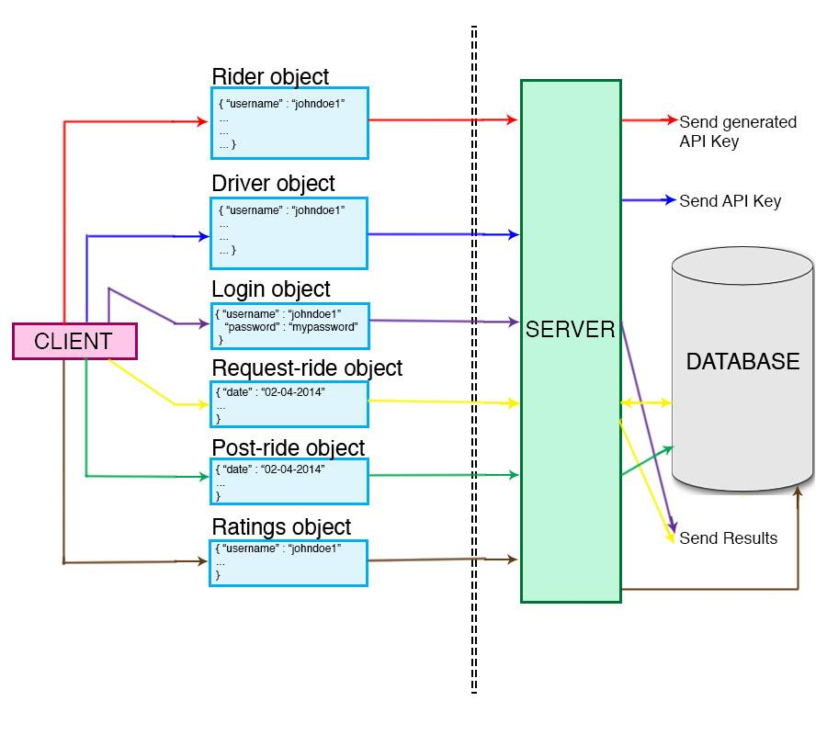

Security Framework
The importance of a secure and privacy sensitive architecture is cornerstone to the success and widespread use/trust of our service.

1. Geolocation vulnerabilities
There are a few obvious issues with publicly available information related to the location and tracking services offered by our application.
One potential issue would be that users could be tracked by others for malicious/indecent purposes. To protect the privacy of our users we have considered a feature that will activate GPS and location services to broadcast real-time positioning of an individual only in the case that said individual has explicitly approved the right to do so. An expiration time can be set during each new session to protect users from accidentally forgetting to disable locating services through our interface.
Another issue with release of this information is the shear number of unacquainted users that will have the ability to access current location information of others. To mitigate the risk here we can offer multiple tiers of security settings.
1. Do not release any location related data to any user EVER
2. Release location related data only to those whom have received an average rating above #.#
3. Release location only to those whom I explicitly invite or have agreed to rideshare (default)
4. Make location data visible to all people in my area (proximity based heuristic)
5. Make location data visible to all users (not recommended)
Giving users the ability to customize privacy settings will not only protect them from potential harm but also give them ease of mind that our service is safe and relatively controlled.

2. SQL Injection vulnerabilities (general rule and coding standards... not specific to our application)
Using our service to search, filter results, or make database queries in any way will also make our system vulnerable to SQL injection attacks. SQL injection attacks occur when a user accidentally or, more likely, maliciously inserts SQL formatted entries to corrupt the requests that reach our database.

3. Cookies
Securing the legitimacy and validity of user cookies is another major element to account for when considering security weaknesses of the “Let’s Carpool” application.

Forcing continual cookie renewal will help to ensure the sanctity of user information and other sensitive data. Details to be added

Database
“Let’s Carpool” will utilize a PostgreSQL database to maintain the relational data system required to keep record of users, profile information, routes, ride requests, and other vital information.

Database Details: ER Diagram

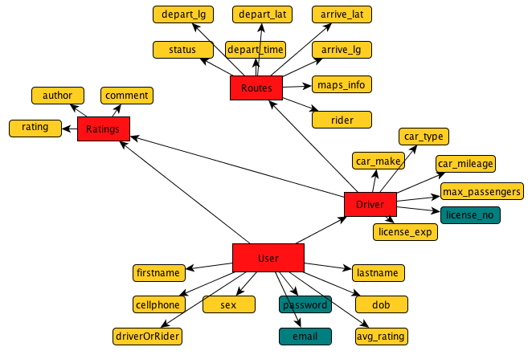

Red- Tables

Yellow- Datums

Blue- Datums (encrypted)

Algorithm
The major algorithm at work here will be utilized when riders begin to search for available rides based on a list of heuristics that they choose and specify. For example, a user looking for a ride can organize the available routes by proximity. Our algorithm will rate and return available routes based on user’s input of estimated departure/arrival time and departure/arrival locations while accounting for a specified maximum tolerable time or location difference. Again, using Google Maps API we will calculate latitude and longitude of the locations input by our user searching for the ride. We then calculate distances between the locations and return those that meet the criteria of maximum allowable difference between requested location and available routes. This calculation will consist of a few hypotenuse calculations and conversions between lat/long and miles. Filter based on time will be more straightforward since it will be a simple difference to calculate and return. The two aforementioned filters can be set in sequence or individually to add more or less specificity, depending on the rider’s preference.

Also, we may decide to develop a tool to help drivers pick up their passengers by the most effective and efficient means possible using some sort of shortest path algorithm (Dijkstra's or other similar algorithms). This feature could be implemented on both sides to better match the riders with drivers instead of forcing drivers to manually select the best group of passengers that will help to maximize riders on each trip.

Invariants
User
- E-mail address must be valid and unique
- Password must be alphanumeric with minimum of 8 characters
- Age (calculated by DoB) must be 18+

Driver (Override User)
- Must be assigned to a user only
- Age must be 21+ instead of 18+
- Must have a valid driving license (license number, issue date, expiration date)
- Average rating must be a positive float, between 1 to 5

Rider (Override User)
- Average rating must be a positive float, between 1 to 5

Ride
- Must be assigned to a driver only
- Must have departure location and destination location
- Must have estimated departure time
- Must provide the type of car
- Number of available seats must be positive and greater than 1

Request
- Must be assigned to a user only
- Must have departure location and destination location
- Must have estimated departure time
- Number of companions must be non-negative

Rating
- Rating must be an integer, between 1 to 5
- Must be assigned from 1 user to another user (driver to rider or vice versa)

Protocols
HTTPs(Hypertext Transfer Protocol Secure)
The communication between the server and the client will happen over HTTPs. HTTPs, which is known to be the most dominant method of establishing secure HTTP for connection, is the result of layering HTTP on top of SSL/TLS protocol to add security. The django server deployed on Heroku will be set up to support HTTPS, and the client side can simply use HTTPs by starting the url with “https://” in the Java HTTPClient. By using HTTPs, it can prevent third parties from reading or modifying the message between the client and the server (also known as “man-in-the-middle” attack). HTTPs will be used for any communication that contains non-public information such as, user profile info, password, apikey, location and etc.

As far as transfer of sensitive data (ie. Emails, passwords, etc.) we will most likely rely on the built-in support from Django and use a SHA-1 approach to encryption on both front and back ends. We have considered using Facebook authentication in order to further simplify the event of logging in. However, the login method provided by Facebook appears to be a little unnecessary for our needs. At this point we are going to rely on built-in authentication with Django and Android, but consideration of Facebook authentication is definitely worth mentioning.

Class Descriptions
1. User Class
This class is a container used to keep track of the user’s information.

User(firstname: String, lastname: String, email: String, password: String, dob: datetime, sex: Boolean, cellphone: String, avg_rating: Float, driverOrRider: Boolean)

2. Driver Class (User subclass)

Driver(user: foreign key, car_make: String, car_type: String, car_mileage: String, max_passengers: String, license_no: String, license_exp: String)

3. Route Class

Route(driver: foregin key, status: Boolean, depart_lg: Float, depart_lat: Float, arrive_lg: Float, arrive-lat: Float, maps_info: String, rider: Int, depart_time: String)

4. Ratings Class

Rating(user: foreign key, driver: Boolean, comment: String, author: String, rating: Int)

Views Details

The Homepage will pop up automatically if the phone owner has already set up an account with our service.

Name: Home View [0]
Content | Component | Description
I’m a Driver | Button | If the user is a driver and he would like to find riders or post his route specifications, links to the driver page [4]
I’m a Rider | Button | If the user is a rider and he would like to find a route in the nearby vicinity, links to the rider page [6]
Proceed to Profile | Button | If the user is logged in and would like to check in on specifications of past and pending requests along with rendezvous or posted routes, links to the user’s profile [8]

If it is their first time using the app/ they haven’t created an account then the user signup page will be shown before the homepage. The signup page is a collection of key information and checkboxes that will specify as to whether or not the user should then proceed to creation of the Driver and/or Rider profile setups.

Name: Signup View [1]
Content | Component | Description
Name | Text-field | An user’s first and last name
Email | Text-field | An user’s email
Cell # | Text-field | An user’s phone number
Driver | Checkbox | Indicating whether the user is a driver or not
Rider | Checkbox | Indicating whether the user is a rider or not
Password | Text-field | User’s password… soon to be encrypted
DOB | Date-picker | To calculate age and mitigate risk
Sex | Radio button | Not necessary

If it is the first time the user click on “I’m a Driver” or “I’m a Rider”, they will be redirected to each respective setup screen before continuing onto their requested task.
The Driver Profile setup will collect various pieces of information that will be publicly displayed to riders looking to find a driver.

Name: Driver Setup View [2]
Content | Component | Description
Car Type | Selection bar | The model of the car
Car Make | Text-field | To add some specificity
Max Riders | Text/Selection bar | The max capacity of the car
Mileage | Integer picker | Added specificity
License Number | Text-field | To check for valid license on file
License Exp | Text-field | For further verification purposes

Clicking on the “I’m a Driver” button (after setting up the profile) will direct to a sequence of screens respectively, which allows a driver to easily enter start point and destination (later we can include waypoints and maximum approved deviation from posted route). The driver can also specify their compensation terms.

Name: Posting Ride View [4]
Content | Component | Description
Start Point | Text-field or Drop Pin on map | Starting point of the route
End Point | Text-field or Drop Pin on map | Destination of the route
Request Compensation | Text/Selection bar | The compensation of the trip

After entering basic route data the user will be able to use our interface (based on Google Maps API) to then drag the highlighted route to use specific roads and further customize their names of travel

Name: Map View [5]
Content | Component | Description
Departure Location Address | Text-field | Departure location of route
Destination Location Address | Text-field | Destination location of route
Search button (for address) | Button | Drop markers for the location and create the route on map
Map Fragment with markers and route | Google Maps Android API v2 | Enable users to drag and drop markers on the map
Submit | Button | Submit and create the route

The "Map Me!” option under both “I’m a Driver” and “I’m a Rider” will load a map (using Google Maps API) of all local available routes. The route is generated based on user’s departure location and destination location. Our goal is to implement these routes are updated in real time so that the rider can see where the driver is along their path (and make a request to get picked up if appropriate)

Name: Finding Ride View [6]
Content | Component | Description
Pick Nearby Routes to find a ride | Google Maps API | When the highlighted routes are clicked, a small popup will be shown for the information below:
Name: Finding Ride Popup View [7]
Content | Component | Description
Driver Info | Form | General information of the driver
Driver Rating | Form | Review of the drivers by the riders
Cost of route | Form | Budget of the whole trip
ETD | Form | Estimated Time of destination
ETA | Form | Estimated Time of arrival

If the user clicks “Proceed to Profile” then they will be redirected to the their own profile page.

Name: User Profile View [8]
Content | Component | Description
Pending Requests | Button | Redirected to the screen for all available requests received [9]
Published Routes | Button | Redirected to the screen for all routes that the user posted [10]
Scheduled Rendezvous | Button | Redirected to the screen for all upcoming rendezvous [11]

Name: Pending Requests View [9]
Content | Component | Description
Requests | Table | Listing all the ride requests

Name: Published Routes View [10]
Content | Component | Description
Published Routes | Google Maps API | Showing the actual route on the map
 | Table | Listing all the ride posted by the user

Name: Scheduled Rendezvous [11]
Content | Component | Description
Rendezvous | Table | Listing all the upcoming rendezvous

Once the journey is complete and both users are on their separate ways, we will send a request to rate their counterpart and leave comments/feedback for public view.

Name: Driver Review View [12]
Content | Component | Description
Rating | Score | Overall rating of the driver  (1-5)
Comments | Text-field | Particular comments/ feedback about the driver
Submit | Button | Send and save the review

Name: Rider Review View [13]
Content | Component | Description
Rating | Score | Overall rating of the rider  (1-5)
Comments | Text-field | Particular comments/ feedback about the rider
Submit | Button | Send and save the review

Implementation plan

Programming Tasks
Difficulty of task scale: 1 (Very easy) - 5 (Moderate) - 10 (Very difficult)
Tasks labeled together should ideally be implemented together for efficient testing.

Task 1 (i)
User Case: User Rider Signup (Front-end)
Programming Task: Define User parent class and Rider subclass with its respective methods for front-end
Difficulty of task: 4
Dependencies: Server needs to be ready to accept and process requests, and database needs to be up and running for user signup to work (refer to Task 1 (iii))
Developer-days: 1

Task 1 (ii)
User Case: User Driver Signup (Front-end)
Programming Task: Define Driver subclass and implement class-specific methods
Difficulty of task: 5
Dependencies: Server needs to be ready to accept and process requests, and database needs to be up and running for user signup to work (refer to Task 1 (iii))
Developer-days: 1

Task 1 (iii)
User Case: User Signup (Server-side)
Programming Task: Define user model for both Riders and Drivers and their respective methods
Difficulty of task: 6
Dependencies: Database needs to be set up
Developer-days: 1

Task 2 (i)
User Case: User Login
Programming Task: Send User Login JSON Object to server to verify credentials for both Rider and Driver
Difficulty of task: 3
Dependencies: Server needs to be able to verify user by accessing database (refer to Task 2 (ii))
Developer-days: 0.5

Task 2 (ii)
User Case: User Login (Server-side)
Programming Task: Implement user model methods to access database and verify credentials for user
Difficulty of task: 5
Dependencies: Database needs to be set up
Developer-days: 0.5

Task 2 (iii)
User Case: Forgot Password
Programming Task: Implement email-sending capability on server to send email to user with password
Difficulty of task: 4
Dependencies: User Signup needs Tasks 1(i), 1(ii), 1(iii) to be implemented to fully test Forgot Password.
Developer-days: 0.5

Task 3 (i)
User Case: Search Ride
Programming Task: Client sends Request Ride JSON Object to server, in which the algorithm will run and return matching results (Ride Results JSON Object)
Difficulty of task: 7
Dependencies: User functionality has to be fully implemented (Task 1 and Task 2 (i), Task 2 (ii))
Developer-days: 2

Task 3 (ii)
User Case: Send ride request
Programming Task: Server retrieves Driver email from database and sends email notification to retrieved email
Difficulty of task: 7
Dependencies: None (although ideally, Task 3 (i) should be completed to help with testing)
Developer-days: 2

Task 3 (iii)
User Case: Accept/Change/Reject ride request
Programming Task: Retrieves ride object from database, adds requesting rider user to rides object and add to database if driver accepts
Difficulty of task: 5
Dependencies: Task 3 (ii) Send ride request needs to be completed first
Developer-days: 1

Task 4 (i)
User Case: Post Driver Feedback (Server-side)
Programming Task: Implement methods within user model class to support feedback for Drivers. Run necessary methods (e.g. average rating), and add feedback to database
Difficulty of task: 5
Dependencies: None
Developer-days: 1

Task 4 (ii)
User Case: Show/Post Driver Feedback (Front-end)
Programming Task: Implement front end (e.g. stars widget in layout) layout and send JSON object to server.
Difficulty of task: 5
Dependencies: Task 4 (i) should be completed to allow full testing
Developer-days: 1

Task 5
User Case: Display location’s address besides latitude and longitude. (on Search Ride View, and Ride Details View)
Programming Task: Decode the given latitude and longitude (either from back-end server or from google) into the correct address of the location.
Difficulty of Task: 5
Dependencies: Search Ride View, Ride Details View
Developer-days: 2

Task 6
User Case: Select destination on map first, then departure location
Programming Task: Allow user to select whether the marker is departure location or destination location when they drop the marker by clicking the map fragment.
Difficulty of Task: 4
Dependencies: None
Developer-days: 1

Task 7
User Case: Accept ride will update the route on the map
Programming Task: Allow the route generated by adding two more intermediate locations.
Difficulty of Task: 6
Dependencies: None
Developer-days: 1

Task 8
User Case: Allow GPS/Wireless Location
Programming Task: Allow to use GPS/Wireless Location as the departure location or default location of the map view.
Difficulty of Task: 5
Dependencies: Only possible if cookie can be stored in the device, and based on user’s setting.
Developer-days: 1

Implementation Tasks
We are splitting up the tasks for Iteration 1.0 by front-end and back-end. Back-end team consists of Aime, AJ, Peter. Front-end consists of Alex, Stephanie, Sam.

Goal for Iteration 1.0
- Implement basic Routing functionality of being able to send/store/receive information from the database by communicating with server (request ride and post ride)
- Implement Google API
- Implement basic front-end functionality (moving between views, buttons, showing text)

List of tasks to complete by Iteration 1.0 are below:
(Urgency in order of what needs to be completed first)

Front-end
Task: Search Ride - client sends Request Ride JSON Object to server
Dependencies: Server must be set up and ready to receive request
Testing Order/Urgency: 1
Estimate time for completion: 1 day

Task: Search Ride UI with Google API - show points on map to user
Dependencies: None
Testing Order/Urgency: 3
Estimate time for completion: 3 days

Back-end
Task: Server to receive JSON Object and return matching results (Ride Results JSON Object)
Dependencies: Ride methods to be set up in models.py
Testing Order/Urgency: 2
Estimate time for completion: 1 day

Task: Set up/Request Ride - retrieves ride object from database, adds requesting rider user to rides object and add to database if driver accepts
Dependencies: Database needs to be configured
Testing Order/Urgency: 4
Estimate time for completion: 1 day

Task: Send ride request: server retrieves Driver email from database and sends email notification to retrieved email
Dependencies: Set up/Request Ride needs to be completed
Testing Order/Urgency: 5
Estimate time for completion: 1 Day

Goal for Iteration 2.0
- Implement user signup and creation of profile
- Create user login page and work on authentication
- Build tool for filtering routes based on distance and/or etd/eta
List of tasks to complete by Iteration 2.0 are below:
(Urgency in order of what needs to be completed first)

Front-end
Task: Creating user signup page(s)
Dependencies: Alignment with backend methods
Testing Order/Urgency: 1
Estimate time for completion: 2 day

Task: Login Page
Dependencies: Appropriate initial user profile setup, also authentication eventually
Testing Order/Urgency: 2
Estimate time for completion: 2 days

Task: Route Filtering Tool
Dependencies: There needs to be a match between available rides that are within the range of specifications listed by the rider
Testing Order/Urgency: 3
Estimate time for completion: 2 days

Back-end
Task: Handle creation of new users
Dependencies: Correct db setup
Testing Order/Urgency: 2
Estimate time for completion: 1 day

Task: Validate logins and work on authentication means
Dependencies: Utilize Django or possibly facebook authentication
Testing Order/Urgency: 2
Estimate time for completion: 1 day

Task: Handle route filter and respond with valid possibilities
Dependencies: Preloaded routes and proper user-roles (driver and rider)
Testing Order/Urgency: 3
Estimate time for completion: 2 Day

Plan for future iterations
- Implement push notifications
- Implement user feedback
- Work on UI and UX issues
- Add widget

Major Risk:
- Rider/Driver Reliability and Trustworthiness
For new riders and drivers, there is always the potential that they may not be who they say they are. To mitigate this risk, we can verify the driver’s license.

Testing plan

Unit Testing

1. Back-end
Unit testing will be performed using the built in frameworks in the Python standard library. Some tests will be performed as Doctest, embedded the test in the functions’ docstrings and are written in the way that emulates a session of the Python interactive interpreter. Doctest can perform most of the simple tests for the methods. Besides using the Doctest, some other tests are more complicated, and they will be performed by importing the unittest library, and they are expressed as methods on a Python class that subclasses unittest.TestCase or Django’s customized TestCase.

Since Google Maps API is used in the front-end, unit tests will be performed to test our particular implementation of the API. When the app is in development mode, a special testing activity can be started that runs unit tests of the methods of the app. Through this unit test, all methods can be tested if they function as expected in a fast and organized way. This activity will show the results of the tests so the developer can see what particular methods/workflows failed and where the error lives. Honing in on the location of our errors will be vital to quick bug fixes and rapid development. Our team plans to use test-driven development to ensure that all methods meet a predefined standard of use cases. The test-suite will include sections targeting each individual method as well as tests that walk through user stories specified above and in our requirements document. This strategy, used in tandem with agile development, will allow for a steady development process that builds upon a sturdy platform of code during each iteration.

Functional Testing
We will require automated testing frameworks from the very beginning in order to automate the tedious processes of creating new users, setting routes, and filtering requests. Trying to test these functions manually would be extremely inefficient. We plan on testing a wide range of possible user input while also dividing between front-end, back-end, and complete functionality. The back-end functional testing will consist of method calls and verifying the individual responses. Our test-suite also includes test that verify that front-end function calls also react as expected. Finally, we plan to test our system by automizing user input and verifying that the front and back ends work individually and communicate effectively with one another. Automizing user signups and creation of routes will also be very helpful in other testing methods that rely on this preloaded data.

User walkthroughs will be used to test the multitude of user stories that we plan to implement functionalities for. Using the emulator with different Android releases, as well as using a physical phone, will be useful to ensure functionality of our methods and classes while validating that a user is able to successfully complete certain tasks. This type of testing will be useful in understanding UI issues and making sure that we offer the most positive user experience possible.

UI Testing
Google Maps will be tested by feeding different locations (both latitude and longitude) to it. The Map should be able to display the pins of the location, and should be able to generate a route between the locations. Creating a suite of routes to auto-load for testing, coupled with our testing of specific method calls that relate to specifying details of route, will be an adequate means of testing our routing functionality and map view. Relatively extensive manual testing will be useful in both validating functionality and better optimizing the user experience. User testing, and utilizing test-subjects, will be a hugely important aspect of our testing, not only for UI but all back-end functionality and general usability.

Buttons interaction will be tested by installing the .apk onto both the android phone and the emulator. Testing across a wide range of Android versions will help to ensure stability across many phones, both old and new. Testing on physical phones will be vital to verifying usability and functionality for our users through physical use of the application (as opposed to using an emulator and mouse). Testing user-driven events will help to keep the structure of front-end code clean and simple while continuously validating the functionality of buttons, text-boxes, and other mediums of user input.

