**CS5542 Big Data Apps and Analytics**

**In Class Programming –10**

**29th October 2020**

**Due Date: 11/3/2020 (Tuesday by 11:59pm)**

**Submit ICP Feedback in Class. :** [**Lnik to Feed back Form**](https://docs.google.com/forms/d/e/1FAIpQLSesllFh5_STnj7RbHyQainRG_2EIKw1csp8ObP5FWjpVnGVOg/viewform)

**Deep Q-Learning:**

**Implementing Deep Q-Learning in Python using Keras & OpenAI Gym:**

In deep Q-learning, we use a neural network to approximate the Q-value function. The state is given as the input and the Q-value of all possible actions is generated as the output. The comparison between Q-learning & deep Q-learning is illustrated below:

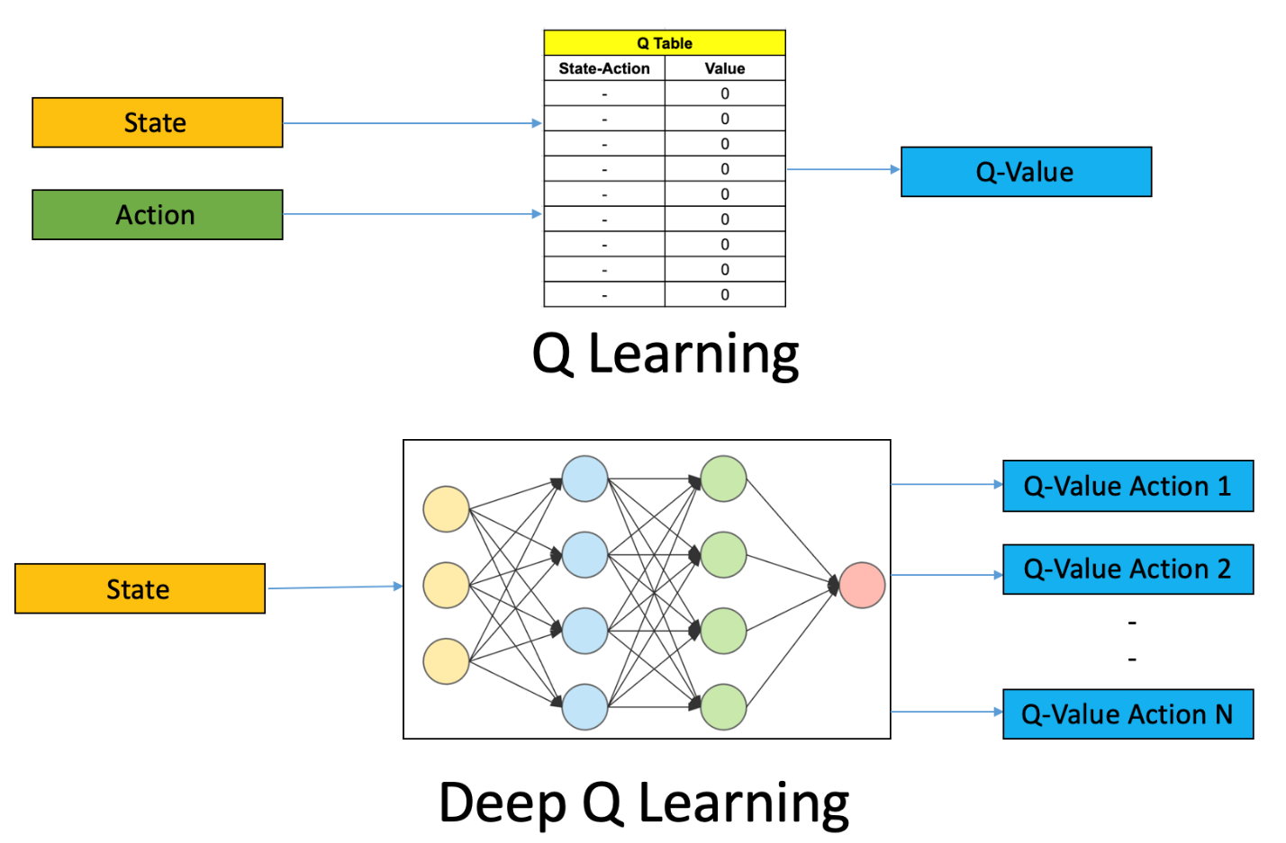

CartPole is one of the simplest environments in the OpenAI gym (a game simulator). The idea of CartPole is that there is a pole standing up on top of a cart. The goal is to balance this pole by moving the cart from side to side to keep the pole balanced upright.

Design a Deep Q learning Network (DQN), using Keras & OpenAI Gym , for cartpole game and visualize your results.

ICP Requirements:

1. Designing a DQN for cartpole game in python using Keras & OpenAI Gym (70 points)
2. Visualization of DQN cartpole game (10 points)
3. overall code quality (10 points)
4. Pdf Report quality, video explanation (10 points)

Submission Guidelines:

Same as previous ICPs.