2.1. Motivation for the algorithm and related work

Co-clustering simultaneously clusters both objects and features together [24]. This provides two membership functions: the partition or object membership function and the ranking or the feature membership function. The latter serves to filter out the relevant features only during the computation of the object membership function and thus solves the problem of sparseness of data by reducing the dimensionality. The co-clustering algorithm is thus suited to applications with large dimensions and is found to be apt for our experiments on multi-feature color images. The problem of outliers is also minimized by using feature member-ship function [26]. The problem with using only the feature memberships is that it may lead to coincident/overlapping clusters therefore highlighting the need for both feature and object memberships. Further we include the distance function of feature data points from the feature cluster centroids in the co-clustering process to create richer co-clusters than other fuzzy co-clustering algorithms. The inclusion of the distance factor in the degree of aggregation reduces the optimization problem to a minimization one. In this work co-clustering is integrated with the Fuzzy approach with a view to obtain distinct clusters [24,26]. Both the object and feature memberships in the proposed method are fuzzy, i.e. the object membership is calculated when different clusters compete for a data point and feature memberships are defined when different features compete for a cluster. Thus we have two constraints on the two fuzzy memberships (object and feature memberships) in our method.

Therefore the aim is to have a co-clustering algorithm with the following advantages:

- It must be insensitive to initialization and form distinct clusters. (Fuzzy clustering)

- It should perform well in high dimensions and provide well defined clusters. (Co-clustering)
- It should minimize the impact of outliers to improve the accuracy of co-clustering. (Ranking/Feature memberships)

- Its objective function should integrate the distance measure of input features w.r.t. feature centroids into the entropy regular-ization framework.

5. It must be reasonably fast enough
Several maximum entropy clustering algorithms and their variants are available in the literature [34,35]. One such approach of interest to

the present work is the variant of FCM which props on entropy regularization [36]. It involves the minimization of the following objective function:

subject to the constraint

where the symbols C,N represent the number of clusters and data points respectively, u_{ci} the fuzzy membership function, T_{u} the weight factor in the entropy term, Dist(x_{i},p_{c}) the dissimilarity term equal to the square of the Euclidean distance between pixel x_{i} and cluster center p_{c}.
The first term in the R.H.S of (1) denotes the effective squared distance, the second term is the entropy which serves as a regulating factor during the minimization process. The proposed approach aims at co-clustering in the entropy framework of FCM. For this we begin by replacing the distance function Dist(x_{i},p_{c}) with Dist(x_{ij},p_{cj}) in the proposed objective function. Dist(x_{ij},p_{cj}) is computed for each feature j=1,2,…,K separately.

2.2. Formulating the objective function

Let X={ x₁, x₂, …,x_{i}, …, x_{N}} Є R^{k} be the set of N data points associated with an image I of size N₁xN₂= N, and K is the dimension of the feature space associated with each data point. Let x_{ij} denote the jth feature of the i^{th} data point, P = {p_{cj}} be the set of feature cluster centers and D_{cij} = Dist(x_{ij},p_{cj}) be the square of the Euclidean distance between feature data point x_{ij} and the feature cluster centroid p_{cj} given by

D_{cij} = d²(x_{ij}, p_{cj}) = (x_{ij}−p_{cj})²(3)

Let u_{ci} denotes the object membership of the ith data point to cluster c, U = {u_{ci}} be the CxN object membership function matrix of image I, v_{cj} denotes the feature membership defined as the membership of feature j to the cth cluster and V = {v_{cj}} be the corresponding CxK feature membership matrix for image I.
Including the feature membership function v_{cj} in the first term of (1) and replacing the distance function by D_{cij} = Dist(x_{ij}, p_{cj}) yields ∑^{C}_{c} ₌ ₁∑^{N}_{i=} ₁∑^{K}_{j=} ₁u_{ci}v_{cj}D_{cij}, which is regarded as the degree of aggregation of the proposed objective function J_{FCCI}. Separate entropy regularizing terms ∑^{C}_{c} ₌ ₁∑^{N}_{i=} ₁u_{ci}logu_{ci} and ∑^{C}_{c} ₌ ₁∑^{K}_{j=} ₁ v_{cj}logv_{cj} for the object and feature membership functions constitute the second and third terms of J_{FCCI} respectively. Minimizing these two terms is equivalent to maximizing the fuzzy entropies −∑^{C}_{c} ₌ ₁∑^{N}_{i=} ₁u_{ci}logu_{ci} and −∑^{C}_{c} ₌ ₁∑^{K}_{j=} ₁v_{cj}logv_{cj}. The entropies are maximized when the fuzzy memberships u_{ci} and v_{cj} are uniformly distributed according to their constraints i.e. u_{ci} = 1=C and v_{cj} = 1=K.

The objective function J_{FCCI} resulting from combining all the above terms is

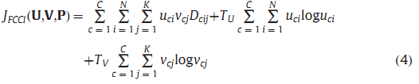
the above expression is minimized subject to the following constraints:
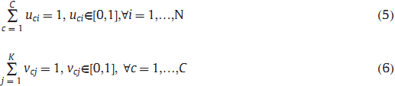
The minimization of the first term in (4) assigns to the object a higher membership value taking into account the feature cluster center it is closest to and which is more relevant than other features for that particular cluster. The inner product {v_{cj}D_{cij}} assigns a higher weight to the distance function pertaining to the prominent features and a lower weight to that of the irrelevant features. The first term therefore denotes the effective squared distance. The second and third entropy regularization terms combine all u′_{ci}sand v′_{cj}s separately. These contribute to the fuzziness in the resulting clusters. T_{U} and T_{V} are the weighting parameters that specify the degree of fuzziness. Increasing T_{U} and T_{V} increases the fuzziness of the clusters.

2.3. Deriving the update equations

The constrained optimization problem of FCCI can now be defined from (4) by applying the Lagrange multipliers λ_{i} and γ_{c} to constraints (5) and (6) respectively as shown below.

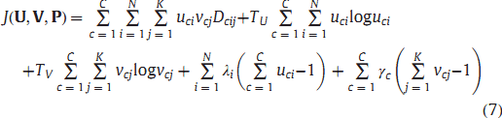
Taking the partial derivative of J(U,V,P) in (7) with respect to U and setting the gradient to zero we have,
Subjecting u_{ci} derived from (8) to the constraint in (5) the formula for computing the object membership function u_{ci} reduces to,

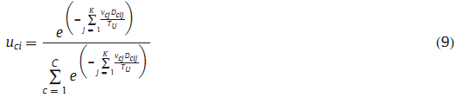
In a similar manner, taking the partial derivative of J(0,V,P) with respect to V and setting the gradient to zero we have,
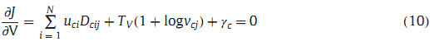
Applying the constraint (6) to v_{cj} derived from (10), we obtain the formula for the feature membership function v_{cj} as
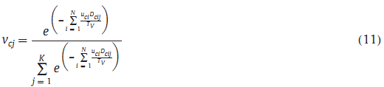

Taking the partial derivative of J(U,V,P) with respect to P and setting the gradient to zero we have
Solving (12) yields the formula for p_{cj} as :
The solution of the constrained optimization problem in (7) can be approximated by Picard iteration or Alternating Optimization (AO) [37] through (9), (11) and (13) which are the update equations for the object, feature memberships and the cluster centroids respectively in each iteration. Optimal partitions U* of X can be obtained by solving for (U*,V*,P*) at the local minima of J_{FCCI}. The proof of convergence of the FCCI algorithm to a local optimum is given in Appendix A. Since U*,V* and P* are unknowns, the objective function in (4) is neither concave nor convex and usually has many local optima. To find a global optimum of the constrained optimization problem, the FCCI algorithm is further given as a learning step to the Bacterial Foraging algorithm which optimizes the values of the weight parameters T_{U} and T_{V}.

2.4. Pseudo-code of FCCI algorithm

- 1. Initialize the parameters T_{U}, T_{V}, maximum error limit ε and maximum number of iterations τ_{max}.
- Set iteration number τ =1.
- Initialize u_{ci} such that 0 ≤u_{ci} ≤1.
4.REPEAT
- Calculate p_{cj} using (13)
- Calculate D_{cij} using (3).
- Calculate v_{cj} using (11).
- Calculate u_{ci} using (9).
- Calculate τ= τ+1.
- UNTIL max(ju_{ci}(τ)−u_{ci}(τ−1)j) ≤ε or τ =τ_{max}.

Since all our experiments are found to converge within 200 iterations, τ_{max} =200 and the maximum error limit ε taken to be 10⁻².

3. Color image segmentation using FCCI

3.1. A. Algorithm for color segmentation

3.1.1. Review of Xie and Beni’s cluster validity S

According to Xie and Beni [33] the validity function S of the clusters for the worst case is defined by
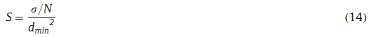
The d min in (14) is evaluated from
where d_{min} is the minimum distance between the cluster centroids p_{cj} for cluster c =1,…,C and feature j and s is the maximum variation among all the clusters C, given by
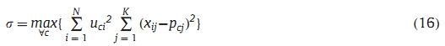
To determine the number of clusters based on the above Cluster Validity S a flowchart is given in Fig. 1 which checks for the occurrence of the first local minima of S.
3.2. Algorithm for color image segmentation using FCCI

The algorithm is outlined as follows:
- Obtain the three dimensional RGB input image.
- Convert RGB color space into the CIELAB color space with color dimensions K=2, i.e. {a*,b*}.

- Perform 2D to 1D transformation [38] (by lifting the elements columnwise) to generate data point x_{ij} in the jth dimension, j=1,2 for each pixel i=1,…,N, where N is the size of the data. This step is important since the computations become simpler when data is one dimensional rather than two dimensional.

- Determine the number of clusters C as per the flowchart in Fig. 1.

- Run the FCCI algorithm for C clusters and obtain the object u_{ci} membership function.
- Defuzzify u_{ci} into clusters.

  - B. Bacterial Foraging for the global minimum

The Bacterial Foraging (BF) [39] based on the bacterial chemo-tactic behavior of E. Coli is used for optimizing the values of fuzzy parameters T_{U} and T_{V} in the FCCI algorithm. The BF algorithm initially accepts a set of initial values from the user before optimizing these to global minimum values by subsequent iterations. The following initial values: T_{U} =10, T_{V} =9x10⁷ are assumed for the color segmentation experiments. The choice of these initial values is made by conducting a set of random experiments by hit and trial. Bacterial Foraging is treated as an optimization process

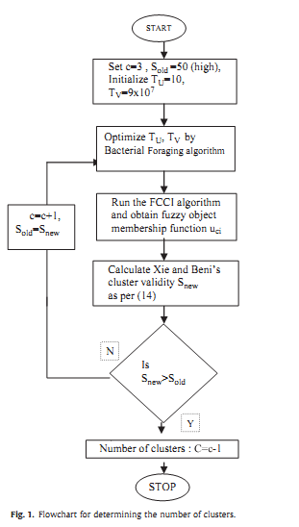
[40], where each bacterium seeks to maximize the energy obtained per unit time spent on foraging. Suppose that θ is the position of a bacterium and let J_{D}(θ) represent the combined effects of attractants and repellents from the environment, for e. g. J_{D}(θ)<0, J_{D}(θ)= 0, J_{D}(θ)>0, representing that the bacterium at location is in nutrient rich, neutral, and noxious environments, respectively.

Chemotaxis is a foraging behavior that implements a type of optimization where bacteria try to climb up the nutrient concentration (i.e. find lower and lower values of J_{D}(θ)<0 termed as swim), avoid noxious substances (for J_{D}(θ)>0 termed as tumble), and search for ways out of neutral media (avoid being at positions where J_{D}(θ)= 0).

At the end of the required number of chemotaxis steps an assessment is made about the health of the bacteria by sorting them in the ascending order. Half of the healthy bacteria is replicated by assigning the same location and the other half is eliminated. This operation constitutes the reproduction step.

After the end of the desired number of reproduction steps, each bacterium may be eliminated or dispersed with some probability. This step is known as Elimination and dispersal and is meant shake up the bacteria so as to move them to better locations.

The initialization for the Bacterial Foraging algorithm is done as per the guidelines in [39]

1. Set the number of bacteria B =50.
- The number of parameters w to be optimized are 2: T_{U}, T_{V.}

- Swimming length N_{s} =4.

- N_{c}, the number of iterations in a chemotactic loop is set to 100.
- N_{re}, the number of reproduction steps is set to 2.
- N_{ed}, the number of elimination and dispersal events is set to 2.
- The probability p_{ed} that each bacterium will be eliminated/ dispersed is set to 0.25.
- Location of each bacterium L(w,B, N_{c}, N_{re}, N_{ed}).

  - C. Results of color segmentation

3.4.1. Segmentation evaluation indices

The quality of the segmentation is generally judged by two types of indices: the goodness methods such as Liu’s F-measure which ascertains the color difference in the CIELAB color space and also penalizes the formation of large number of segments, and the discrepancy methods which ascertain the quality with respect to some reference result like ground truth images for example the RAND index. The above two types of quality measures are used together to judge the efficiency and practicality of the proposed algorithm.

- Liu’s Evaluation Measure (F): The performance of color segmentation is evaluated using Liu and Yang’s [41] evaluation function F:

where I is the segmented image and N₁xN₂ is the image size, G is the number of regions of the segmented image, A_{i} is the area and e_{i} is the average color error of the ith region where e_{i} is defined as the sum of Euclidean distances between the {a*,b*} color vector of the pixels of region i and the color centroid attributed to region i in the segmented image. The smaller the value of F(I) the better the segmentation result. We choose Liu’s F-factor as one of our evaluation criteria since it gives an accurate measure of the color differencing achieved by the segmentation algorithm and at the same time penalizes large number of regions formed.

- (a) Probabilistic RAND index (PR): The PR index is a generalization of the RAND index [42] introduced by Unnikrishnan et al. in [43]. It allows a comparison of the test segmentation with multiple ground truth images through soft non-uniform weighting of pixel pairs as a function of the variability in the ground truth sets.

Suppose each human k provides information about the seg-mentation in the form of binary numbers ∏(l_{i}^{Sk} = l_{j}^{Sk} ) for each pair of pixels (x_{i},x_{j}). The set of all perceptually correct segmentations defines a Bernoulli distribution giving a random variable with the expected value denoted as h_{ij}. The Probabilistic RAND index (PR) is then defined as
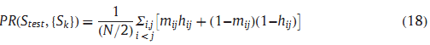
where m_{ij} denotes the event of a pair of pixels i and j having the same label in the test image S_{test}:

m_{ij} = ∏(l_{i}^{Stest} = l_{j}^{Stest} ) | (19)

This measure takes values [0,1], where 0 means no similarities between S_{test} and {S₁,S₂,…S_{K}}, and 1 means all segmentations are identical.

(b) Normalized Probabilistic RAND index (NPR): The Normalized PR index by Unnikrishnan et al. in [12], is an excellent means of qualitative comparison among image segmentation algorithms. Once the segmentation of all the test images for all the algorithms being compared has been compiled the Normalized PR index is calculated so that a global measure is possible.
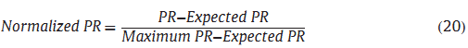
The above equation assures that the expected value of normal-ized index is zero providing a wider range. The maximum value of PR, MaximumPR, in (20) is taken as 1.

3.4.2. Color segmentation results

In this section experimental results are presented to prove the effectiveness of the proposed color segmentation algorithm on the natural images. For these results MATLAB (ver.7.9) software is run on a Pentium-IV 1.4 GHz PC. All images are digitized to 24 bits per pixel in the RGB format. Since the distance between any two points in the RGB space is not proportional to their color difference, transformation from the RGB space to a uniform color space: CIELAB [31] is performed. The vector {a*,b*} of CIELAB color space contains the total chrominance color information of pixels and is the feature space for our color segmentation experiments. The vector {L*} or luminance vector which decides the darkness or fairness of the image segments is discarded in the clustering process to ensure that the illumination effects do not affect the segmentation process. It is observed that the FCCI algorithm yields highly crisp values of object membership function u_{ci} (close to 0 and 1). On the other hand the feature membership values v_{cj} are highly fuzzy (close to 0.5) due to averaging over the entire dataset. The v_{cj} values however are accentuated by the high values of parameter T_{V} (≈10⁸) in Eq. (4) creating a considerable influence in the computation of u_{ci}, eventually leading to crisp values of u_{ci} after the iterative procedure. This helps in crisp classification during the defuzzification process.

A set of 100 test images is taken from the Berkeley segmentation database [44,45] along with 5–7 ground truth segmentations available for each image in the database for the evaluation of the results. The size of each image is either 321x481 or 481x321 and the average time taken by the FCCI algorithm for each image is approximately 35 s. The segmentation of all 100 images by the proposed FCCI algorithm is shown in Fig. 2, with the edges superimposed on original images. The corresponding graphs for Liu’s F-factor and the Probabilistic RAND index (PR) is shown in Fig. 3 for 100 images bestowing excellent values for both segmen-tation evaluation measures. The results show a good match with human ground truth segmentations as indicated by a high value of Probabilistic RAND index (PR), and also efficient color differentiation as indicated by a low value of Liu’s evaluation measure F. The number of clusters is determined from the first local minima in the cluster validity S graph (normally <7 clusters for our experiments) as demonstrated by the example shown in Fig. 4.

Some observations made from the results obtained are as follows:

- Tradeoff between color differencing and human perception: in the case of images with distinct colors (Fig. 5) there is an excellent correspondence with human perception (high NPR) but the color differentiation is not so good (high Liu’s F-factor). In the case of images with indistinct colors (Fig. 6), very good color difference is observed (low Liu’s F-factor) but the results appear to be over-segmented and hence NPR value is relatively less. The proposed technique therefore maintains a good tradeoff between the two segmentation evaluation measures.

- Sensitivity to parameters: the algorithm is found to be more sensitive to the values of T_{U} than T_{V} since the values of u_{ci}

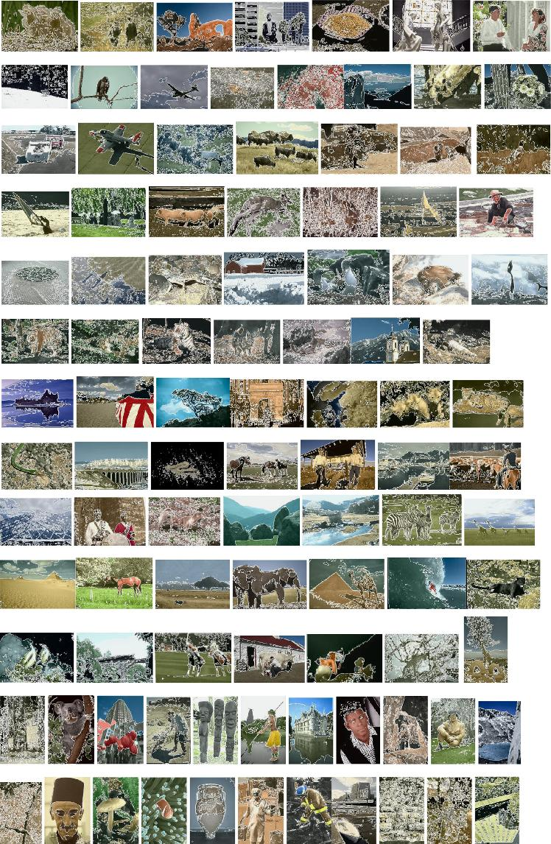

Fig. 2. Color Segmentation Results of 100 test images from Berkeley segmentation database [44] by the proposed method. (For interpretation of the references to color in this figure legend, the reader is referred to the web version of this article.)

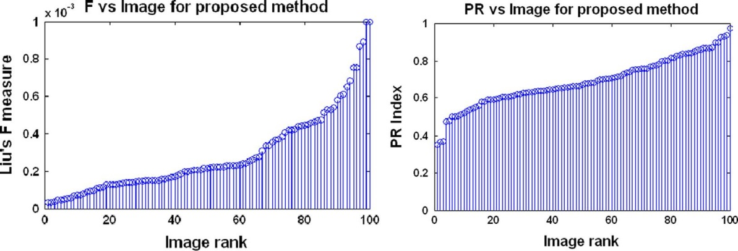

Fig. 3. Liu’s F-measure and PR index in the increasing order for segmentations of 100 test images from Berkeley dataset [44] by the proposed method.
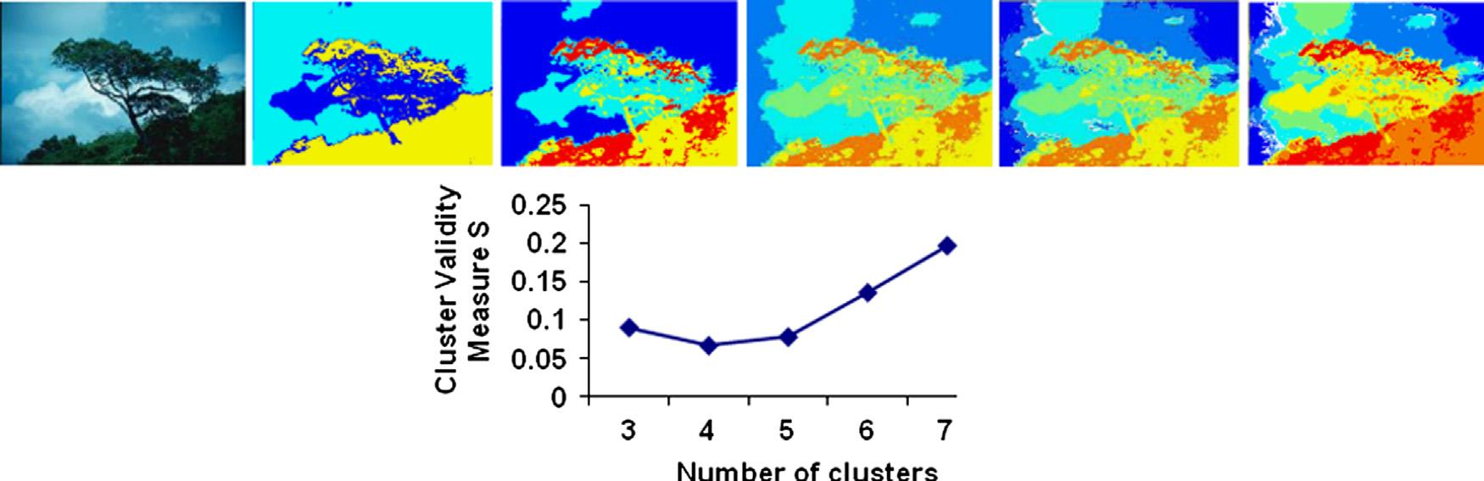

Fig. 4. Original image and Segmentation results (from left to right and top to bottom) of “Tree” image and the corresponding Clustering validity graph as the number of clusters c is varied from 3 to 7. Corresponding values of NPR and Liu’s F-factor are: c: 3, 4, 5, 6, 7, NPR: 0.5519, 0.5203, 0.1314, −0.213, −0.1332, F: 0.00044, 0.000347, 0.000322, 0.000332, 0.000342. Number of clusters is aptly determined to be C =4 (from the first local minima in the graph) as it results in the most optimum combination of NPR and Liu’s F-factor.

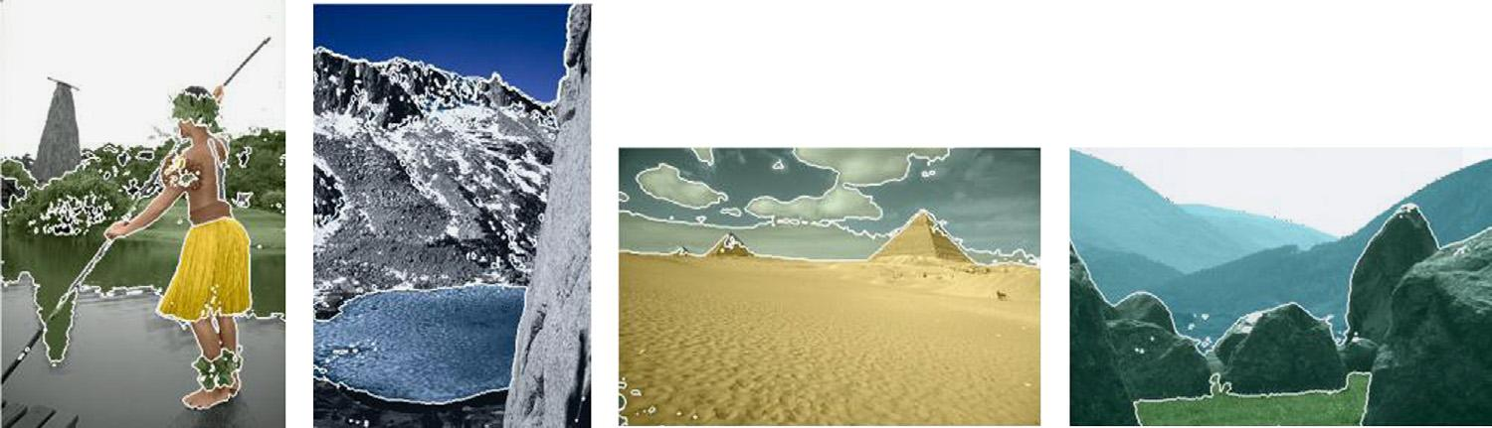

Fig. 5. Example segmentations of images with distinct colors—NPR(from left to right): 0.6065, 0.7962, 0.8007, 0.9213, F(from left to right): 0.00047, 0.000138, 0.000134, 0.000085. (For interpretation of the references to color in this figure legend, the reader is referred to the web version of this article.)

obtained are very crisp and a careful choice of T_{U} in (4) is required for the algorithm to converge. Replacing the Bacterial Foraging optimization by the Genetic algorithm in our experi-ments results in a large computational overhead with an initial population of 100 chromosomes required for acceptable results, while Bacterial Foraging starts giving good results for the initial population of 8 bacteria, thereby, significantly redu-cing the computational overhead.

The value of T_{U} in our experiments is found to range from 1–30 for different images with values close to 1 for images with non-distinct colors (Fig. 6) and higher values for visually distinct colors (Fig. 5). The valid values of T_{V} ranges widely from 10⁶– 10⁸ and do not have a major impact on the resulting clusters since its only function is to contribute to the computation of u_{ci} by scaling v_{cj}.

- Complex illumination Patterns: the algorithm is able to segment natural scenes containing non-uniform illumination efficiently
(Fig. 7(a)) by segregating shadows from sunlit portions thus agreeing with human perception. However in the cases where the shadows tend to merge with the colors in the scene (Fig. 7 (b)) result tends to look over-segmented in spite of very good color differencing (low F).

- Under-segmentation: only in rare cases (1 out of 100) the algorithm fails to segregate extremely indistinct colors as demonstrated by the under-segmented result in Fig. 8 due to formation of highly fuzzy clusters.

3.4.3. Comparisons with other methods

The proposed color segmentation technique is compared with some well known methods in literature for unsupervised color segmentation: Fuzzy C-Means (FCM) [22,37], Normalized Graph-Cut (N-CUT) Method [10], Gaussian Mixture model (GMM) [8] and
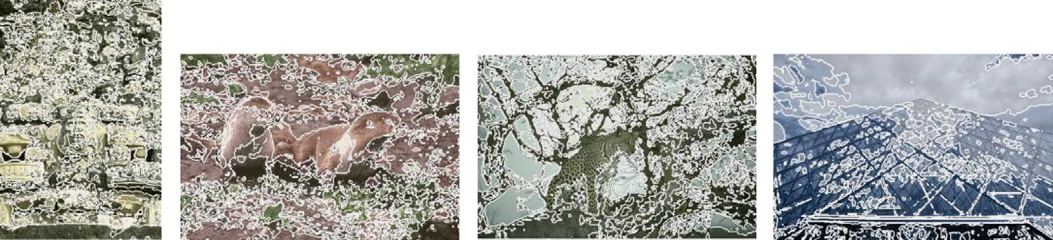

Fig. 6. Example segmentations of images with indistinct/similar colors—NPR (from left to right): −0.284, −0.391, −0.334, −0.098, F(from left to right): 0.000053, 0.00023, 0.000057, 0.0000701. (For interpretation of the references to color in this figure legend, the reader is referred to the web version of this article.)
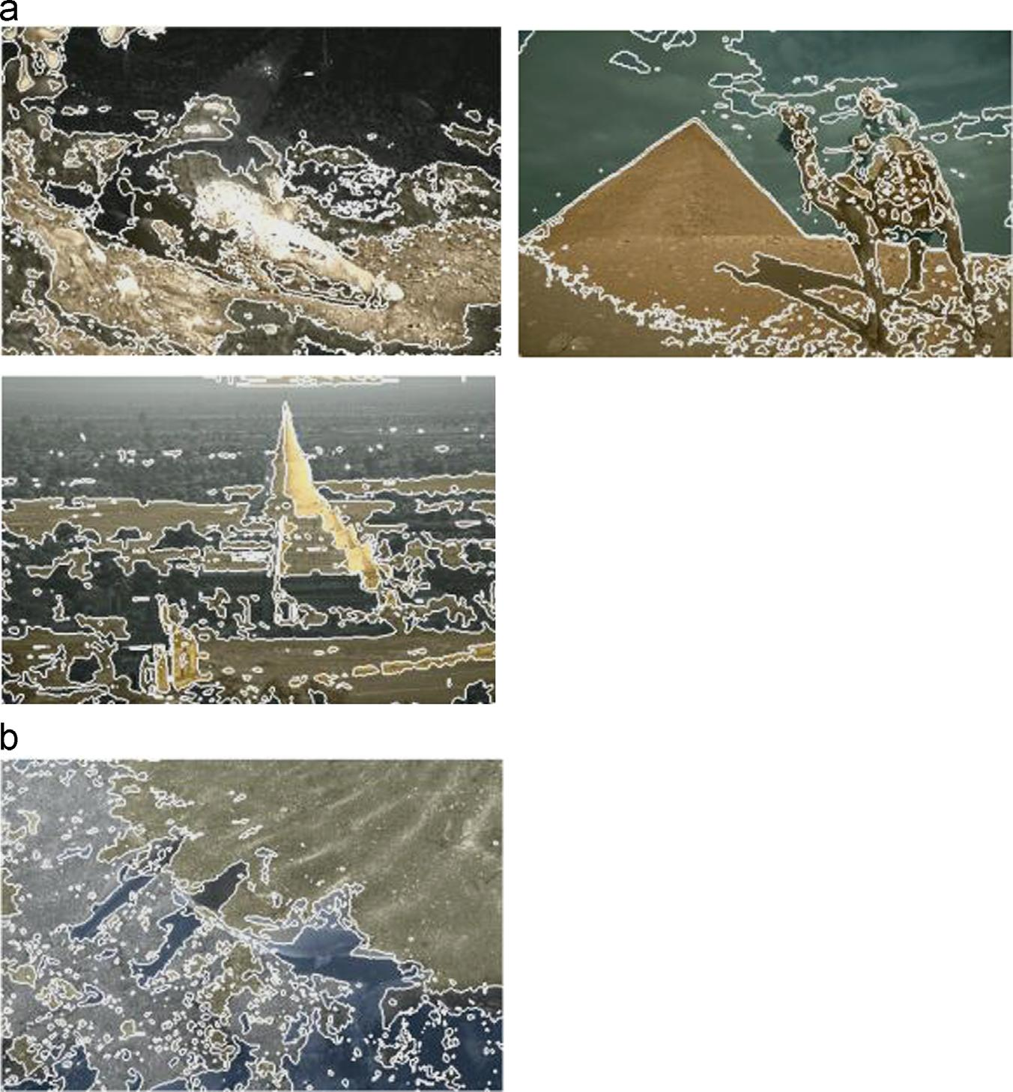

Fig. 7. Example segmentations with shadows and non-uniform illumination. NPR(from left to right): (a)−0.301, 0.314, −0.022 and (b) −0.7609, F(from left to right):

(a) 0.00025, 0.00023, 0.00026 and (b) 0.00015

Mean-Shift (MS) [9] segmentation methods. The CIELAB color space is used for all the comparisons. While both mean shift and NCUT graph based method are popular feature space clustering methods, FCM is chosen since it is a widely popular fuzzy clustering method for image segmentation. The parameters for FCM algorithm used in our experiments are: index of fuzziness m=2, maximum error limit ε = 10⁻², maximum iteration =200. Normalized Cuts graph based segmentation method uses eigen-vector techniques to obtain graph partitions. It finds minimum cuts in a graph while minimizing the similarity between different patches. GMM models the color features as a mixture of Gaussian kernels using Expectation Maximization algorithm for estimation of parameters of the Gaussian mixture and is a popular method for image segmentation and retrieval. Figs. 9 and 10 show the graphs for F and NPR indices for the 100 test images from the Berkeley Segmentation Dataset in the form of histograms for the five methods. It is observed from the graphs that the proposed FCCI algorithm provides the most optimum combination of the lowest values of F-measure (of the order of 10⁻⁴) and sufficiently high values of NPR index among all the five methods proving the efficiency of the proposed color segmentation algorithm by strik-ing a neat balance between color differencing and human percep-tion standards.

Fig. 11 shows the color segmented results of the five methods for six randomly selected test images from the Berkeley Segmen-tation Dataset namely: ’Mud-Huts’, ‘Plane’, ‘Eagle’, ‘Building’, ‘Wolf’, ‘Tree’. The corresponding F and NPR segmentation evalua-tion indices are listed in Table 1 depicting the lowest values of F for the proposed method as compared to all other methods. The NPR readings are also observed from Table 1, to be overall best for the proposed method though the Mean-Shift algorithm performs better for ‘Plane’ image. It is observed from the segmentation results in Fig. 11(b) that the proposed method FCCI forms well defined and interpretable clusters even when the color difference
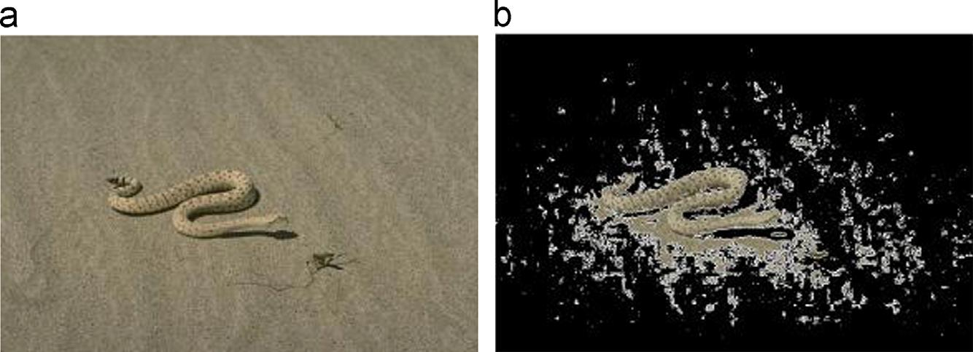

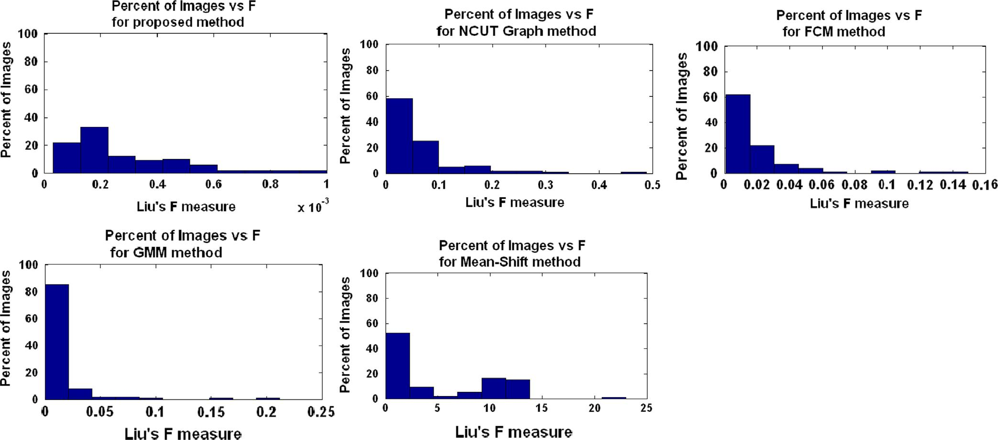

Fig. 9. Histograms of Liu’s F-measure achieved for individual images for the proposed method, NCUT Graph based method, FCM, GMM, Mean-shift segmentation methods.

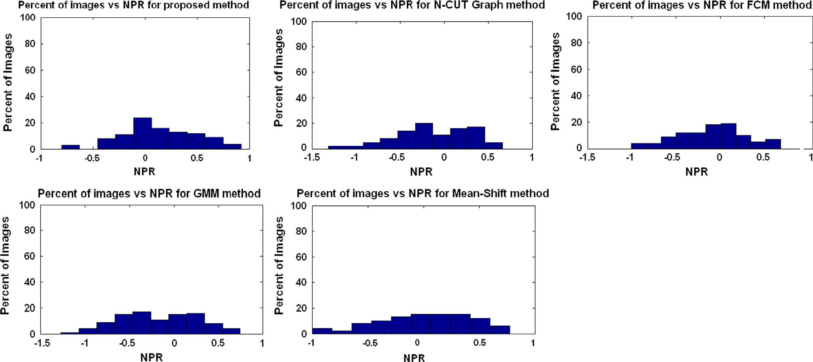

Fig. 10. Histograms of NPR Index achieved for individual images for the proposed method, NCUT Graph based method, FCM, GMM, Mean-shift segmentation methods.

between two regions is not too distinct as in the case of ‘Wolf’ image. The proposed technique is efficient in segmenting out uniform color regions and gives less fake boundaries as observed in the case of ‘Building’ image in Fig. 11(b) where the windows of the building are nicely segmented out visually as compared to other methods. An important factor that gives FCCI an edge over
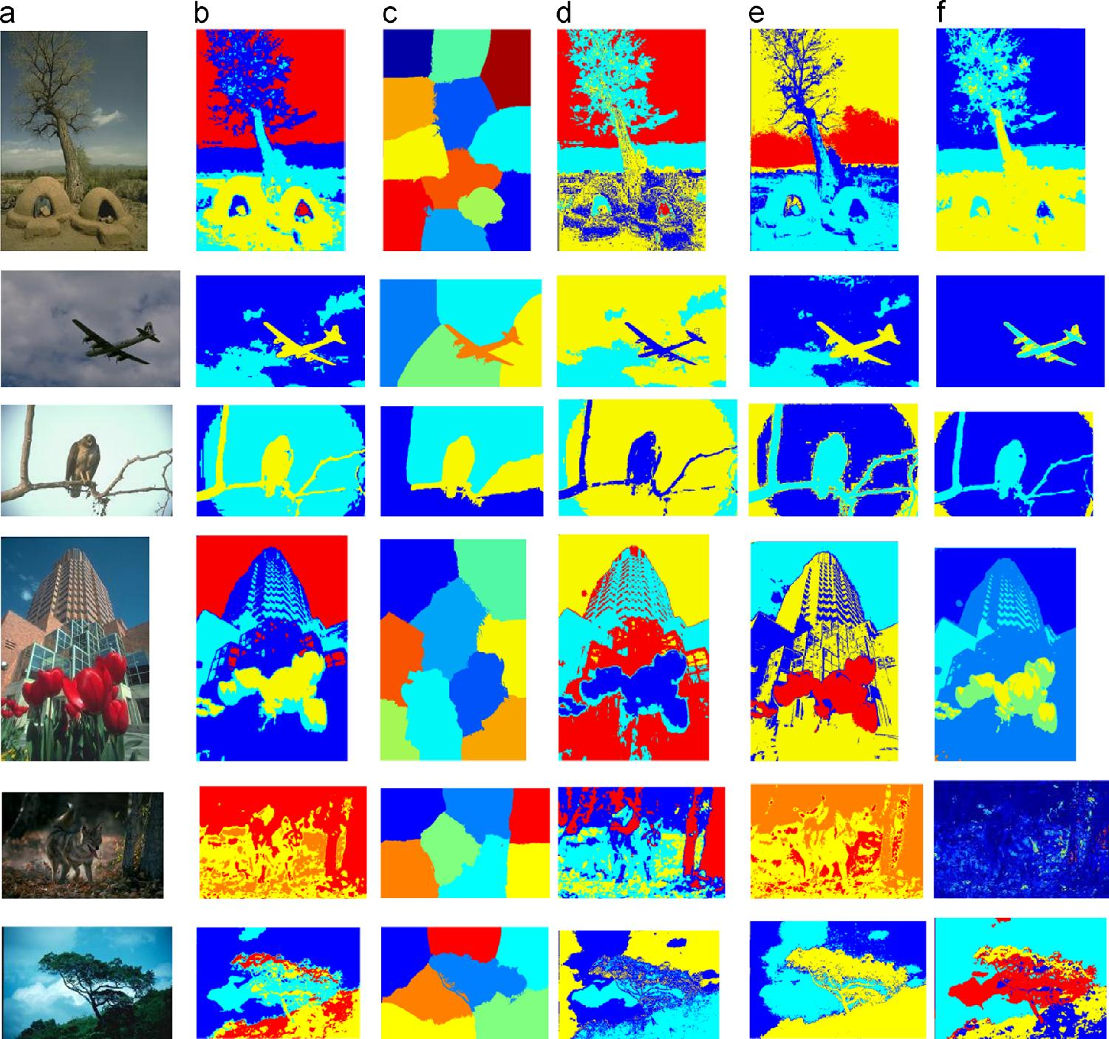

Fig. 11. Color segmentation results (a) Original images from Berkeley segmentation database [57] : ‘Mud-Huts’, ‘Plane’, ‘Eagle’, ‘Building’, ‘Wolf’, ‘Tree’ (b) Proposed method [(from top to bottom): T_{U} ={10.96,1.15,2.05,9.52,4.81,11.79}, T_{V} = 10⁸] (c) N-CUT (d) FCM (e) GMM (f) Mean Shift segmentations [Space Bandwidth h_{s} = 15, Color bandwidth h_{r} (from top to bottom): {7,3,4,10,1,8}]. (For interpretation of the references to color in this figure legend, the reader is referred to the web version of this article.)
Table 1
Liu ’ s F-measure and normalized probabilistic RAND index for the six test images: ‘ Mud-Huts’ , ‘ Plane ’ , ‘ Eagle ’ , ‘ Building’ , ‘ Wolf ’ , ‘ Tree’

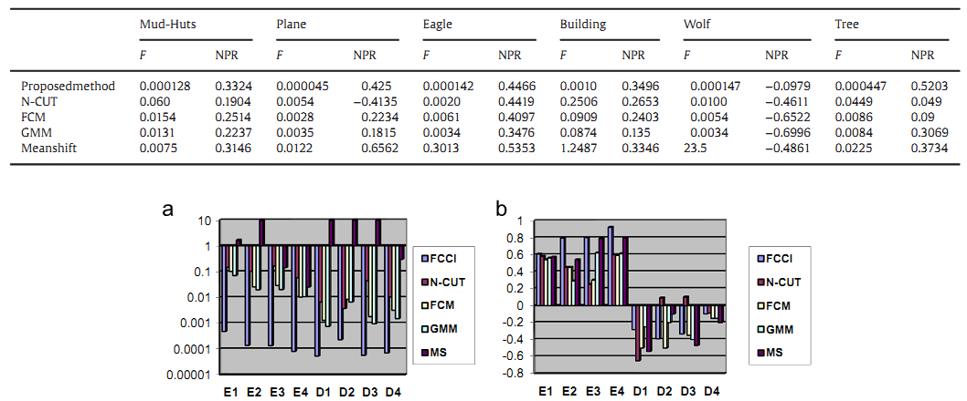

Fig. 12. The plots for (a) F-value (logarithmic scale) and (b) NPR readings for 4 easy (E1 to E4) images (from Fig. 5) and 4 difficult (D1 to D4) images (from Fig. 6) are shown below.

FCM clustering technique is the reduced time complexity. The time required by FCM for clustering is 10–15 min while the proposed algorithm hardly takes 1 min for the same. How fuzzy co-clustering scores over fuzzy clustering can be observed by comparing the segmentations of the proposed method (Fig. 11(b)) with that of FCM (Fig. 11(d)). The criterion for choosing number of clusters is the same as that for the proposed method (from the local minima in the clustering validity graph). As seen in the ‘Tree’ image co-clustering forms distinct and correct clusters with criteria being maximum separation between clusters/colors. Thus the green foliage and the blue sky being of distinct colors are grouped into separate clusters by the proposed method whereas in FCM, the parts of sky/clouds are clustered together with green foliage. FCM also suffers from the problem of outliers as observed from the pigmented segmentations in the ‘Mud-Huts’ example in Fig. 11(d). The co-clustering results are improved because of the grading/relevance factor (feature membership function) assigned to each of the color feature (a^{n},b^{n}) with respect to a particular

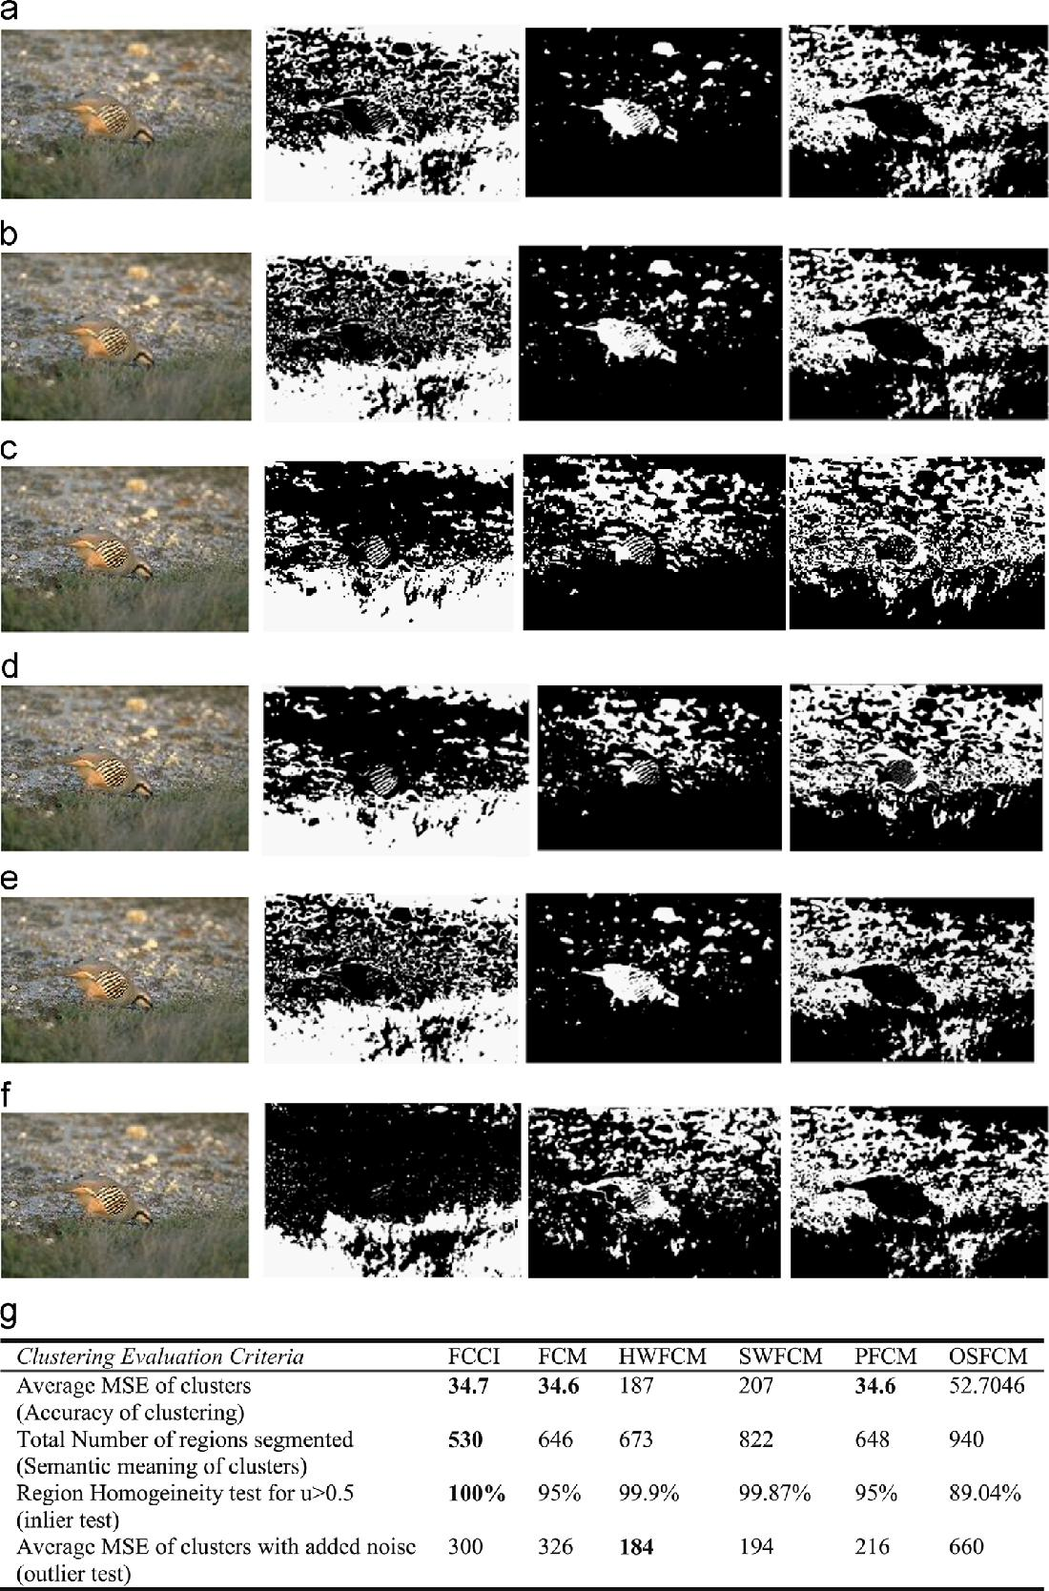

Fig. 13. The comparison of fuzzy clustering results (with the best values in bold) on the ‘Bird’ image for three clusters (a) FCCI (b) FCM (c) Histogram Weighted FCM(d) Spatially Weighted FCM (e) PFCM (f) OSFCM (g) Segmentation Evaluation results in terms of Mean Square Error (MSE), Region Homogeneity Test (RH) and Mean Square Error (MSE) in the presence of noise.

cluster which leads to correct evaluation of clusters and also solves the problem of outliers. The N-CUT Graph based method does not give a very good correctness with respect to human ground truth images as compared to the proposed method and mean shift method. Also it tends to segregate uniform color regions into large chunks. GMM by Expectation Maximization algorithm is an unsupervised technique resulting in blob like segments. It classi-fies the entire tree and green foliage of the example ‘Tree’ in Fig. 11(e) into 1 segment performing well with respect to human evaluation but poorly for color difference between regions. More-over, the resulting blobs contain no internal details as demon-strated in the blobs formed in ’Eagle’ image in Fig. 11(e). The mean shift algorithm performs well corresponding to human ground truths as indicated by a high value of NPR (example–‘Plane’ image in Fig. 11(f)). However it fails in the absence of any dominant colors in the scene as seen in the example of ‘Wolf’ image where the colors are visually indistinct. The Liu’s F-measure values are found to be generally high in the case of both mean shift and N-CUT graph based algorithms. Also the mean shift method is very sensitive to its color bandwidth parameter h_{r} with a slight change causing large changes in granularity of segmentation. The h_{r} values for the test images are in the range 1–15 while the space bandwidth is h_{s} =15. Though some feature weighted clustering algorithms have been proposed in the past [46] and were applied for image segmentation problems [47], they do not incorporate a separate feature membership to be independently updated in each iteration along with pixel memberships and cluster centroids. Fig. 12 shows the comparison (F and NPR values) between the five methods for the mix of easy and difficult images in Figs. 5 and 6 respectively taken in the same order. The results affirm that F-values are minimum for FCCI for all images, a fact already established from the graphs in Fig. 9, while NPR values are highest for FCCI for all the easy images E1 to E4 and most of the difficult images except for the D2 difficult image for which NCUT, GMM and Mean Shift yield better results. In Fig. 13 we compare the segmentations using some recent fuzzy clustering algorithms apart from FCM namely Spatially weighted FCM [48], Histogram weighted FCM [49], Possibilistic FCM [50] and Orientation sensi-tive FCM (OSFCM) [51] on an example image ‘Bird’ containing three main clusters, the bird, the stones and the grass. The experimental parameters of these algorithms are summarized in Table 2. The results in Fig. 13 indicate that FCCI provides the most optimum segmentation with respect to human evaluation of the scene and is equivalent to FCM in terms of accuracy of the clusters formed. FCM and FCCI form the most visually acceptable clusters of the scene segmenting out the bird nicely in Cluster 2. Hence the reason that FCM among all the existing fuzzy clustering algorithms is most popular for image segmentation purpose. FCCI yields the cleaner image of the two (with lesser number of regions as compared to FCM as seen in Fig. 13) complying more with human perception of the scene.

The inlier or bridge pixels are properly clustered by FCCI as compared to all other clustering algorithms as indicated by the region homogeneity tests (criteria being u_{ci} 40.5), though the outlier problem of FCM persists. The inlier pixels are defined as those that are equidistant from all centroids and have a membership of 0.5 to all clusters as a result. Since FCCI computes feature memberships as well which evaluates the relationship of a cluster to a feature, it is taken into account the feature value distribution of the inlier to compute its membership to a cluster. However the outlier points or noise pixels are a problem since for these data points the algorithm behaves like FCM and is sensitive though some marginal improvement is noticed from the Table in Fig. 13. Table 3 evaluates the memberships obtained from FCCI, FCM and PFCM algorithms for the X₁₁ dataset fX₁₀∪(inlier)gin [50] where X₁₀ contains 10 two dimensional data points. The results are found to be best for the proposed FCCI algorithm in terms of crisp values of memberships (1,0) obtained and the definitive values of inlier memberships that is indicative of the clusters (u_{ci} 40.5) to which they belong to. The only shortcoming of FCCI clustering is the response to the outliers which need to be minimized.
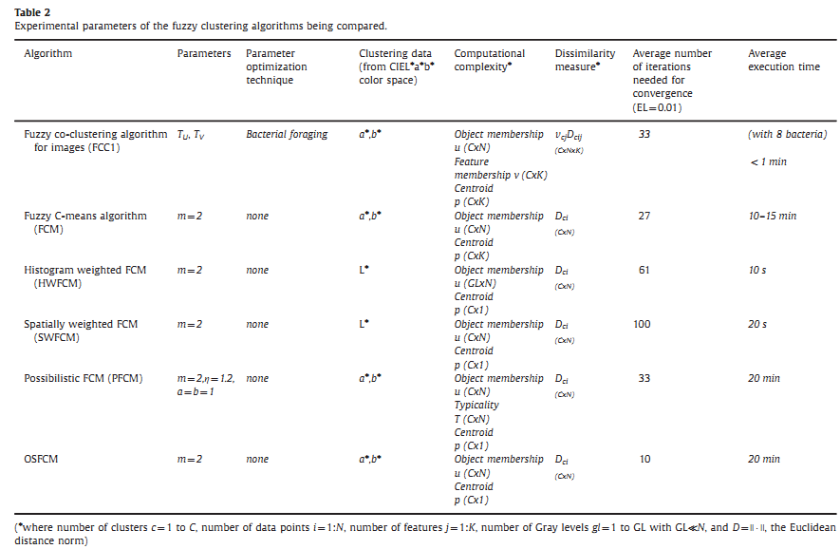
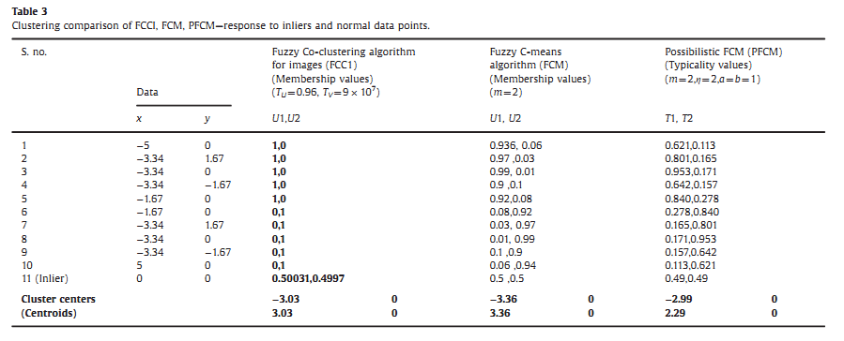

4. Conclusions

In this paper, the Fuzzy co-clustering approach based on the simultaneous clustering of both object and feature memberships is used for the color segmentation of natural images. A new objective function is formulated and the update rules are derived. The new algorithm (FCCI) is tried for color segmentation on 100 test images from the Berkeley segmentation dataset yielding precise segmen-tation. The color vectors {a*,b*} of CIELAB color space are the feature variables for the color segmentation algorithm. The per-formance is evaluated on the basis of Liu’s Function F, and the Normalized Probabilistic RAND (NPR) index. The number of clusters is determined from the first local minima of Xie and Beni’s cluster validity curve and is found to produce apt results (low F and high NPR). The proposed method produces accurate color differencing and at the same time adheres to the human perception in segmenting the natural scenes with non-uniform illumination and shading. It is also compared with some of the existing color segmentation techniques and is found to outperform them. The future scope of this work lies in improving the image segmentation in the presence of outliers and exploring other evolutionary algorithms for speedy solutions of the two para-meters involved.
Appendix A

The proof of convergence of the FCCI algorithm is shown below:
Theorem 1. The updated values of u_{ci} given by Eq.(9) never increase the objective function in every iteration
Proof. Consider the objective function as a function of u_{ci} alone.
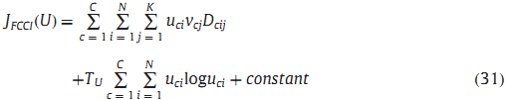

where, constant = T_{V} ∑^{C}_{c} ₌ ₁∑^{K}_{j=} ₁v_{cj}logv_{cj}

Also, the product v_{cj} D_{cij} may be considered as constant. To prove Theorem 1 we have to prove that U*, i.e the updated values of u_{ci} given by Eq. (9) are the local minima of the objective function J_{FCCI}(U*) provided that the constraints in (5) and (6) are satisfied.
For this we need to prove that the Hessian matrix ∆²J_{FCCI}(U*) is positive deﬁnite.
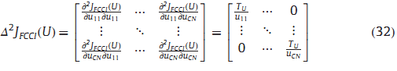

At U*, u_{ci}≥0 and T_{U} is always assigned a positive value. Therefore the Hessian matrix ∆²J_{FCCI}(U*) is positive definite. We have proved the first necessary condition (∂J_{FCCI} (u_{ci})=∂u_{ci}) = 0 and the second sufficient condition: ∆²J_{FCCI}(U*) is positive definite. There-fore u_{ci}^{n} updated is indeed a local minima of J_{FCCI}(U) and it never increases the objective function value.

Theorem 2. For every iteration the updated values of v_{cj} given by Eq. (11) never increases the objective function.

Proof. Proof is similar to proof of Theorem 1.

Theorem 3. The following constraint is satisfied by J_{FCCI} in (4):
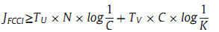
Proof. Since the minimum value of u_{ci} and v_{cj} is 0, and D_{cij}≥0, the first term of J_{FCCI} reduces to

The second and third terms denote the entropy values and maximum value of entropy occurs when u_{ci} =1/C and v_{cj} =1/K.
In view of these the point of minima is
Corollary. Theorems 1–2 prove that the updated equations of FCCI point to a local minima of the Objective function and Theorem 3 indicates the lower limit of J_{FCCI}.

Appendix B

The CIELAB color space is obtained from the RGB color space by the following transformation:

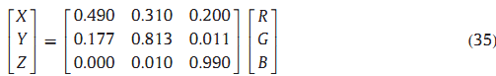
The features of CIELAB are derived from
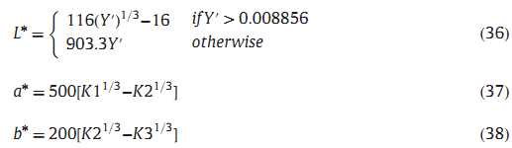
Where
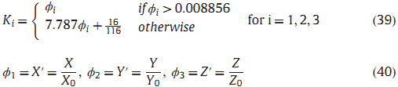

The X₀, Y₀ and Z₀ are the values of X,Y,Z for the reference white, respectively. The reference white is defined as {R =G=B =255}.

