English Helper

1. Overview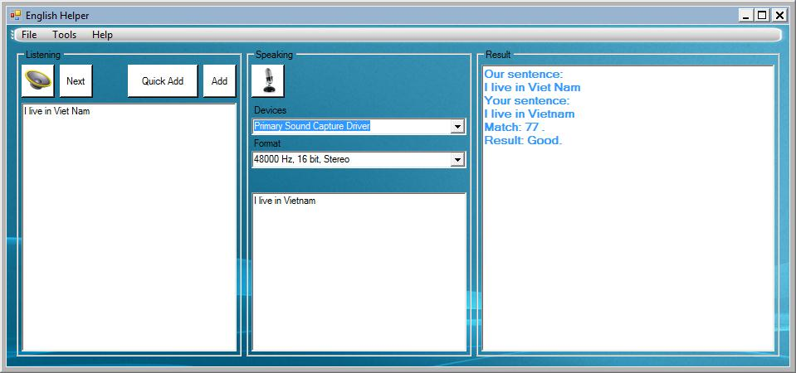
2. Listenning:

You can write a sentence or get one from db by click Next button,then press the “button read” to transforms your text into speech and hear a lovely voice appears,that’s how to read this sentence

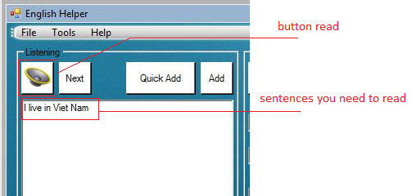

1. Speaking:

After listenning, press “button recording” to activate recording process and press again to finish. The software can recognite what you say, and show it in textbox below.We used google speech recognition service,so if you want to use this feature,you must have internet connection.

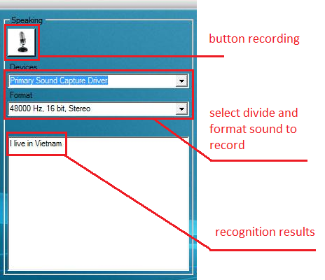

1. Result:

As you can see:

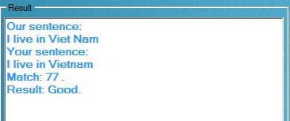

1. Future developments

We aim to “perfect” software to everyone who loves to improve English skill everytime and everywhere with no cost,so this is my future direction:

+ Make more feature for this apps

* Spell and grammar checking
* Log on and save mark for each user
* Offline speech recognition feature for computer has no internet connection

+ Convert this to silverlight web apps