Python Lecture Notes 3/22/2021

1.1 Introduction
- multiple uses, server application, use along software, read/modify files, handle large amounts of data, automation of tasks, AI
- has pseudo-code like syntax that emphasizes readability and expressiveness (it’s easy to read and most similar to English)
- Python is a high level and general purpose programming language
- Python supports multiple paradigms:
  - object-oriented programming
  - functional programming
  - imperative programming
  - procedural procedural

1.2 Working with Python Interactive Shell
- first line in the interactive shell is the Python version info.

1.3 Writing and Running simple scripts
- you can use it to test a quick hypothesis you want to test out
- a document containing python code is called a module

1.3.1 Running a file Containing Invalid Commands
- Stack traces tells us where the error occurred, type of error and what other calls were triggered
- read from the bottom to the top
- another name for stack trace is a traceback

1.5 Variables
- 1.5.1 Values
- 1.5.2 Type Conversion
- 1.5.3 Multiple Assignment
- 1.5.4 Naming ID’s and reserved words
- 1.5.5 Python Naming Conventions

1.5.2 Type Conversion
- Python allows you to convert string type values to integer type and vice versa

1.5.5 Naming Conventions
- Be consistent throughout the program and be able to follow the naming convention for variable
- Be clear and concise with naming conventions
- All UPPERCASE variables are constants (const)

1.6 User Input, Comments, and Indentations
- 1.6.1 User input from keyboard
  - call a function that uses command line interface using keyword input ()
- 1.6.2 Passing in a prompt to the input functional, example:
  - tongue_twister = input(“Enter a tongue twister: “)
- 1.6.3 Using different input data types in your program

- 1.6.4 Comments
  - # this is a comment
  - “””
This is for comments that are longer or over two lines, called doc strings
“””
- 1.6.5 Indentation
  - must be the same, otherwise the it will break the program.

3/29/21 Lecture Notes

2.1 Data Types
- Numbers
  - Integers, can be positive or negative
  - Floating point numbers – numbers with a decimal place value
  - Binary and hexadecimal

- Function – to declare in python the keyword is def function name ( ):
  - Parameters are the variables inside the ( ) of a function (ex: fname)
  - Arguments are the values placed inside the ( ) of a function when it is called (ex: “Alex”)

>>> def my_function (fname):
print(fname + " Ciorra")

>>> my_function ("Alex")
Alex Ciorra
>>>
- Modulo % (Or the remainder)

2.3 Strings
- A sequence of characters enclosed in either ‘ ‘ or “ “ marks
- Concatenate - adding strings together

2.5 Indexing
- Always starts with zero
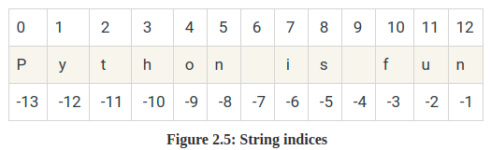

- Lists
  - same indexing for numbers

- Slicing
  - accessing characters within a range of indices in a string and get a slice/sub-string of that string

- String Formatting
  - String interpolation is the most popular str.format( )
Example:
pie = 3.14
print(f”I ate some {pie} and it was yummy!”)

Escape Sequences:
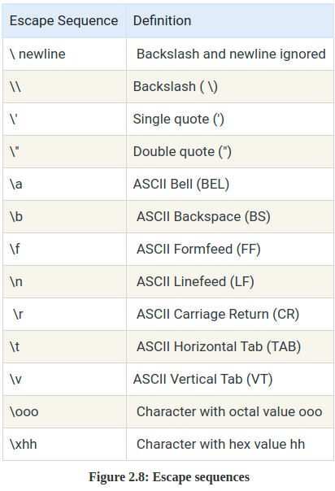

4/5/21 Lecture Notes:

Lesson 3: Control Statements

Algorithms – you can solve any computing problem by executing a series of specific actions in a certain order to achieve the desired result.

Pseudocode - the English-like language for thinking out an algorithm
Example: prompts the user to enter 2 integers, inputs them from the user at the keyboard, adds them, then stores and displays their sum:
- Prompt the user to enter the first integers
Input the first integers
- Prompts the user to enter the second integers
Input the second integers
- Add first and second integers together, store their sum
Display the numbers and their sum

Repetition Statements:
- If Statements (example problem: an exam has a score of 60 or higher they passed the exam)
  - ask the user for their grade on the exam
  - if grade is greater than or equal to 60 they passed
  - display “Pass”
    - If else statements – if the student’s grade is equal to or greater than 60, print “Pass”. ELSE print “Fail”
- While Loops – the code will continue to run while the set condition remains true

4/12/21
Lesson 4 – Functions

