Title

Author

9/20/2020

# Level 1

Do you see any Teletubbies in here? Do you see a slender plastic tag clipped to my shirt with my name printed on it? Do you see a little Asian child with a blank expression on his face sitting outside on a mechanical helicopter that shakes when you put quarters in it? No? Well, that’s what you see at a toy store. And you must think you’re in a toy store, because you’re here shopping for an infant named Jeb.

Normally, both your asses would be dead as fucking fried chicken, but you happen to pull this shit while I’m in a transitional period so I don’t wanna kill you, I wanna help you. But I can’t give you this case, it don’t belong to me. Besides, I’ve already been through too much shit this morning over this case to hand it over to your dumb ass.

* List
* List
  + Star
  + Plus

1. One
2. Two 2.1 Two point 1
   * Star

library(palmerpenguins)  
  
penguins %>%  
 head %>%  
 flex("Penguins Table")

Table 1 Penguins Table

| species | island | bill_length_mm | bill_depth_mm | flipper_length_mm | body_mass_g | sex |
| --- | --- | --- | --- | --- | --- | --- |
| Adelie | Torgersen | 39.1 | 18.7 | 181 | 3750 | male |
| Adelie | Torgersen | 39.5 | 17.4 | 186 | 3800 | female |
| Adelie | Torgersen | 40.3 | 18.0 | 195 | 3250 | female |
| Adelie | Torgersen | NA | NA | NA | NA |  |
| Adelie | Torgersen | 36.7 | 19.3 | 193 | 3450 | female |
| Adelie | Torgersen | 39.3 | 20.6 | 190 | 3650 | male |

penguins %>%  
 ggplot()+  
 geom_point(aes(x=bill_length_mm, y=body_mass_g, color=sex))

## Warning: Removed 2 rows containing missing values (geom_point).

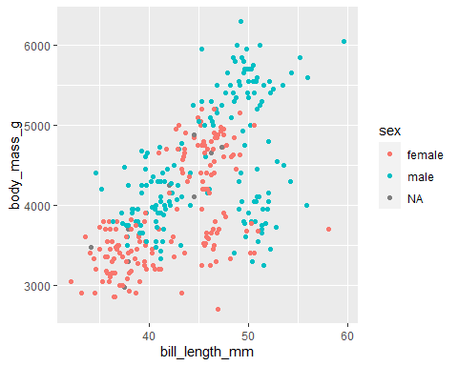

Figure 1: An amazing plot

## Level 2

### Level 3

#### Level 4

##### Level 5

Association for the Advacement of Sustainability in Higher Education. (2019a). *History*. <https://stars.aashe.org/about-stars/history/>

Association for the Advacement of Sustainability in Higher Education. (2019b). *STARS tehncial manual version 2.2*.

Bullock, G., & Wilder, N. (2016). The comprehensiveness of competing higher education sustainability assessments. *International Journal of Sustainability in Higher Education*, *17*(3), 282–304. <https://doi.org/10.1108/IJSHE-05-2014-0078>

Chui, Q. (2020). Sustainability performance in american higher education: A multiple case study of four exemplary institutions that participated in the sustainability tracking, assessment & rating system [PhD dissertation, Florida Atlantic University]. <http://citeseerx.ist.psu.edu/viewdoc/download?doi=10.1.1.633.3350&rep=rep1&type=pdf>

Elijido-Ten, E. (2007). Applying stakeholder theory to analyze corporate environmental performance. *Asian Review of Accounting*, *15*(2).