R/R Markdown Table Options for Multilevel Models

Anthony Schmidt

2020-09-06

I am currently taking a multilevel modeling class in my PhD program. It is week 3-ish and I am learning a lot. The course is software-agnostic, meaning we can use any software we want (SPSS, SAS, Stata, R, HLM). The first assignment comes as a data set and word document. I am working completely in R / R Markdown to generate both the data and model analyses and to complete the Word-based homework. Because I am working in an R -> Word workflow, I need to know what options I have for creating nice tables of my models.

So, I am taking a break from my first assignment to compare the default output of the most popular R model summary packages, look at some extended features, and make a cross-package comparison for my own future reference.

Let’s begin!

## The Models

For this example, I am going to use Allison Horst’s palmerpenguins package for the data and produce two simple and non-substantive multi-level models. I will use lme4::lmer and lmerTest::lme4, which produces p-values and a few different estimates. Note: I will not be interpreting these models.

library(palmerpenguins)  
  
# unconditional model  
model_0 <- lme4::lmer(body_mass_g ~ 1 + (1 | island), REML = F, data=penguins)  
  
model_0_lmertest <- lmerTest::lmer(body_mass_g ~ 1 + (1 | island), REML = F, data=penguins)  
  
model_1 <- lme4::lmer(body_mass_g ~ sex + (1 | island), REML = F, data=penguins)  
  
model_1_lmertest <- lmerTest::lmer(body_mass_g ~ sex + (1 | island), REML = F, data=penguins)

## The Packages

The most popular packages that can take a model object and produce a neat table summary include modelsummary, gtsummary, huxtable, and sjPlot. I will generate default tables with each of these packages with the goal of being able to insert them into a Word document via knitr. I will try to keep customization to a minimum.

### modelsummary

[modelsummary](https://vincentarelbundock.github.io/modelsummary/articles/modelsummary.html) offers the msummary function and allows me to create side-by-side tables. This **will** work for lme4 models, but **will not** work for lmerTest models unless you load the package broom.mixed first.

modelsummary::msummary(list(  
 "Null Model" = model_0,   
 "Model 1" = model_1))

|  | Null Model | Model 1 |
| --- | --- | --- |
| (Intercept) | 4048.143 | 3713.505 |
|  | (275.116) | (273.909) |
| sd_(Intercept).island | 471.900 | 468.149 |
|  |  |  |
| sd_Observation.Residual | 626.335 | 532.804 |
|  |  |  |
| sexmale |  | 674.365 |
|  |  | (58.402) |
| AIC | 5393.7 | 5147.3 |
| BIC | 5405.2 | 5162.5 |
| Log.Lik. | -2693.833 | -2569.644 |

Here, I have loaded broom.mixed and added a call for significance stars with stars=T.

library(broom.mixed)

## Registered S3 methods overwritten by 'broom.mixed':  
## method from   
## augment.lme broom  
## augment.merMod broom  
## glance.lme broom  
## glance.merMod broom  
## glance.stanreg broom  
## tidy.brmsfit broom  
## tidy.gamlss broom  
## tidy.lme broom  
## tidy.merMod broom  
## tidy.rjags broom  
## tidy.stanfit broom  
## tidy.stanreg broom

modelsummary::msummary(list(  
 "Null Model" = model_0_lmertest,   
 "Model 1" = model_1_lmertest), stars = T)

|  | Null Model | Model 1 |
| --- | --- | --- |
| (Intercept) | 4048.143*** | 3713.505*** |
|  | (275.116) | (273.909) |
| sd__(Intercept) | 471.900NA | 468.149NA |
|  |  |  |
| sd__Observation | 626.335NA | 532.804NA |
|  |  |  |
| sexmale |  | 674.365*** |
|  |  | (58.402) |
| AIC | 5393.7 | 5147.3 |
| BIC | 5405.2 | 5162.5 |
| Log.Lik. | -2693.833 | -2569.644 |
| * p < 0.1, ** p < 0.05, *** p < 0.01 | | |

#### Screenshot from Word

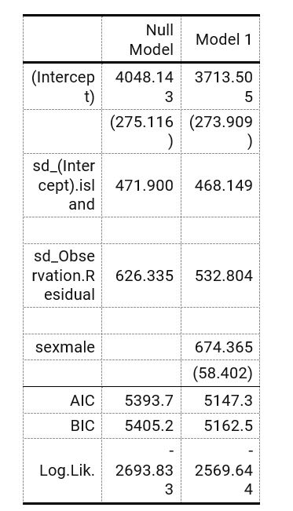

Screenshot from Word for msummary

#### Notes

* msummary produces a decent side-by-side table in Word.
* The default style looks like APA, which is something I would want.
* However, it splits the fixed effects of intercept and sex up so that intercept is above the random effects and sex is below.
* Finally, the default width is a bit narrow, meaning additional customization is needed. It can easily be customized using flextable, which works well in Word. The following code coverts it to flextable:

modelsummary::msummary(list("Null Model" = model_0, "Model 1" = model_1), output = 'flextable')

## gtsummary

gtsummary is based on the gt package, which allows easy and advanced customization of tables in R.

I could not get gtsummary to make a table for my null model, model_0. It produced the error: Error: must be a character vector, not a logical vector.. However, it worked for model_1 and model_1_lmertest. Here is the no frills default:

gtsummary::tbl_regression(model_1_lmertest)

|  |  |  |  |
| --- | --- | --- | --- |
| **Characteristic** | **Beta** | **95% CI** | **p-value** |
| sex |  |  |  |
| female |  |  |  |
| male | 674 | 560, 789 | <0.001 |

That table is *clearly* not a good table. I did some googling, and found I had to add the following tidy function to produce a table with all estimates:

gtsummary::tbl_regression(model_1_lmertest, tidy_fun = broom.mixed::tidy)

## Table printed with `knitr::kable()`, not {gt}. Learn why at  
## http://www.danieldsjoberg.com/gtsummary/articles/rmarkdown.html  
## To suppress this message, include `message = FALSE` in the code chunk header.

|  |  |  |  |
| --- | --- | --- | --- |
| **Characteristic** | **Beta** | **95% CI** | **p-value** |
| sex |  |  |  |
| female |  |  |  |
| male | 674 | 560, 789 | <0.001 |
| sd__(Intercept) | 468 |  |  |
| sd__Observation | 533 |  |  |

#### Screenshot from Word

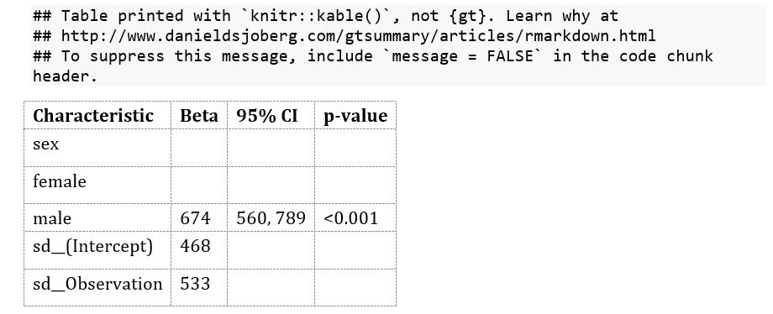

Screenshot from Word of gtsummary

#### Notes

* This table is created in gt, but as of right now, gt doesn’t work with Word so it was automatically converted to a kable table.
* You can do a lot of customization using gt and then convert it to kable or flextable (using as_flex_table()).
* While adding confidence intervals are nice, the lack of fit statistics makes the default output inadequate. Looking through the gtsummary reference, I do not see a way to add these.
* Side-by-side tables requires saving each table as an object and then using tbl_merge.

## huxtable

[huxtable](https://cran.r-project.org/web/packages/huxtable/vignettes/huxtable.html) works with both lme4 and lmerTest. It uses the huxreg function and can easily make side-by-side tables.

huxtable::huxreg(list(  
 "Null Model" = model_0_lmertest,   
 "Model 1" = model_1_lmertest))

## Warning in huxtable::huxreg(list(`Null Model` = model_0_lmertest, `Model 1` = model_1_lmertest)): Unrecognized statistics: r.squared  
## Try setting `statistics` explicitly in the call to `huxreg()`

|  |  |  |
| --- | --- | --- |
|  | Null Model | Model 1 |
| (Intercept) | 4048.143 *** | 3713.505 *** |
|  | (275.116) | (273.909) |
| sd__(Intercept) | 471.900 | 468.149 |
|  | (NA) | (NA) |
| sd__Observation | 626.335 | 532.804 |
|  | (NA) | (NA) |
| sexmale |  | 674.365 *** |
|  |  | (58.402) |
| N | 342 | 333 |
| logLik | -2693.833 | -2569.644 |
| AIC | 5393.665 | 5147.289 |
| *** p < 0.001; ** p < 0.01; * p < 0.05. | | |

#### Screenshot from Word

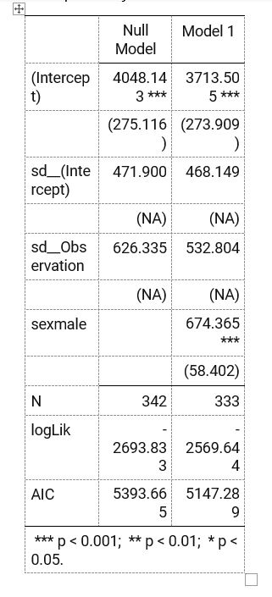

Screenshot from Word of huxtable

#### Notes

* By default huxreg produces a nice side-by-side table.
* The default *looks like* simple ASCII/Markdown table, **but** it knits to Word nicely without any need to make changes.
* Output looks like modelsummary::msummary but lacks ICC values.
* huxtable also separates fixed effects like modelsummary
* Can be customized via huxtable or flextable via as_flextable - though I could not get this to work.

## sjPlot

[sjPlot](https://strengejacke.github.io/sjPlot/) is a table and visualization package meant for a number of social science methods (linear models, generalized linear models, PCA, robust standard errors, etc.).

Below is the HTML table. This table can be styled with CSS.

sjPlot::tab_model(model_0, model_1,   
 dv.labels = c("Null Model", "Model 1"))

Null Model

Model 1

Predictors

Estimates

CI

p

Estimates

CI

p

(Intercept)

4048.14

3508.92 – 4587.36

<0.001

3713.50

3176.65 – 4250.36

<0.001

sex [male]

674.37

559.90 – 788.83

<0.001

Random Effects

σ2

392294.95

283879.82

τ00

222689.64 island

219163.06 island

ICC

0.36

0.44

N

3 island

3 island

Observations

342

333

Marginal R2 / Conditional R2

0.000 / 0.362

0.185 / 0.540

#### Screenshot from Word

**NONE**

#### Notes

* It works with lmerTest. However, if you only use lme4, sjPlot automatically adds p-values.
* sjPlot creates a *very* nice table with random effects listed with their Greek values, $σ^{2}$ and $τ$, plus ICC and $R^{2}$!
* Unfortunately, it produces only an HTML table and this table cannot be automatically added to Word.
* Styling the table for HTML requires CSS.
* It cannot be converted to flextable or kable

## Final Thoughts

In a perfect world, we would be able to knit the sjPlot table to Word and be done with it. Unfortunately, this does not work for now. The best and easiest option would be using modelsummary::msummary. If you need p-values, use lmertest and broom.mixed, and be sure to call stars = T inside msummary. Then, make sure to also include output = 'flextable' to add more customization and allow your table to knit to Word.

The following example creates a simple function to automatically customize the table (useful if you will have multiple tables), and adds ICC and R2. I did not have time to organize the fixed and random effects, nor add the Greek symbols (ideally, in parentheses), but I think it’s easy to see how well modelsummary and flextable work together for your multilevel models!

library(tidyverse)  
library(flextable)  
  
#table formatting function  
flex <- function(data, title=NULL) {  
 set_table_properties(data, layout = "autofit", width = 1) %>%  
 fontsize(size=12, part="all") %>%  
 set_caption(title,   
 autonum = officer::run_autonum(seq_id = "tab",   
 pre_label = "Table ",   
 post_label = "\n",   
 bkm = "anytable"))  
}  
  
#adding ICC and R2 - note you can also write a function with glance_custom  
# https://vincentarelbundock.github.io/modelsummary/articles/newmodels.html  
mlm_added <- tribble(~term, ~"Null Model", ~"Model 1",  
 "ICC",   
 performance::icc(model_0)$ICC_conditional,   
 performance::icc(model_1)$ICC_conditional,  
 "pseudo R2",  
 performance::r2(model_0)[["R2_conditional"]][["Conditional R2"]],  
 performance::r2(model_1)[["R2_conditional"]][["Conditional R2"]])  
  
#changing names of coefficients  
cm <- c("sexmale"="Male",  
 "sd__(Intercept)"="SD Intercept (τ00)",  
 "sd__Observation" = "SD Observation (σ2)",  
 "(Intercept)" = "Intercept")  
  
#the final table  
modelsummary::msummary(list("Null Model" = model_0,   
 "Model 1" = model_1),   
 output = 'flextable',   
 add_rows = mlm_added,  
 coef_map = cm) %>%  
 flex("Multilevel Model of Palmer Penguins")

Table  Multilevel Model of Palmer Penguins

|  | Null Model | Model 1 |
| --- | --- | --- |
| Male |  | 674.365 |
|  |  | (58.402) |
| SD Intercept (t00) | 471.900 | 468.149 |
|  |  |  |
| SD Observation (s2) | 626.335 | 532.804 |
|  |  |  |
| Intercept | 4048.143 | 3713.505 |
|  | (275.116) | (273.909) |
| AIC | 5393.7 | 5147.3 |
| BIC | 5405.2 | 5162.5 |
| Log.Lik. | -2693.833 | -2569.644 |
| ICC | 0.362 | 0.355 |
| pseudo R2 | 0.362 | 0.540 |

#### Screenshot from Word

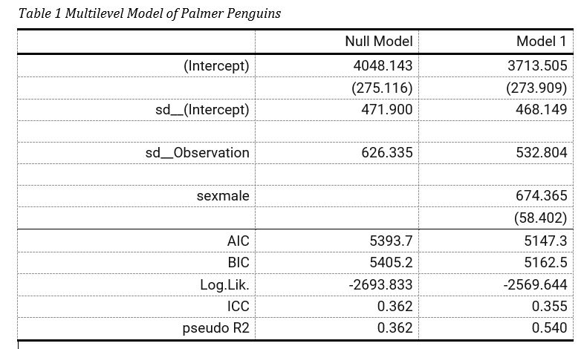

Screenshot from Word of Customized modelsummary

Do you know a better way to make great MLM tables in R Markdown, or have you figured out a sjPlot hack!? Please let me know.

*Thanks to Vincet Arel-Bundock (*[*https://twitter.com/VincentAB*](https://twitter.com/VincentAB)*; author of modelsummary) for the tip about loading broom.mixed*

*Thanks to Daniel (*[*https://twitter.com/strengejacke*](https://twitter.com/strengejacke)*; author of sjPlot) for pointing out to use dv.labels*