ONLINE APPENDIX TO ARTICLE TITLED

“DIMENSIONS AND DYNAMICS OF NATIONAL CULTURE: SYNTHESIZING HOFSTEDE WITH INGLEHART”

PUBLISHED IN THE JOURNAL OF CROSS CULTURAL PSYCHOLOGY

BY

Sjoerd Beugelsdijk AND CHRIS WELZEL

ONLINE APPENDIX
OVERVIEW OF ADDITIONAL TABLES, ANALYSES AND FIGURES

TABLE A1: Overview of items included in Hofstede’s six dimensions
TABLE A2: Sample characteristics
TABLE A3: Selection of questions
TABLE A4: Robustness of Table 6 (regression results) for alternative specification of
three cultural dimensions
TABLE A5: Correlation between original Hofstede dimensions and new dimensions
TABLE A6: Formula to generate three dimensions and missing data imputation
TABLE A7: Random versus Fixed effects Hausman test
TABLE A8: Definition of exogenous correlates used in Table 7
TABLE A9: Wave-averaged country scores on three dimensions
TABLE A10: Cross-cohort correlations between dimensions
TABLE A11: Country-fixed effects for all countries resulting after controlling for GDPpc & cohort-specific effects in the panel regression
ANALYSIS A1: Cluster analysis using the three dimensions
ANALYSIS A2: Response bias analysis
FIGURE 1A,1B,1C: Series of three scatter plots of GDP per capita and the three dimensions
FIGURE A2: Plot of the country fixed effects of the Collectivism-Individualism dimension and the Duty-Joy dimension

APPENDIX Table A1: overview of items included in Hofstede’s six dimensions
Original Hofstede dimensions; 1980; page 61
Abbreviated survey question | Code in Hofstede’s survey | Used in dimension | Result factor analysis | Loading in ecological factor analysis
employees not afraid to disagree  low percentage perceived manager 1 or 2  high percentage preferred manager 3 | B46  A55  A54 | PD  PD  PD | One factor  explaining 24% | .75  -.76  .74
Importance personal time  low importance physical conditions  low importance training  importance freedom  low importance skills  importance challenge (2nd loading) | A18  A12  A9  A13  A17  A5 | IDV  IDV  IDV  IDV  IDV, MAS  IDV, MAS | One factor  explaining 24% | .82  -.62  -.62  .59  -.58  .41
low importance manager  importance earnings  low importance cooperation  importance recognition  importance challenge  low importance desirable area  low importance employment security  importance use of skills (2nd loading)  importance advancement (2nd loading) | A16  A7  A8  A11  A5  A6  A14  A17  A15 | MAS  MAS  MAS  MAS  MAS, IDV  MAS  MAS  MAS, IDV  MAS | One factor  explaining 13% | .71  -.68  -.67  .60  .60  -.53  -.51  .43  .39
Company rules may be broken  Low stress  Continue less than five years | B60  A37  A43 | UA  UA  UA | One factor  explaining 12% | .76  .62  .59
Most recently added dimensions based on World Values Survey data; Hofstede et al 2010;

 | WVS/EVS code | Used in dimension | Result factor analysis | Weight in ecological factor analysis
Service to others important in lifeª  Important child quality: thrift  Proud of nationality | A007  A038  G006 | LTO  LTO  LTO | n.a. | n.a.
Leisure time is important in life  How happy one is  How much freedom of choice and control | A003  A008  A173 | IVR  IVR  IVR | n.a. | n.a.
Note: IDV refers to Individualism, PD to Power distance, UA to Uncertainty avoidance, MAS to Masculinity, LTO to Long-term orientation, and IVR to Indulgence versus Restraint.
ª This question is limitedly available in WVS-EVS. Hofstede et al (2010) used imputation techniques to expand the country coverage.

APPENDIX Table A2: Sample characteristics
Survey period | # respondents | Anglo-  Saxon | Nordic | Western Europe | Central & Eastern Europe | Latin America | Rest of the World
1980s | 32,023 | 19 | 13 | 19 | 8 | 9 | 33
1990s | 174,942 | 7.5 | 5 | 15 | 28 | 12 | 33
2000s | 211,555 | 5 | 5 | 8 | 22 | 8 | 52
2010s | 69,339 | 10 | 4 | 6 | 14 | 11 | 54
Note: The total number of respondents reported here (487,859) is smaller than the total of 495,011 mentioned in the text, because of missing data on survey year for a small number of respondents. Percentages may not add up to 100 percent due to rounding. EVS(-WVS) started in 1981 including a limited number of mainly European countries. Over the years the survey has expanded to countries that were less accessible during the first waves. The relative share of western European countries went down from nearly twenty percent in the 1980s to six percent in the most recent wave. The relative presence of individuals from European and Anglo Saxon countries declines and that of Latin America and the rest of the world increases over the years. This sampling structure is relevant for the analysis of intergenerational value shift based on birth cohorts, because one cannot simply compare cohorts without carefully controlling for the countries included. Defining birth cohorts while keeping the sample constant limits the country coverage significantly when assessing cultural change.
APPENDIX Table A3: Question selection
Of the 237 value related questions in WVS-EVS, 26 questions correlate |.5| or higher with the Hofstede dimensions, of which 20 with the original four dimensions and 6 questions correlate with the two dimensions that were added later (LTO and IVR). As these two additional dimensions are already based on WVS data, it should come as no surprise that their correlations are relatively high. Of the 20 questions, 9 need to be dropped because of low coverage across waves. Of the remaining 11, one is dropped despite high correlation and good coverage across waves (A025). This is a dummy question on whether one should always love one’s parents or whether this should be earned. This question has limited variation. Moreover, relationship to parent is covered by question D054 which has a 4 point scale and thus more variation. The fifteen remaining questions are used in the factor analysis as described in the main text. We refer to the WVS and EVS codebooks for the exact meaning of the below questions.
Number | Correlation with original Hofstede dimension | Code WVS-EVS question | WVS wave coverage | EVS wave coverage | Used in the factor analysis?
1 | .65 with IDV; -.60 with PD | D054 | 3 out of 5 | 1 out of 4 | Yes, item1
2 | .66 with IDV; -.63 with PD | E036 | 4 out of 5 | 3 out of 4 | Yes, item 2
3 | .57 with IDV; -.52 with PD | F118 | 5 out of 5 | 4 out of 4 | Yes, item 3
4 | .63 with IDV; -.47 with PD | F120 | 5 out of 5 | 4 out of 4 | Yes, item 4
5 | .63 with IDV; -.58 with PD | C002disagree | 4 out of 5 | 4 out of 4 | Yes, item 5
6 | -.68 with IDV, .65 with PD | A025 | 4 out of 5 | 4 out of 4 | No
7 | .62 with IDV; -.53 with PD | C038 | 2 out of 5 | 2 out of 4 | No
8 | .54 with IDV; -.51 with PD | C041 | 2 out of 5 | 2 out of 4 | No
9 | -.74 with IDV | E063 | 2 out of 5 | - | No
10 | -.72 with IDV; .64 with PD | E219 | 1 out of 5 | - | No
11 | .63 with IDV; -.66 with PD | C009 | 3 out of 5 | - | No
12 | .54 with IDV; -.61 with PD | Y002 | 5 out of 5 | 4 out of 4 | Yes, item 10
13 | .56 with UA | E069_12 | 4 out of 5 | 1 out of 4 | Yes, item 6
14 | .61 with UA | E069_17 | 4 out of 5 | 4 out of 4 | Yes, item 7
15 | .62 with UA | E128 | 4 out of 5 | - | Yes, item 9
16 | -.53 with UA; .51 with IDV; -.53 with PD | A165 | 5 out of 5 | 4 out of 4 | Yes, item 8
17 | .69 with UA | A168 | 1 out of 5 | 1 out of 4 | No
18 | .52 with UA | E065 | 2 out of 5 | - | No
19 | .66 with UA | E068 | 2 out of 5 | - | No
20 | .93 with MAS | D077 | 2 out of 5 | - | No
The following 6 WVS-EVS items were already included in the two dimensions added by Hofstede (LTO and IVR)

 | Correlation with IVR and or LTO | Code WVS-EVS question | WVS wave coverage | EVS wave coverage | Used in final set?
21 | .72 with IVR | A003 | 4 out of 5 | 3 out of 4 | Yes, item 13
22 | .78 with IVR | A008 | 5 out of 5 | 4 out of 4 | Yes, item 14
23 | .79 with IVR | A173 | 5 out of 5 | 4 out of 4 | Yes, item 15
24 | .84 with LTO | A007 | 2 out of 5 | 1 out of 5 | No
25 | .58 with LTO | A038 | 5 out of 5 | 4 out of 4 | Yes, item 11
26 | .80 with LTO | G006 | 5 out of 5 | 4 out of 4 | No

APPENDIX Table A4: Robustness of Table 6 (regression results) for alternative specification of Collectivism-Individualism.
As discussed in section 3 of the main text, there is a limited set of alternatives to construct dimensions based on the items selected from WVS-EVS. Here we show that the findings reported in Table 6 in our article are not dependent on the exact combination of items.
In the main analysis, we constructed Collectivism-Individualism using five items. These five items are question 1 (live to make parents proud), item 2 (state versus private ownership), item 3 (justifiability of homosexuality), item 4 (justifiability of abortion), and item 5 (when jobs are scarce, priority should be given to own nationals). Based on results of the factor analysis, one could argue that there are two alternatives to construct this dimension.
Alternative 1: add question 8 (generalized trust) to the first dimension Collectivism-Individualism. This 6 item based alternative correlates .99 with the 5 item based Collectivism-Individualism dimension used in the main analysis.
Alternative 2: exclude question 2 (state versus private ownership) from the first dimension Collectivism-Individualism. This 4 item based alternative of Collectivism-Individualism correlates .99 with the 5 item based Collectivism-Individualism dimension used in the main analysis.
 | Model 3 in Table 6 in main text | Alternative 1:  Add item 8 to Collectivism-Individualism | Alternative 2:  exclude item 2 from Collectivism-Individualism
GDP per capita  Cohort 1900-1919  Cohort 1920-1939  Cohort 1940-1959  Cohort 1960-1979  Cohort 1980-1999  Constant | 3.30**  (1.19)  Reference category  16.77***  (2.38)  25.64***  (2.46)  27.22***  (2.63)  25.65***  (2.71)  -15.66†  (9.37) | 2.88*  (1.23)  Reference category  17.13***  (3.73)  24.00***  (3.88)  24.65***  (3.91)  22.40***  (3.96)  -13.07  (10.43) | 2.71*  (1.39)  Reference category  20.12***  (3.71)  28.47***  (3.86)  30.22***  (3.94)  29.02***  (4.05)  -15.51  (11.50)
Number of obs.  Number of countries  Country fixed effects | 364  96  Yes | 317  85  Yes | 317  85  Yes
In the below table we replicate the main result from Table 6 (regression with Collectivism-Individualism as dependent variable and GDPpcapita as main regressor with cohort specific dummies and country fixed effects). It shows that our main conclusion is not affected by the specific choice of item inclusion in Collectivism-Individualism.
Note: *** p<.001,** p<.01, * p<.05. † p< .10. Cluster adjusted standard errors in parentheses.

APPENDIX Table A5: Correlation between three dimensions and original Hofstede dimensions
 | Dimension 1:  Collectivism- Individualism | Dimension 2:  Duty- Joy | Dimension 3:  Distrust- Trust
Hofstede’s Individualism | .69 (63) | .25 (62) | .21 (62)
Hofstede’s Power distance | -.59 (63) | -.41 (62) | -.19 (62)
Hofstede’s Uncertainty avoidance | -.13 (63) | -.21 (62) | -.64 (62)
Hofstede’s Masculinity | -.25 (88) | .01 (62) | -.06 (62)
Hofstede’s Long-term orientation | .38 (90) | -.35 (87) | .05 (87)
Hofstede’s Indulgence versus restraint | .24 (63) | .92 (89) | .04 (89)
Correlations between three dimensions
Collectivism-Individualism | 1
Duty-Joy | .34 (105) | 1
Distrust-Trust | .10 (102) | .14 (103) | 1
Note: Correlations are at the country level. Number of countries between parentheses.

APPENDIX Table A6: Formulas to generate scores for three dimensions and missing data imputation
The “raw” WVS-EVS data can be downloaded from the respective websites and used to calculate the score on each dimension. We recommend the following stepwise procedure.
- Make sure the anchors of the WVS-EVS questions are correct. The anchors should be defined as described in Table 2. In some cases we reverse coded the original raw data from WVS-EVS to align the anchors with the substantive meaning of the dimension. In those cases, we have added an “r” to the name of the question in the below formulas.
Question number in Table 2 & 3 in main text | Abbreviated question | Code in the WVS-EVS original data | Remarks
1 | Live to make parents proud | D054
2 | Private ownership | E036 | Reverse coded
3 | Homosexuality justified | F118
4 | Abortion justified | F120
5 | Jobs scarce own nationals | C002 | % disagree
6 | Confidence politics | E069_12
7 | Confidence justice | E069_17
8 | People can be trusted | A165 | % who trust
10 | Materialism-Postmaterialism | Y002
11 | Thrift as a child quality | A038
13 | Leisure time | A003 | Reverse coded
14 | Happiness | A008 | Reverse coded
15 | Freedom choice and control | A173

- Aggregate the individual scores from the raw data to the chosen level of analysis, in our case country. The score cannot be calculated for individuals using the below formulas. As explained in the main text, the dimensions are based on ecological correlations.
- Apply the below formulas to obtain the score on the three dimensions:
Collectivism-Individualism
The formula to calculate Collectivism-Individualism using all 5 items (with the WVS-EVS country codes) is the following:
Coll_Ind = -42.75725+ 12.92147*d054 + 2.156073 * e036r + 3.116588*f118 + 7.655039*f120 + 27.24707*c002disagree.
This yields scores for 90 countries.

Duty-Joy
The formula to calculate Duty-Joy using all 5 items (with the WVS-EVS country codes) is the following:
Duty_joy = -250.6868 - 23.04844*a038 + 25.38927*a003r + 24.79048*a008r + 14.23204*a173 + 32.71082*y002.
This yields scores for 106 countries
Distrust-Trust
The formula to calculate Distrust-Trust using all 3 items (with the WVS-EVS country codes) is the following:
Distrust_Trust = 169.6748 - 25.20006*e069_12 - 27.35769*e069_17 +17.99822*a165mosttrusted.
This yields scores for 104 countries.

MISSING DATA IMPUTATION
Item 1 missing for 13 countries
There are 13 countries for which the first item d054 (live to make parents proud) is missing. The formula to calculate Collectivism-Individualism without the first question (d054-live to make parents proud) looks as follows:
Coll_Ind = -34.39059 + 2.91847*e036r + 3.437544*f118 + 10.65413*f120 + 22.89284*c002disagree.
This yields scores for an additional 13 countries (Austria, Belgium, Northern Cyprus, Czech Rep., Denmark, Greece, Iceland, Ireland, Luxemburg, Malta, Portugal, Northern Ireland, Kosovo).
Item 5 missing for 3 countries
There are 3 countries for which item c002disagree (jobs scarce own nationals) is missing. The formula to calculate Collectivism-Individualism without the fifth question (c002disagree-when jobs are scarce own nationals come first) looks as follows:
Coll_Ind = -45.98062 + 11.1499*d054 + 2.967422*e036r + 4.159634*f118 + 8.655772*f120.
This yields score for an additional 3 countries (Lebanon, Iraq, Tunisia).
The correlation between these two alternative ways of calculating Collectivism-Individualism is very high: .99. Also we would note that the main descriptive statistics are similar; the mean score of Collectivism-Individualism using all 5 items is 32.04 in the sample of 90 countries, and the mean for the 4-item based index for the same set of 90 countries is also 32.04. As we show below, results reported in our main regression analyses are not affected when using these imputed scores. The below Table replicates Model 3 in Table 6 as shown in the main text. It includes a dummy for those 16 countries for which we used imputed scores for Collectivism-Individualism. The dummy is insignificant, and results on GDP per capita and the cohorts are similar to the main results reported in Model 3 of Table 6.

 | Model 3 in Table 6 in main text | Additional dummy for imputed country scores
GDP per capita  Cohort 1900-1919  Cohort 1920-1939  Cohort 1940-1959  Cohort 1960-1979  Cohort 1980-1999  Dummy for imputation  Constant | 3.30**  (1.19)  Reference category  16.77***  (2.38)  25.64***  (2.46)  27.22***  (2.63)  25.65***  (2.71)  -15.66†  (9.37) | 3.34**  (1.19)  Reference category  16.71***  (2.38)  25.58***  (2.46)  27.14***  (2.62)  25.71***  (2.71)  -7.09  (5.43)  -14.96  (9.34)
Number of observations  Number of countries  Country fixed effects | 364  96  Yes | 364  96  Yes
Note: *** p<.001,** p<.01, * p<.05. † p< .10. Cluster adjusted standard errors in parentheses.

TABLE A7: Random versus Fixed effects Hausman test
To test whether a fixed or random effects model is preferred, we perform a Hausman test. To that end, we first estimate a fixed effects model, then a random effects model, and then we compare the coefficients between those models. We have run the test for the largest sample possible, i.e. Model 3 in Table 6 with Collectivism-Individualism as the dependent variable and the unbalanced panel. The below table shows the estimated coefficients in the FE and the RE model, and compares them.

---- Coefficients ----
| (b) (B) (b-B) sqrt(diag(V_b-V_B))
| fixed random Difference S.E.
-------------+----------------------------------------------------------------
GDPpc | 3.30187 8.447056 -5.145186 .4668164
cohort |
2 | 16.77602 15.27961 1.496417 .
3 | 25.64157 22.2477 3.393869 .
4 | 27.22403 20.41568 6.808341 .
5 | 25.6553 17.38052 8.274777 .180118
------------------------------------------------------------------------------
b = consistent under Ho and Ha; obtained from xtreg
B = inconsistent under Ha, efficient under Ho; obtained from xtreg
The Hausman test (Green, 2008, chapter 9) tests whether the unique errors are correlated with the regressors. The null hypothesis is they are not. The result of the Hausman test is supportive of a fixed effects model.
Test: Ho: difference in coefficients not systematic
chi2(5) = (b-B)'[(V_b-V_B)^(-1)](b-B)
= 121.26
Prob>chi2 = 0.0000

APPENDIX Table A8: Overview of Remote Historic Drivers

Variable Label | Meaning | Scaling | Source
Agrarian Suitability | Number of domesticable plants and animals orginally available in a given area | Number count | Olsson, O. & Paik C. (2012). “A Western Reversal Since the Neolithic? The Long-run Impact of Early Agriculture.” Online Manuscript (https://papers. ssrn.com/sol3/papers.cfm?abstract_id=2206198).
Cool Water Index | Combination of periodically (albeit not permanently) frosty winters with mostly mild summers under continuous precipitation throughout the seasons in proximity to permanently navigable waterways | Range from 0 (minimum) to 1 (maximum), with decimal fractions for intermediate positions | Welzel (2013; 2014) in reference list based on geo-climatic data from Parker P.M. (2010). Physioeconomics: The Basis of Long-run Economic Growth, Boston: MIT Press as well as Gallup J.L., Mellinger A.D. & Sachs J. (2010). “Geography Datasets.” Center for International Development, Boston: Harvard University.
Distance from First Agrarian Center | Country-centroid’s latitudinal-longitudinal block distance from closest earliest center of agriculture (Mesopotamia for Middle Eastern and European countries, Nile delta for African countries, Indus valley for South Asian countries, Yangtse delta for East Asian and Oceania countries, Southeastern Mexico for North and Central American and Caribbean countries, Lake Titicaca/Peru for all South American countries) | Degrees of combined latitudinal-longitudinal distance, after doubling degrees of latitude to make them even to degrees longitude | Our own calculations based on country-centroid latitudes and longitudes provided by Parker P.M. (2010). Physioeconomics: The Basis of Long-run Economic Growth, Boston: MIT Press as well as Gallup J.L., Mellinger A.D. & Sachs J. (2010). “Geography Datasets.” Center for International Development, Boston: Harvard University.
Earliness of Agriculture | Years passed since the adoption of settled agriculture in a country | Year count in hundreds | Putterman L. (2006). “Agricultural Transition Year Country Dataset.” Online Resource (http://www.brown. edu/Departments/Economics/Faculty/ Louis_Putterman/Agricultural %20Transition%20Data%20Set.pdf).
to be continued ...
... Appendix Table A6 (continuation1)

Variable Label | Meaning | Scaling | Source
Foreign Occupation 1900 | Country-territory’s degree of independence in 1900 | Ordinal scale ranging from 1 (colony), 2 (satellite territory of a land empire), 3 (formerly independent territory de facto under control of foreign powers), 4 (formally and de facto independent state), 5 (central territory of a land empire), 6 (colonial power) | Our own research.
Genetic Distance from West | Genetic distance of the population in 1500 from the British | Degrees of genetic difference | Spolaore & Wacziarg (2009) in reference list.
Historic Pathogen Load | Occurance of tropical diseases in pre-colonial times | Number count | Murray & Schaller (2010) in reference list.
Irrigation Dependence | Percent territory in impact group five of FAO’s irrigation impact groups (group five being the category where irrigation has the greatest impact on raising agrarian yields | Percentages | Bentzen J.S., Kaarsen N. & Wingender A.M. (2017). “Irrigation and Autocracy.” Journal of the European Economic Association 15: 1-53.
Liberal Democracy 1900 | Extent of electoral democracy (contested office under universal suffrage) with civil liberties | Range from 0 (minimum) to 1 (maximum), with decimal fractions for intermediate positions | Varieties of Democracy (V-Dem): Coppedge M., Gerring J. & Lindberg S. et al. (2016). “V-Dem Codebook v6.” (www.v-dem.net).
to be continued ...
... Appendix Table A6 (continuation 2)

Variable Label | Meaning | Scaling | Source
Long-term Life Strategy Gene | Demographic frequency of a bundle of certain genetic polymorphisms responsible for various hormone emissions | Factor scores | Minkov and Bond (2015) in reference list.
Northern Out-of-Africa Route | Indicates whether the ancestors of a country’s dominant population exited Africa via the Northern (i.e., North of the beachcomber) route | Dummy variable coded 1 for the Northern route and 0 otherwise | Drew A.J. & Kriz A.P. (2012). “Towards a Theoretical Framework to Examining Societal-level Institutional Change.” In Tihanyi L. et al. (eds.), Institutional Theory in International Business and Management, London: Emerald, pp. 65-98.
Migratory Distance from East Africa | Country-centroids’ latitudinal-longitudinal block distance from Ethiopia for all countries, except the Americas where it is the distance from Alaska plus Alaska’s distance from Ethiopia | Degrees of combined latitudinal-longitudinal distance, after doubling degrees to latitude to make it even to degrees longitude | Our own calculations based on geo-climatic data provided by Parker P.M. (2010). Physioeconomics: The Basis of Long-run Economic Growth, Boston: MIT Press as well as Gallup J.L., Mellinger A.D. & Sachs J. (2010). “Geography Datasets.” Center for International Development, Boston: Harvard University.
School Attendance 1900 | Average years of schooling per person in 1900 | Year count | Murtin F. (2013). “Long-term Determinants of the Demographic Transition.” The Review of Economics and Statistics 95: 617-632.
State Antiquity Index | Number of continuous years of state organization from 0 till 1900 | Year count | Bockstette V., Chanda A. & Putterman L. (2002). “States and Markets.” Journal of Economic Growth 7: 347-369.
State Corruption 1900 | Level of state corruption in 1900 | Range from 0 (minimum) to 1 (maximum), with decimal fractions for intermediate positions | Varieties of Democracy (V-Dem): Coppedge M., Gerring J. & Lindberg S. et al. (2016). “V-Dem Codebook v6.” (www.v-dem.net).
to be continued ...
... Appendix Table A6 (continuation 3)

Variable Label | Meaning | Scaling | Source
Western Family Pattern 1850 | Combination of characteristics covering late female marriages, possibility of female land property inheritance, female consent to marriage, neo-local household formation and 2-generation (nuclear) families | Ordinal scale from 1 for the least to 7 for the most presence of these nuclear family features | Dilli S. (2015). “Family Systems and the Historical Roots of Global Gaps in Democracy.” Economic History of Developing Regions 1: 1-53.
Women’s Civil Liberties 1900 | Extent of civil liberties attributed to women in 1900 | Range from 0 (minimum) to 1 (maximum), with decimal fractions for intermediate positions | Varieties of Democracy (V-Dem): Coppedge M., Gerring J. & Lindberg S. et al. (2016). “V-Dem Codebook v6.” (www.v-dem.net).

APPENDIX Table A9: Wave averaged country scores on three dimensions

The country scores were generated using the formulas explained in Table A6. To re-iterate, we imputed scores for a subset of 16 countries (explained in Table A6). As described in the main text, this allows us to generate country scores on all three dimensions for as many countries as possible.
We have country scores on all three dimensions without imputation for 86 countries. With imputation on this first dimension we have data on all three dimensions for 102 countries. These scores are shown in the below table. Keep in mind these are the wave averaged country scores, not taking into account differences in wave coverage across countries. We recommend using the above formulas to calculate wave (i.e. year) specific scores.
Country | Collectivism-Individualism | Duty-  Joy | Distrust-Trust
Albania | 34.2 | 0.0 | 27.8
Algeria | 9.8 | 43.2 | 26.6
Andorra | 92.3 | 89.4 | 21
Argentina | 36.2 | 66.0 | 15.9
Armenia | 26.3 | 28.3 | 17
Australia | 66.3 | 89.4 | 36.8
Austria | 53.4 | 71.7 | 45.6
Azerbaijan | 24.1 | 22.1 | 49.4
Bangladesh | 4.2 | 17.0 | 61
Belarus | 42.1 | 13.4 | 33.8
Belgium | 56.2 | 62.1 | 35.3
Bosnia | 36.2 | 46.0 | 33.7
Brazil | 25.3 | 63.7 | 18
Bulgaria | 46.6 | 10.9 | 18.9
Burkina | 15.5 | 14.3 | 25.8
Canada | 58.6 | 86.6 | 46.2
Chile | 24.5 | 60.8 | 26.1
China | 29.6 | 29.2 | 78.9
Colombia | 16.6 | 86.3 | 16.1
Croatia | 43.7 | 52.9 | 17.9
Cyprus | 31.7 | 70.9 | 44.5
Czech Republic | 63.0 | 41.2 | 27
Denmark | 94.3 | 87.8 | 64.2
Dominican Republic | 26.2 | 67.1 | 7.8
Ecuador | 14.1 | 84.5 | 15
Egypt | 2.8 | 13.1 | 52.4
El Salvador |  |  | 15.7
Estonia | 48.2 | 27.9 | 32.2
Ethiopia | 21.6 | 41.3 | 26.9
Finland | 73.3 | 80.3 | 53.6
France | 68.1 | 54.4 | 34.6
Georgia | 23.2 | 32.2 | 21.6
Germany | 62.5 | 57.6 | 39.1
Ghana | 7.6 | 70.8 | 41.1
Great Britain | 56.6 | 77.5 | 40.1
Greece | 48.4 | 61.6 | 28.5
Guatemala | 12.3 | 70.0
Hong Kong | 37.7
Hungary | 44.2 | 32.8 | 40.5
Iceland | 67.2 | 78.9 | 56.8
India | 22.3 | 24.2 | 48.3
Indonesia | 4.8 | 50.2 | 40.6
Iran | 11.5 | 43.2 | 39.1
Iraq | 2.7 | 21.4 | 27.1
Ireland | 29.8 | 72.0 | 45.8
Italy | 48.5 | 47.0 | 27.8
Japan | 47.6 | 42.1 | 41.9
Jordan | 0.0 | 48.2 | 49.8
Kazakhstan | 22.5 | 45.4 | 45.8
Kosovo | 11.9 | 42.6 | 55.7
Kyrgyzstan | 15.3 | 49.3 | 29.2
Latvia | 48.0 | 19.8 | 20.9
Lebanon | 30.3 | 50.5 | 22.4
Libya | 3.4 | 62.3 | 21
Lithuania | 38.3 | 30.3 | 18.4
Luxemburg | 71.0 | 62.8 | 54.4
Macedonia | 35.6 | 43.9 | 20
Malaysia | 15.5 | 64.9 | 57.6
Mali | 21.0 | 34.6 | 42.8
Malta | 11.4 | 63.1 | 40.3
Mexico | 28.7 | 77.4 | 22.9
Moldova | 27.2 | 18.4 | 21.3
Montenegro | 33.6 | 47.5 | 29.4
Morocco | 5.3 | 21.5 | 33.8
Netherlands | 79.8 | 70.8 | 45.5
New Zealand | 65.9 | 90.4 | 33.2
Nigeria | 8.8 | 69.0 | 32.6
Northern Cyprus | 32.7 | 41.5 | 44.9
Northern Ireland | 34.2 | 72.7 | 41
Norway | 79.4 | 79.8 | 63.8
Pakistan | 9.5 | 8.0 | 26.6
Palestine |  | 33.8 | 25.6
Peru | 19.1 | 56.1 | 0
Philippines | 22.5 | 45.3 | 45.8
Poland | 29.7 | 38.4 | 27.3
Portugal | 40.8 | 35.7 | 31.2
Puerto Rico | 18.3 | 100.0 | 29.4
Qatar | 1.4 | 79.4
Romania | 34.7 | 33.8 | 17.3
Russia | 39.2 | 13.0 | 23.6
Rwanda | 15.9 | 50.3 | 49.6
Saudi Arabia | 12.5 | 51.5
Serbia | 40.5 | 33.5 | 17.1
Serbia and Montenegro | 55.1 | 31.8 | 10.2
Singapore | 30.1 | 59.2 | 66.3
Slovakia | 47.0 | 31.4 | 28.8
Slovenia | 63.2 | 56.6 | 24
South Africa | 23.3 | 52.7 | 45.5
South Korea | 35.0 | 36.7 | 39.5
Spain | 50.1 | 55.9 | 36.8
Sweden | 100.0 | 86.7 | 54.8
Switzerland | 67.2 | 75.7 | 50.3
Taiwan | 36.1 | 49.9 | 23
Tanzania | 9.1 | 24.8 | 55.8
Thailand | 20.8 | 50.5 | 48.3
Trinidad and Tobago | 14.8 | 79.6 | 16.9
Tunisia | 4.0 | 28.6 | 14.2
Turkey | 19.0 | 44.1 | 41.3
Uganda | 15.2 | 58.3 | 39.7
Ukraine | 36.3 | 11.7 | 16.2
United States | 52.6 | 84.7 | 42
Uruguay | 48.0 | 80.2 | 34.3
Uzbekistan | 17.9 | 61.4 | 85.7
Venezuela | 12.4 | 90.4 | 12.2
Vietnam | 17.9 | 45.3 | 100
Yemen | 7.8 | 13.2 | 6.7
Zambia | 25.2 | 46.8 | 31.3
Zimbabwe | 11.4 | 39.7 | 37.3
Note: scores in Italics mean these country scores have been based on imputation techniques as explained in Table A6. Trust scores for Vietnam and Uzbekistan (and to a lesser extent China) need to be interpreted with care (see Analysis A2 below).

APPENDIX Table A10: cross-cohort correlations between dimensions
The below tables show the correlations between cohort scores. Cohorts are only included when they have at least 100 respondents and countries are only included when a score is available for at least 4 cohorts. As explained in the main text, this results in 68 countries and 4 cohorts. The results show that the correlation between cohort 2 (1920-1939) and 5 (1980-1999) on the Collectivism-Individualism dimension is .89; for Duty-Joy .75 and for Distrust-Trust .82. This illustrates the relative stability over time.
Collectivism-Individualism (N=68)
 | Cohort 2 | Cohort 3 | Cohort 4 | Cohort 5
Cohort 2 | 1
Cohort 3 | .97 | 1
Cohort 4 | .94 | .99 | 1
Cohort 5 | .89 | .95 | .96 | 1

Duty-Joy (N=68)
 | Cohort 2 | Cohort 3 | Cohort 4 | Cohort 5
Cohort 2 | 1
Cohort 3 | .96 | 1
Cohort 4 | .91 | .98 | 1
Cohort 5 | .75 | .86 | .91 | 1

Distrust-Trust (N=68)
 | Cohort 2 | Cohort 3 | Cohort 4 | Cohort 5
Cohort 2 | 1
Cohort 3 | .97 | 1
Cohort 4 | .93 | .98 | 1
Cohort 5 | .82 | .86 | .89 | 1
|

APPENDIX TABLE A11: Country fixed effects
This table shows the country fixed effects resulting from the regression analyses in Table 6. It shows the country fixed effects for Collectivism-Individualism (model 3 in Table 6), Duty-Joy (model 6 in Table 6) and Distrust-Trust (model 9 in Table 6). Figure A2 visualizes these fixed effects for the Collectivism-Individualism dimension and the Duty-Joy dimension.
Country | Fixed effect Collectivism-Individualism | Fixed effect Duty-Joy | Fixed effect Distrust-Trust
Albania | 1.3 | -46.0 | -5.6
Algeria | -25.7 | -6.8 | -6.1
Azerbaijan | -9.9 | -28.5 | 12.0
Argentina | 0.9 | 14.2 | -25.5
Australia | 29.2 | 32.4 | -2.8
Austria | 17.6 | 16.5 | 5.6
Bangladesh | -27.9 | -23.0 | 29.6
Armenia | -10.2 | -23.6 | -19.1
Belgium | 21.4 | 5.1 | -4.7
Brazil | -8.5 | 18.1 | -16.3
Bulgaria | 12.2 | -33.3 | -18.2
Belarus | 5.8 | -36.0 | -0.7
Canada | 23.1 | 30.0 | 6.2
Chile | -10.5 | 9.8 | -12.7
China | 0.0 | -5.4 | 48.3
Taiwan | -0.3 | -0.6 | -12.1
Colombia | -20.6 | 32.6 | -18.1
Croatia | 6.2 | 1.4 | -19.3
Czech Republic | 29.6 | -7.7 | -10.4
Denmark | 58.3 | 31.1 | 27.6
Dominican Republic | -8.5 | 23.4 | -22.5
Ecuador | -22.3 | 33.1 | -18.8
Ethiopia | -12.1 | 3.2 | 1.8
Estonia | 10.8 | -24.0 | -4.1
Finland | 33.1 | 22.3 | 15.9
France | 32.4 | -2.1 | -4.8
Georgia | -13.6 | -20.1 | -14.3
Germany | 24.5 | 2.3 | 0.7
Ghana | -26.7 | 25.9 | 9.7
Greece | 8.6 | 8.7 | -6.1
Guatemala | -23.7 | 23.3
Hungary | 8.1 | -19.5 | 1.7
India | -7.8 | -11.8 | 16.0
Indonesia | -26.7 | 7.7 | 7.6
Iran | -24.5 | -7.0 | 5.7
Iraq | -33.2 | -29.1 | -8.4
Ireland | -2.2 | 18.2 | 7.5
Italy | 12.0 | -5.8 | -10.7
Japan | 13.2 | -8.9 | 3.2
Kazakhstan | -16.6 | -14.8 | 9.4
Jordan | -36.4 | -2.7 | 15.8
South Korea | 0.5 | -9.7 | 7.6
Kyrgyzstan | -18.2 | -3.0 | -6.1
Lebanon | -6.3 | -1.1 | -11.0
Latvia | 8.5 | -29.9 | -13.8
Libya | -34.0 | 9.1 | -11.9
Lithuania | 1.7 | -19.6 | -17.8
Malaysia | -21.2 | 13.2 | 24.0
Mali | -11.2 | -3.1 | 13.9
Mexico | -6.8 | 28.1 | -13.0
Moldova | -8.7 | -32.3 | -14.2
Morocco | -30.2 | -28.2 | 1.9
Netherlands | 39.2 | 10.7 | 3.9
New Zealand | 26.4 | 29.5 | -5.4
Nigeria | -24.1 | 25.7 | 0.7
Norway | 40.4 | 21.1 | 23.8
Pakistan | -24.0 | -31.2 | -3.9
Peru | -15.3 | 7.4 | -36.8
Philippines | -9.8 | 1.7 | 10.8
Poland | -5.8 | -12.8 | -9.0
Portugal | 11.0 | -11.4 | -5.2
Puerto Rico | -16.4 | 48.2 | -10.5
Romania | 0.8 | -8.5 | -17.4
Russia | 7.2 | -39.9 | -8.9
Rwanda | -16.5 | 9.9 | 20.1
Singapore | -7.0 | 6.5 | 31.5
Slovakia | 10.9 | -18.0 | -8.5
Vietnam | -12.6 | 7.2 | 68.5
Slovenia | 26.9 | 7.3 | -12.8
South Africa | -11.5 | 3.7 | 8.6
Zimbabwe | -22.4 | -5.0 | 6.9
Spain | 16.9 | 5.3 | -1.1
Sweden | 61.6 | 27.7 | 14.9
Switzerland | 29.4 | 13.6 | 11.5
Thailand | -11.2 | 6.6 | 14.4
Trinidad and Tobago | -24.0 | 20.1 | -20.3
Tunisia | -32.1 | -23.3 | -17.2
Turkey | -16.2 | -6.2 | 8.5
Uganda | -17.5 | 21.6 | 9.4
Ukraine | 0.8 | -34.7 | -20.0
Macedonia | 0.4 | -3.8 | -13.6
Egypt | -29.1 | -28.8 | 21.0
Great Britain | 18.9 | 20.6 | -0.1
Tanzania | -22.8 | -12.2 | 27.2
United States | 16.3 | 25.7 | 1.8
Burkina | -17.3 | -25.2 | -0.2
Uruguay | 11.4 | 25.8 | -3.7
Uzbekistan | -19.3 | 6.1 | 49.5
Venezuela | -25.2 | 31.6 | -25.7
Yemen | -27.2 | -35.3 | -24.2
Serbia and Montenegro | 18.6 | -16.9 | -25.3
Zambia | -8.4 | 5.2 | 0.2
Serbia | 5.2 | -11.9 | -18.4
Montenegro | -1.8 | 0.1 | -5.0
Bosnia | 1.8 | -1.7 | 0.3
Kosovo | -21.3 | -0.7 | 24.3
APPENDIX ANALYSIS A1:
A cluster analysis (using Ward’s hierarchical method) of the 86 countries for which all three dimension scores are available results in a dendrogram as shown in the below Figure.
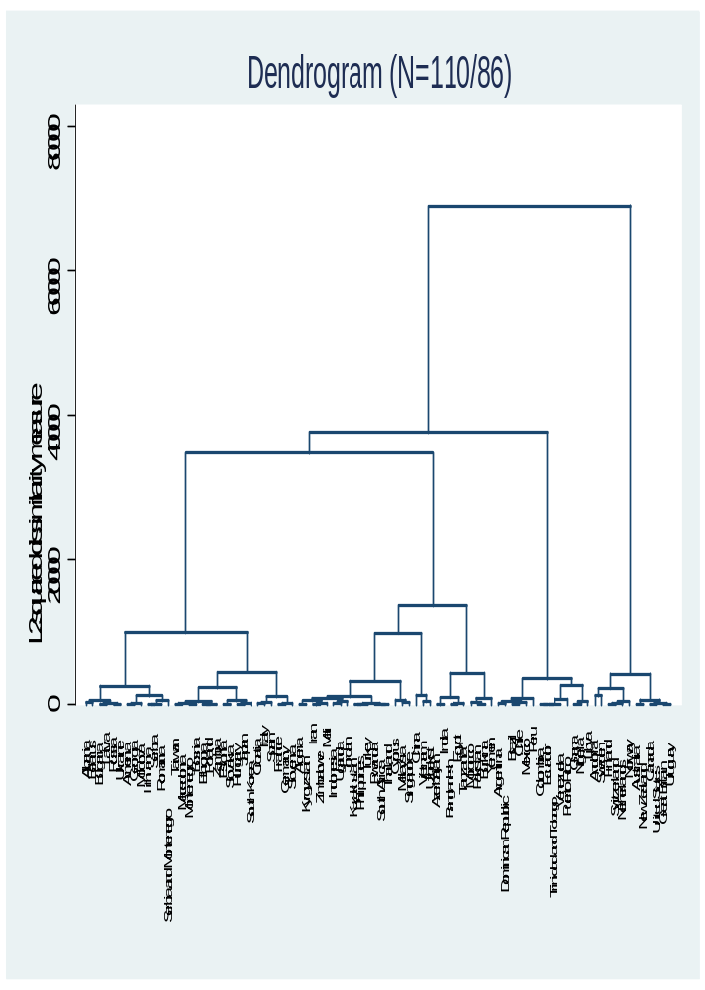
The dendrogram shows four major cultural clusters. The first cluster consists of Anglo-Saxon and Nordic countries. The second major block are the Latin American countries. The third is the European block excluding the Nordics. This European block consists of three clear sub-clusters: a group of western European countries, and two groups of eastern European countries, one of which is clearly more Russian-influenced. The fourth block is a mix of African and Asian countries. The dendrogram shows that this cluster is relatively heterogeneous compared to the other three clusters, a finding not uncommon for cluster analysis (Ronen & Shenkar, 2013). Our resulting cultural clusters coincide with theory-driven attempts to group countries on the basis of cultures. A linear discriminant analysis (LDA) shows that our dimensions fit Ronen and Shenkar’s (2013) meta-analysis of cultural clusters very well. A LDA on 69 countries leads to only four misclassified countries (Taiwan, Cyprus, Malaysia and South Africa), suggesting a percentage of 94 percent of ´correctly´ classified countries. There are 13 countries that just barely fall into a cluster other than the one suggested by Ronen and Shenkar, or are classified in clusters that actually make as much or even more intuitive sense than the Ronen and Shenkar classification. An example of the former is Zambia that is grouped in the Near East cluster with a probability of .32 and in the African cluster (in which it is supposed to be according to Ronen and Shenkar) with a probability of .29. Such a small difference in probabilities also holds for France, Croatia, Hungary and Indonesia. An example of a country that is officially misclassified, but is grouped into a cluster that makes at least as much sense is Slovenia which is supposed to be in the East Europe cluster but is grouped in the Latin Europe cluster. Given Slovenia’s history and its geographic location bordering Italy this is not a surprising outcome.

Overall, this clustering of countries on the basis of our dimensions is in line with intuition and previous clustering attempts, thus increasing the credibility of these dimensions.
APPENDIX ANALYSIS A2: Response bias and outlier analysis
When people complete a survey, the assumption is that that their answers are based on substantive meaning of the items to which they respond. Response style bias occurs when respondents have a tendency to respond systematically to questionnaire items regardless of their content (Baumgartner & Steenkamp, 2001). The most common problem concerns the tendency to give extreme responses versus the tendency to select responses lying in the middle of the answer scale (middle response style) (Harzing, 2006; Johnson et al., 2005). We apply a common procedure to test for possible response bias using outlier analysis and regression techniques (Fischer, 2004; Hui & Triandis, 1983; House et al., 2004).
Response bias is most relevant for Likert scale questions of which we have nine. As shown in Table 2 in our article, we use four questions with a ten point scale, and five questions with a four point scale. The ten point questions are most susceptible for response bias because of the possibility to give more extreme responses. We first calculate the global mean score on the 4 ten point questions, and subsequently calculate the mean on these 4 questions for each country. We then subtract the global mean from each country specific mean, an approach called grand mean centering (Fischer, 2004). We repeat the same procedure for the 5 four point questions.
We use these corrected scores to calculate the dimensions. Of the three dimensions, recall that the Collectivism-Individualism dimension includes 3 ten point questions and 1 four point question. The Duty-Joy dimension contains 2 four point questions and 1 ten point question. The Distrust-Trust dimension includes two four point questions. If there is a response bias, we think it is most likely to show up in the first dimension because this dimension contains most ten point questions.
Before testing for a possible response bias we first check if the factor structure using the corrected scores is similar to the one using the uncorrected scores and reported in Table 4 in the article (Fischer, 2004). Results show that this is the case. To test for outliers in response style we first regress the corrected dimension on the uncorrected dimension (House et al., 2004). The explained variance is .88 for the first dimension, .63 for the second and .62 for the third. This is the equivalent of saying the correlation between the uncorrected and corrected dimension is .94, respectively .78 and .79. We use the results of these regression analyses to perform a formal outlier analysis. The outlier analysis is based on a combined assessment of Cook’s d, the studentized residuals, and a leverage versus residual plot. We do this for each dimension separately.
We find that two countries consistently show up as outliers for the Collectivism-Individualism dimension: Sweden and the United States. A closer analysis of the responses to the questions included in the first dimension shows that Sweden scores relatively high on the justifiability questions (i.e. Swedes tend to find abortion and homosexuality justifiable) but relatively low on the preference for private ownership. For the US we find the opposite pattern. Although these responses may cause Sweden and the US to be considered as outliers, ‘outliers cannot be unambiguously be attributed to cultural response bias’ (House et al., 2004: 750). In this case, the response pattern is not caused by a systematic tendency to give extreme response but the response pattern uncovered is a characterizing feature of the value system in these two countries. The value system in these two countries may not fit the general tendency uncovered in the overall sample, yet it is precisely for that reason that it is of theoretical interest.
A similar procedure for the other dimensions shows that Vietnam and Uzbekistan (and to a lesser extent China) as two countries consistently showing up as outliers on the Distrust-Trust dimension. Vietnam and Uzbekistan have the two highest scores on the Distrust-Trust dimension. This is because these countries score extremely high on level of confidence in political parties and the justice system. Given these findings on Vietnam and Uzbekistan, it is also not surprising that these countries cluster together (with China) in the cluster analysis (see Analysis A1 in the Appendix). We have to be careful in interpreting the results of the outlier analysis for this Distrust-Trust dimension, because of the lack of a substantial number of ten point questions.
To conclude, we do not interpret the response patterns in Sweden and the US on the Collectivism-Individualism dimension as evidence of a response bias, but of a response pattern with substantive meaning. It is well established that especially in the US, permissiveness regarding homosexuality is closely related to the dominant role of religion. Despite increased permissiveness in the last decades (Treas, 2002), the US is relatively speaking still not as permissive as other countries with equal levels of economic development.
We are careful when interpreting the country scores on the Distrust-Trust dimension for Vietnam and Uzbekistan. Given its outlier score on the trust dimension we have excluded Vietnam in Fig. 9 in the group of low income countries (as there are only seven countries in this group, the very high score of Vietnam gets a disproportionate weight). Uzbekistan is not included in Fig. 7-9. As we control for country fixed effects in our regression analyses (Table 6 in the main text), we see no reason to exclude these countries from the regression analyses. As expected Vietnam and Uzbekistan (and China ranked 3rd) have high fixed effects in the Distrust-Trust regression (see Table A11 in this Appendix).

References
Baumgartner, H. & Steenkamp, J.B. (2001) Response styles in marketing research: a cross national investigation. Journal of Marketing Research 38.2: 143-156.
Fischer, R. (2004). Standardization to account for cross-cultural response bias. Journal of Cross-Cultural Psychology 35(3): 263-282.
Harzing, A.W. (2006). Response styles in cross national survey research: A 26 country study. International Journal of Cross Cultural Management 6.2: 243–266.
House R.J., Hanges P.J., Javidan M., Dorfman P.W., & Gupta V. (2004). Culture, Leadership and Organizations: the GLOBE Study of 62 Societies. Sage: London.
Hui, C.H. & Triandis, H.C. (1989). Effect of culture and response format on extreme response style. Journal of Cross Cultural Psychology 20: 296-309.
Johnson, T., Kulesa, P., Ik Cho, Y., & Shavitt, S. (2005). The relation between culture and response styles, Journal of Cross Cultural Psychology 36: 264-277.
Treas, J. (2002). How cohorts, education, and ideology shaped a new sexual revolution on American attitudes toward non-marital sex, 1972-1998. Sociological Perspectives, 45.5: 267-283.

APPENDIX FIGURES 1A, 1B, 1C:
Series of three scatter plots of (log) GDP per capita and the three cultural dimensions. In all three figures, the sample is similar to the one used in the unbalanced panel regression in models 3,6 and 9 as shown in Table 6 in the main text. Each dot in the figures is a country-cohort combination.
FIGURE 1A: scatter plot of (log) GDP per capita and Collectivism-Individualism
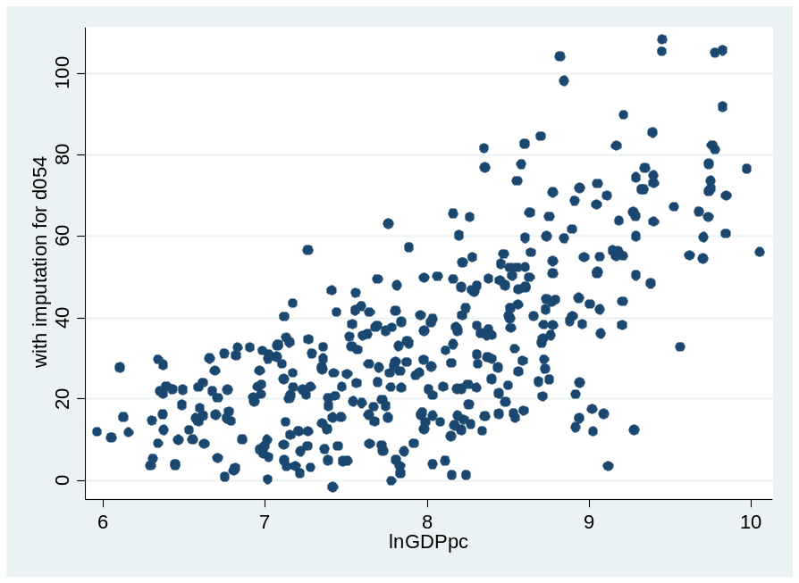

FIGURE 1B: scatter plot of (log) GDP per capita and Duty-Joy
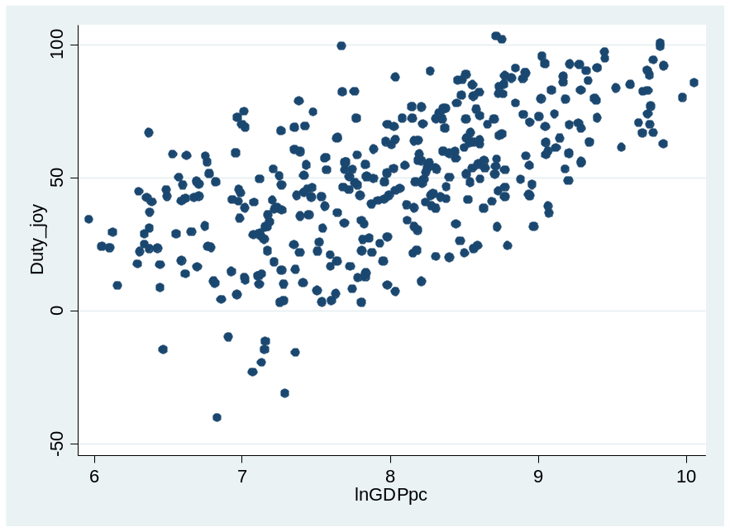
FIGURE 1C: scatter plot of (log) GDP per capita and Distrust-Trust
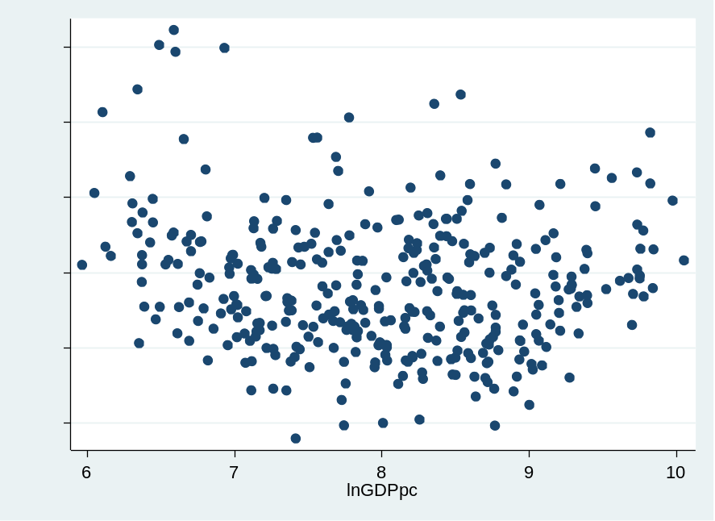

APPENDIX FIGURE A2:
Figure A2 is a plot of the country fixed effects of two dimensions; Collectivism-Individualism and Duty-Joy. The scores are based on the fixed effects as included in Table A11 in this Appendix. The plot illustrates the uncorrelated nature of the fixed effects of these dimensions. In addition it clearly visualizes that after accounting for economic development and cohort specific effects, countries tend to cluster together based on their geographic conditions and / or historical trajectories as argued in our article.

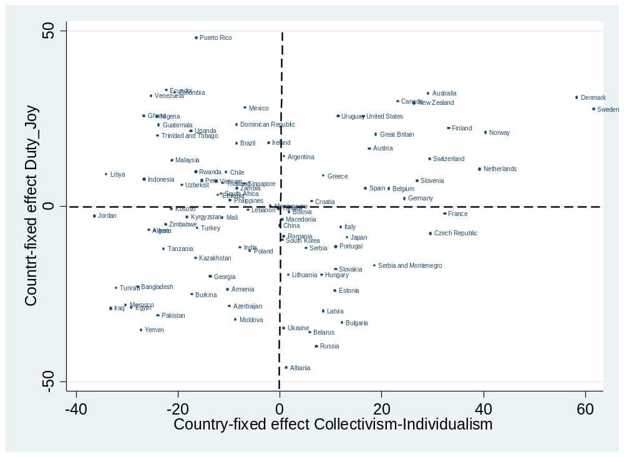

An alternative approach is to take the mean and standard deviation across all items for each respondent. These grand means and standard deviations are used to correct each individual’s score on each question by subtracting the individual’s average response from the actual response and dividing it by the standard deviation (see Triandis, 1994 chapter in Handbook of industrial and organizational psychology, and also Fischer, 2004). This is however only possible with ordinal questions with e.g. a 7 or 10 point scale. The questions used in this study cannot be treated in this way as not all questions are measured on a 7 or 10 point scale.

