ESM Comprehensive Exam

Anthony Schmidt

Date of Comprehensive Defense

Committee Members:

Louis Rocconi, PhD

Chair Gary Skolits

PhD Christina Ergas

PhD Joshua Rosenberg, PhD

Table of Contents

Letter of Introduction 4

Evaluation and Applied Research Experience 5

List of Evaluation and Applied Research Projects 5

Level Three 5

Description and Reflection of Experiences 5

Example Evaluation/Applied Research Proposals and Logic Models 5

Statistical Analysis Experience 6

List of Statistical Analysis Experiences 6

Description and Reflection of Experiences 6

Measurement and Instrument Development Experiences 7

List of Measurement Tools/Protocols 7

Description and Reflection of Experiences 7

Scholarly Writing Experience 8

List of Evaluation/Assessment/Technical Reports 8

List of Research Papers 8

List of Publications 8

Description and Reflection of Experiences 8

Presentation Experience 9

List of Presentations at Professional Conferences 9

List of Presentations for Clients 9

Description and Reflection of Experiences 9

Teaching or Supervisory Experience 10

Teaching Experience 10

Student Supervision 10

Professional Workshops/Trainings 10

Description and Reflection of Experiences 10

Appendix A – Materials from Section A (Evaluation and Applied Research Experience) 11

Appendix B – Materials from Section B (Statistical Analysis Experience) 12

Appendix C – Materials from Section C (Measurement and Instrument Development Experience) 13

Appendix D – Materials from Section D (Scholarly Writing Experience) 14

Appendix E – Materials from Section E (Presentation Experience) 15

Appendix F – Materials from Section F (Teaching or Supervisory/Training Experience) 16

Appendix G – ESM Coursework and Matrix 17

Final Plan of Study 17

ESM Program Matrix 17

Appendix H– Scholarly Writing Sample 18

Appendix I– Brief Curriculum Vita 19

# Letter of Introduction

The first section of the portfolio is designed for the student to present their qualifications and introduce the structure of the portfolio. This may include, but is not limited to, providing information on degrees, areas of specialization in evaluation, statistics, and/or measurement, specific skills sets that you have mastered, areas of research interest and experience, courses completed (do not list courses – that information is included elsewhere), additional training, and accomplishments (e.g., professional presentations, service activities, and memberships). This should be written similar to a job cover letter. It is limited to 2 pages.

list courses – that information is included elsewhere), additional training, and accomplishments (e.g., professional presentations, service activities, and memberships). This should be written similar

asasasa

# Evaluation and Applied Research Experience

## List of Evaluation and Applied Research Projects

### Level Three

#### Level Four

## Description and Reflection of Experiences

## Example Evaluation/Applied Research Proposals and Logic Models

# Statistical Analysis Experience

## List of Statistical Analysis Experiences

## Description and Reflection of Experiences

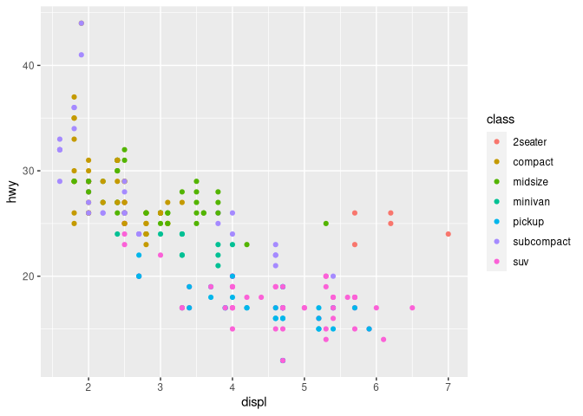

# Measurement and Instrument Development Experiences

## List of Measurement Tools/Protocols

## Description and Reflection of Experiences

# Scholarly Writing Experience

## List of Evaluation/Assessment/Technical Reports

## List of Research Papers

## List of Publications

## Description and Reflection of Experiences

# Presentation Experience

## List of Presentations at Professional Conferences

## List of Presentations for Clients

## Description and Reflection of Experiences

# Teaching or Supervisory Experience

## Teaching Experience

## Student Supervision

## Professional Workshops/Trainings

## Description and Reflection of Experiences

# Appendix A – Materials from Section A (Evaluation and Applied Research Experience)

# Appendix B – Materials from Section B (Statistical Analysis Experience)

# Appendix C – Materials from Section C (Measurement and Instrument Development Experience)

# Appendix D – Materials from Section D (Scholarly Writing Experience)

# Appendix E – Materials from Section E (Presentation Experience)

# Appendix F – Materials from Section F (Teaching or Supervisory/Training Experience)

# Appendix G – ESM Coursework and Matrix

## Final Plan of Study

## ESM Program Matrix

# Appendix H– Scholarly Writing Sample

Completed scholarly writing sample (dissertation chapters or first-authored journal article Dissertation chapters Chapters 1-2 Must be in UT template Journal article Must be a first-authored journal article that was written while as a student in the ESM program Can be one that has already been submitted to a journal or one that is ready to submit If it is an article that is ready to submit also include the specific journal guidelines

# Appendix I– Brief Curriculum Vita

The student will include a brief CV (no more than 5 pages).