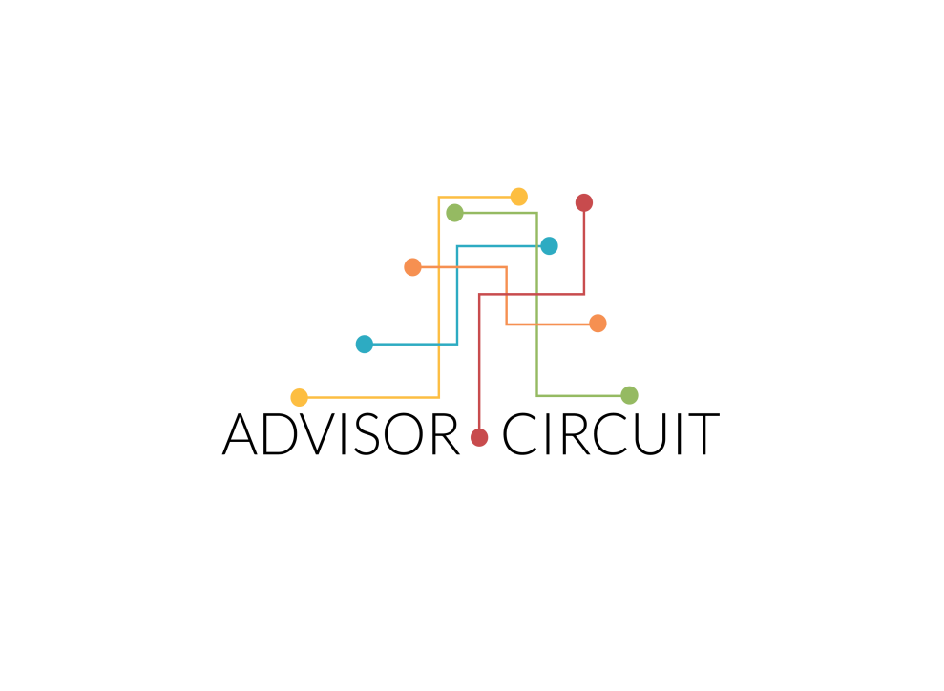

**MOCK INTERVIEW EVALUATION FORM**

**PERSONAL DETAILS**

Interviewee’s Name:

Date:

Interviewed By:

Type Of Interview (Job/Institute/Others):

**FEEDBACK**

**Rating**

Please provide the interviewee a rating for each of the below questions.

The rating key is described as under:

**NS**: NOT SATISFACTORY; **S**: SATISFACTORY; **VS**: VERY SATISFACTORY; **NA**: NOT APPLICABLE

**EDUCATION, WORK EXPERIENCE & CV**

**Is the interviewee’s resume neat and targeted to the applied job position/ institute?**

Rating:

Comments:

**Does the interviewee have the appropriate educational qualifications or training for the applied job position or institute?**

Rating:

Comments:

**Does the interviewee have appropriate and sufficient experience through past work for the applied job position or institute?**

Rating:

Comments:

**Does the interviewee have technical skills required for the applied job position or institute?**

Rating:

Comments:

**INTERPERSONAL SKILLS & PERSONALITY TRAITS**

**Does the interviewee express his or her thoughts clearly in all forms of communication?**

Rating:

Comments:

**Does the interviewee possess the following personality traits? [Please give a Rating for each]**

**Maturity:**

**Calmness:**

**Engaging:**

**Professional:**

Comments:

**Did the interviewee exhibit leadership skills needed for the applied position?**

Rating:

Comments:

**OVERALL ASSESSMENT**

**Please rate the interviewee’s performance in the mock interview across the below parameters:**

**Accuracy of answers to the questions asked**

**Communication Skills**

**Confidence**

**Did the interviewee show interest for the applied job position or institute?**

Rating:

Comments:

**Did the interviewee ask appropriate questions to the interviewer in the end?**

Rating:

Comments:

**How strong is the interviewee’s profile for the applied job or institute?**

Rating:

Comments:

**Please rate the overall performance of the interviewee in the mock interview**

Rating: 1-10

Comments:

**What are the strengths of the interviewee’s profile?**

**Where all can the interviewee improve his profile?**

**Any other comments**