The Experiment Report of Machine Learning



December 9, 2017

Grade:

Undergraduate

Student ID：

201530613511

Supervisor:

Mingkui Tan

Author:

袁强

**SUBJECT:**SOFTWARE ENGINEERING

**SCHOOL:** SCHOOL OF SOFTWARE ENGINEERING

[1]Linear Regression, Linear Classiﬁcation and Gradient Descent

Abstract—

# INTRODUCTION

Logistic Regression and Linear Classification are both used to do classifier task. The different is that Logistic Regression calculate a probability, then classifier base to it. Linear Classification use SVM to calculate the margin of the two positive and negative samples, and maximum it. The two methods have to minimum the loss, and the gradient descent is a good and normal method. The main idea of it is that update the ‘w’ along the negative direction of the loss function iteratively.

# METHODS AND THEORY

Logistic Regression tries to minimum the loss function :

$J\left(w\right)=\frac{1}{n}\sum_{i=1}^{n}{log⁡(1+e^{-y_{i}w^{T}x_{i}})}+\frac{λ}{2}{\left\|w\right\|}^{2}$.

The theory is to maximum likelihood function.

Linear Classification tries to minimum the loss function:

$f\left(w,b\right)=\frac{{|\left|w\right||}^{2}}{2}+ C\sum_{i=1}^{N}{max(0,1-y_{i}\left(w^{T}x_{i}+b\right))}$

The theory is to maximum margin between positive and negative sample.

# Experiment

1. Load the training set and validation set.

2. Initialize logistic regression and linear classifier model parameters by setting them up to zeros.

3. Select loss function respectively.

4. Calculate gradient toward loss function from partial samples.

5. Update model parameters using different optimized methods(NAG，RMSProp，AdaDelta and Adam).

6. Select threshold 0.5, then mark the sample whose predict scores greater than it as positive, on the contrary as negative. Predict under validation set and get the different optimized method loss ，， and .

7. Repeat step 4 to 6 for several times, and drawing graph of $L_{NAG}$， $L_{RMSProp}$， $L_{AdaDelta}$ and $L_{Adam}$ with the number of iterations.

# conclusion

Logistic Regression Loss:

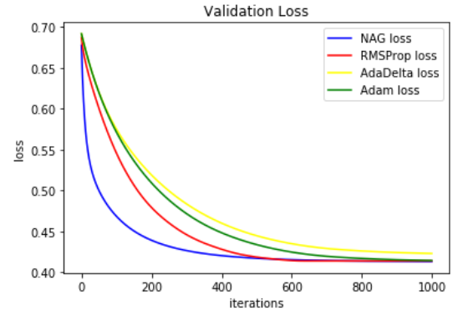

Linear Classification Loss:

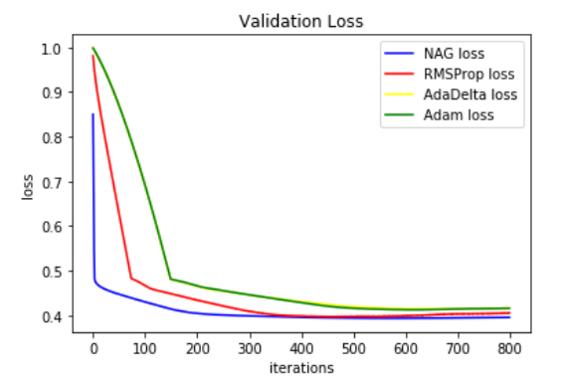

1.