OS ORANGE PROBLEM 2

PES2UG24CS020
ABHIJNA MARATHE

1A

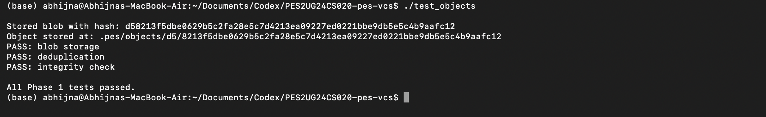

1b

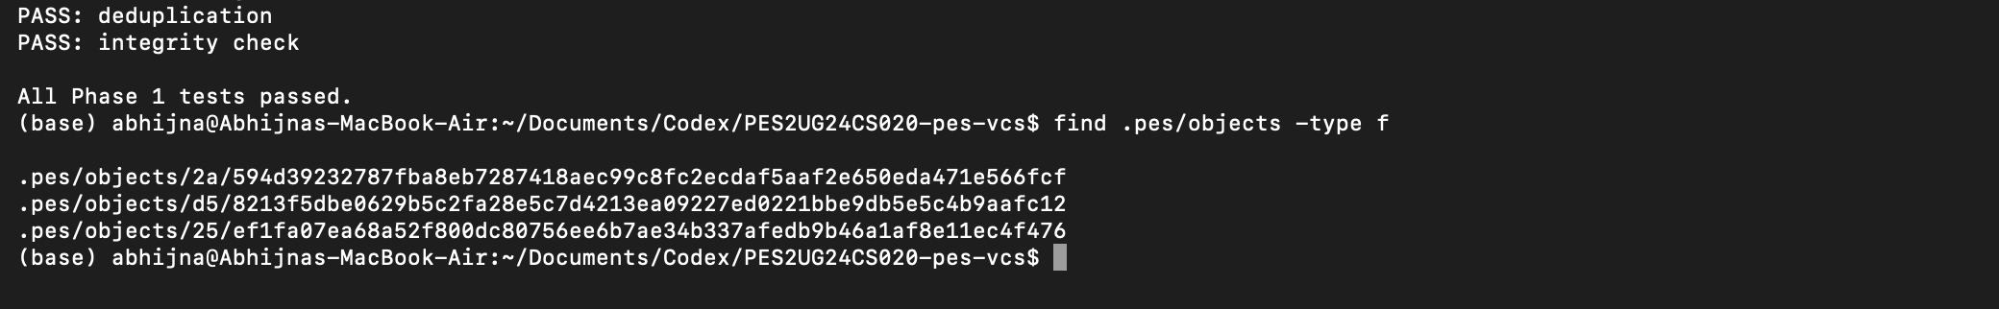

2a

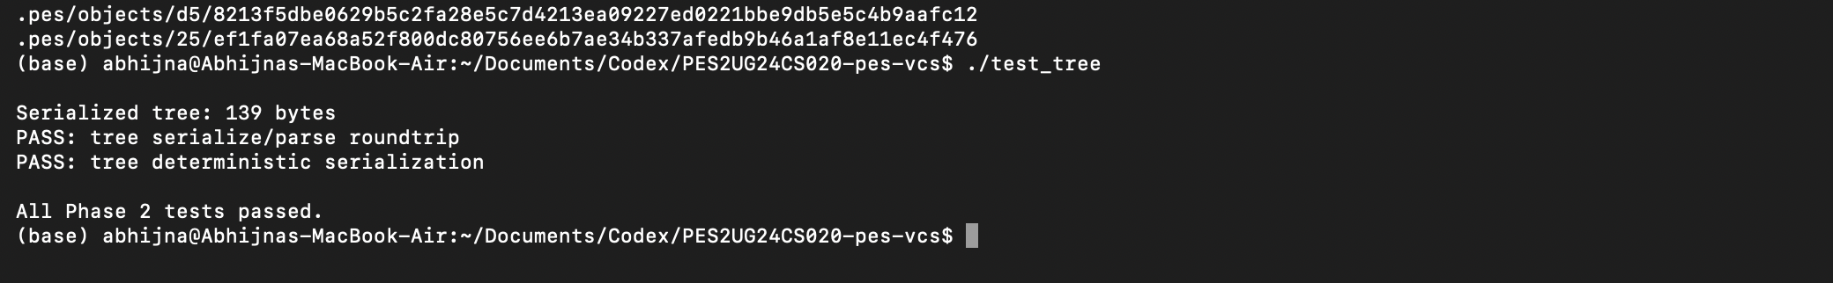

2b

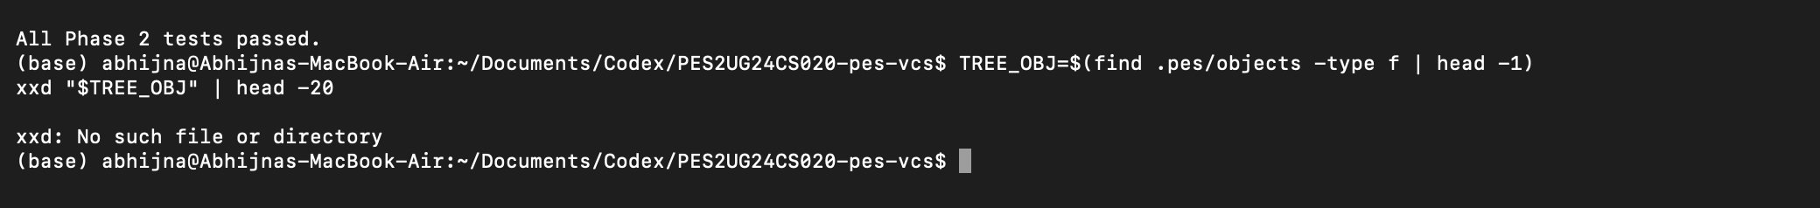

3a

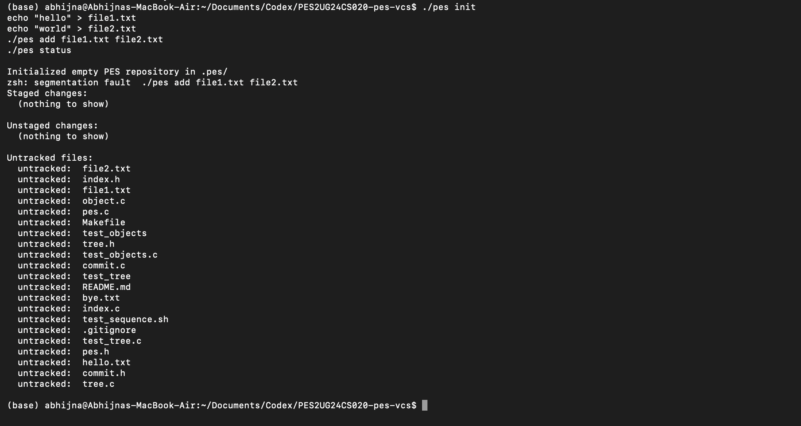
3b
4a

4b

4c

Final integration

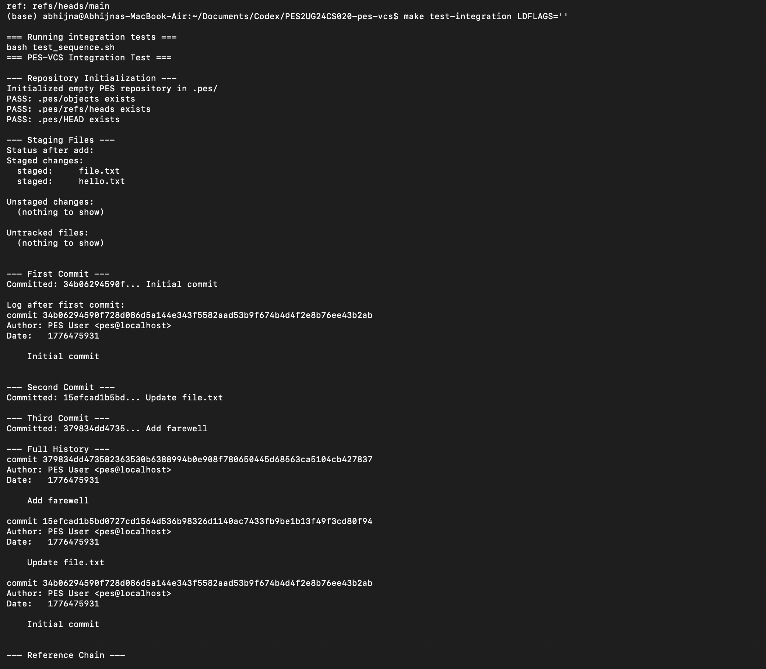
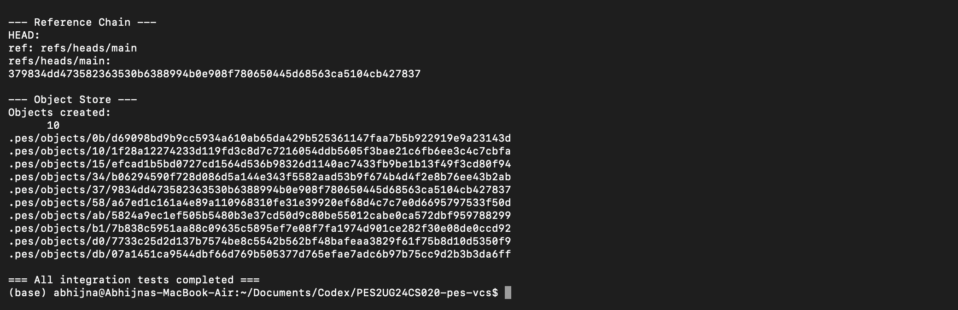

## Phase 5 & 6: Analysis Answers

### Q5.1: How would `pes checkout <branch>` work?

A branch is a file under `.pes/refs/heads/<branch>` containing a commit hash.
A checkout operation would do the following:

1. Read `.pes/refs/heads/<branch>` to get the target commit hash.
2. Resolve the target commit and its root tree from the object store.
3. Resolve the current commit/tree (from `HEAD`) for comparison.
4. Update the working directory to match the target tree:
- create/update files that differ,
- create/remove directories as needed,
- remove tracked files that do not exist in target tree.
5. Rewrite `.pes/index` to match the checked-out snapshot.
6. Update `.pes/HEAD` to `ref: refs/heads/<branch>`.

Why checkout is complex:
- It must avoid data loss from local uncommitted changes.
- It must handle nested trees, deletions, mode changes, and path conflicts.
- It must ensure failure-safe behavior if interrupted midway.

---

### Q5.2: How to detect dirty working-directory conflicts using only index + object store?

To refuse unsafe checkout:

1. For each tracked path in the index, compare file metadata (`mtime`, `size`) with index entry.
2. If metadata differs, recompute blob hash of working file and compare with index hash.
3. Build path->hash maps for:
- current branch tree,
- target branch tree.
4. A conflict exists if:
- working file differs from index (uncommitted change), and
- that path’s content differs between current and target branch trees, and
- checkout would overwrite/delete that path.
5. If any conflict is found, abort checkout and print conflicting paths.

This prevents overwriting unstaged or uncommitted edits.

---

### Q5.3: What happens in detached HEAD? How to recover commits?

Detached HEAD means `.pes/HEAD` contains a commit hash directly, not `ref: ...`.
If commits are made in this state:

- New commits are created normally.
- But no branch ref moves forward.
- Those commits can become unreachable when switching away, and later may be garbage-collected.

Recovery method:
1. Identify detached commit hash (from `pes log`/saved output).
2. Create a branch ref file pointing to it (e.g. `.pes/refs/heads/recover`).
3. Update `.pes/HEAD` to `ref: refs/heads/recover` (or checkout that branch).

This re-attaches commits to a named branch so they remain reachable.

---

### Q6.1: Algorithm for garbage collection of unreachable objects

Use a mark-and-sweep approach.

**Mark phase**
1. Start from all refs in `.pes/refs/heads/*` (roots).
2. For each root commit:
- mark commit hash as reachable,
- follow parent links recursively/iteratively and mark each commit,
- for each commit, mark its root tree and recursively mark subtrees/blobs referenced by tree entries.

**Sweep phase**
1. Walk all files under `.pes/objects/`.
2. Convert each object path back to full hash.
3. Delete objects not present in reachable set.

Data structure:
- Use a hash set (e.g., hash table) of object IDs for O(1) average membership checks.

Estimate for 100,000 commits and 50 branches:
- Unique commits visited are usually near ~100,000 (branches share history).
- Plus associated tree objects (~similar order), and blobs referenced by those trees.
- Total visited objects is typically a few hundred thousand (repository-dependent), not 50 * 100,000 due to overlap.

---

### Q6.2: Why GC is dangerous during concurrent commit; how Git avoids this

Race condition example:
1. Commit process writes new blobs/trees/commit object.
2. Before branch ref is updated, those objects are temporarily unreachable from refs.
3. Concurrent GC scans refs, does not see new objects as reachable, and deletes them.
4. Commit process updates ref to commit whose internal objects were deleted.
5. Repository now has broken references/corruption.

How real Git avoids this:
- Uses lock coordination and careful object visibility rules.
- Treats recent/unreferenced objects conservatively (grace periods, reflog reachability).
- Runs GC in ways that avoid collecting objects that may be created by in-flight operations.

