**LIBRA**

**Ahmet Can Küçükkör 150114031**

**Can Berk Durmuş 150115037**

**Gözde Çakırel 150113024**

**1.0 INTRODUCTION**

Our project will be run on Android phones. Our application that makes it easier for users to track their library will also allow them to interact with each other. Our practice aims to improve the ecosystem of book sharing.

**1.1 Purpose**

This document contains a technical detailed description of the application Libra, which will be developed for use by the final user.

**1.2 Scope**

This document is the RSD document that contains the software architecture of the Libra application. In this document you can access the use case diagram and requirements.

**1.3 Definitions, Acronyms and Abbreviations**

RSD: Requirement Specification Document

UCD: Use Case Diagram

UI: User Interface

PHP: It is a programming language that run on a server  
 NodeJS: İt is a programming language that can create a server and run on it.

Mysql: It is a relational database management system

Socket.io: It is a web socket library.

**1.4 References**

- http://mimoza.marmara.edu.tr/~berna.altinel/courses/cse344/

- Ian Sommerville, Software Engineering, 8th ed. 2007

**2.0 GENERAL CONSTRAINTS**

**2.1** The app will run on Android

**2.2** The backend server will be written in NodeJS and PHP

**2.3** Data will keep on Mysql Database.

**2.4** For realtime data transfer like chat, socket.io will be used.

**3.0 ASSUMPTIONS AND DEPENDENCIES**

**3.1** The system should be easy to understand for the users.  
 **3.2** User can reach their account any Android mobile phone.  
 **3.3** User can add friends and show their library.  
 **3.4** User can add an advertising for book swap.

**4.0 REQUIREMENTS**

**4.1 - FUNCTIONAL REQUIREMENTS**

**4.1.1 - USER**

**4.1.1.1** - The app should have one type of system user: Member.

**4.1.1.2** - To use this app, members of the system should login in the application with their username and password.

**4.1.1.3** - System should allow users to add, hide and remove books from their library.

**4.1.1.4** - Users should be able to add, hide and remove their preferred book change location.

**4.1.1.5** - System should be able to provide other users in the same city to take books to the user.

**4.1.2 - HELP**

**4.1.2.1** - The system should provide to the users a guide system which gives information about the application usage.

**4.1.2.2** - Login

**4.1.2.3** - Adding books to the user’s library

**4.1.2.4** - Adding preferred location

**4.1.2.5** - Searching books around

**4.1.3 - SEARCHING**

**4.1.3.1** - The system should allow users to find books with name, author, genre, location

**4.1.3.2** - The system should provide a map to see the locations

**4.2 - NON-FUNCTIONAL REQUIREMENTS**

**4.2.1 - SAFETY**

**4.2.1.1** - User’s information and action data will bi kept on an online database and will be served by a rest api.

**4.2.2 - SECURITY**

**4.2.2.1** - All information will bi checked by the rest api before inserting the database.

**4.2.2.2** - The system will not allow users to get sensitive information, like passwords, about the other users.

**4.2.2.3** - Other users will not be able to edit or change other user data.

**4.2.2.4** - The users will sign in to the system with their unique email and password.

**4.2.3 - AVAILABILTY**

The user can access their account 24 hours.

**4.2.4 - PERFORMANCE**

**4.2.4.1** - Performance should be optimized to work on mobile platforms.

**4.2.4.2** - The system will send a request or receive a respond in ten seconds at most.

**5.0 APPENDIX**

**A:** Application, Abbreviations, Acronym, Android, Android Studio, Availability, Assumptions; **B:** Book; **C:** Constraints; **D:** Definitions, Dependencies, Diagram; **F:** FAQ, Functional Requirements; **G:** General Constraints; **H:** Help; **M:** Member, Mysql; **N:** Non-functional, NodeJS; **R:** Requirements; **P:** Purpose, Performance, PHP; **R:** Requirements; **S:** Scope, SQL, Security, Safety, socket.io; **U:** Use Case, User, UML

**6.0 USE CASE DIAGRAM**

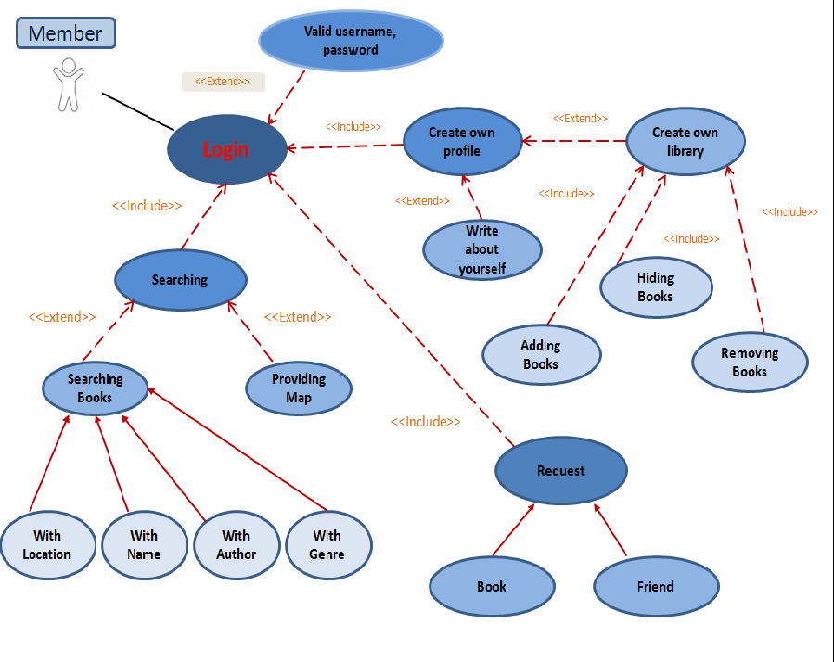

|  |  |
| --- | --- |
| Ahmet Can Küçükkör | 1.0 INTRODUCTION 2.0 GENERAL CONSTRAINTS 3.0 ASSUMPTIONS AND DEPENDENCIES |
| Can Berk Durmuş | 4.0 REQUIREMENTS 5.0 APPENDIX |
| Gözde Çakırel | 6.0 USE CASE DIAGRAM |