For xml

1)top level is hibernate-mapping then class
2)Each class has a table and can has a meta tag
3)every class has a property tag where we can give type and column name corresponding
4)id always has type and column as of property in (3) with a generator property
5)(many to many) and (one to many) require a collection to be taken generally set is taken
6)
<!--The <key> element is the column in the EMP_CERT table that holds the foreign key to the-->
<!--parent object ie. table EMPLOYEE and links to the certification_id in the CERTIFICATE table.-->
<set name="certificates" cascade="save-update" table="EMP_CERT">
<!--The name attribute is set to the defined Set variable in the parent class,
in our case it is certificates
Here we used name attribute to set the intermediate table name to EMP_CERT.
.-->
<key column="employee_id"/>
<!--The <many-to-many> element indicates that one Employee object relates to many Certificate-->
<!--objects and column attributes are used to link intermediate EMP_CERT.-->
<many-to-many column="certificate_id" class="com.chetan.HibernateManyToMany.Certificate"/>
</set>
7)In many to many where set is being used One of the entity called employee has
another entity like
set certificates in it
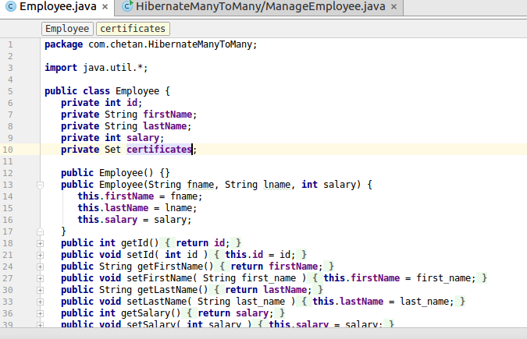
]]]

while certificates has
equals and hashcode into it
8)
<set name="certificates" cascade="all">
<key column="employee_id"/>
<one-to-many class="com.chetan.HibernateOneToMany.Certificate"/>
</set>
For One to many

9)
For one-to-one
<many-to-one name="address" column="address"
class="com.chetan.HibernateOneToOne.Address" not-null="true" unique="true"/>
10)

Restrictions with Criteria:
Criteria cr = session.createCriteria(Employee.class);
cr.add(Restrictions.eq("salary", 2000));
List results = cr.list();
gt,lt,ilike,isNull, isNotNull,isEmpty,
// Case sensitive form of the above restriction.
cr.add(Restrictions.ilike("firstName", "zara%"));
Criteria cr = session.createCriteria(Employee.class);
You can create AND or OR conditions using LogicalExpression restrictions as follows:
Criterion salary = Restrictions.gt("salary", 2000);
Criterion name = Restrictions.ilike("firstNname","zara%");

// To get records matching with OR conditions
LogicalExpression orExp = Restrictions.or(salary, name);
cr.add( orExp );

// To get records matching with AND conditions
LogicalExpression andExp = Restrictions.and(salary, name);
cr.add( andExp );

List results = cr.list();

Pagination
Criteria cr = session.createCriteria(Employee.class);
cr.setFirstResult(1);
cr.setMaxResults(10);
List results = cr.list();

Projections & Aggregations:
Criteria cr = session.createCriteria(Employee.class);

// To get total row count.
cr.setProjection(Projections.rowCount());

// To get average of a property.
cr.setProjection(Projections.avg("salary"));

// To get distinct count of a property.
cr.setProjection(Projections.countDistinct("firstName"));

// To get maximum of a property.
cr.setProjection(Projections.max("salary"));
https://www.tutorialspoint.com/hibernate/hibernate_query_language.htm

ORDER BY Clause
To sort your HQL query's results, you will need to use the ORDER BY clause. You can order the results by any property on the objects in the result set either ascending (ASC) or descending (DESC). Following is the simple syntax of using ORDER BY clause:
String hql = "FROM Employee E WHERE E.id > 10 ORDER BY E.salary DESC";
Query query = session.createQuery(hql);
List results = query.list();
If you wanted to sort by more than one property, you would just add the additional properties to the end of the order by clause, separated by commas as follows:
String hql = "FROM Employee E WHERE E.id > 10 " +
"ORDER BY E.firstName DESC, E.salary DESC ";
Query query = session.createQuery(hql);
List results = query.list();

GROUP BY Clause
This clause lets Hibernate pull information from the database and group it based on a value of an attribute and, typically, use the result to include an aggregate value. Following is the simple syntax of using GROUP BY clause:
String hql = "SELECT SUM(E.salary), E.firtName FROM Employee E " +
"GROUP BY E.firstName";
Query query = session.createQuery(hql);
List results = query.list();

Using Named Paramters
Hibernate supports named parameters in its HQL queries. This makes writing HQL queries that accept input from the user easy and you do not have to defend against SQL injection attacks. Following is the simple syntax of using named parameters:
String hql = "FROM Employee E WHERE E.id = :employee_id";
Query query = session.createQuery(hql);
query.setParameter("employee_id",10);
List results = query.list();

INSERT Clause
HQL supports INSERT INTO clause only where records can be inserted from one object to another object. Following is the simple syntax of using INSERT INTO clause:
String hql = "INSERT INTO Employee(firstName, lastName, salary)" +
"SELECT firstName, lastName, salary FROM old_employee";
Query query = session.createQuery(hql);
int result = query.executeUpdate();
System.out.println("Rows affected: " + result);
//Update and delete also has executeUpdate()
The distinct keyword only counts the unique values in the row set. The following query will return only unique count:
String hql = "SELECT count(distinct E.firstName) FROM Employee E";
Query query = session.createQuery(hql);
List results = query.list();
avg,max,min,sum

11)First level cache
//Get employee with id=1
Employee emp = (Employee) session.load(Employee.class, new Long(1));
//Fetch same data again, check logs that no query fired
Employee emp1 = (Employee) session.load(Employee.class, new Long(1));
//START: evict example to remove specific object from hibernate first level cache

//evict the employee object with id=1
session.evict(emp);
System.out.println("Session Contains Employee with id=1?" + session.contains(emp));
//START: clear example to remove everything from first level cache
session.clear();
12) Native sql

Scalar queries:
The most basic SQL query is to get a list of scalars (values) from one or more tables. Following is the syntax for using native SQL for scalar values:
String sql = "SELECT first_name, salary FROM EMPLOYEE";
SQLQuery query = session.createSQLQuery(sql);
query.setResultTransformer(Criteria.ALIAS_TO_ENTITY_MAP);
List results = query.list();
for(Object object : data)
{
Map row = (Map)object;
System.out.print("First Name: " + row.get("first_name"));
System.out.println(", Salary: " + row.get("salary"));
}

13)Annotations

Always annotate field or getter value , never setter value

@Entity
@Table(name = "student")
public class Student implements java.io.Serializable {
@Id
@GeneratedValue(strategy = IDENTITY)
@Column(name = "id", unique = true, nullable = false)
public Integer getId() {
return this.id;
}
public void setId(Integer id) {
this.id = id;
}
@Column(name = "name", length = 50)
public String getName() {
return this.name;
}
Many to Many

Stock.java

@ManyToMany(fetch = FetchType.LAZY, cascade = CascadeType.ALL)
@JoinTable(name = "stock_category",joinColumns = {
@JoinColumn(name = "STOCK_ID", nullable = false, updatable = false) },
inverseJoinColumns = { @JoinColumn(name = "CATEGORY_ID",
nullable = false, updatable = false) })
public Set<Category> getCategories() {
return this.categories;
}
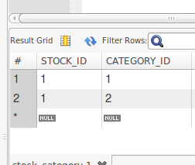
So here table name will be stock_category while id fields will be CATEGORY_ID and STOCK_ID

Category.java
@ManyToMany(fetch = FetchType.LAZY, mappedBy = "categories")
public Set<Stock> getStocks() {
return this.stocks;
}
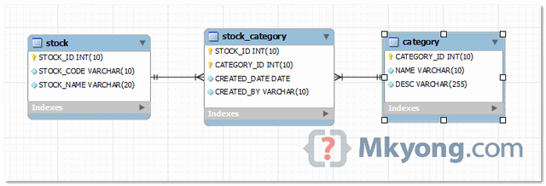

12) hibernate.cfg.xml
<hibernate-configuration>
<session-factory>
<property name="hibernate.connection.driver_class">com.mysql.jdbc.Driver</property>
<mapping class="com.chetan.HibernateManyToManyAnnotationsMkyongExample.stock.Stock" />

OR

<mapping resource="com/chetan/HibernateManyToOne/Employee.hbm.xml"/>

proprties

13)

