Command pattern is a data driven design pattern and falls under behavioral pattern category.

A request is wrapped under an object as command(aadesh(hindi)) and passed to invoker object. (so invoker may not be the starting point)
Invoker object looks for the appropriate object which can handle this command and passes the command to the corresponding object which executes the command.

Implementation
We have created an interface Order which is acting as a command.

We have created a Stock class which acts as a request. We have concrete command classes BuyStock and SellStock (which looks like a command going by name)implementing

Order interface which will do actual command processing. A class Broker is created which acts as an invoker object. It can take and place orders.
Broker object uses command pattern to identify which object will execute which command based on the type of command. CommandPatternDemo, our demo class, will use Broker class to demonstrate command pattern.
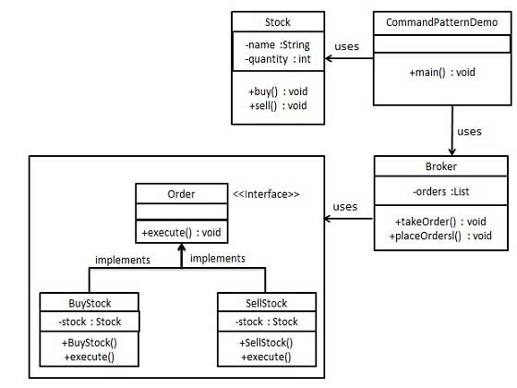

So in shoret copmmand desgin patter is how a order is gioven to a class Broker as an invoker and gives to a command interface which has certain commands which needs to be excuted
Broker serves as a mediator

