Decorator pattern allows a user to add new functionality to an existing object without altering its structure. This type of design pattern comes under structural pattern as this pattern acts as a wrapper to existing class.
This pattern creates a decorator class which wraps the original class and provides additional functionality keeping class methods signature intact.
We are demonstrating the use of decorator pattern via following example in which we will decorate a shape with some color without alter shape class.

Implementation
We're going to create a Shape interface and concrete classes implementing the Shape interface. We will then create an abstract decorator class ShapeDecorator implementing the Shape interface and having Shape object as its instance variable.
RedShapeDecorator is concrete class implementing ShapeDecorator.
DecoratorPatternDemo, our demo class will use RedShapeDecorator to decorate Shape objects.
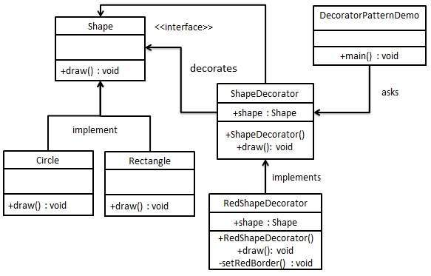

Important Shapedecorartor decorates interface Shape

//Like the adapter pattern here we see that as the adapter the decorator is also extending the
// class it has to decorate
here as p[er above definition it is important to note that signature of draw
reemains same

