Adapter pattern works as a bridge between two incompatible interfaces. This type of design pattern comes under structural pattern as this pattern combines the capability of two independent interfaces.
This pattern involves a single class which is responsible to join functionalities of independent or incompatible interfaces. A real life example could be a case of card reader which acts as an adapter between memory card and a laptop. You plugin the memory card into card reader and card reader into the laptop so that memory card can be read via laptop.
We are demonstrating use of Adapter pattern via following example in which an audio player device can play mp3 files only and wants to use an advanced audio player capable of playing vlc and mp4 files
Implementation
We have a MediaPlayer interface and a concrete class AudioPlayer implementing the MediaPlayer interface. AudioPlayer can play mp3 format audio files by default.
We are having another interface AdvancedMediaPlayer and concrete classes implementing the AdvancedMediaPlayer interface. These classes can play vlc and mp4 format files.
We want to make AudioPlayer to play other formats as well. To attain this, we have created an adapter class MediaAdapter which implements the MediaPlayer interface and uses AdvancedMediaPlayer objects to play the required format.
AudioPlayer uses the adapter class MediaAdapter passing it the desired audio type without knowing the actual class which can play the desired format. AdapterPatternDemo, our demo class will use AudioPlayer class to play various formats.

Implementation
We have a MediaPlayer interface and a concrete class AudioPlayer implementing the MediaPlayer interface. AudioPlayer can play mp3 format audio files by default.
We are having another interface AdvancedMediaPlayer and concrete classes implementing the AdvancedMediaPlayer interface. These classes can play vlc and mp4 format files.
We want to make AudioPlayer to play other formats as well. To attain this, we have created an adapter class MediaAdapter which implements the MediaPlayer interface and uses AdvancedMediaPlayer objects to play the required format.
AudioPlayer uses the adapter class MediaAdapter passing it the desired audio type without knowing the actual class which can play the desired format. AdapterPatternDemo, our demo class will use AudioPlayer class to play various formats.

So if we look at broader there is a class called audiuoiplayer which is incompiutable and a class called media adapter which makes it compatible with the help of advance media player

So basically media adapter though pluggable in Audioplayer becomes a sort of extensaion that provides extra functionality
Here diffrence with decorator can be think of

Here one fact is important to consider that MediaAdapter and Audioplayer are siblings of Media Player
Need to check if it holds for all Adapter Pattern

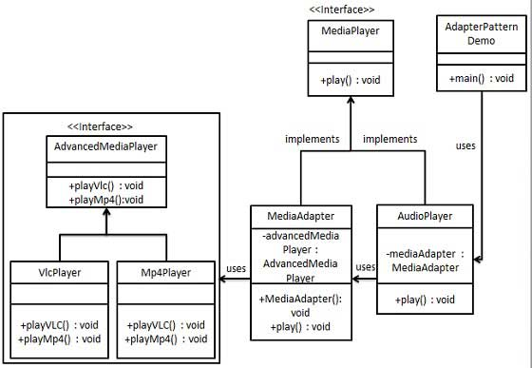

uses simply means composition or something needs to be plugged

