我没有看到过关于这种清单的文章，于是，我就自己创建了一篇。作为一名设计师， web程序部分的编写一直是我最困难的部分。但现在有很多非常棒的辅导教程来指导我们怎么使用一些简单的XHTML + CSS去创建惊人的布局效果，他们会解释真正发生在事件背后的的每一个步骤。学习怎么正确地使用CSS，创建布局，忘掉表格布局，享受真正的CSS布局的 强大，然后, 良好地使用《43个PSD转XHTML, CSS辅导教程》！

1.[PSD 转 XHTML 教程](http://css-tricks.com/video-screencasts/1-converting-a-photoshop-mockup-part-1-of-3/)

在这第一个视频博客网站中，我开始转变为使用Adobe Photoshop模式来创建真正的基于CSS的网站。这里聚集很多不同类型的人，我相信，随着时间的转移将会有更多的侧重点。

[](http://css-tricks.com/video-screencasts/1-converting-a-photoshop-mockup-part-1-of-3/)

2. [怎么创建水平滚动的网站](http://css-tricks.com/how-to-create-a-horizontally-scrolling-site/)

[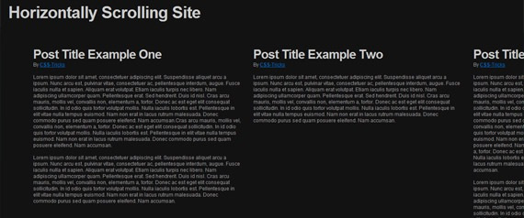](http://www.1stwebdesigner.com/wp-content/uploads/2009/02/horizontally-scrolling-site.jpg)

3. [PSD 转 HTML, 一步步地构造网站设计](http://nettuts.com/site-builds/from-psd-to-html-building-a-set-of-website-designs-step-by-step/)

[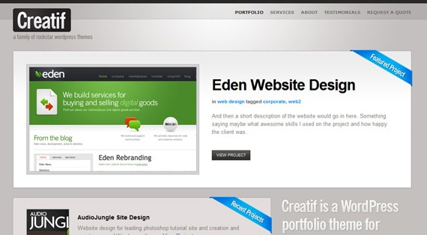](http://nettuts.com/site-builds/from-psd-to-html-building-a-set-of-website-designs-step-by-step/)

4. [Subcide: 从零开始创建CSS布局](http://www.subcide.com/tutorials/csslayout/)

[](http://www.subcide.com/tutorials/csslayout/)

5. [从零开始创建一个时尚的站点 - PSD+XHTML 教程](http://net.tutsplus.com/tutorials/site-builds/build-a-sleek-portfolio-site-from-scratch/)

[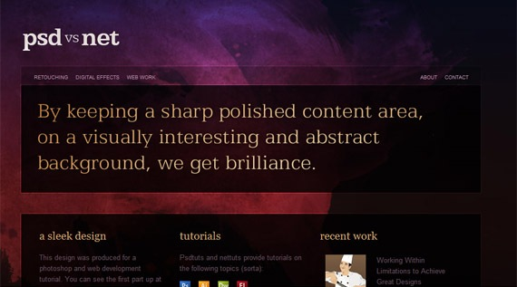](http://net.tutsplus.com/tutorials/site-builds/build-a-sleek-portfolio-site-from-scratch/)

6. [4个简短的PSD 转 CSS教程](http://csshowto.com/layout/)

[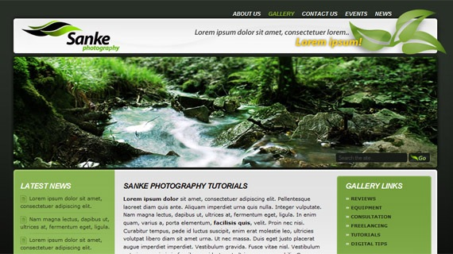](http://csshowto.com/layout/)

7. [用Drupal创建The Killer乐队网站：6个部分教程系列](http://www.gomediazine.com/tutorials/create-a-killer-band-site-with-drupal-introduction/)

大量的通过Illustrator创建站点的辅导教程，Drupal编写的源代码，符合标准的XHTML和CSS。

完整的教程索引:

[阅读第一部分 - 使用Illustrator设计页面](http://www.gomediazine.com/tutorials/create-a-killer-band-site-in-drupal-part-1-design/)  
[阅读第二部分 - 使用Illustrator切图](http://www.gomediazine.com/tutorials/create-a-killer-band-site-in-drupal-part-2-slicing-in-illustrator/)  
[阅读第三部分 - XHTML](http://www.gomediazine.com/tutorials/create-a-killer-band-site-in-drupal-part-3-xhtml/)  
[阅读第四部分 - Drupal 主题模板](http://www.gomediazine.com/tutorials/create-a-killer-band-site-in-drupal-part-4-theming-drupal/)  
[阅读第五部分 -Drupal 管理](http://www.gomediazine.com/tutorials/create-a-killer-band-site-in-drupal-part-5-drupal-admin/)  
[阅读第六部分 - 总结及附加资源](http://www.gomediazine.com/tutorials/create-a-killer-band-site-in-drupal-part-6-additional-functionality-and-resources/)

[](http://www.gomediazine.com/tutorials/create-a-killer-band-site-with-drupal-introduction/)

8. [如何使用CSS创建性感的按钮](http://www.oscaralexander.com/tutorials/how-to-make-sexy-buttons-with-css.html)

9. [讨人喜欢的水平菜单](http://csshowto.com/menus/horizontal-menus-that-grow-on-you/)

在这快速指南，我将讨论如何建立一个工整的简单效果的菜单。我在liDock上作了配音，因为当鼠标移动到上面时，菜单的大小会随之缩放，就像OS-X上的节点(the dock on OS-X)，也是因为这是一个列表菜单。

[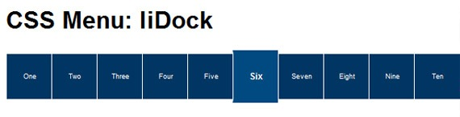](http://csshowto.com/menus/horizontal-menus-that-grow-on-you/)

10. [CSS 模板教程](http://freecss.info/free-css-tutorials/css-template-tutorial-setting-up/)

[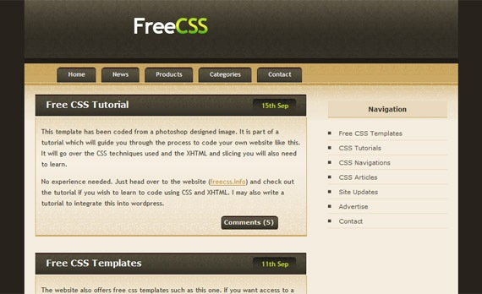](http://freecss.info/free-css-tutorials/css-template-tutorial-setting-up/)

11. [CSS渐变文字特效教程](http://www.webdesignerwall.com/tutorials/css-gradient-text-effect/)

[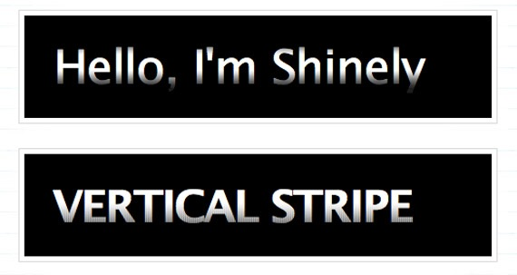](http://www.webdesignerwall.com/tutorials/css-gradient-text-effect/)

12. [怎么创建: CSS超大背景教程](http://www.webdesignerwall.com/tutorials/how-to-css-large-background/)

[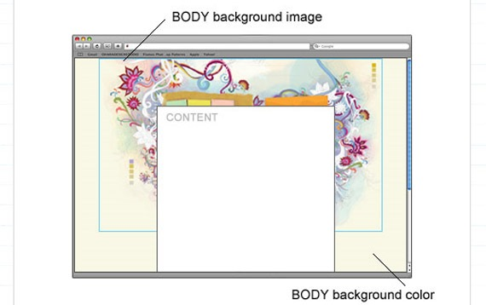](http://www.webdesignerwall.com/tutorials/how-to-css-large-background/)

13. [PSD效果图转换成HTML](http://net.tutsplus.com/videos/screencasts/converting-a-design-from-psd-to-html/)

[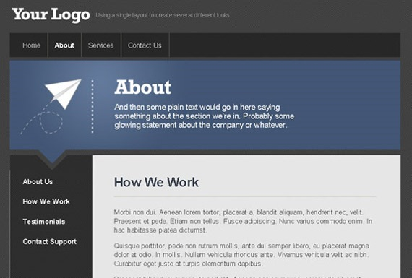](http://net.tutsplus.com/videos/screencasts/converting-a-design-from-psd-to-html/)

14. [PSD切图](http://net.tutsplus.com/videos/screencasts/slice-and-dice-that-psd/)

[](http://net.tutsplus.com/videos/screencasts/slice-and-dice-that-psd/)

15. [模糊背景效果](http://css-tricks.com/examples/BlurryBackgroundEffect/)

[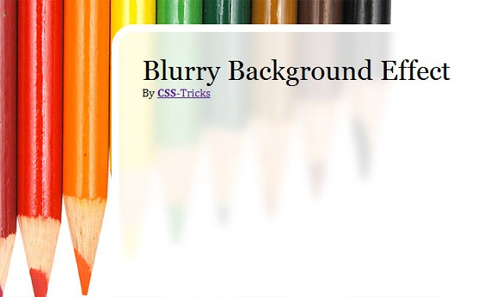](http://css-tricks.com/examples/BlurryBackgroundEffect/)

16. [使用 CSS Sprites 教程](http://net.tutsplus.com/videos/screencasts/exactly-how-to-use-css-sprites/)

[using-css-sprites](http://net.tutsplus.com/videos/screencasts/exactly-how-to-use-css-sprites/)

17. [手绘风格的 CSS 导航按钮](http://www.webdesignerwall.com/tutorials/advanced-css-menu/)

[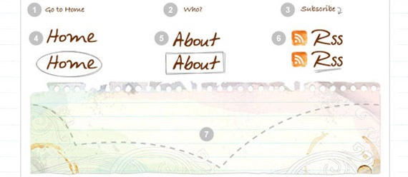](http://www.webdesignerwall.com/tutorials/advanced-css-menu/)

18. [创建类似Crazy Egg价格列表效果的表格列高亮效果](http://www.askthecssguy.com/2007/08/creating_a_table_with_dynamica.html)[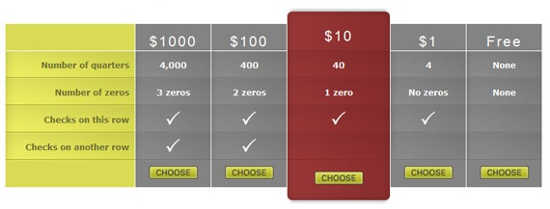](http://www.askthecssguy.com/2007/08/creating_a_table_with_dynamica.html)

19. [CSS 菜单教程](http://www.ndesign-studio.com/resources/dreamweaver/css-menu/)

[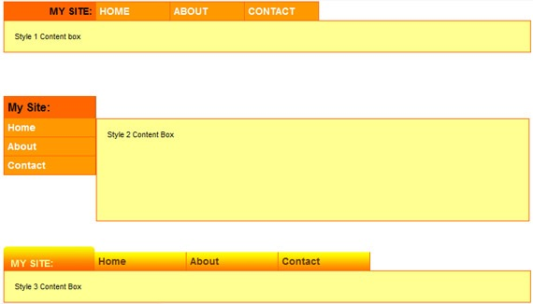](http://www.ndesign-studio.com/resources/dreamweaver/css-menu/)

20. [Photoshop 教程 + 切片部分 + css 编码](http://bwebi.com/clean_vertical_menu.html)

这篇教程会教导您怎么使用Adobe Photoshop来创建整洁的、漂亮的垂直效果的菜单。

[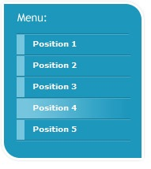](http://bwebi.com/css_graphic_menu_with_rollovers.html)

21. [切片模板和使用 CSS 编码](http://www.tutorialcode.com/html/slice-a-template-and-code-it-using-css/)

[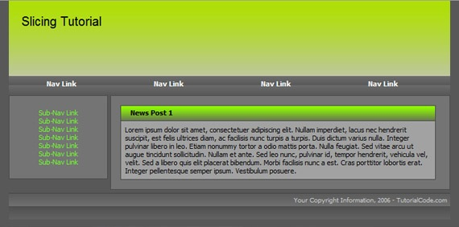](http://www.tutorialcode.com/html/slice-a-template-and-code-it-using-css/)

22. [编码您的第一个PSD教程](http://hv-designs.co.uk/2007/10/10/coding-your-1st-psd-tutorial/)

[](http://hv-designs.co.uk/2007/10/10/coding-your-1st-psd-tutorial/)

23. [通过简单的工作完成复杂的 CSS 布局](http://leftjustified.net/site-in-an-hour/)

[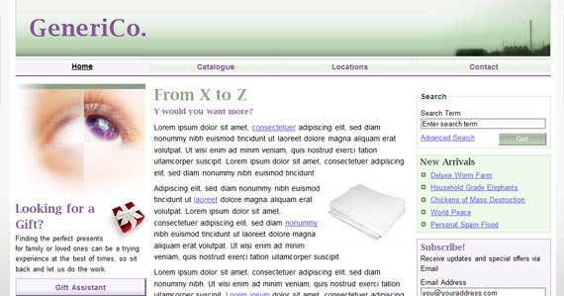](http://www.1stwebdesigner.com/wp-content/uploads/2009/02/generico.jpg)

24. [使用CSS固定您的页脚](http://fortysevenmedia.com/blog/archives/making_your_footer_stay_put_with_css/)

[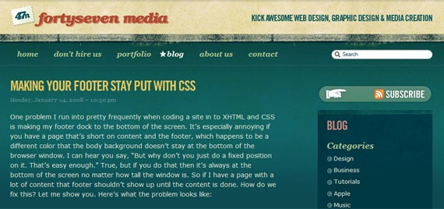](http://fortysevenmedia.com/blog/archives/making_your_footer_stay_put_with_css/)

25. [教你如何转换 PSD 为 xHTML - 视频教程](http://net.tutsplus.com/videos/screencasts/how-to-convert-a-psd-to-xhtml/)

[](http://net.tutsplus.com/videos/screencasts/how-to-convert-a-psd-to-xhtml/)

26. [高级CSS导航](http://www.3point7designs.com/blog/2007/12/22/advanced-css-menu-trick/)

[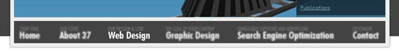](http://www.3point7designs.com/blog/2007/12/22/advanced-css-menu-trick/)

27. [教程：编码布局](http://erraticwisdom.com/2006/01/29/tutorial-coding-a-layout)

[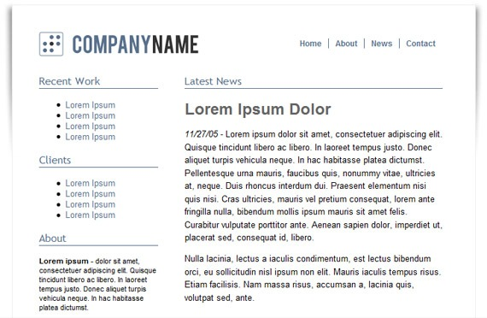](http://erraticwisdom.com/2006/01/29/tutorial-coding-a-layout)

28. [植入式的整体风格切换 - 了解如何切换风格](http://www.alistapart.com/d/bodyswitchers/iotbs.html)

[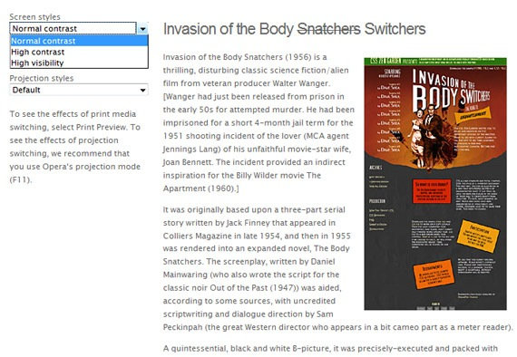](http://www.alistapart.com/d/bodyswitchers/iotbs.html)

29. [浮动教程 - 循序渐进式的](http://css.maxdesign.com.au/floatutorial/index.htm)

[](http://css.maxdesign.com.au/floatutorial/index.htm)

30. [CSS 切片教程: 选择正确的布局](http://www.csslicingguide.com/guide/stage_1.html)

[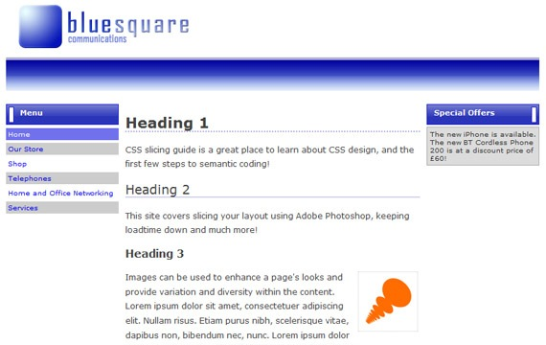](http://www.csslicingguide.com/guide/stage_1.html)

31. [使用Prototype和Scriptaculous创建简单、智能的手风琴效果](http://net.tutsplus.com/tutorials/javascript-ajax/create-a-simple-intelligent-accordion-effect-using-prototype-and-scriptaculous/)

[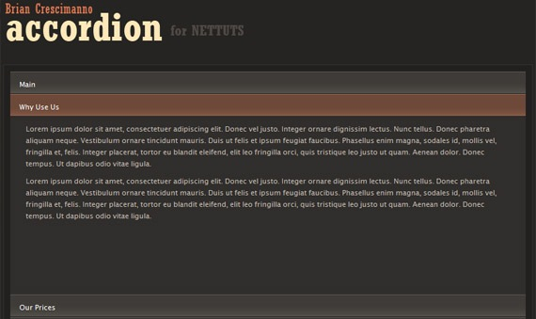](http://net.tutsplus.com/tutorials/javascript-ajax/create-a-simple-intelligent-accordion-effect-using-prototype-and-scriptaculous/)

32. [CSS Sprites + 圆角](http://cssglobe.com/post/3714/css-sprites-rounded-corners)

[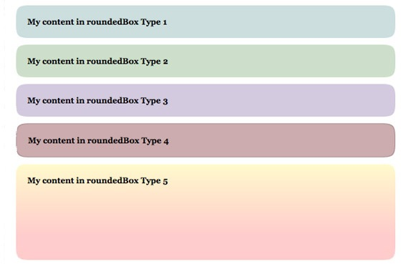](http://cssglobe.com/post/3714/css-sprites-rounded-corners)

33. [3个简单的步骤编码实现圆角](http://cssglobe.com/post/1415/3-simple-steps-in-coding-a-rounded-corners-layout)

[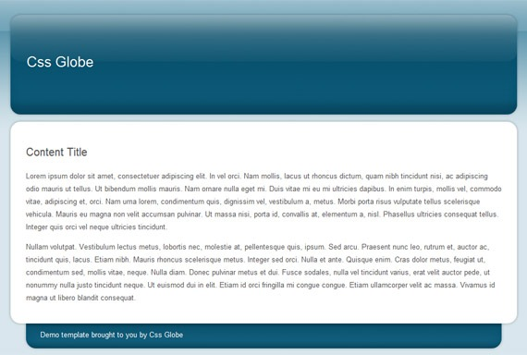](http://cssglobe.com/post/1415/3-simple-steps-in-coding-a-rounded-corners-layout)

34. [精通CSS样式教程](http://www.westciv.com/style_master/academy/hands_on_tutorial/index.html)

[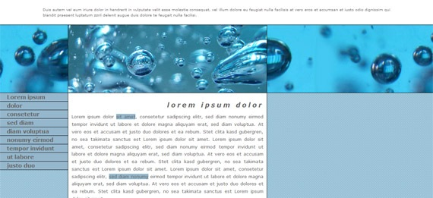](http://www.westciv.com/style_master/academy/hands_on_tutorial/index.html)

35. [转换的Photoshop图样: 第二部分，第一章](http://css-tricks.com/video-screencasts/12-converting-a-photoshop-mockup-part-two-episode-one/)

[](http://css-tricks.com/video-screencasts/12-converting-a-photoshop-mockup-part-two-episode-one/)

36. [CSS垂直导航秀](http://www.sohtanaka.com/web-design/css-vertical-navigation-with-teaser/)

[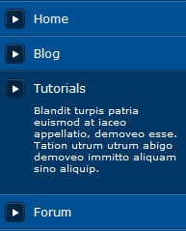](http://www.sohtanaka.com/web-design/css-vertical-navigation-with-teaser/)

37. [CSS固定页脚背景图](http://www.sohtanaka.com/web-design/fixed-footer-backgrounds-with-css/)

[](http://www.sohtanaka.com/web-design/fixed-footer-backgrounds-with-css/)

38. [3栏布局简单介绍](http://joshuaink2006.johnoxton.co.uk/blog/196/a-simple-guide-to-3-column-layouts)

[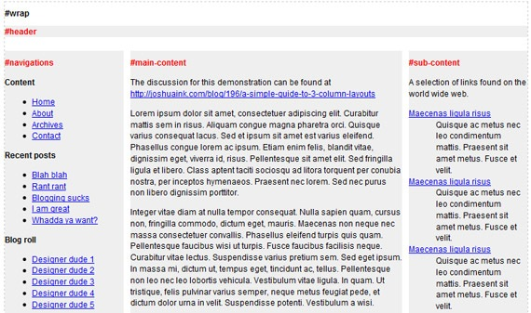](http://joshuaink2006.johnoxton.co.uk/blog/196/a-simple-guide-to-3-column-layouts)

39. [CSS实现两列布局](http://www.sebastiansulinski.co.uk/web_design_tutorials/css/layout_divider.php)

[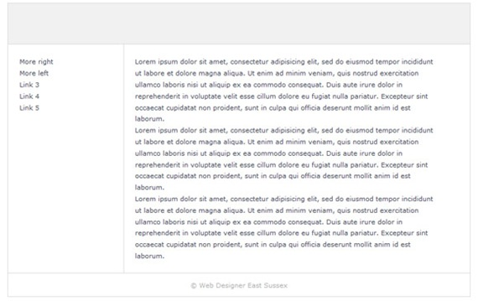](http://www.sebastiansulinski.co.uk/web_design_tutorials/css/layout_divider.php)

40. [CSS布局技巧 – 实现 100% 高度](http://realdesignnetwork.com/blog/archives/29)  
[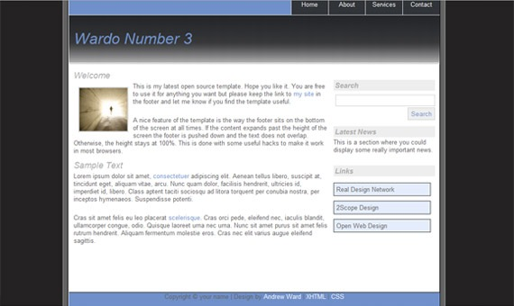](http://www.realdesignnetwork.com/blog/archives/29)

41. [附带“行为”文件的CSS垂直菜单](http://www.divitodesign.com/2008/01/vertical-css-menu-with-a-behavior-file/)

[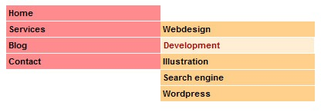](http://www.divitodesign.com/2008/01/vertical-css-menu-with-a-behavior-file/)

42. [圆滑的设计规范 - HTML](http://gilleard.co.uk/design/tutorials/sleek/live/)

[](http://gilleard.co.uk/design/tutorials/sleek/live/)

43. [突破CSS盒布局](http://www.sitepoint.com/article/breaking-out-of-the-box/1/)

[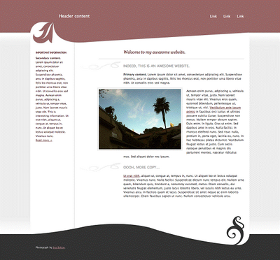](http://www.sitepoint.com/article/breaking-out-of-the-box/1/)

好了，现在您应该已经对创建标准兼容的XHTML + CSS布局有了非常深刻的基础。应用这些技术，在日后，我应该还会发布一篇关于Photoshop布局的辅导文章。

[我想网](http://www.iwanna.cn/archives/2009/05/03/) 板凳 翻译