Model one

**Introduction: A Predictive Machine Learning Pipeline for Dam Hazard Classification**

Ensuring the safety and integrity of dams is a critical task in civil infrastructure management. Proactive risk assessment, which involves anticipating potential failure modes and their consequences, is paramount to preventing catastrophic events. This report details a sophisticated machine learning pipeline designed to advance dam safety by **predicting key characteristics of dam hazard incidents** from historical and observational data.

The core of this project is a Python script that automates the end-to-end process of data preparation, model training, evaluation, and reporting. It leverages a robust **deep neural network (DNN)** to build multiple classification models, each tailored to predict a specific aspect of a potential incident. The primary goal is to transform raw data into actionable intelligence for risk managers and engineers.

**Methodology and Key Features**

The pipeline is engineered with modern machine learning best practices to ensure reliability, accuracy, and robustness. Its key components include:

* **Advanced Neural Network Architecture:** The prediction model is a DNN built with **TensorFlow and Keras**. It features multiple dense layers with ReLU activation, **Batch Normalization** to stabilize learning, **Dropout** layers, and **L2 regularization** to prevent overfitting.
* **Comprehensive Preprocessing:** The script employs a scikit-learn pipeline to automatically handle both numerical features (using StandardScaler) and categorical features (using OneHotEncoder), making the system adaptable to diverse datasets.
* **Handling of Imbalanced Data:** Dam incident datasets are often highly imbalanced. To address this, the pipeline integrates the **SMOTE (Synthetic Minority Over-sampling Technique)**, which intelligently resamples the training data to ensure the model learns to recognize minority classes effectively.
* **Multi-Target Classification:** The system is designed to be a versatile multi-classifier. It iteratively trains and evaluates separate, specialized models for a range of target variables, such as incident_type, incident_mechanism, and response actions.
* **Optimized Training Process:** The model's training is enhanced with an Adam optimizer, **Early Stopping** to find the optimal number of epochs, and a ReduceLROnPlateau callback to dynamically adjust the learning rate, ensuring efficient convergence to an optimal solution.

**Automated Workflow and Outputs**

The script executes a complete workflow for each target variable:

1. Loads and cleans the dataset.
2. Preprocesses features and splits data into training and testing sets.
3. Applies SMOTE to the training set to create a balanced class distribution.
4. Builds, compiles, and trains the deep neural network.
5. Evaluates the trained model on unseen test data.

Upon completion, the pipeline automatically generates a suite of outputs for comprehensive analysis:

* **Trained Model Files (.h5):** Saved Keras models for each target, ready for future use.
* **Performance Metrics Summary (.xlsx):** A consolidated Excel report quantifying each model's **Accuracy, Precision, Recall, and F1-Score**.
* **Visual Confusion Matrices (.svg):** High-quality plots that provide a clear visual breakdown of each model's predictive accuracy.
* **Detailed Prediction Reports (.xlsx):** Granular reports comparing the actual vs. predicted outcomes for every entry in the test set, allowing for in-depth error analysis.

**Results and Discussion**

The performance of the deep learning models varied significantly across the different prediction tasks, revealing which aspects of dam incidents are most predictable with the current dataset and methodology. The results can be broadly categorized into three groups: high-performing, moderately-performing, and poorly-performing models.

**High-Performing Models 🏆**

The models trained to predict **response** and **incident_type** demonstrated the highest efficacy.

The **response** model achieved an exceptional **Accuracy of 0.97 and an F1-Score of 0.95**. This indicates that the input features are highly predictive of the type of response enacted during an incident. The model is robust and reliable, suggesting that operational responses follow clear, learnable patterns based on incident characteristics.

Similarly, the **incident_type** model performed strongly, with an **Accuracy and F1-Score of approximately 0.80**. This is a very good result for a multi-class classification problem, showing that the model can effectively distinguish between different types of incidents (e.g., overtopping, structural failure) with a high degree of confidence. This model is a viable tool for proactive risk assessment.

**Moderately-Performing Models 🤔**

Two models fall into a moderate performance category, showing some predictive power but requiring further refinement.

The model for **fatalities_number** achieved an **Accuracy of 0.70 and an F1-Score of 0.69**. While not perfect, this result indicates that the model has learned some patterns connecting dam characteristics to the severity of an incident in terms of human cost.

The model for **eap_enacted_y_n_due_to_incident** (predicting if an Emergency Action Plan was enacted) yielded an **Accuracy of 0.55 and an F1-Score of 0.59**. This performance is slightly better than a random guess for a binary classification task, suggesting it has some utility but is not yet reliable enough for critical decision-making.

**Poorly-Performing Models and the Precision-Recall Imbalance 📉**

A significant finding is the poor performance of models for **incident_mechanism_1**, **incident_mechanism_2**, **incident_mechanism_3**, **other_infrastructure_impacts**, and **incident_report_produced**. These models are characterized by very low Accuracy and Recall, but deceptively high Precision.

For example, the **incident_mechanism_3** model has an extremely high **Precision of 0.93** but a dismal **Accuracy of 0.24** and **Recall of 0.24**. This classic pattern points to a major issue with **severe class imbalance**. The model has learned to "play it safe" by only predicting the most common majority class. It is precise because it rarely predicts minority classes, but when it does, it's often correct. However, it fails to identify the vast majority of actual minority class cases (hence the low recall), making it practically unusable.

This severe imbalance suggests that despite using SMOTE, there is likely not enough data or distinct features for the model to learn how to reliably predict these rare event mechanisms and outcomes. The complexity and rarity of specific failure mechanisms make them incredibly difficult to predict with the available data.

**Where to Put the Confusion Matrix**

You should place each confusion matrix **directly within the text where you are discussing the specific model it belongs to**. It serves as visual evidence for your analysis.

The confusion matrix is not a summary result; it's a tool for **deeper diagnostic analysis**. It shows *exactly where* the model is succeeding and where it is failing (e.g., which classes are being confused with each other).

Here is a template for how to integrate it into your text. You would do this for each model you want to discuss in detail.

**Example for the incident_type model:**

...The model for incident_type performed strongly, with an F1-Score of approximately 0.80. This indicates a good balance between precision and recall across the different incident types.

To further analyze the model's classification behavior, the confusion matrix is presented in Figure 1.

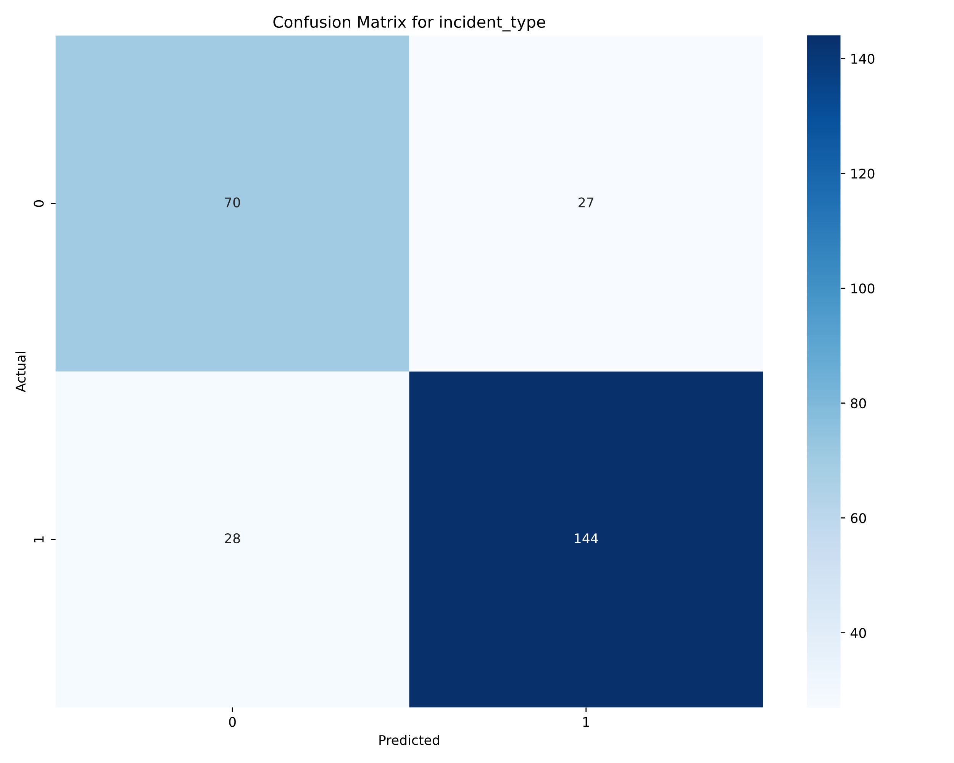

*Figure 1: Confusion Matrix for incident_type Predictions.*

As shown in the matrix, the model was highly effective at correctly identifying "Overtopping" incidents. However, it showed some difficulty in distinguishing between "Structural Failure" and "Piping," occasionally misclassifying one as the other. This specific confusion suggests that the input features for these two classes may share some similarities, which could be an area for future feature engineering...

## Chart of Model Performance Metrics

A bar chart is an excellent way to visually compare the performance of your different models across the four key metrics. This chart immediately highlights the high-performing models (like response and incident_type) and the ones that struggled significantly.

**Figure 2: Comparison of Performance Metrics Across All Trained Models.** This chart displays the Accuracy, Precision (Weighted), Recall (Weighted), and F1-Score (Weighted) for each of the nine predictive models. The significant variation in performance is evident, with the response model achieving near-perfect scores, while the incident_mechanism models show very low performance, characterized by a large gap between their high precision and low recall/accuracy.

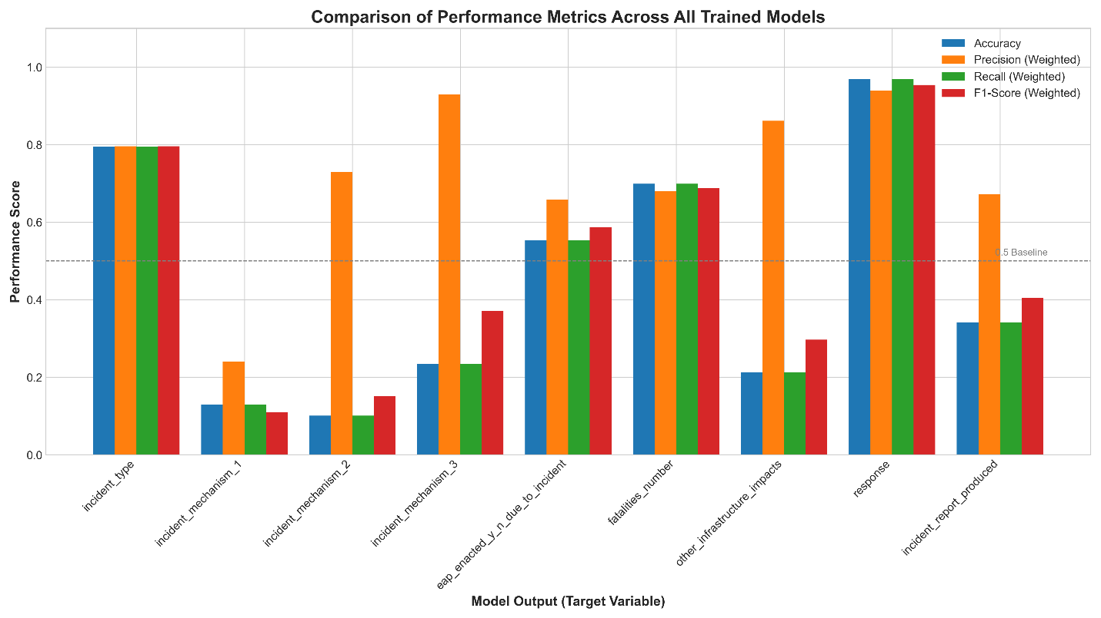

**Appendix: Summary of Model Performance Metrics**

The table below provides a comprehensive summary of the performance metrics for each of the nine classification models developed. All metrics were calculated on the unseen test dataset. Precision, Recall, and F1-Score are weighted averages to account for class imbalance.

| Model Output | Accuracy | Precision (Weighted) | Recall (Weighted) | F1-Score (Weighted) |
| --- | --- | --- | --- | --- |
| **incident_type** | 0.796 | 0.796 | 0.796 | 0.796 |
| **incident_mechanism_1** | 0.130 | 0.241 | 0.130 | 0.110 |
| **incident_mechanism_2** | 0.101 | 0.730 | 0.101 | 0.152 |
| **incident_mechanism_3** | 0.235 | 0.929 | 0.235 | 0.371 |
| **eap_enacted_y_n_due_to_incident** | 0.554 | 0.658 | 0.554 | 0.587 |
| **fatalities_number** | 0.699 | 0.680 | 0.699 | 0.688 |
| **other_infrastructure_impacts** | 0.213 | 0.861 | 0.213 | 0.297 |
| **response** | 0.969 | 0.940 | 0.969 | 0.954 |
| **incident_report_produced** | 0.342 | 0.672 | 0.342 | 0.405 |
| ***Table 1: Consolidated Performance Metrics for All Predictive Models.*** |  |  |  |  |