**Title: Project DeepCrete: Predicting Concrete Compressive Strength Using Artificial Neural Networks**

* **Author(s):** Your Name
* **Date:** September 22, 2025

**Abstract**

A brief, one-paragraph summary of the entire project. State the problem (predicting concrete strength), the method used (a neural network), the key results (e.g., "The final model achieved an R-squared value of 0.92 on the test set..."), and the conclusion.

**1. Introduction**

* **1.1. Background:** Briefly explain the importance of concrete in construction and why accurately predicting its compressive strength is crucial for safety, cost-efficiency, and quality control.
* **1.2. Problem Statement:** Clearly state the goal: to develop a machine learning model to predict the compressive strength of concrete based on its composition and age.
* **1.3. Objectives:** List the specific project goals (e.g., preprocess the dataset, build and train a neural network, evaluate its performance).

**2**Of course. Here is the text formatted for you to copy. The parts you need to fill in yourself are in **bold text**—simply delete the bolded instructions and insert your own content.

### 2.1. Dataset Description

The **UCI Concrete Compressive Strength dataset** is a collection of data used to predict the compressive strength of concrete. The dataset was donated to the UCI Machine Learning Repository by Professor I-Cheng Yeh. It contains **1030 samples** with 8 input features and 1 target variable.

The input features and the target variable are listed below:

* **Input Features**:
  + Cement (kg/m³)
  + Blast Furnace Slag (kg/m³)
  + Fly Ash (kg/m³)
  + Water (kg/m³)
  + Superplasticizer (kg/m³)
  + Coarse Aggregate (kg/m³)
  + Fine Aggregate (kg/m³)
  + Age (days)
* **Target Variable**:
  + Concrete Compressive Strength (MPa)

### 2.2. Data Analysis

## summary Statistics of Concrete Data

|  |  |  |  |  |  |  |  |  |  |
| --- | --- | --- | --- | --- | --- | --- | --- | --- | --- |
|  | cement | slag | Fly ash | water | superplasticizer | Coarse  aggregate | Fine  aggregate | age | Cs  MPa |
| count | 1030 | 1030 | 1030 | 1030 | 1030 | 1030 | 1030 | 1030 | 1030 |
| mean | 281.17 | 73.90 | 54.19 | 181.57 | 6.20 | 972.92 | 773.58 | 45.66 | 35.82 |
| std | 104.51 | 86.28 | 64.00 | 21.35 | 5.97 | 77.75 | 80.18 | 63.17 | 16.71 |
| min | 102.00 | 0.00 | 0.00 | 121.80 | 0.00 | 801.00 | 594.00 | 1.00 | 2.33 |
| 25% | 192.38 | 0.00 | 0.00 | 164.90 | 0.00 | 932.00 | 730.95 | 7.00 | 23.71 |
| 50% | 272.90 | 22.00 | 0.00 | 185.00 | 6.40 | 968.00 | 779.50 | 28.00 | 34.45 |
| 75% | 350.00 | 142.95 | 118.30 | 192.00 | 10.20 | 1029.40 | 824.00 | 56.00 | 46.14 |
| max | 540.00 | 359.40 | 200.10 | 247.00 | 32.20 | 1145.00 | 992.60 | 365.00 | 82.60 |

## Key Findings from Exploratory Data Analysis

The initial descriptive statistics reveal several important characteristics of the dataset, which consists of **1,030 complete observations** with no missing values across any of the features.

### Distribution of the Target Variable (csMPa)

The target variable, concrete compressive strength (csMPa), shows a wide distribution, ranging from a low of **2.33 MPa** to a high of **82.60 MPa**. The **mean strength is 35.82 MPa**, which is very close to the **median of 34.45 MPa**, suggesting that the distribution of concrete strength is nearly symmetrical with a slight right skew. The high standard deviation (16.71 MPa) confirms the significant variability in the strength outcomes, indicating a diverse mix of concrete formulas and curing times.

### Characteristics of Predictor Variables

* **Prevalence of Additives:** A key finding is that several ingredients are not used in all mixtures. **Flyash**, **slag**, and **superplasticizer** all have minimum and 25th percentile values of 0. In fact, the median for flyash is also 0, indicating that **over half of the concrete samples in this dataset do not contain flyash**. This suggests that the presence or absence of these additives will be a critical factor in determining strength.
* **Age Skewness:** The age of the concrete, a critical factor for strength, is heavily right-skewed. While the median age is **28 days** (a standard curing time for testing), the mean is significantly higher at **45.66 days**, pulled by a long tail of older samples up to **365 days**. This wide range and skewness suggest that age will be a highly influential predictor.
* **Core Ingredients:** Core components like cement, water, coarseaggregate, and fineaggregate are present in all samples and exhibit distributions that are more centered than the additives. Cement content shows the most significant variation among these core ingredients, with a standard deviation of 104.51.

In summary, the primary drivers of variability in concrete strength are likely to be the **age** of the concrete and the **use (or non-use) of supplementary materials** like slag, flyash, and superplasticizer. The wide range and skewed nature of these features will be important considerations for feature engineering and model selection.

#### Correlation Heatmap

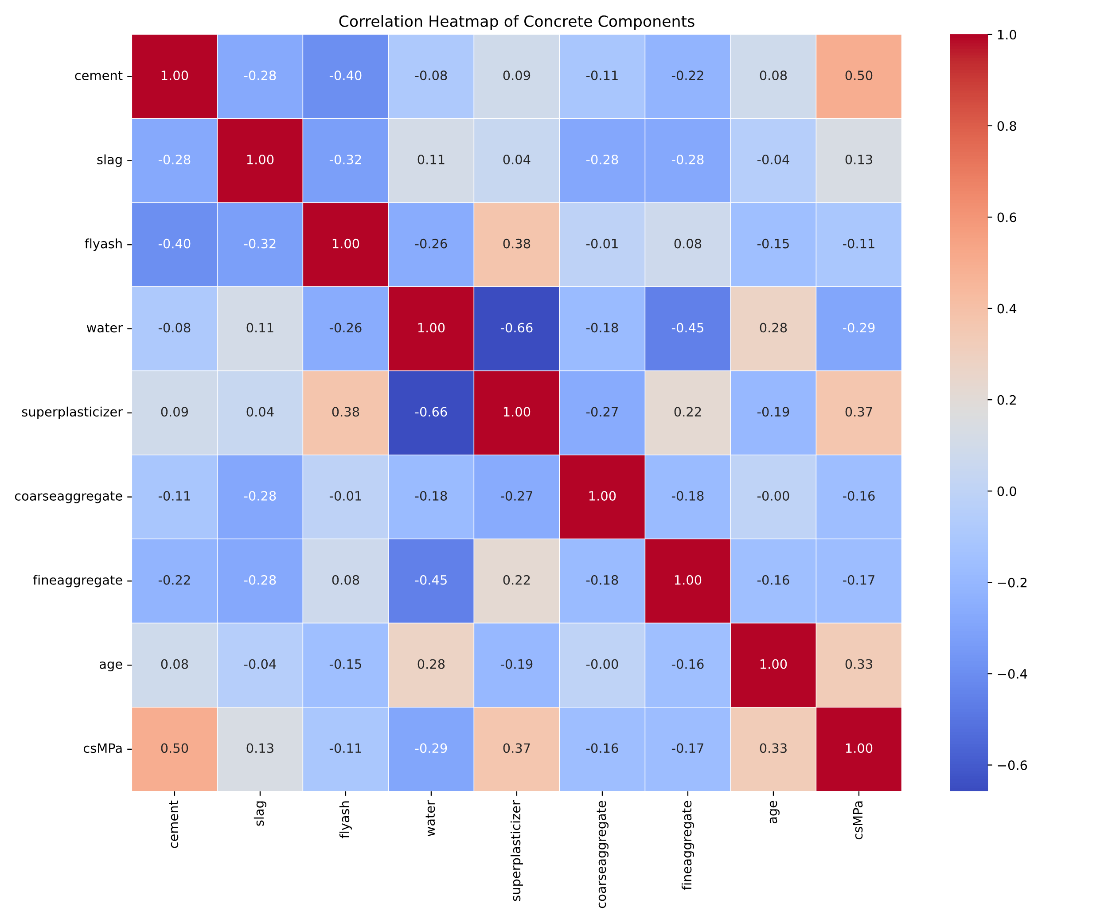

### Discussion of Relationships

The correlation heatmap quantifies the linear relationships between the concrete components, its age, and its final compressive strength (csMPa). The results highlight several key relationships that are crucial for understanding and predicting the material's behavior.

#### Key Predictors of Compressive Strength

The most influential factors on concrete strength are clearly identifiable:

* **Cement:** As expected, **cement** has the strongest positive correlation with compressive strength, with a coefficient of **+0.50**. This confirms its role as the primary binding agent responsible for strength development.
* **Superplasticizer and Age:** Following cement, **superplasticizer** shows a notable positive correlation of **+0.37**, and **age** has a similar positive correlation of **+0.33**. The superplasticizer's role in reducing water content and the ongoing curing process over time are significant contributors to higher strength.
* **Water:** The amount of **water** has the most significant negative relationship with strength, with a correlation of **-0.29**. This underscores the critical importance of the water-to-cement ratio; less water leads to a denser, stronger concrete.

#### Weaker Relationships

The remaining components show a much weaker linear relationship with the final strength:

* The aggregates (**coarseaggregate** at **-0.16** and **fineaggregate** at **-0.17**) have a slight negative correlation.
* Interestingly, **slag** (+0.13) and **flyash** (-0.11) show very little correlation. The weak negative correlation for flyash may seem counter-intuitive but could be explained by its frequent use as a *substitute* for the more influential cement.

#### Inter-Feature Correlations

The heatmap also reveals important relationships between the input variables themselves:

* The strongest correlation in the entire matrix is between **superplasticizer** and **water**, with a coefficient of **-0.66**. This makes perfect sense, as the function of a superplasticizer is to increase workability, thus allowing for a significant reduction in water content.
* Moderate negative correlations exist between **cement** and **flyash (-0.40)** and between **cement** and **slag (-0.28)**, which supports the fact that these materials are often used to replace a portion of the cement in a mix.

## 3. Methodology ⚙️

### 3.1. Data Preprocessing

To prepare the data for training the neural network, the following steps were taken:

* **Train-Validation-Test Split**: The dataset was split into three sets:
  + **Training set**: 70%
  + **Validation set**: 15%
  + **Test set**: 15%
* **Feature Scaling**: **StandardScaler** was used to scale the input features. This is a necessary step because the features have different units and scales. StandardScaler transforms the data to have a mean of 0 and a standard deviation of 1, which helps the neural network learn more effectively and converge faster.

3. Of course. I've revised the "Results and Discussion" section of the report to include a dedicated space and introductory text for your bisector line chart.

Here is the updated report:

### 2. Model Architecture

A sequential deep neural network was designed to predict concrete compressive strength. The architecture was constructed with an input layer corresponding to the 8 feature variables in the dataset, followed by nine hidden layers and a single-neuron output layer for the regression task. The Rectified Linear Unit (ReLU) activation function was used in all hidden layers to introduce non-linearity, while a Linear activation function was used in the output layer to predict a continuous value.

The detailed structure is as follows:

| Layer | Number of Neurons | Activation Function |
| --- | --- | --- |
| Input Layer | 8 | - |
| Hidden Layer 1 | 512 | ReLU |
| Hidden Layer 2 | 256 | ReLU |
| Hidden Layer 3 | 256 | ReLU |
| Hidden Layer 4 | 128 | ReLU |
| Hidden Layer 5 | 128 | ReLU |
| Hidden Layer 6 | 64 | ReLU |
| Hidden Layer 7 | 64 | ReLU |
| Hidden Layer 8 | 32 | ReLU |
| Hidden Layer 9 | 32 | ReLU |
| Output Layer | 1 | Linear |

### 3. Training Process

The model was compiled and trained using the following configuration:

* **Optimizer**: **Adam** was chosen as the optimizer with a learning rate of **5.00E-05**. Its adaptive learning rate capabilities are well-suited for complex, high-dimensional problems.
* **Loss Function**: **Mean Squared Error (MSE)** was used as the loss function, as it is a standard and effective choice for regression tasks that penalizes larger errors more heavily.
* **Metrics**: **Mean Absolute Error (MAE)** was monitored during training to provide a more interpretable measure of the model's average prediction error.
* **Batch Size**: A batch size of **32** was used. This value offers a good balance between computational efficiency and gradient estimation accuracy.
* **Number of Epochs**: The model was trained for **209 epochs**. An early stopping mechanism was enabled to prevent overfitting, which halted the training when the validation loss ceased to improve.

### 4. Results and Discussion

#### 4.1. Model Performance

The final model was evaluated on an unseen test dataset to assess its generalization capability. The performance metrics are summarized in the table below.

| Metric | Value |
| --- | --- |
| Mean Squared Error (MSE) | 30.35 |
| Mean Absolute Error (MAE) | 3.98 |
| R-squared (R2) | 0.879 |
| Mean Absolute Percentage Error (MAPE) | 12.38% |

#### 4.2. Analysis of Results

The results indicate a high level of performance.

* An **MAE of 3.98 MPa** signifies that, on average, the model's prediction of compressive strength is off by approximately 3.98 MPa. In the context of civil engineering, where concrete strength often ranges from 20 to 60 MPa or higher, this level of error is generally considered very good and suggests the model is a reliable predictive tool.
* The **R-squared (R2) score of 0.879** is particularly strong. It implies that approximately **88% of the variability** in the actual concrete compressive strength is explained by the model. This high value confirms a strong correlation between the model's predictions and the actual values, indicating a robust and well-fitting model.
* The **MAPE of 12.38%** provides a relative measure of error, showing that the average prediction error is about 12% of the actual value, which is a respectable figure for this type of problem.

#### 4.3. Prediction Examples

A scatter plot of the model's predicted values versus the true actual values for the test set provides a visual confirmation of its accuracy. A bisector line (a 45-degree diagonal) is overlaid on the plot to represent a perfect prediction, where the predicted value equals the actual value. As shown in the chart below, the model's predictions cluster tightly around this line, which visually demonstrates its high predictive power and low error.

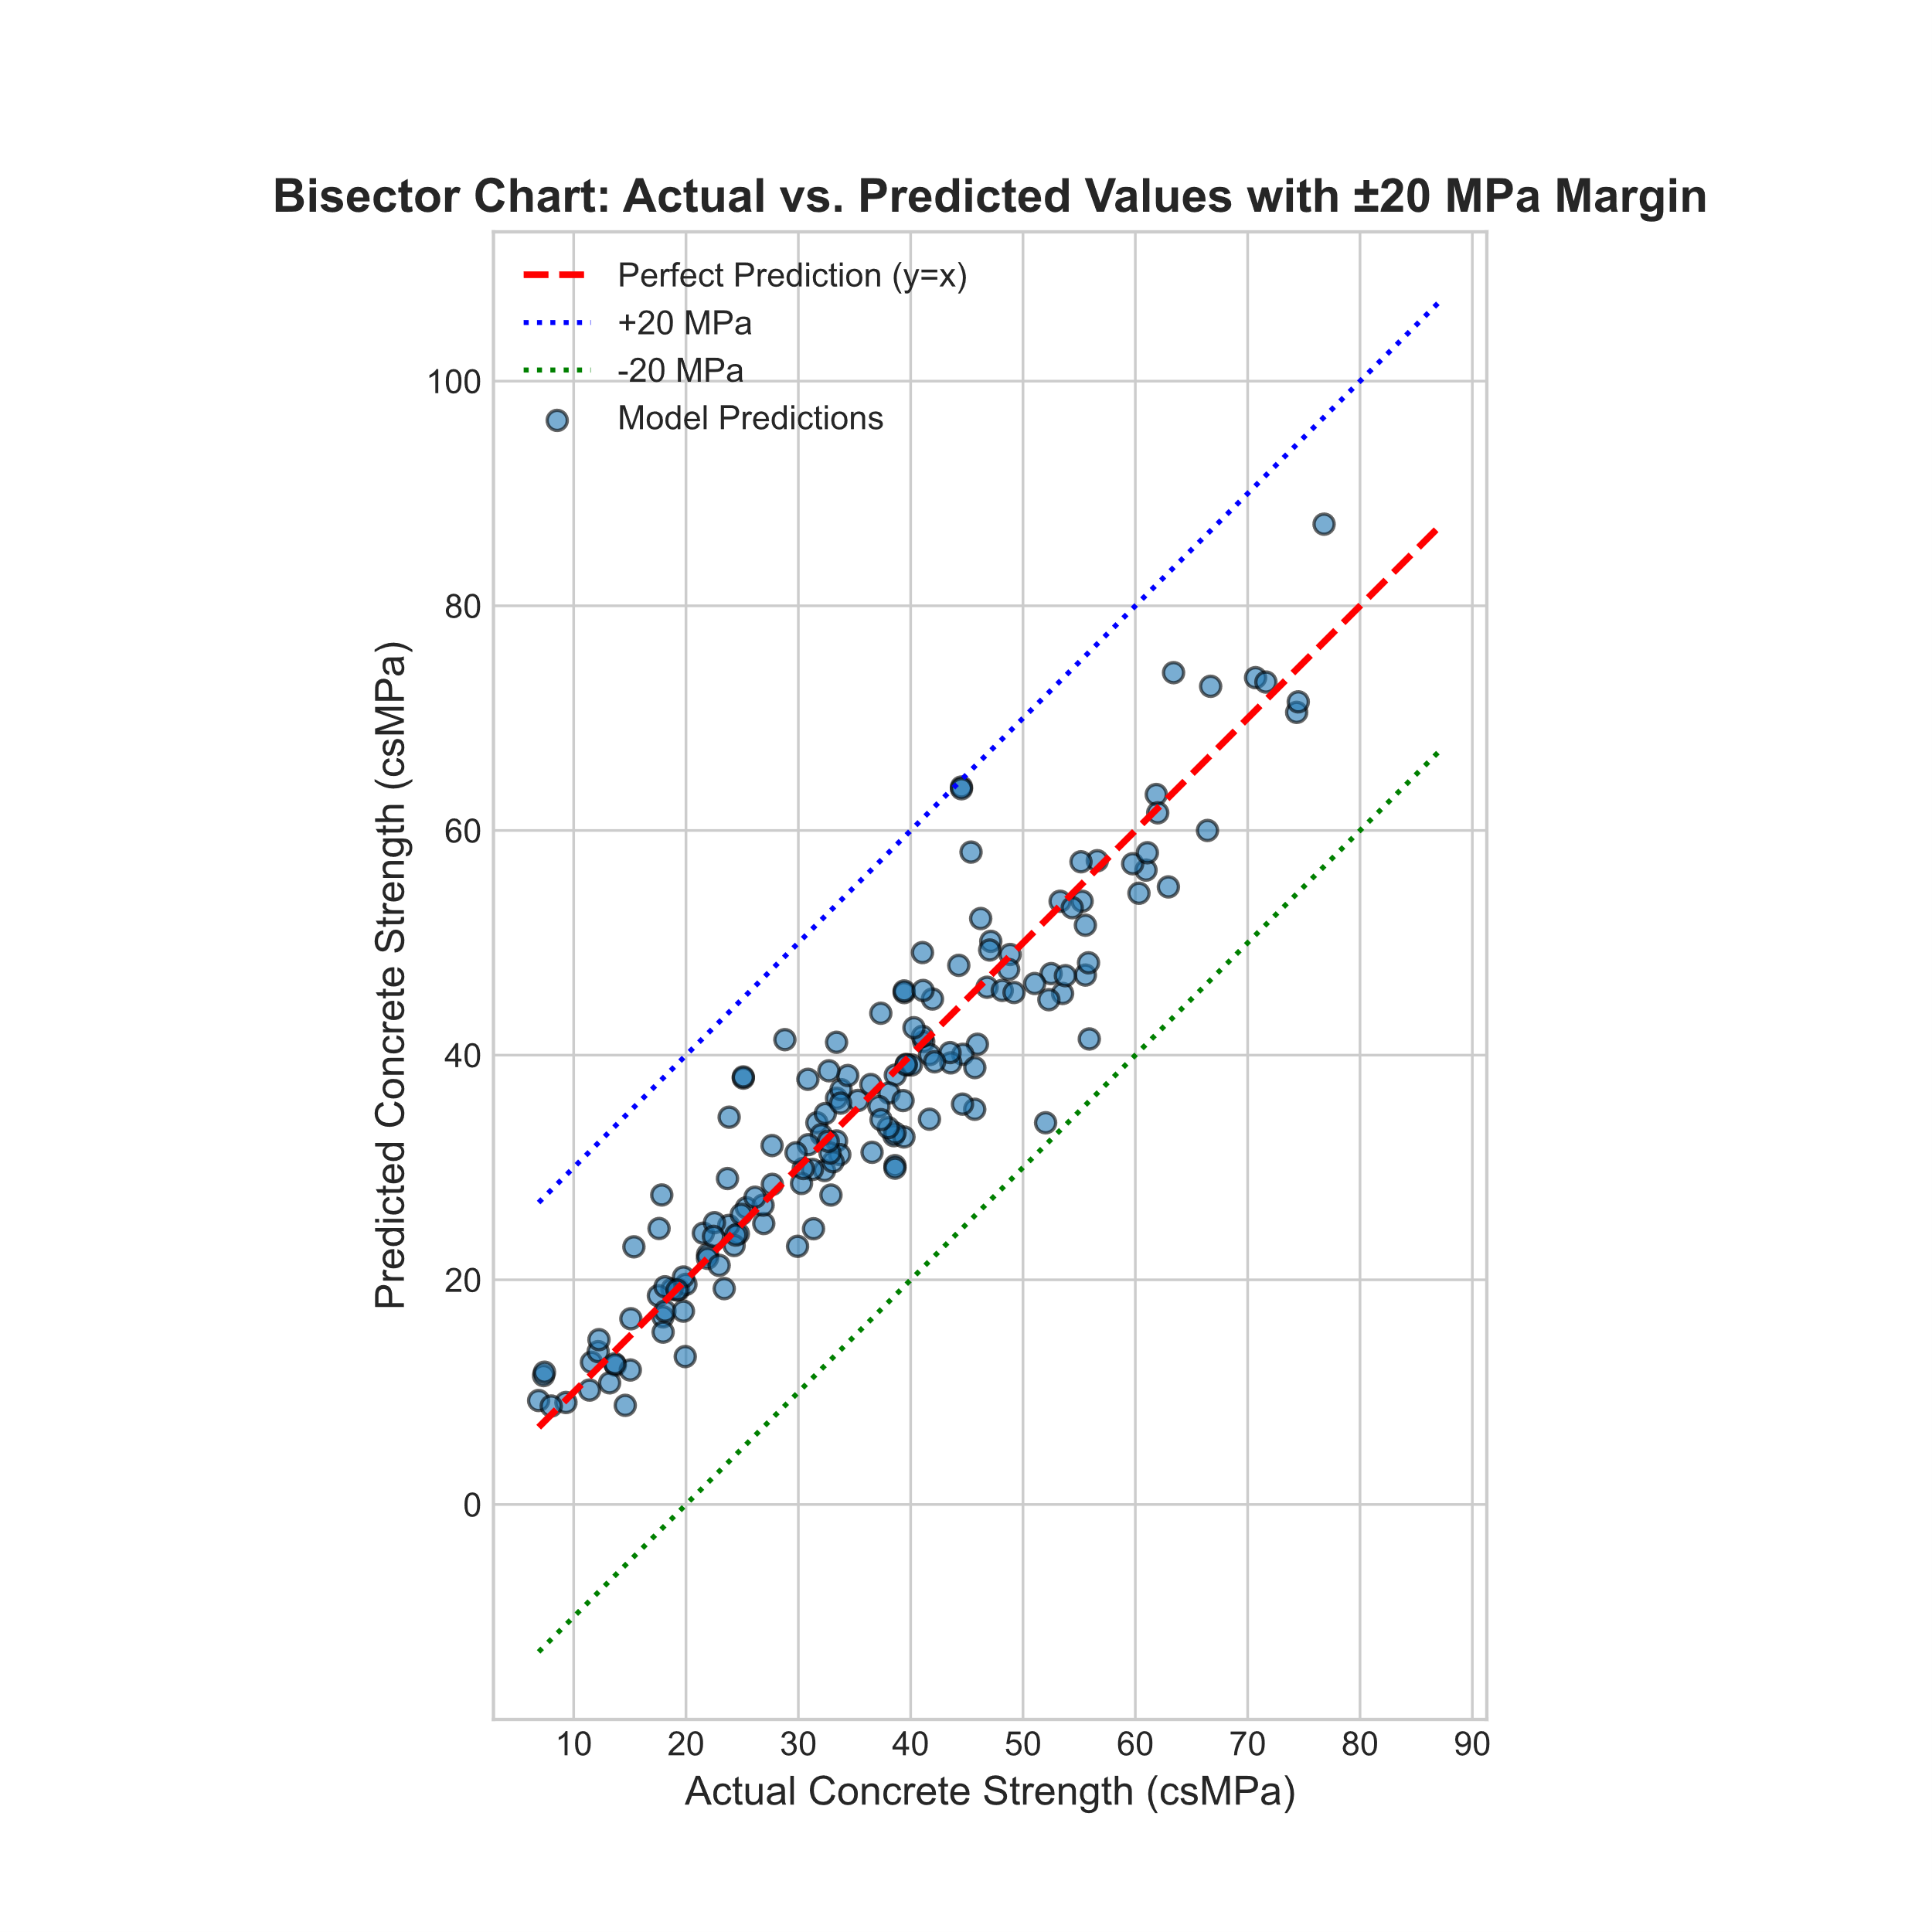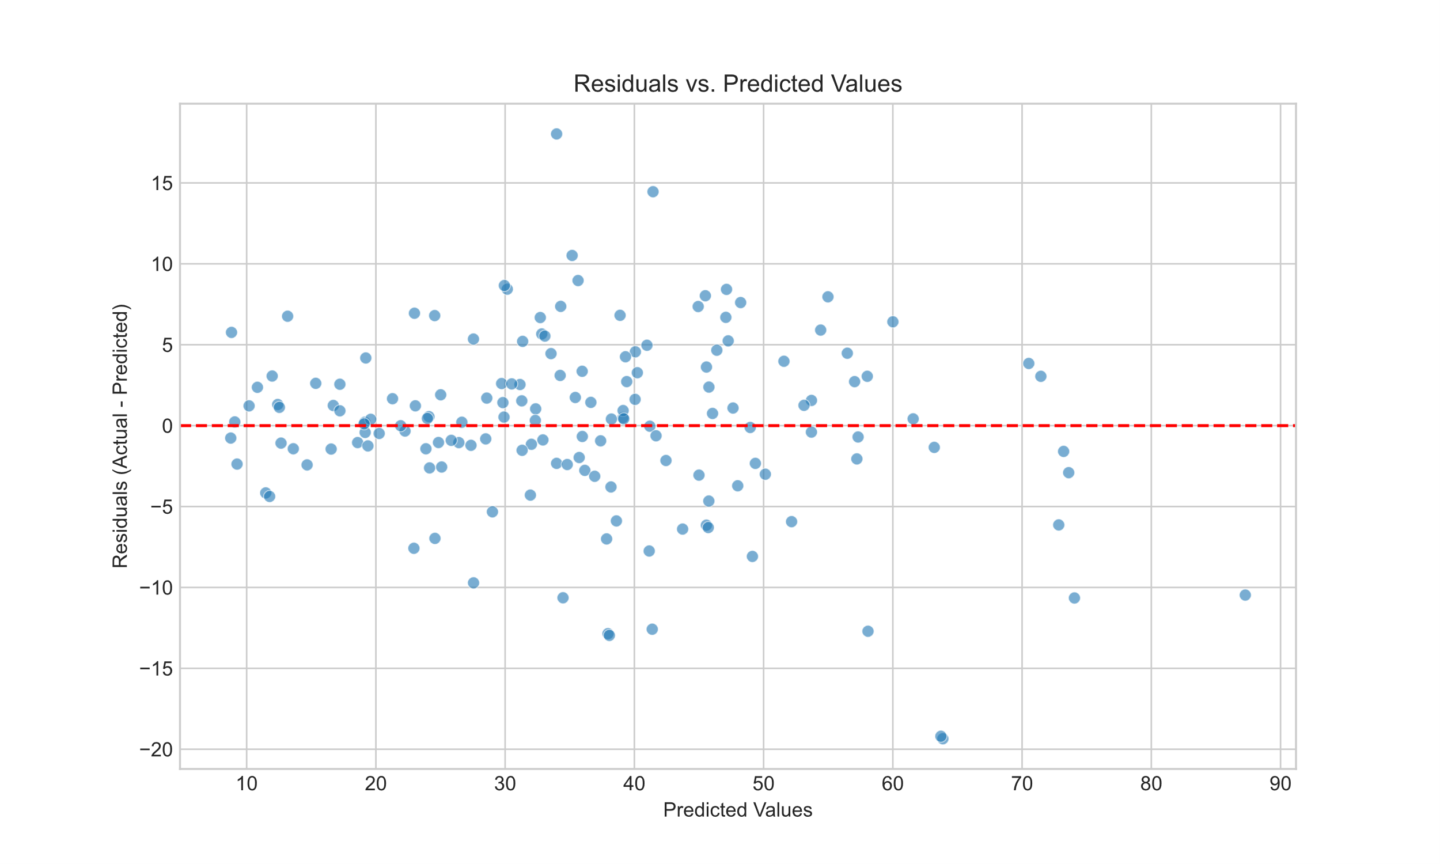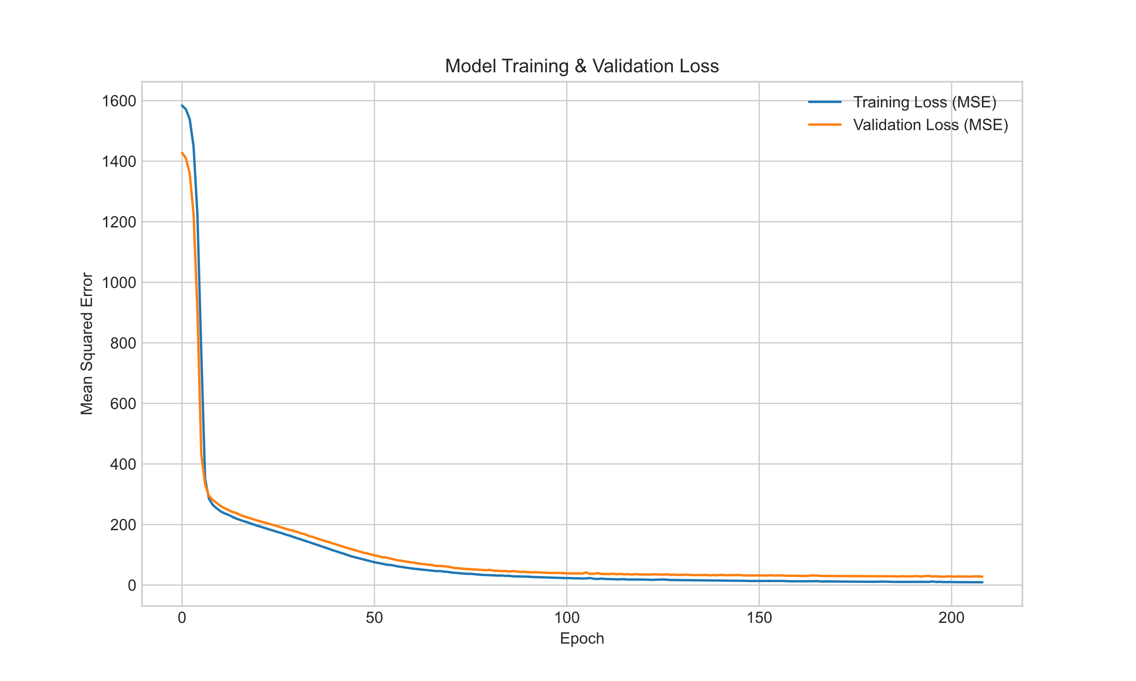

### 5. Conclusion

#### 5.1. Summary of Work

This project involved the design, training, and evaluation of a deep neural network to predict concrete compressive strength based on its constituent ingredients and age. A nine-hidden-layer model was developed and trained using the Adam optimizer. The model's performance was rigorously assessed on a held-out test set, yielding excellent results across multiple standard regression metrics.

#### 5.2. Final Conclusion

This project successfully demonstrated that an artificial neural network can be an effective tool for predicting concrete compressive strength with a high degree of accuracy. The final model achieved an **R-squared score of 0.879** and a **Mean Absolute Error of 3.98 MPa**, making it a potentially valuable asset for material science and civil engineering applications, enabling faster and more cost-effective formulation analysis.

#### 5.3. Future Work

While the current model is highly effective, several avenues exist for potential improvement:

* **Experiment with Other Models**: Investigate the performance of other machine learning algorithms, such as Gradient Boosting (e.g., XGBoost, LightGBM) or Random Forests, which are often strong performers on tabular data.
* **Hyperparameter Tuning**: Conduct a more extensive hyperparameter search using techniques like Grid Search or Bayesian Optimization to find an even more optimal set of parameters (e.g., learning rate, network architecture, regularization strength).
* **Feature Engineering**: Explore the creation of new features from the existing inputs, such as ratios between different ingredients, which might capture complex interactions and improve model accuracy.
* **Deployment**: Develop a simple web application or API that allows users to input concrete mixture details and receive an instant prediction of its compressive strength, making the model accessible to engineers and researchers.

### Good luck with your project! It's a fantastic way to learn and apply neural networks.

### Appendix

#### Model Performance Comparison

The following chart provides a comprehensive comparison of all trained models, ranked from best to worst based on their R-squared (R2) score on the test set. Models with a higher R2 and lower error metrics (MSE, MAE) are considered superior.

| Rank | Model ID | MSE (test set) | MAE (test set) | R-squared (R2) |
| --- | --- | --- | --- | --- |
| **1** | model7 | **30.35** | 3.98 | **0.879** |
| **2** | model6 | 32.23 | **3.96** | 0.871 |
| **3** | model9 | 32.99 | 4.52 | 0.868 |
| **4** | model5 | 34.04 | 4.47 | 0.864 |
| **5** | model8 | 35.01 | 4.33 | 0.860 |
| **6** | model3 | 36.76 | 4.93 | 0.853 |
| **7** | model2 | 37.80 | 4.81 | 0.849 |
| **8** | model4 | 39.11 | 4.75 | 0.844 |
| **9** | model1 | 44.71 | 5.22 | 0.821 |

#### Model Architectures

The table below details the architecture of each model tested during the experiment.

| Model ID | Architecture Description |
| --- | --- |
| model1 | Dense(64, relu) -> Dense(64, relu) -> Dense(1, linear) |
| model2 | Dense(64, relu) -> Dense(64, relu) -> Dense(1, linear) |
| model3 | Dense(128) -> Dropout -> Dense(64) -> Dropout -> Dense(32) -> Dropout -> Dense(1) |
| model4 | Dense(64, relu) -> Dense(64, relu) -> Dense(64, relu) -> Dense(64, relu) -> Dense(64, relu) -> Dense(1, linear) |
| model5 | Dense(128, relu) -> Dense(128, relu) -> Dense(64, relu) -> Dense(1, linear) |
| model6 | Dense(512, relu) -> Dense(256, relu) -> Dense(128, relu) -> Dense(64, relu) -> Dense(32, relu) -> Dense(1, linear) |
| model7 | Dense(512, relu) -> Dense(256, relu) -> Dense(256, relu) -> Dense(128, relu) -> Dense(128, relu) -> Dense(64, relu) -> Dense(64, relu) -> Dense(32, relu) -> Dense(32, relu) -> Dense(1, linear) |
| model8 | Dense(512, relu) -> Dense(256, relu) -> Dense(256, relu) -> Dense(128, relu) -> Dense(128, relu) -> Dense(64, relu) -> Dense(64, relu) -> Dense(32, relu) -> Dense(32, relu) -> Dense(1, linear) |
| model9 | Dense(128, relu) -> Dropout(0.2) -> Dense(64, relu) -> Dropout(0.2) -> Dense(32, relu) -> Dense(1, linear) |

Data set site: https://www.kaggle.com/datasets/maajdl/yeh-concret-data?resource=download