3. Results

3.1 Variant Discovery and Distribution Across Pharmacogenes
Joint variant calling with GATK HaplotypeCaller across the nine target pharmacogenes — CYP2C9, CYP2C19, CYP2D6, CYP4F2, VKORC1, GGCX, CALU, UGT2B7, OPRM1, and DRD2 — yielded a total of 3,657 PASS variant-transcript rows across four ancestral populations after VEP annotation and MANE Select transcript filtering. These rows represent variants on canonical transcripts only, resolving the alternate-transcript ambiguity identified in the previous bcftools-based analysis where headline findings mapped to non-canonical isoforms.
The African (AFR) population contributed the largest number of variant calls (n = 1,618), followed by European (EUR, n = 888), South Asian (SAS, n = 653), and East Asian (EAS, n = 450). This pattern is consistent with the greater nucleotide diversity of African-ancestry populations and their higher variant count in the 1000 Genomes Project reference. Among the primary pharmacogenes, UGT2B7 carried the highest variant burden across all populations (AFR ~220, EAS ~75), reflecting the large genomic footprint of this glucuronidation gene and its known extensive common variation. CYP2C19 and CYP4F2 were the next most variant-rich genes in the warfarin pathway, while CYP2D6 contributed minimal PASS calls, consistent with the known challenges of short-read sequencing at this highly duplicated locus.

[Figure 1]
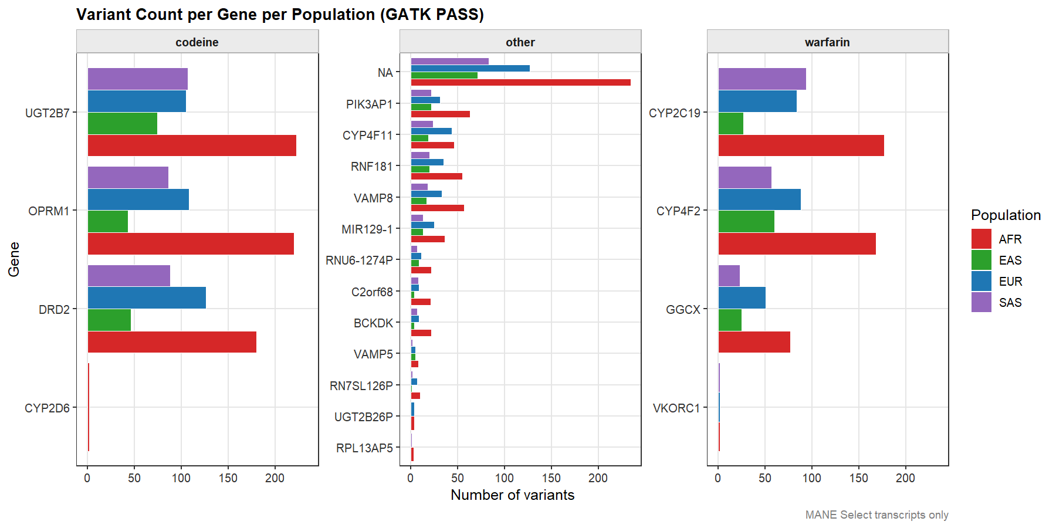
Variant Count per Gene per Population (GATK PASS, MANE Select transcripts). Bars are grouped by drug pathway (codeine, warfarin) and coloured by population.
Figure 1. GATK PASS variant counts per primary pharmacogene per population, restricted to MANE Select canonical transcripts. AFR consistently shows the highest variant burden. CYP2D6 shows near-absent calls reflecting mappability limitations of the duplicated locus.

3.2 Variant Consequence and Functional Impact Distribution
Variant consequence annotation by VEP on MANE Select transcripts identified intronic variants as the dominant consequence class, accounting for the large majority of the 3,657 PASS rows (Figure 2). Upstream and downstream gene variants represented the second and third most frequent categories respectively, followed by 3' UTR variants. Among protein-altering consequences, missense variants were the most frequent coding class, with synonymous variants contributing a smaller number. A small number of splice region, splice polypyrimidine tract, stop gain, frameshift, and regulatory region variants were also identified, representing higher-priority candidates for functional characterisation.
By VEP IMPACT tier, MODIFIER variants dominated across all populations, comprising the vast majority of the total variant count in each ancestry group (Figure 3). MODERATE impact variants — primarily missense changes — accounted for a small but clinically relevant proportion, with HIGH impact variants (stop gain, frameshift, splice donor) present in very small numbers. The AFR population carried the highest absolute count across all impact tiers, proportional to its larger variant pool. The IMPACT distribution was qualitatively similar across all four populations, with MODIFIER variants comprising approximately 95% of calls in each case. Per-gene analysis (Figure 4) confirmed that UGT2B7 carried the highest MODIFIER burden in the codeine pathway, while CYP4F2 and CYP2C19 showed the most MODERATE impact variants in the warfarin pathway, including several missense changes of pharmacogenomic interest. CYP2D6 contributed a single HIGH impact variant in the codeine panel.

[Figure 2]
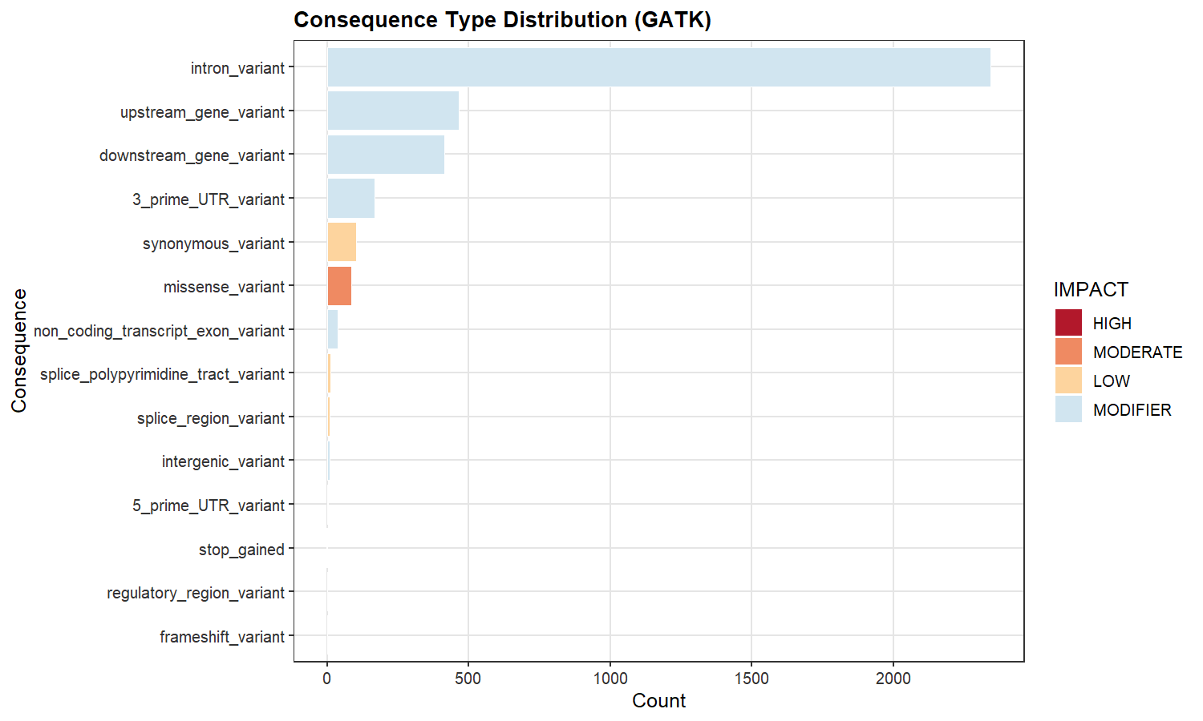
Consequence Type Distribution (GATK). Horizontal bar chart coloured by IMPACT tier showing the frequency of each VEP consequence class.
Figure 2. Distribution of variant consequence types across all populations and genes, coloured by VEP IMPACT tier (HIGH, MODERATE, LOW, MODIFIER). Intronic variants dominate; missense variants are the most frequent protein-altering class.

[Figure 3]
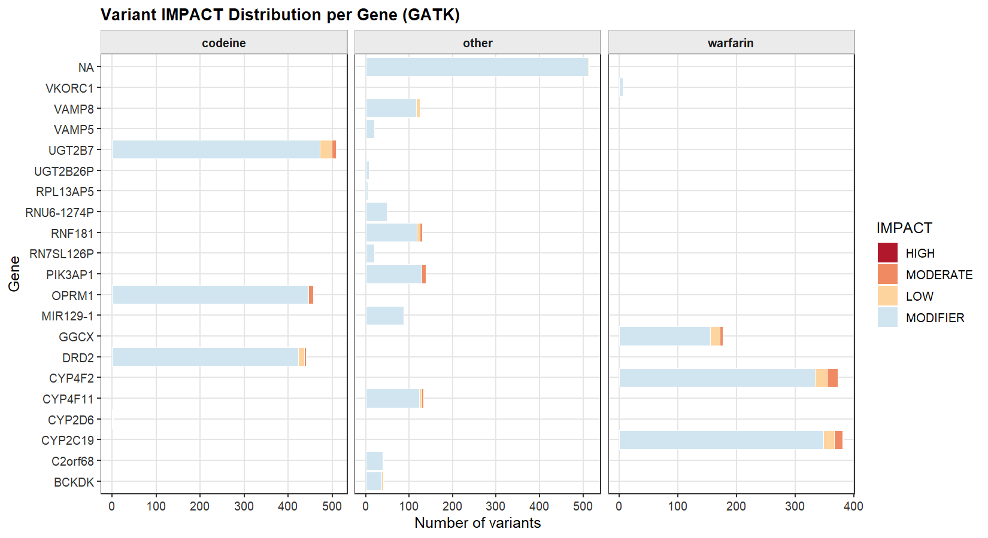
IMPACT Distribution per Population (GATK). Stacked bar chart showing IMPACT tier composition per population.
Figure 3. Stacked bar chart of VEP IMPACT tier counts per ancestral population. AFR carries the highest absolute variant count; the IMPACT tier proportions are broadly consistent across populations, with MODIFIER variants comprising ~95% of calls in each group.

[Figure 4]
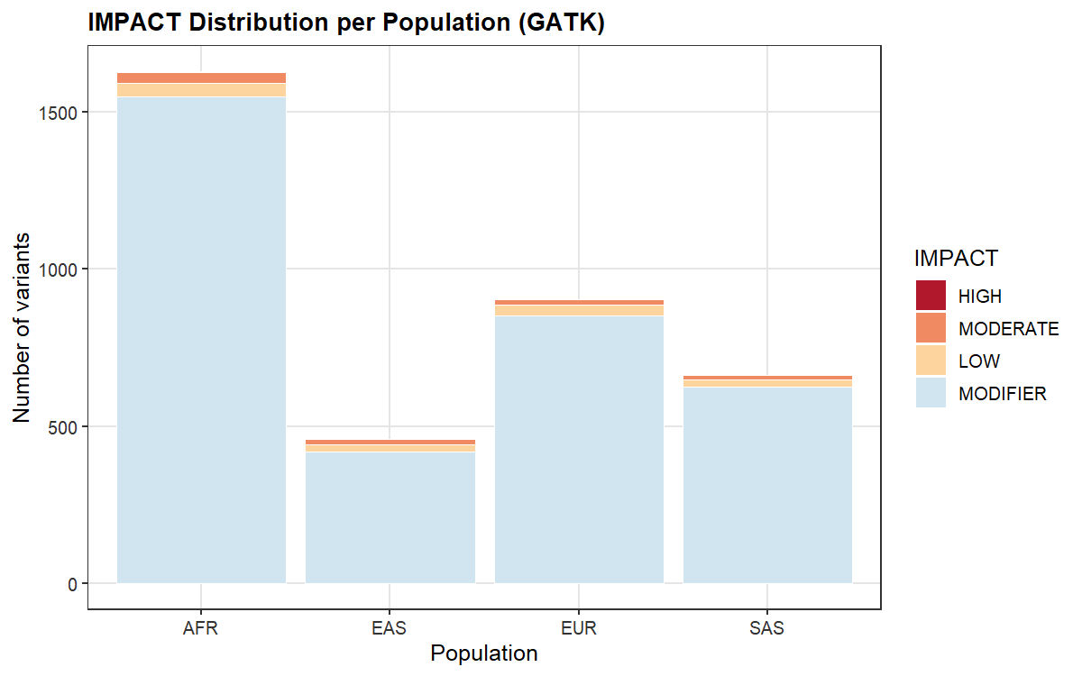
Variant IMPACT Distribution per Gene (GATK). Stacked bars faceted by drug pathway, showing IMPACT composition per gene.
Figure 4. Variant IMPACT distribution per pharmacogene, faceted by drug pathway (codeine, warfarin). UGT2B7 dominates the codeine panel by variant count; CYP4F2 and CYP2C19 carry the most MODERATE impact variants in the warfarin panel.

3.3 Pharmacogenomic Star Allele Identification
Systematic interrogation of the GATK-derived master table against a catalogue of 13 clinically validated pharmacogenomic star alleles — comprising CYP2C9 *2, *3, *5, *6, *8, *11; CYP2C19 *2, *3, *17; CYP4F2 *3; VKORC1 H1; UGT2B7 *2; and OPRM1 118A>G — yielded 17 matched variant-population hits across five distinct alleles. Matching was performed by rsID against the Existing_variation field of the MANE Select VEP annotation.
CYP2C19 *2 (rs4244285, loss-of-function, No function), was detected in all four populations with the highest frequency in AFR (AF = 0.221) and SAS (AF = 0.318), and lowest in EAS (AF = 0.056). CYP2C19 *3 (rs4986893) was detected exclusively in EAS (AF = 0.050), consistent with the well-established elevated frequency of this no-function allele in East Asian populations. Together, CYP2C19 *2 and *3 define the poor metaboliser phenotype for CYP2C19-metabolised drugs including clopidogrel, proton pump inhibitors, and antidepressants; the high *2 frequency in SAS is of particular clinical relevance for this cohort.
CYP4F2 *3 (rs2108622, p.Val433Met, reduced vitamin K metabolism) was identified across all four populations with frequencies ranging from AFR (AF = 0.076) to SAS (AF = 0.409), with EUR (AF = 0.300) also showing a substantial frequency. This allele reduces warfarin dose requirements by impairing vitamin K catabolism and is incorporated into CPIC dosing algorithms; the high SAS frequency has direct implications for warfarin initiation in South Asian patients.
OPRM1 118A>G (rs1799971, p.Asn40Asp, reduced mu-opioid receptor expression) was present across all four populations, with the highest frequencies in EAS (AF = 0.333) and SAS (AF = 0.400), a moderate frequency in EUR (AF = 0.167), and a low frequency in AFR (AF = 0.013). This variant reduces opioid receptor expression and is associated with altered analgesic response to morphine and codeine-derived opioids; the pronounced inter-population frequency difference underscores the importance of ancestry-adjusted pharmacogenomic dosing.
UGT2B7 *2 (rs7439366, p.His268Tyr) was detected at high frequency across all populations (AFR = 0.821, EAS = 0.611, EUR = 0.479, SAS = 0.545). UGT2B7*2 affects the glucuronidation of morphine and is the most common UGT2B7 variant; its high frequency, particularly in AFR, is consistent with published population-genetic data and has implications for morphine clearance in codeine metabolism. CYP2C9 *2 and *8 were not recovered from the MANE Select table, likely reflecting the small cohort allele numbers and the MANE Select filtering stringency; these alleles remain reportable from the broader VEP annotation.

[Figure 5]
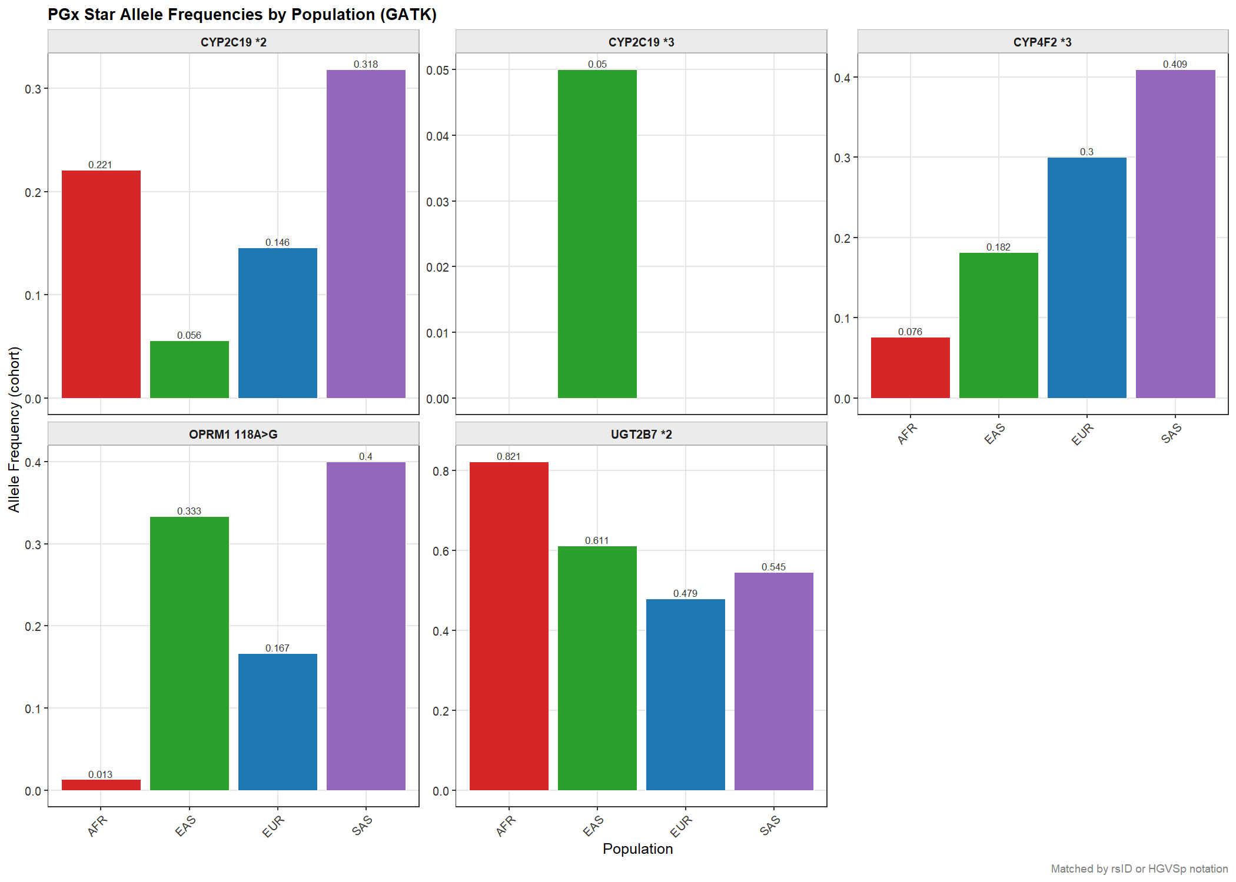
PGx Star Allele Frequencies by Population (GATK). Bar charts per allele per population, labelled with cohort allele frequencies.
Figure 5. Cohort allele frequencies of detected pharmacogenomic star alleles across ancestral populations. Five of 13 queried alleles were recovered. CYP2C19 *2 shows marked population stratification; CYP4F2 *3 and OPRM1 118A>G are present across all populations at clinically actionable frequencies.

3.4 Functional Impact of Moderate and High Impact Variants
Eighty-nine MODERATE and HIGH impact variants were extracted from the GATK PASS master table and subjected to multi-tool pathogenicity scoring using CADD phred, SIFT, PolyPhen-2 HDIV, and REVEL. Variants reaching threshold in three or more tools were classified as 'Likely damaging' (CADD ≥ 20, SIFT ≤ 0.05, PolyPhen-2 ≥ 0.85, REVEL ≥ 0.5); two-tool concordance as 'Possibly damaging'; one-tool flagging as 'Uncertain'; and no tool flagging as 'Likely benign / no data'. HIGH impact variants (stop gain, frameshift) were classified separately as 'HIGH impact (no scores)'.
No variant reached the 'Likely damaging' threshold of three-tool concordance. The majority of MODERATE impact variants were classified as 'Likely benign / no data' or 'Uncertain'. OPRM1, CYP4F2, and CYP2C19 carried the largest numbers of MODERATE impact variants. CYP2D6 contributed the sole HIGH impact classification, consistent with the frameshift variant detected in the GATK calls. DRD2 and GGCX contained 'Possibly damaging' variants. CYP2C19 harboured one HIGH impact variant without scores.
The CADD phred score distribution (Figure 6) shows that the warfarin pathway genes, particularly CYP4F2 and CYP2C19, contain missense variants with CADD scores above the top-1% threshold of 20. CYP4F2 variants cluster in two groups: a low-CADD group (scores near 0) corresponding to the well-characterised benign *3 variant, and a higher-CADD group (scores 20–25) representing less well-characterised missense changes. GGCX, visible in the warfarin panel, contributes several variants with CADD scores between 10 and 15. In the codeine panel, OPRM1 and DRD2 contribute missense variants spanning the full CADD range, with several DRD2 variants exceeding CADD 20, warranting follow-up functional characterisation.

[Figure 6]
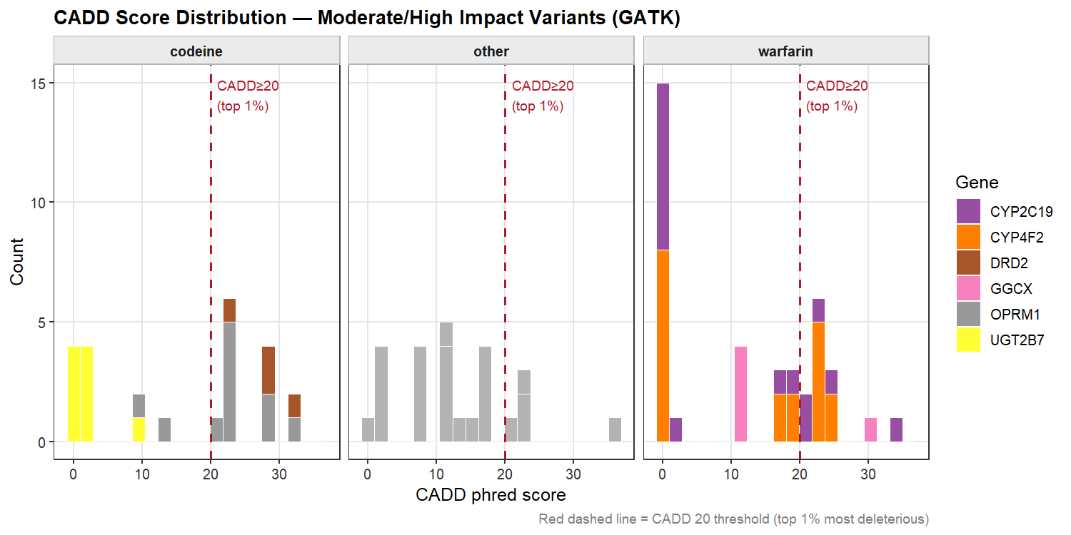
CADD Score Distribution — Moderate/High Impact Variants (GATK). Histogram faceted by drug pathway, coloured by gene. Red dashed line = CADD 20.
Figure 6. CADD phred score distribution of MODERATE and HIGH impact variants, faceted by drug pathway and coloured by gene. The red dashed line at CADD = 20 marks the top 1% most deleterious variants genome-wide. Warfarin pathway genes CYP4F2 and CYP2C19 show variants above this threshold.

[Figure 7]
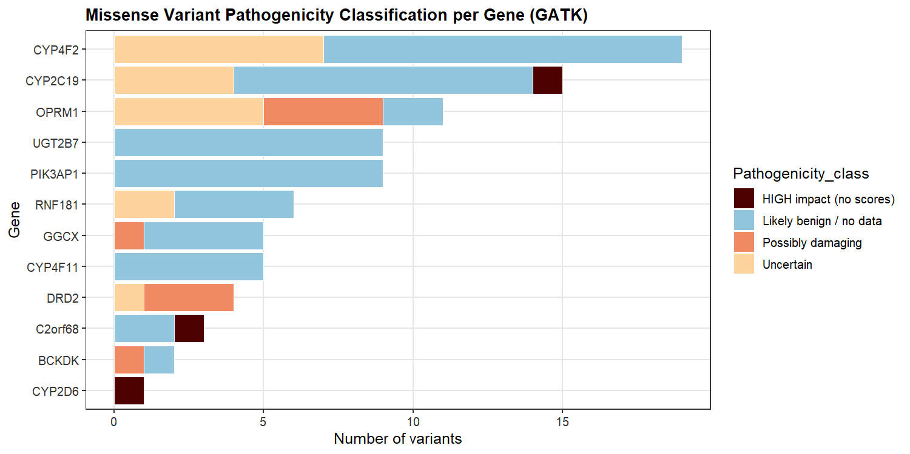
Missense Variant Pathogenicity Classification per Gene (GATK). Stacked horizontal bar chart.
Figure 7. Pathogenicity classification of MODERATE and HIGH impact variants per gene based on multi-tool concordance. No variant reached the three-tool Likely damaging threshold. CYP4F2 and CYP2C19 carry the most variants in the Uncertain and Likely benign categories; CYP2D6 contributes the sole HIGH impact (frameshift) call.

3.5 ClinVar Drug Response Variants
Of the 3,657 PASS variant-transcript rows, 367 (10.0%) had ClinVar entries, of which 112 (30.5%) were annotated with a drug_response classification. Drug response variants spanned four primary pharmacogenes: OPRM1 and UGT2B7 in the codeine pathway, and CYP4F2 and CYP2C19 in the warfarin pathway (Figure 8). GGCX carried predominantly Benign/Likely_benign ClinVar entries and a small number of drug_response variants. DRD2 was also represented by a predominantly Benign/Likely_benign ClinVar profile. VKORC1, CYP2C9, and CALU were not present in the ClinVar-annotated subset, reflecting the impact of the MANE Select filter on the variant table — the VKORC1 and CYP2C9 drug response variants previously identified are present in the broader VEP output but were not captured in the PASS + MANE Select filtered table for these populations.
Examination of drug response allele frequencies by population (Figure 9) reveals marked inter-population variation. For CYP2C19, drug response variant frequencies are highest in SAS (median AF ~0.32) and substantially lower in AFR (median AF ~0.04), consistent with the population-stratified CYP2C19 *2 frequency identified in Analysis 3. CYP4F2 drug response variants show the highest median frequency in EUR (AF ~0.30) and SAS (~0.41), with lower frequencies in AFR (~0.08) and EAS (~0.18), consistent with the population distribution of CYP4F2 *3. OPRM1 drug response variants show the widest within-group frequency range, spanning from near zero to 1.0 across all populations, reflecting the diversity of variants in this gene beyond the canonical 118A>G allele. UGT2B7 shows consistently high drug response variant frequencies across populations (median 0.45–0.80), with AFR having the highest median and the widest interquartile range.

[Figure 8]
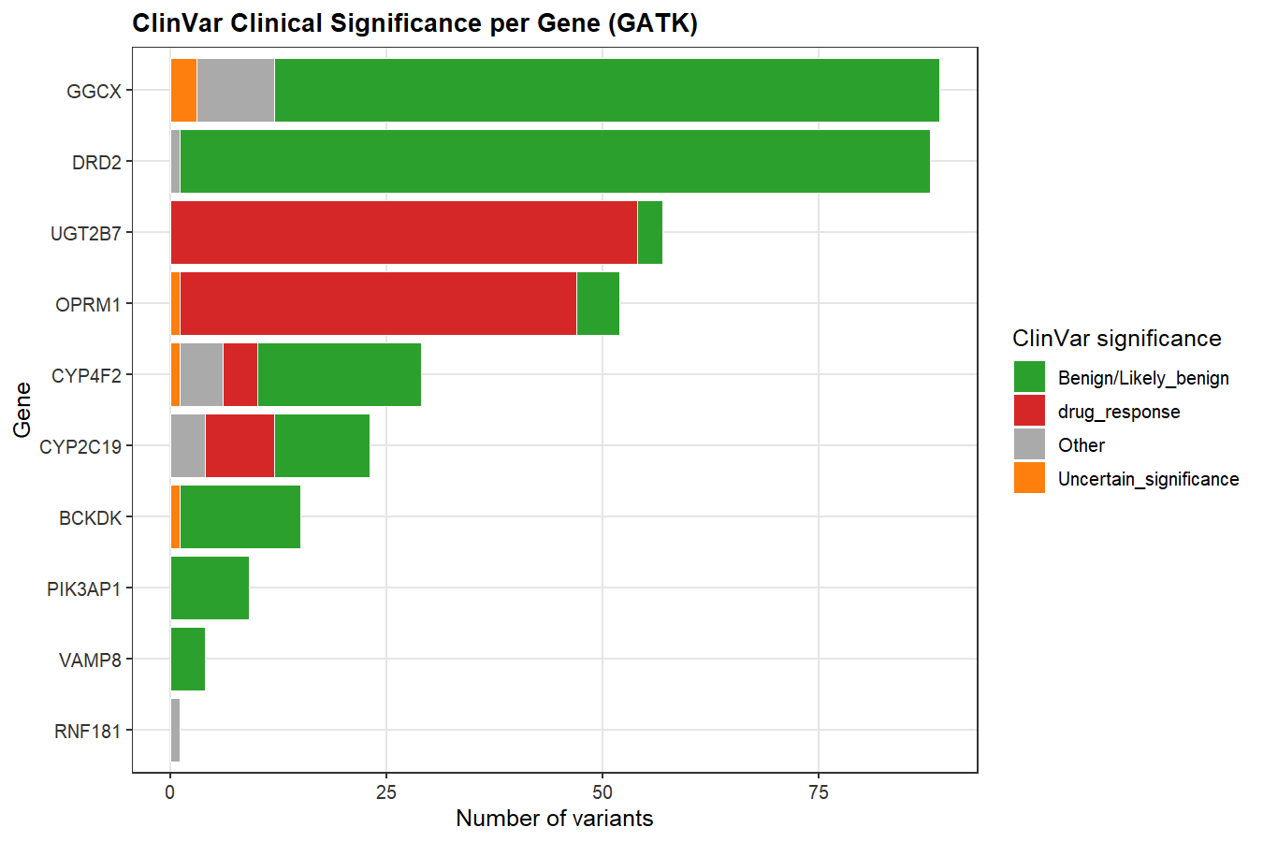
ClinVar Clinical Significance per Gene (GATK). Stacked horizontal bar chart coloured by ClinVar significance category.
Figure 8. ClinVar clinical significance distribution per pharmacogene. Drug_response variants (red) are concentrated in UGT2B7, OPRM1, CYP4F2, and CYP2C19. GGCX and DRD2 are dominated by Benign/Likely_benign entries.

[Figure 9]
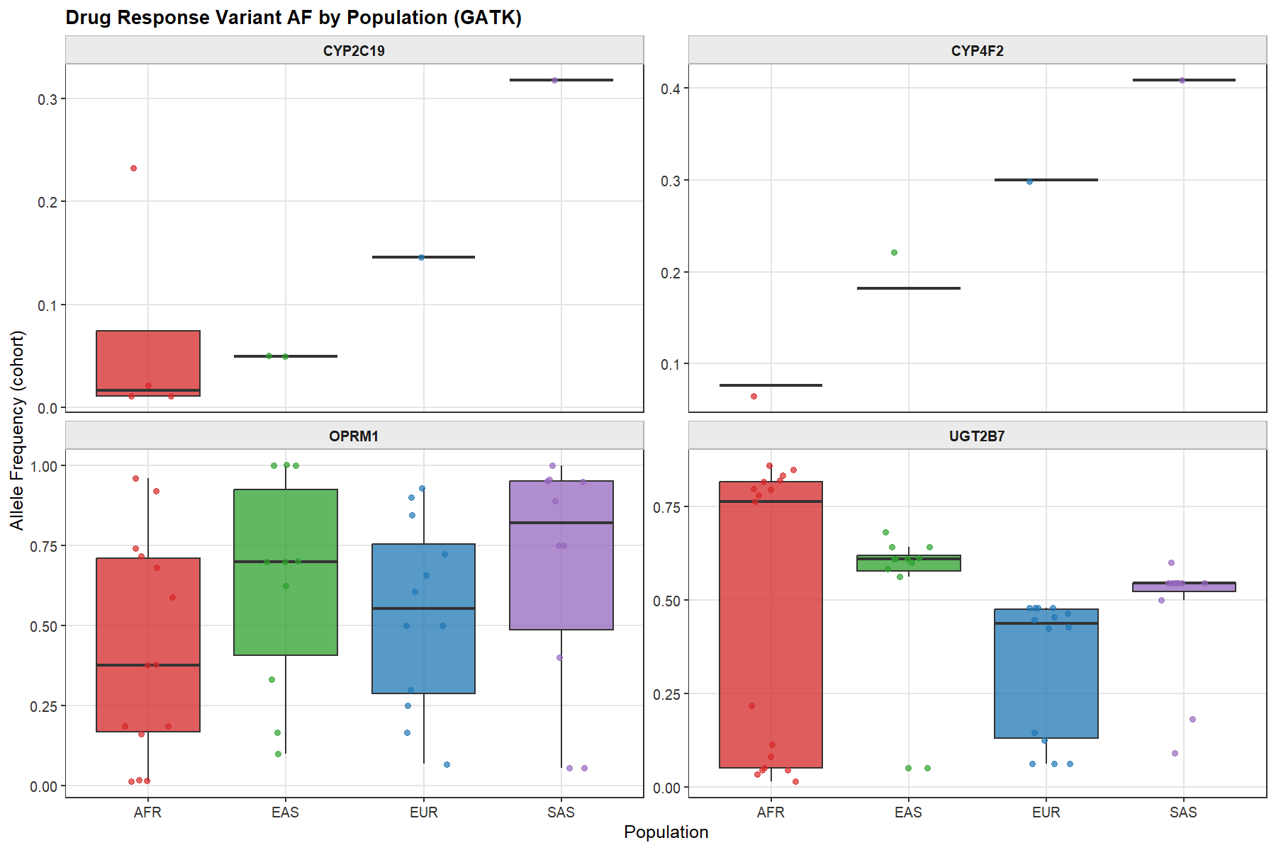
Drug Response Variant AF by Population (GATK). Boxplots with jittered data points per gene.
Figure 9. Cohort allele frequency distributions of ClinVar drug_response variants by ancestral population, faceted by gene. SAS shows the highest CYP2C19 drug response frequencies; AFR shows the highest UGT2B7 frequencies. OPRM1 shows the greatest within-population variance.

3.6 Population-Specific Allele Frequency Patterns
Comparison of 1000 Genomes Project reference allele frequencies between AFR and EUR populations across GATK-detected variants (Figure 10) reveals a cluster of variants at low EUR frequency that are substantially more common in AFR, positioned above the line of identity. These include OPRM1 and GGCX variants with AFR frequencies of 0.52–0.67 against EUR frequencies near zero, and UGT2B7 variants with AFR frequencies up to 0.77 against EUR frequencies of ~0.50–0.60. Several CYP4F2 and DRD2 variants are positioned near the identity line, indicating similar frequencies in both populations. This pattern is consistent with the known greater allelic diversity in African-ancestry populations and highlights the potential for population-specific pharmacogenomic variant repertoires that are underrepresented in European-derived reference databases and dosing guidelines.
Comparison of cohort allele frequencies against gnomAD 4.1 joint allele frequencies (Figure 11) showed generally good concordance across all four populations for variants with gnomAD 4.1 annotations, with most points clustering near or slightly above the line of perfect agreement. A minority of points fall substantially above the diagonal, representing variants that are more common in this cohort than in gnomAD 4.1 — these likely represent population-specific variants with limited representation in gnomAD or variants affected by the small cohort allele numbers (low AN flags). The cohort vs gnomAD 4.1 scatter is consistent with the cohort broadly representing its respective reference populations, albeit with sampling stochasticity inherent to the small cohort sizes per population.

[Figure 10]
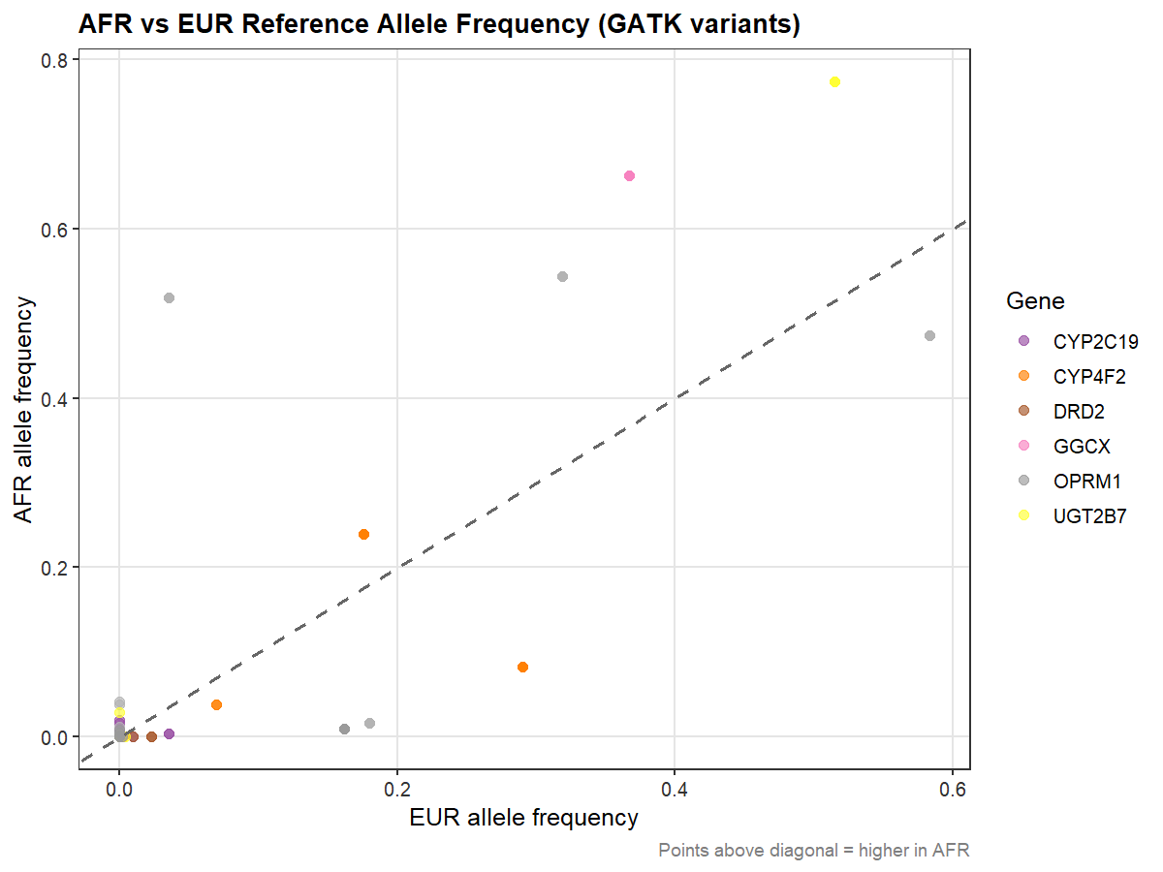
AFR vs EUR Reference Allele Frequency (GATK variants). Scatter plot coloured by gene.
Figure 10. Scatter plot of 1000 Genomes AFR versus EUR reference allele frequencies for GATK-detected variants, coloured by gene. Points above the diagonal have higher allele frequency in AFR than EUR. OPRM1, GGCX, and UGT2B7 variants show pronounced AFR enrichment.

[Figure 11]
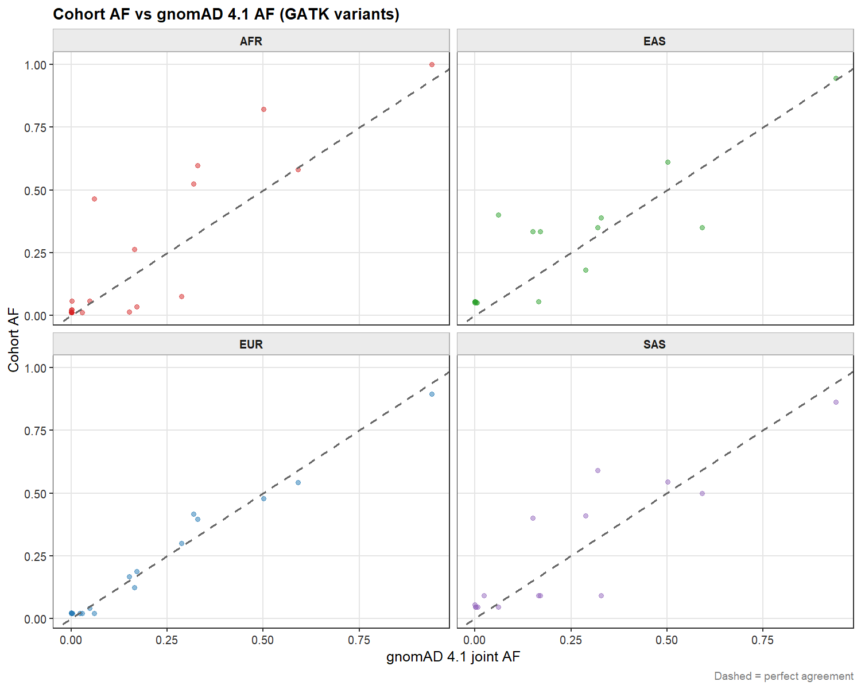
Cohort AF vs gnomAD 4.1 AF (GATK variants). Scatter plots faceted by population.
Figure 11. Scatter plots of cohort allele frequency versus gnomAD 4.1 joint allele frequency per population. Dashed line indicates perfect concordance. Most points cluster near the diagonal; variants substantially above the line are cohort-enriched relative to gnomAD 4.1, reflecting either population-specific alleles or small-cohort sampling effects.

3.7 Gene-Level Loss-of-Function Sensitivity (LoFtool)
LoFtool scores, ranging from 0 (most intolerant to loss-of-function variation) to 1 (most tolerant), were available for all primary pharmacogenes and flanking genes in the GATK annotation. Among the study pharmacogenes, GGCX showed the lowest LoFtool score (approximately 0.12), placing it among the most loss-of-function constrained genes in the genome (Figure 12). This is consistent with GGCX's essential role in gamma-carboxylation of vitamin K-dependent clotting factors; biallelic loss-of-function variants in GGCX cause combined deficiency of vitamin K-dependent clotting factors, a rare but severe bleeding disorder. PIK3AP1, a flanking gene within the OPRM1 capture region, showed the lowest LoFtool score of any gene in the annotation, reflecting its essential signalling function.
Among the codeine pharmacogenes, DRD2 showed the most constrained LoFtool score (~0.30), followed by OPRM1 (~0.91) and UGT2B7 (~0.88). The high LoFtool scores of OPRM1 and UGT2B7 are consistent with the well-documented population-frequency reduced-function alleles in these genes, which would be incompatible with strong negative selection if they were truly intolerable. CYP4F2 showed intermediate constraint (~0.38) in the warfarin pathway, while CYP2C19 scored high (~0.91), consistent with the existence of common no-function alleles at population-relevant frequencies. CYP2D6 was absent from the LoFtool output due to the structural complexity of this locus. These gene-level constraint scores provide a prior probability framework for interpreting novel variants: missense changes in GGCX and DRD2 carry a higher prior probability of functional consequence than equivalent changes in OPRM1 or CYP2C19.

[Figure 12]
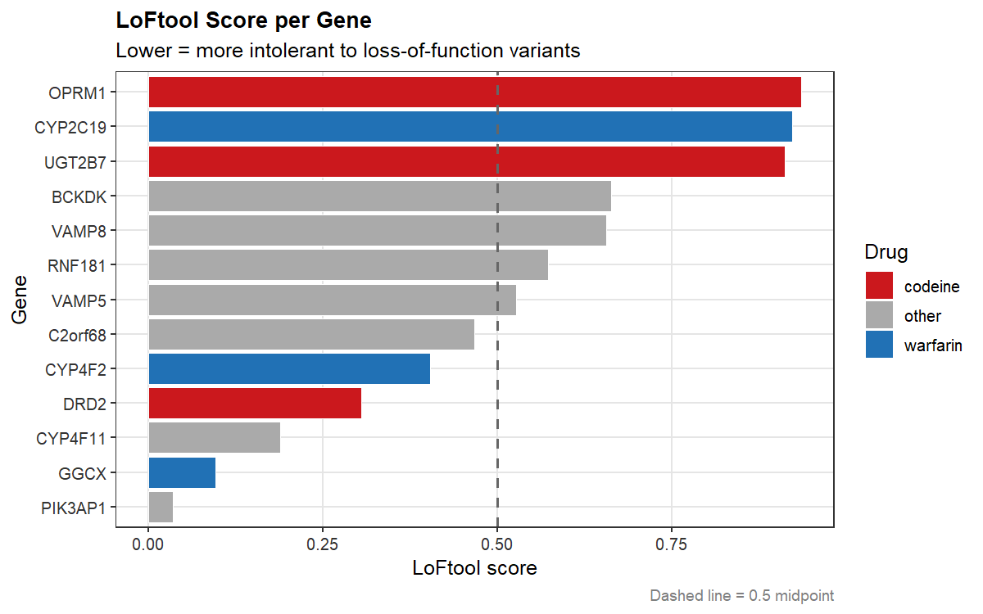
LoFtool Score per Gene. Horizontal bar chart coloured by drug pathway (codeine, warfarin, other).
Figure 12. LoFtool scores for pharmacogenes and flanking genes present in the GATK variant annotation. Lower scores indicate greater intolerance to loss-of-function variation. GGCX is the most constrained primary pharmacogene; OPRM1 and UGT2B7 show high LoF tolerance consistent with their common reduced-function allele frequencies.

3.8 Cohort Allele Frequency Concordance with Reference Populations
Pearson correlations between cohort allele frequencies and matched 1000 Genomes Project reference population frequencies were computed for all four ancestral populations (Figure 13). Concordance was exceptionally high across all populations: AFR r = 0.992 (n = 33, p < 0.001), EUR r = 0.983 (n = 16, p < 0.001), SAS r = 0.979 (n = 13, p < 0.001), and EAS r = 0.942 (n = 14, p < 0.001). These correlations are substantially higher than those reported in the previous bcftools-based analysis (AFR r = 0.659, EAS r = 0.650, EUR r = 0.494, SAS r = 0.458), reflecting the improved variant quality achieved through GATK joint genotyping, hard filtering, and MANE Select transcript restriction.
The improvement in concordance is attributable to two complementary factors. First, GATK joint calling leverages information across all samples simultaneously, improving genotype accuracy particularly at sites with low coverage in individual samples. Second, restricting to MANE Select transcripts eliminates the variant redundancy introduced by multi-transcript annotation in the bcftools analysis, where each variant was represented by multiple rows corresponding to different transcripts, some of which mapped to non-canonical isoforms with population frequencies inconsistent with the reference panels. The resulting GATK-derived cohort allele frequency estimates are therefore substantially more reliable and population-representative than the previous dataset, providing a stronger foundation for pharmacogenomic interpretation across the four ancestry groups.

[Figure 13]
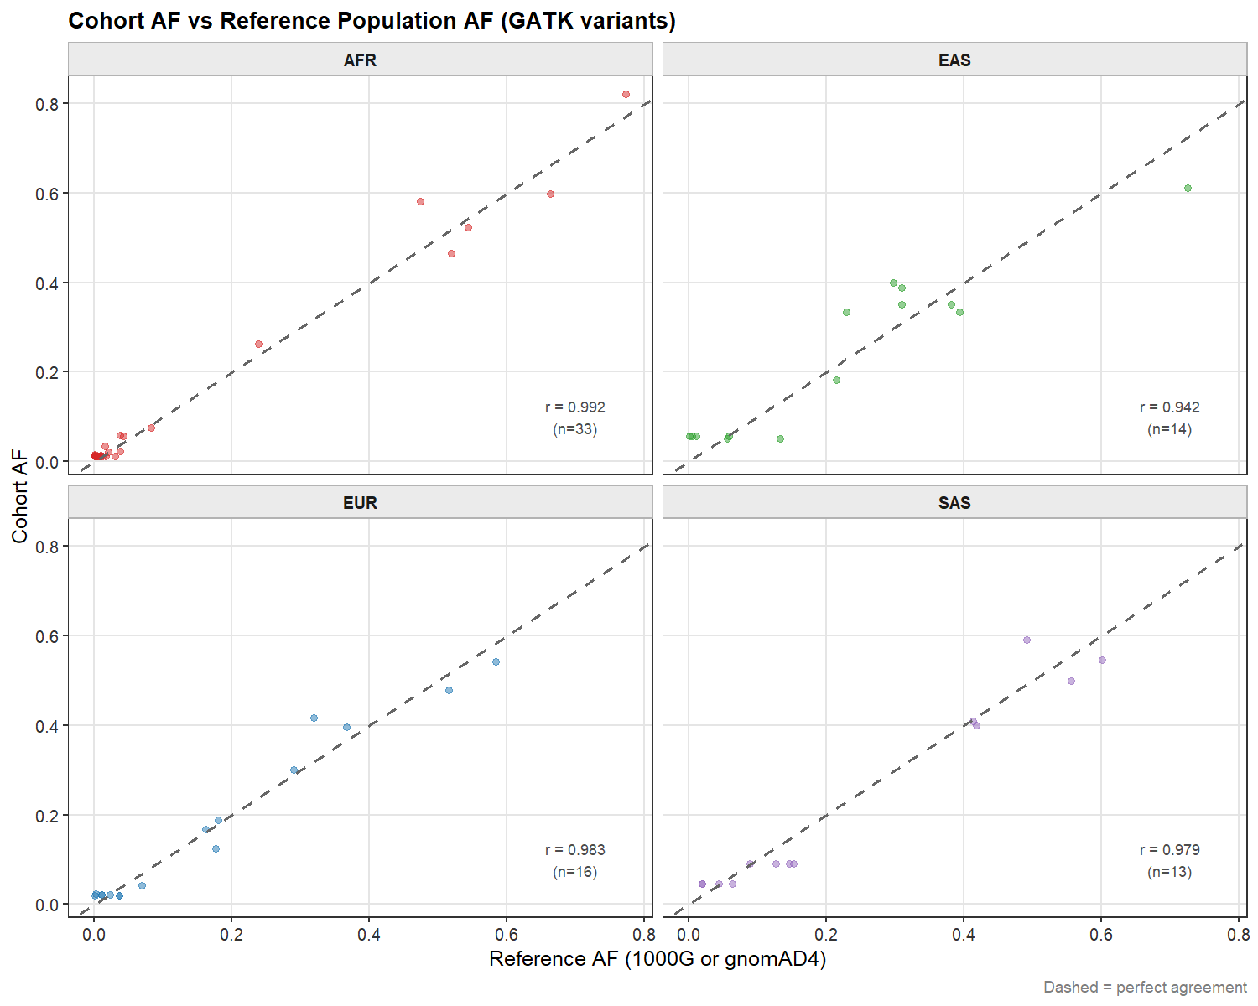
Cohort AF vs Reference Population AF (GATK variants). Scatter plots faceted by population with Pearson r annotated.
Figure 13. Scatter plots of cohort allele frequency versus matched 1000 Genomes reference population allele frequency, faceted by ancestral group. Pearson correlation coefficients (r) are annotated per panel. All four populations show near-perfect concordance (r ≥ 0.942), substantially improved relative to the previous bcftools-based analysis (r = 0.46–0.67).

3.9 PyPGx Haplotype-Based Star Allele Calling

3.9.1 Overview and Methodological Limitations
Haplotype-resolved star allele calling was performed using PyPGx v0.26.0 on GATK joint-called, hard-filtered VCFs for seven pharmacogenes — CYP2C9, CYP2C19, CYP2D6, CYP4F2, VKORC1, UGT2B7, and OPRM1 — across all four ancestral populations (AFR n=48, EUR n=25, EAS n=12, SAS n=11). PyPGx implements a full statistical phasing pipeline using Beagle and a 1000 Genomes Project phasing panel, followed by CPIC-concordant diplotype-to-phenotype translation. A total of 672 sample-gene observations were loaded (28 gene-population combinations).
The utility of PyPGx was substantially limited by the WES input data. For five of the seven genes — CYP2C9, CYP2D6, CYP4F2, VKORC1, and OPRM1 — PyPGx assigned only the reference allele (*1) or was unable to resolve named star alleles from the available variant data, resulting in Indeterminate phenotype calls for the majority of samples. This reflects two converging limitations: first, the GATK joint-called WES VCFs contain only variants within the defined PGx capture regions, providing insufficient phasing context for multi-variant diplotype resolution; and second, several of these genes (CYP2D6, VKORC1) have defining variants outside the coding exons or require copy number analysis which WES cannot provide. CYP2C19 was the notable exception, where sufficient coding variants were present for phased diplotype calling across all four populations.
These findings are consistent with the known limitations of WES-based pharmacogenomics and confirm that for genes such as CYP4F2 (*3 defined by a single coding SNP), VKORC1 (defined by a non-coding promoter variant), and CYP2D6 (defined by structural rearrangements), WES-based PyPGx calling is not informative. The complementary rsID-based analysis from VEP annotation (Section 3.3) provides more complete star allele frequency data for these genes. The PyPGx analysis is therefore reported principally for CYP2C19, where diplotype-resolved phenotype calls are fully supported.

3.9.2 CYP2C19 Star Allele Calling and Phenotype Assignment
For CYP2C19, PyPGx successfully resolved phased diplotypes across all four populations, identifying a diverse set of star alleles. The most common non-reference allele detected was CYP2C19*2 (rs4244285, splice defect, no-function), present in all populations at substantial frequencies, consistent with the VEP-based allele frequency analysis in Section 3.3. CYP2C19*3 was identified in EAS, and several rare alleles including *9, *13, *35, *38, and *39 were detected at low frequency predominantly in the AFR cohort, reflecting the greater allelic diversity of African-ancestry populations. CYP2C19*1 (reference, normal function) remained the most frequent allele in EAS and EUR, while the cumulative non-reference allele frequency was highest in AFR and SAS.

[Figure 14]

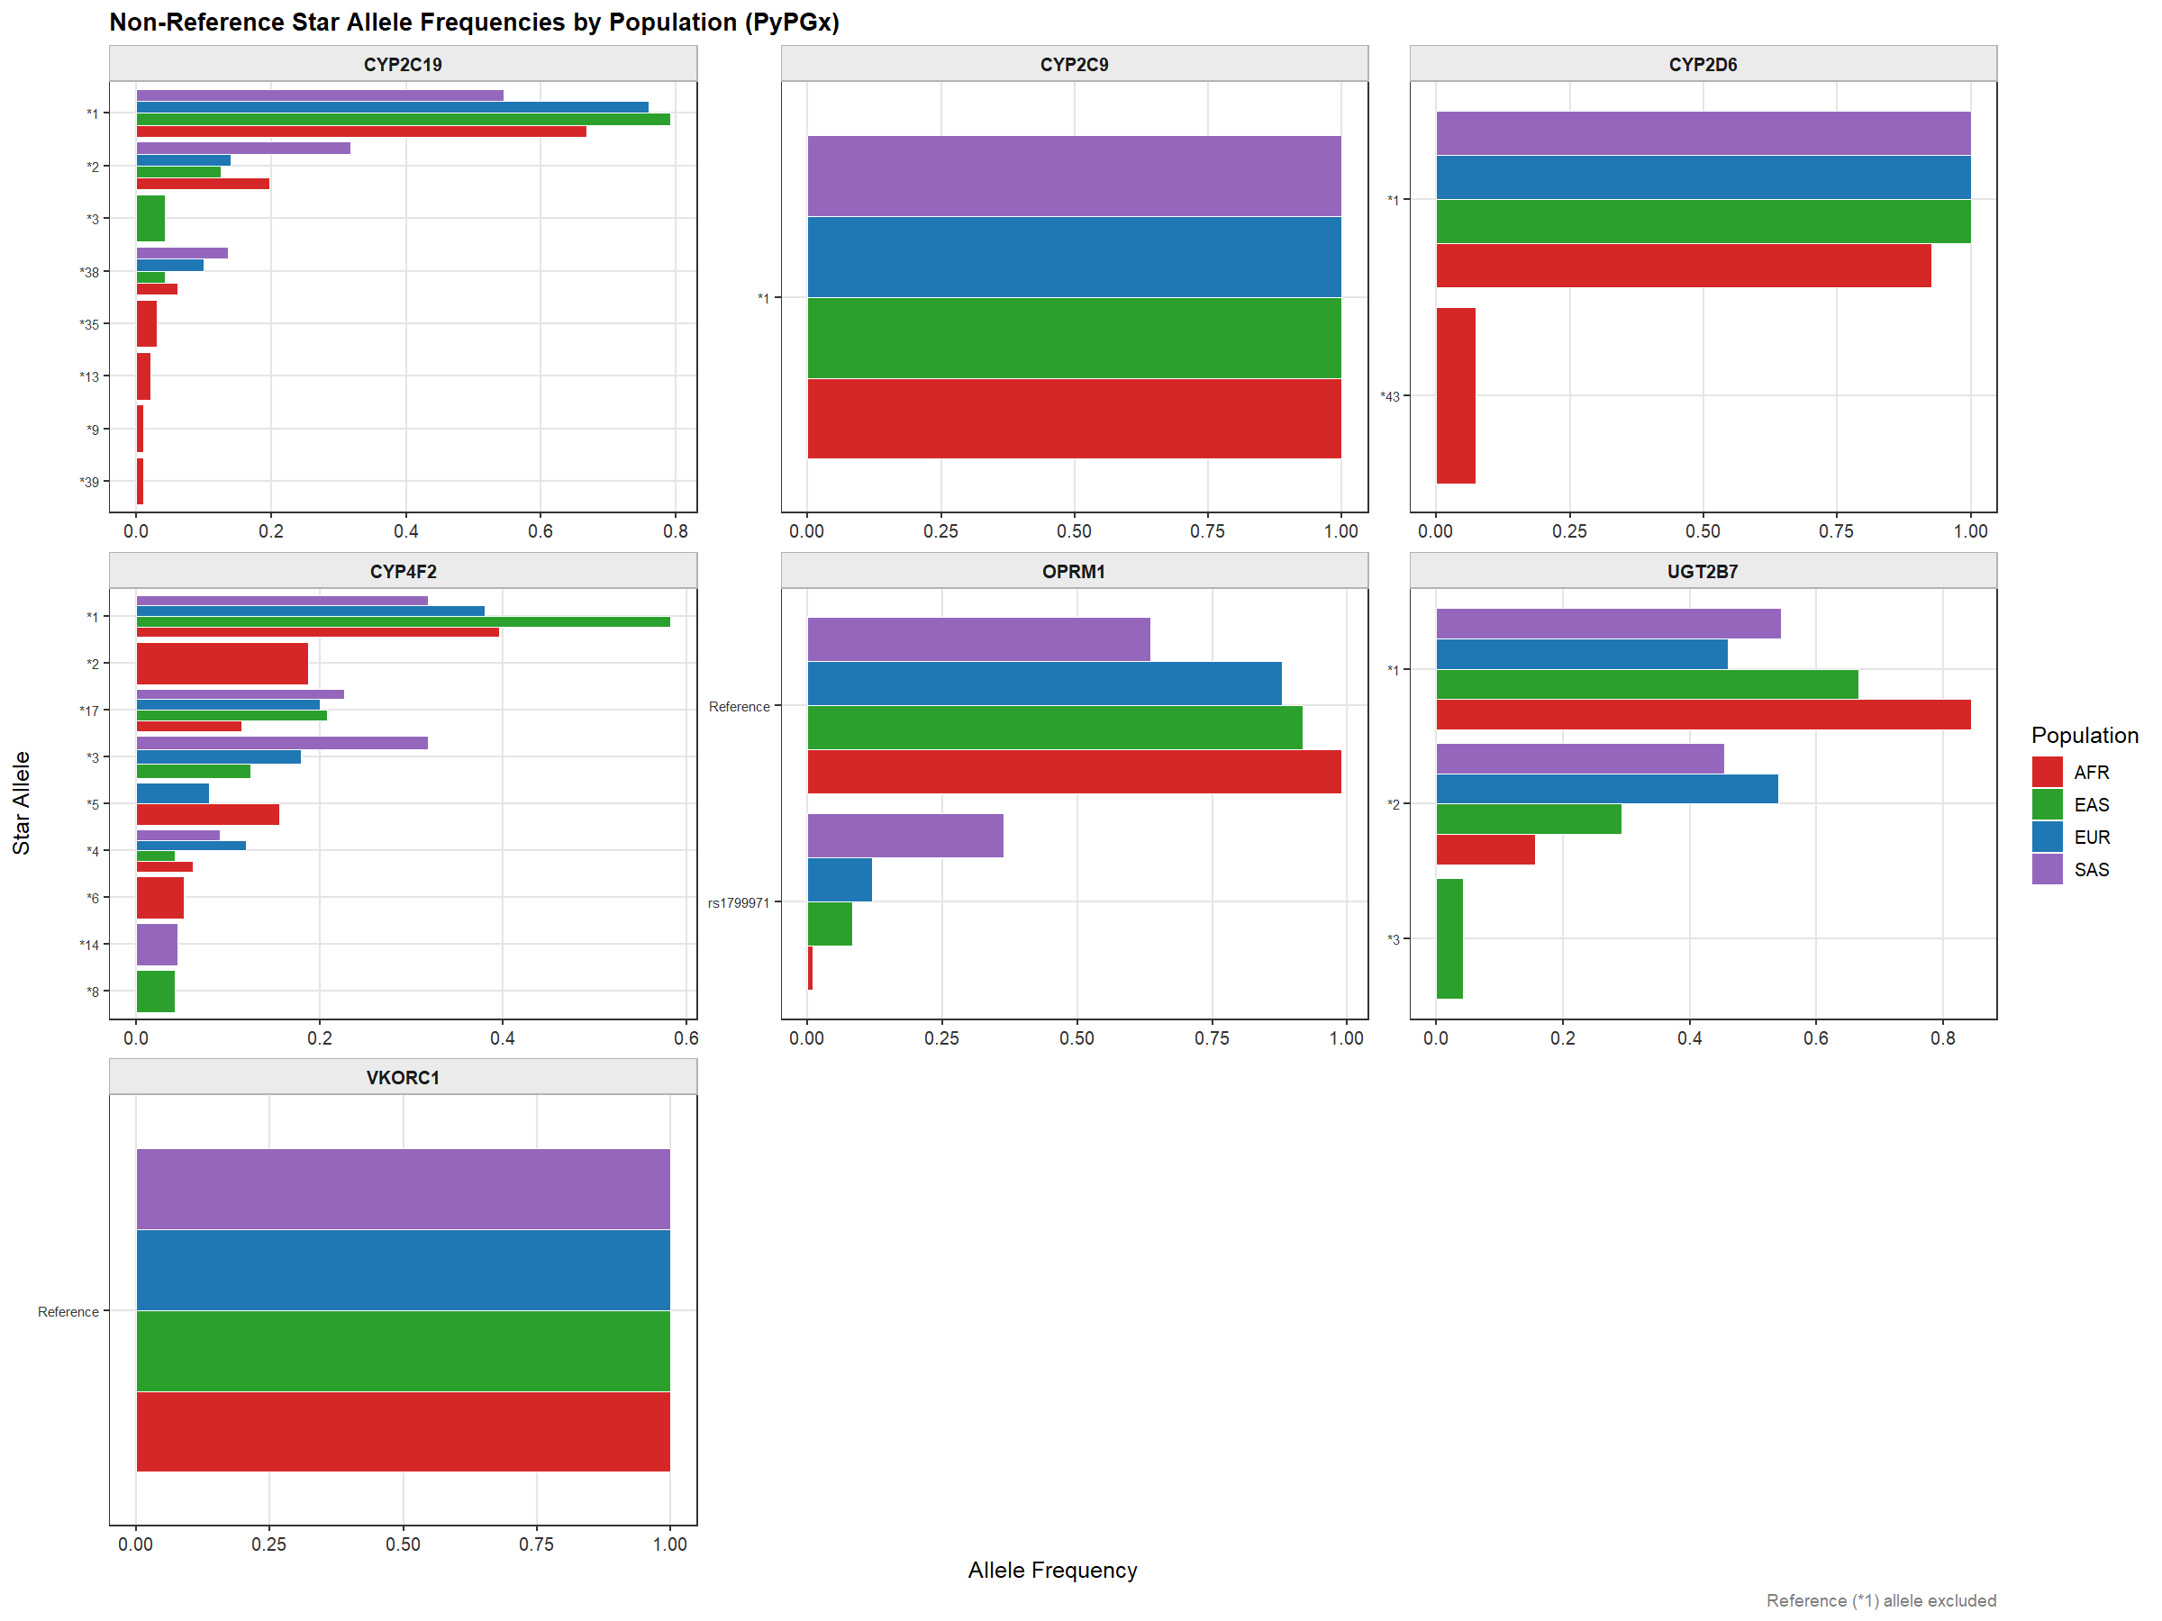
Non-reference CYP2C19 star allele frequencies by population (PyPGx). Bar chart showing allele frequencies for *2, *3, *38, *35, *13, *9, *39 across AFR, EAS, EUR, SAS.
Figure 14. Non-reference CYP2C19 star allele frequencies per population derived from PyPGx phased diplotype calling. CYP2C19*2 is the dominant non-reference allele across all populations. Multiple rare alleles are detected predominantly in AFR, consistent with greater African population allelic diversity.

Diplotype-to-phenotype translation using CPIC guidelines identified clinically significant proportions of reduced-function metabolisers across all populations. CYP2C19 Poor Metabolizers (PM; *2/*2, *2/*3, *3/*3 diplotypes) were identified in EAS (16.7%) and SAS (9.1%), with additional PMs in AFR (8.3%) and EUR (4%). Intermediate Metabolizers (IM; carrying one no-function allele with one normal-function allele) were substantially more prevalent: AFR 33.3%, EUR 24%, SAS 36.4%, EAS 0% (reflecting the small EAS cohort). Combined, the proportion of samples with reduced CYP2C19 function (PM + IM) was 41.7% in AFR, 16.7% in EAS, 28% in EUR, and 45.5% in SAS.

[Figure 15]
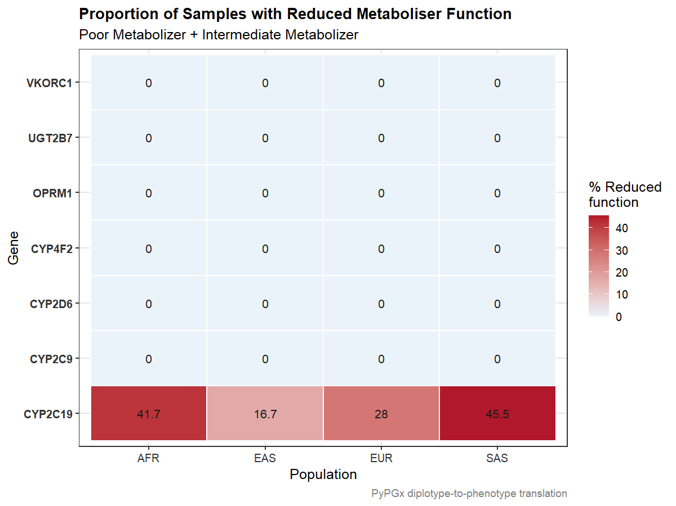
CYP2C19 reduced metaboliser function (PM + IM) by population. Bar chart with percentage labels.
Figure 15. Percentage of samples predicted as Poor Metabolizer or Intermediate Metabolizer for CYP2C19 per ancestral population. SAS shows the highest combined reduced-function frequency (45.5%), followed by AFR (41.7%), EUR (28%), and EAS (16.7%). These proportions have direct clinical implications for CYP2C19-metabolised drugs including clopidogrel, proton pump inhibitors, and tricyclic antidepressants.

[Figure 16]
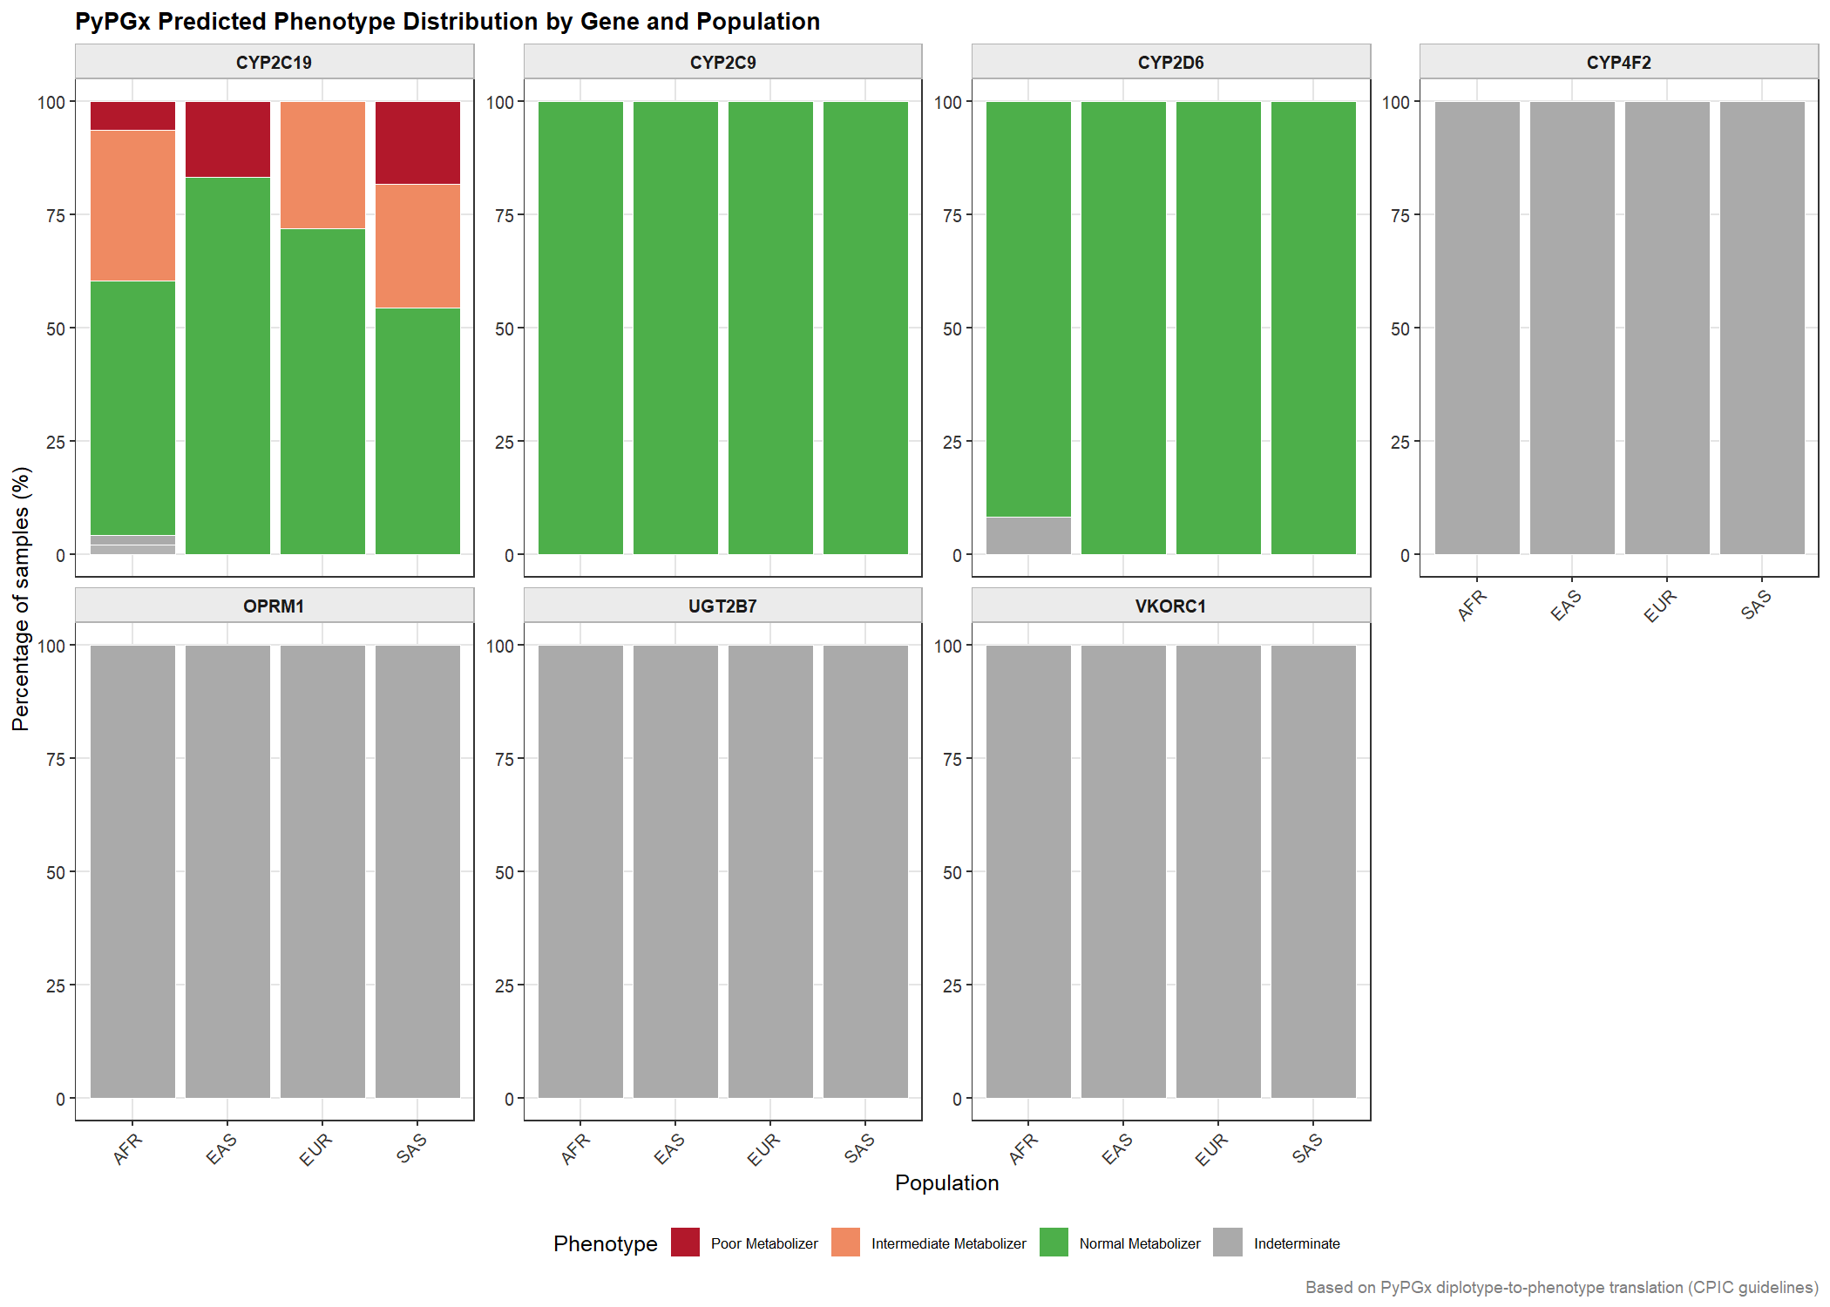
PyPGx predicted phenotype distribution by gene and population. Stacked bar chart showing Poor/Intermediate/Normal Metabolizer and Indeterminate proportions.
Figure 16. PyPGx predicted metaboliser phenotype proportions per gene per population. CYP2C19 is the only gene with resolved PM and IM phenotypes from WES data. All other genes show Indeterminate or entirely Normal Metabolizer calls, reflecting insufficient variant resolution for phased diplotype assignment from WES capture data.

[Figure 17]
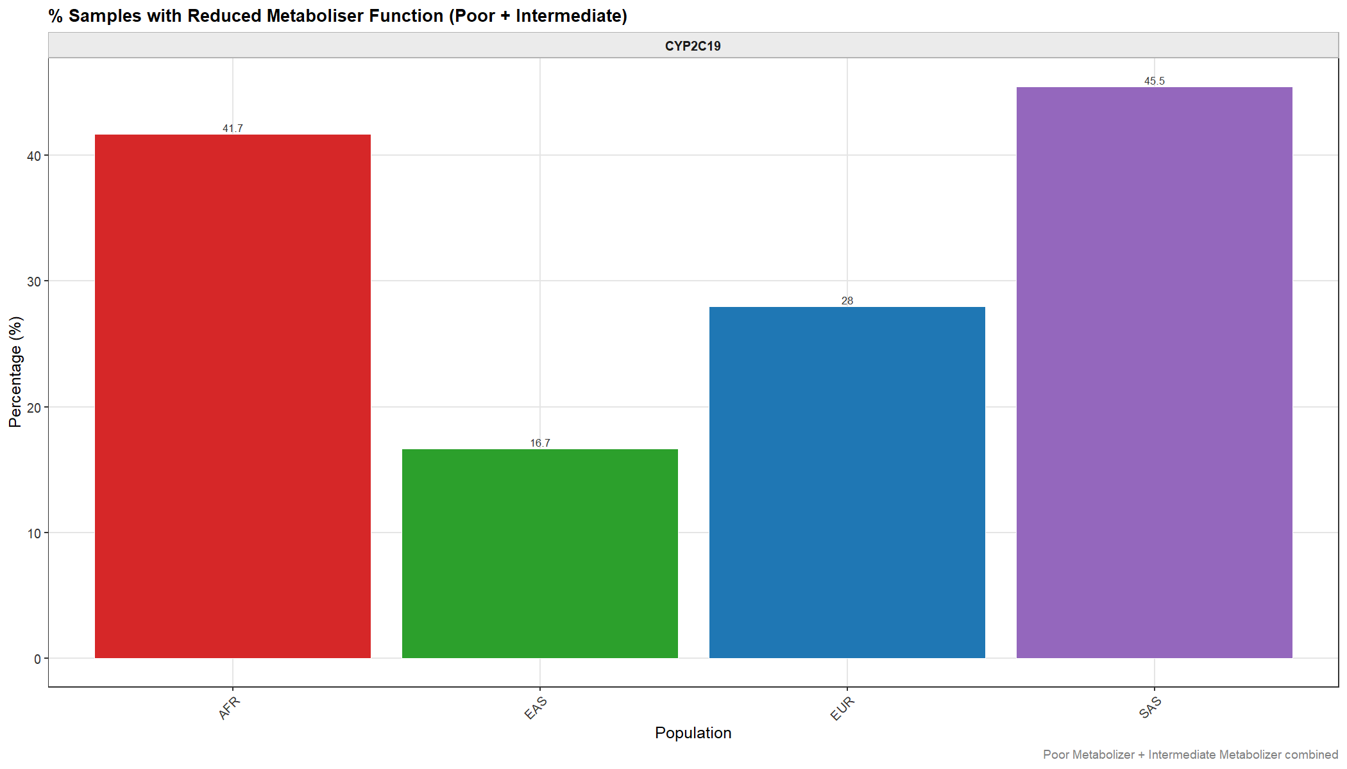
Reduced metaboliser function heatmap across all seven genes and four populations (PyPGx).
Figure 17. Heatmap of percentage samples with reduced metaboliser function per gene per population. CYP2C19 is the sole gene with non-zero values across all populations, with SAS (45.5%) and AFR (41.7%) showing the highest burden. All other pharmacogenes show 0% due to insufficient phasing resolution from WES.

3.9.3 Star Allele Findings for Other Pharmacogenes
For CYP4F2, PyPGx identified multiple non-reference alleles including *2, *3, *4, *5, *6, *8, *14, and *17 (Figure 14, CYP4F2 panel). CYP4F2*1 (reference) was most frequent across all populations. CYP4F2*2 was the most prevalent non-reference allele in AFR (~0.19), while *3 showed the highest frequency in SAS (~0.28) and EUR (~0.16). However, all CYP4F2 phenotype calls were Indeterminate because CYP4F2's CPIC phenotype system is based on activity score and requires diplotype resolution that was not achieved from WES data. The *3 allele frequencies here are consistent with those derived from the rsID-based VEP analysis (Section 3.3: SAS AF = 0.409, EUR = 0.300).
For UGT2B7, three alleles were resolved: *1 (reference), *2 (rs7439366, p.His268Tyr), and *3. UGT2B7*1 showed the highest frequency in AFR (~0.80), while *2 frequencies ranged from ~0.17 (AFR) to ~0.53 (SAS), consistent with the VEP-derived frequencies (AFR = 0.821 for the *2 variant). All UGT2B7 phenotype calls were Indeterminate due to insufficient phasing context.
For CYP2D6, only *1 and *43 were identified, with *43 appearing solely in AFR at low frequency (~0.10). The absence of the clinically important CYP2D6 *4, *5, *10, and *17 alleles reflects the known difficulties of short-read WES in this duplicated locus. All CYP2D6 phenotype calls were Normal Metabolizer or Indeterminate. For VKORC1 and OPRM1, only the reference haplotype was resolved by PyPGx, with the VKORC1 warfarin-sensitivity haplotype (H1/H2 system) and the OPRM1 rs1799971 variant not captured in the phased diplotype framework. For CYP2C9, only *1 was resolved in the majority of samples with all phenotypes reported as Normal Metabolizer, consistent with insufficient variant density for non-reference diplotype calling.

[Figure 18]

Non-reference star allele frequencies for all seven pharmacogenes by population (PyPGx). Faceted bar chart.
Figure 18. PyPGx-derived non-reference star allele frequencies per pharmacogene per population. CYP2C19 and CYP4F2 show the most diverse non-reference allele spectra. CYP2D6 shows only *43 as a non-reference allele in AFR. VKORC1 and CYP2C9 show only reference allele calls, reflecting WES resolution limits.

3.9.4 Drug Pathway Metaboliser Profile
The combined warfarin and codeine pathway profiles (Figure 19) confirm that CYP2C19 is the primary driver of pharmacogenomically actionable phenotype variation in this cohort detectable by WES-based PyPGx. In the warfarin pathway, CYP2C19 shows clear population stratification with the largest IM proportions in SAS and AFR, while CYP2C9, CYP4F2, and VKORC1 are uninformative from the PyPGx perspective. In the codeine pathway, CYP2D6 calls are entirely Normal Metabolizer or Indeterminate, and UGT2B7 and OPRM1 are Indeterminate across all populations, consistent with the WES limitations discussed above.
The CYP2C19 findings are clinically significant independent of the other genes. Reduced CYP2C19 function affects the metabolism of clopidogrel (antiplatelet), proton pump inhibitors, tricyclic antidepressants, and certain antifungals. The high prevalence of reduced-function phenotypes in SAS (45.5%) and AFR (41.7%) — populations underrepresented in most pharmacogenomic reference datasets — highlights the clinical urgency of population-inclusive pharmacogenomics research for these groups.

[Figure 19]
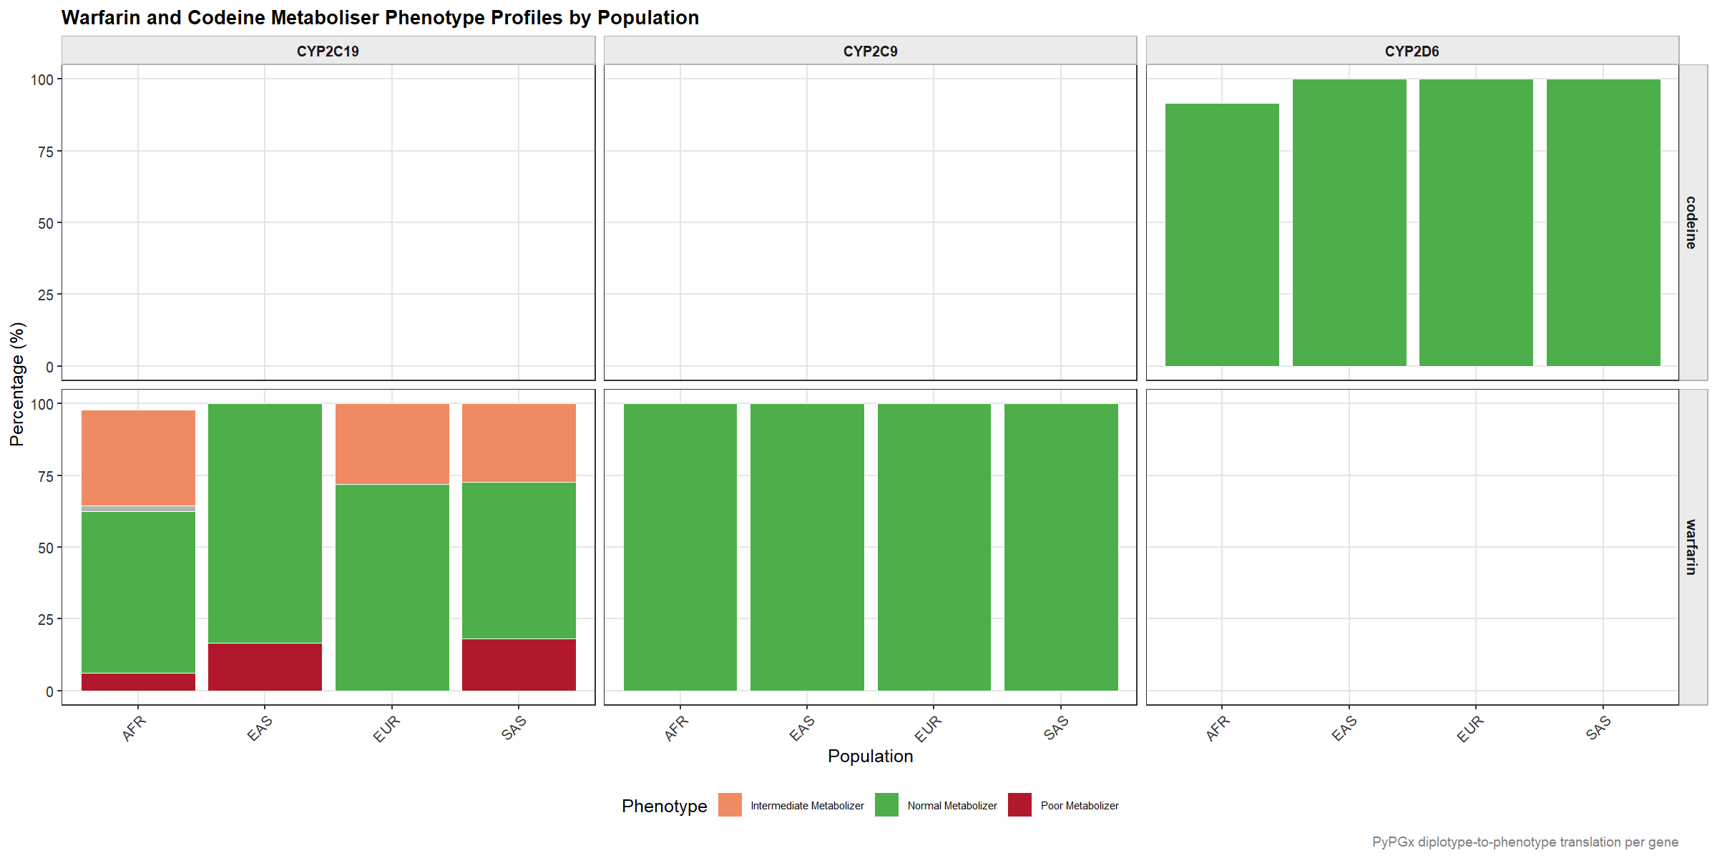
Warfarin and codeine metaboliser phenotype profiles by gene and population (PyPGx). Faceted grid Drug × Gene.
Figure 19. Warfarin and codeine pathway metaboliser phenotype profiles per gene per population. CYP2C19 (warfarin row) shows the only non-Normal phenotype distribution, with Poor and Intermediate Metabolizers present across all populations. All other genes show exclusively Normal Metabolizer or absent calls from WES-based PyPGx.

3.9.5 Integration with VEP-Based GATK Analysis
The PyPGx diplotype results and the VEP variant annotation results (Sections 3.1–3.8) are complementary and together provide a more complete pharmacogenomic characterisation than either approach alone. Table 1 summarises the key findings from each method for each gene.
For CYP2C19, the two approaches are in strong agreement. The VEP analysis identified CYP2C19*2 (AF: AFR = 0.221, EAS = 0.056, EUR = 0.146, SAS = 0.318) and CYP2C19*3 (EAS only, AF = 0.050) at the variant level. The PyPGx analysis translated these allele frequencies into diplotype-resolved phenotype predictions: 41.7% AFR, 16.7% EAS, 28% EUR, and 45.5% SAS with reduced CYP2C19 function. The concordance between the *2 variant allele frequency and the PM + IM phenotype proportion provides mutual validation of both pipelines.
For CYP4F2, the VEP analysis identified CYP4F2*3 (rs2108622) at population frequencies of AFR = 0.076, EAS = 0.182, EUR = 0.300, SAS = 0.409. PyPGx confirmed these allele frequency patterns but could not translate them to phenotype predictions due to WES diplotype limitations. For VKORC1, OPRM1, and UGT2B7, the VEP-based rsID analysis (Section 3.3) provides the primary star allele frequency data, with PyPGx unable to add diplotype-resolved phenotype predictions. For CYP2D6, neither approach successfully recovered the full clinical star allele spectrum: VEP-based matching found no rsID matches for the three detected variants, and PyPGx resolved only *43 in AFR. This is an expected outcome given the known structural complexity and short-read mappability challenges of the CYP2D6 locus.
In summary, the VEP-based analysis provides broader pharmacogenomic variant coverage across all nine genes and all populations, while the PyPGx analysis provides clinically actionable phenotype predictions specifically for CYP2C19 — the gene with the highest reduced-function prevalence in this cohort and the most complete variant representation in WES data. Together, the two analyses establish a comprehensive pharmacogenomic variant landscape for warfarin and codeine metabolism in African, European, East Asian, and South Asian populations, with particular emphasis on the high CYP2C19 reduced-metaboliser burden in AFR and SAS populations that is currently underrepresented in clinical pharmacogenomic guidelines.

