An AVR programmer development base on the UNO

Introducing the UNO AVR programmer

An Atmega 328 device pre-loaded with the Arduino bootloader and the UNO hardware make a very effective combination for developing and running C applications. It is also quite straightforward to program the UNO using a range of external programmers or with another UNO. Arduino is in fact a very flexible system for developing AVR applications. The purpose of the development described here is to extent this flexibility, making it easy to convert the UNO into a general purpose programmer for a number of the Atmega devices.

An Arduino application “UNO_AVR_programmer” is introduced that is hosted on the UNO and enables it to be used to program Atmega devices as follows:

Flash with a hex file loaded at address zero.
Flash with a text file loaded from the maximum address.
The configuration bytes.
The EEPROM with text and numbers.

Two Atmel Studio 7 applications are provided for an Atmega target device.

The first, “Cal_auto_plus_manual” is used to calibrate the target device.
The second, “text_reader” contains the subroutines needed to read text from the flash.
Sample text files are also provided.

Once programming is complete, the target device is automatically put into the run state and the UNO reset button must be pressed to reinitialise the programmer.
Note: Atmel Studio has been chosen because it can build projects for any Atmega device.

UNO programmer Hard Ware.

A photograph of the HW is shown below. The Atmega 328 target is loaded into some plug-in prototyping breadboard and the following connections between the UNO and target are made:

UNO output |  | Atmega 328 target pin and pin number
5V |  | 5V | 7 & 20
0V |  | 0V | 8 and 22
Rx |  | USART TXD | 3
Tx |  | USART RXD | 2
Digital 11 | MOSI | MOSI | 17
Digital 12 | MISO | MISO | 18
Digital 13 | SCK | SCK | 19
A3 |  | Reset | 1
In addition the following extra components are used;
A watch crystal between pins 9 and 10 (TOSC1 and TOSC2) of the target device
A 100nF capacitor between pins 7 and 8 of the target device
A led and 1K resistor between digital output 8 (PB0) of the UNO and 0V.
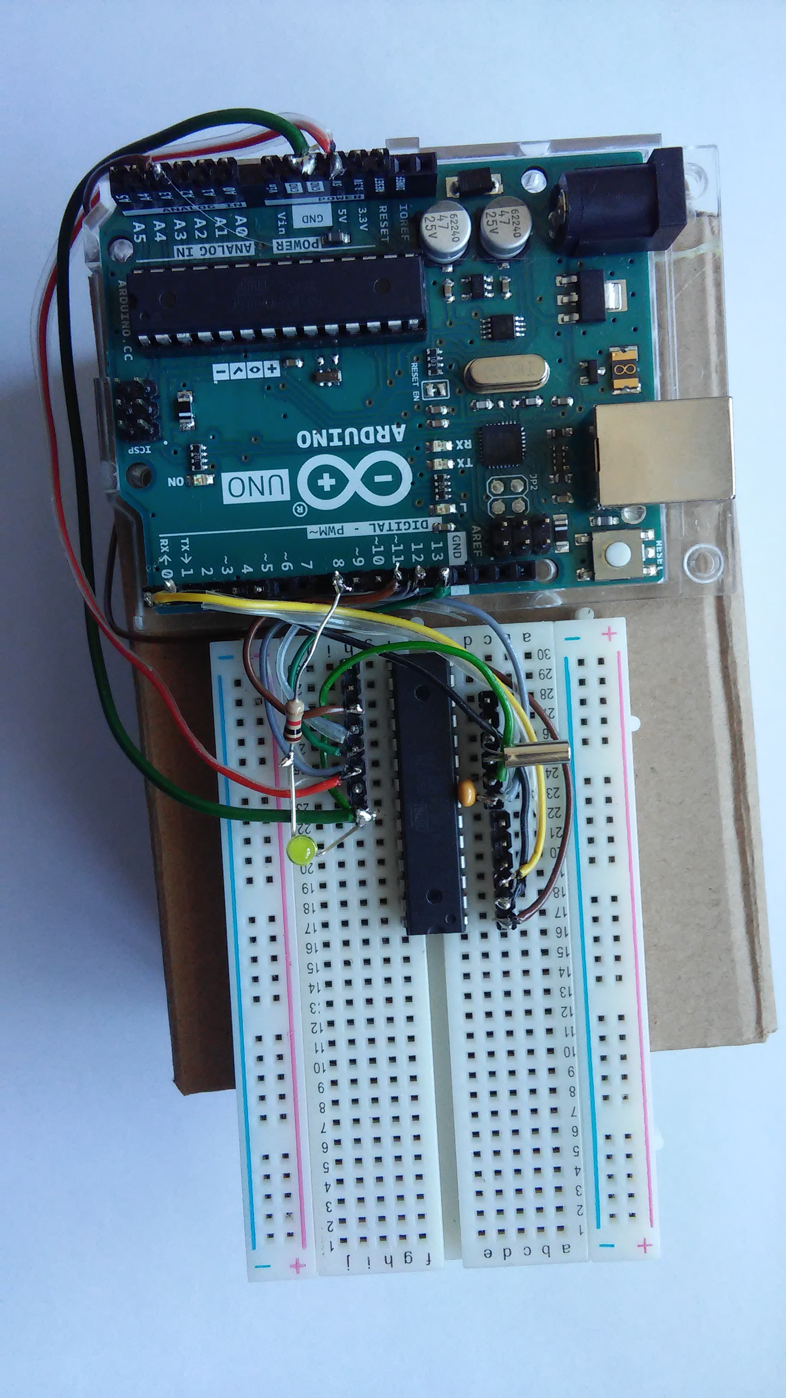 | UNO Programmer HW:  The UNO and breadboard are mounted on a cardboard box.  Note especially the 100nF capacitor beside the crystal. This is particularly important for obtaining an accurate user OSCCAL value.

A user interface for the UNO programmer
A PC application normally used for sending hex files to the target processor hardware has not been written. Instead a terminal program is used and the entire hex file is sent to the UNO. Arduino comes with a basic terminal program and there are several others on the web.
My favourite can be downloaded from https://sites.google.com/site/terminalbpp/. But take care to download the version 20130820, other versions may have an issue with the "scroll" button. Settings for the terminal program are: Baud rate: 38400, 8 data bits, no parity, 1 stop bit and no handshaking.
Running the “UNO_programmer”

Connect the UNO to the PC and open the Arduino application “UNO_programmer”. It should upload OK. Check the comm port number if there are problems.

Open the terminal program. User prompt “s s s s …..” should be generated.
Left click the mouse in the grey area at the bottom of its window and press ‘s’.
The programmer should respond with the message “Target_not_detected”.

Complete the test jig and repeat. This time the response should be either
“Atmega unknown”
or
“Atmega 168/P detected. (Assuming an Atmega168 target)
Press -p- to program flash, -e- for EEPROM or -x- to escape.”

If the target is not recognised its details can be added to the file “Device_characteristics” which is opened by Arduino alongside the main subroutine and header file.

Programming hex files

Press ‘p’ to program a hex file.
Click the “Send File” box and send a hex file when requested.
Press ‘0’ at the “Integer(0-FF)?” prompt.
The file size and config bytes should be printed out.
Note: The config bytes have not been programmed.
For an unused device this gives the default configuration bytes

These use the calibrated RC oscillator for the system clock. Usually if not always they also ensure that the watch dog timer is always on and the chip erase command also clears the EEPROM.

Programming the configuration bytes

Press ‘P’ rather than ‘p’ to program both the hex file and calibration bytes. It is important to check their settings first. Values already entered in file “Device_characteristics” put the watch dog under program control and ensure the EEPROM is only deleted by specific user action. (Press ‘s’ then ‘d’ at the user prompt.)

Programming text files

If ‘y’ is pressed at the “Text_file? y or n” prompt a text file will be requested and immediately echoed back to the terminal program.
Which ever is pressed the program will automatically be launched.
Note that the baud rate must temporarily be reduced while the text is being uploaded.

Programming the EEPROM

At the “s s s…….” prompt press ‘s’, ‘e’ and ‘w’.
Press ‘0’ at the “Integer(0-FF)?” prompt and send the file.
Note that the file has to be sent several times however there is no need to change the baud rate.
At the AK prompt press any key.

Each string is terminated in a null character and is echoed to the screen together with its address.
User applications will require these addresses so that they can print the strings out.
Sample text files are included for both flash and EEPROM.

Target device calibration

The application “Cal_auto_plus_manual” stores calibration bytes in the top two addresses of the target device eeprom. User applications can do without the crystal. Instead they read these bytes and use them to replace the default value of the OSCCAL register.
There is of course no need to restrict the target device to using its internal RC oscillator. However it is the default selection and is in many cases very convenient to do so.

Running the “Cal_auto_plus_manual” application

Connect the programmer to the PC and open the terminal program.
Download the hex file as described above.
There is no text file.
Auto cal will start running automatically and the following dialogue will be printed.
“Calibrating Atmega 168/P
New OSCCAL value 78 (for example)
Press 'x' to finish or Any Other Key for manual cal”

Reading text from the Flash and EEPROM

Upload the application “Text reader” followed by the text file.
The text strings are echoed to the terminal program in numbered format.
Three subroutines are introduced:

“string_counter()”: This counts the number of strings programmed to the flash.
“print_string_num(string_num)”: This prints out any numbered string.
“Char_from_flash()” which implements the “lpm” (load program memory) command.

Note:
Each string is terminated by a null character and the final one is terminated by two.
Both subroutines also need to know the size of the flash in words (3FFF for the Atmega 328).

Code is also included to read strings from the EEPROM.

Configuring the programmer for a range of target devices.

Details of the target device must be entered in the subroutine “set_up_target_parameters()” present in file “Device_characteristics”.

Details have already been entered for the Atmega 48, 88, 168, 328, 32, 644 and ATtiny44 devices.
The user can enter details for their chosen.

Target device data required by the programmer

To program text, data and the calibration bytes
EE_size The amount of EEPROM
FlashSZ The amount of flash

To identify the device more fully:
The second signature and third signature bytes

More details of the flash:
PageSZ The page size
Pamask The page address mask which equals FlashSZ – PageSZ.

The configuration bytes:
Fuses: extended, high and low and the lock byte

Setting up user programs

“UNO Programmer” programs the second and third of the target’s signature bytes at the top of its EEPROM. In all the top five locations should be considered as reserved. These are

EE_size - 1 User calibration byte. (This it the top EEPROM byte)
EE_size - 2 User calibration byte repeated.
EE_size - 3 The default calibration byte.
EE_size - 4 Signature byte 2
EE_size - 5 Signature byte 3
EE_size - 6 EE_top the last byte available for use by the user text/data.

Application “Text_reader_Studio” is intended as a template.
Code segment “setup_HW” is contained in Resources\Text_reader.h
It calls code segment “set_device_type_and_memory_size”.
This reads the second signature byte which determines the device size

Code segment “set_device_type_and_memory_size” is provided for inclusion in user programs.
It reads the signature byte and hence reads off the flash and eeprom sizes.

In the “Text_reader” application code segment “Setup_HW” calls “set_device_type_and_memory_size”

In its turn it calls “Set_device_signatures”. Full details of these code segments can be found in “Text_reader.h”. It is anticipate that these segments would be copied into user applications.

Note:
This process simplifies porting programs between one Atmega device and another.
Thanks to the Atmega architecture it is not necessary to know the EEPROM size to read the signature byte.

Test jig for programmed devices

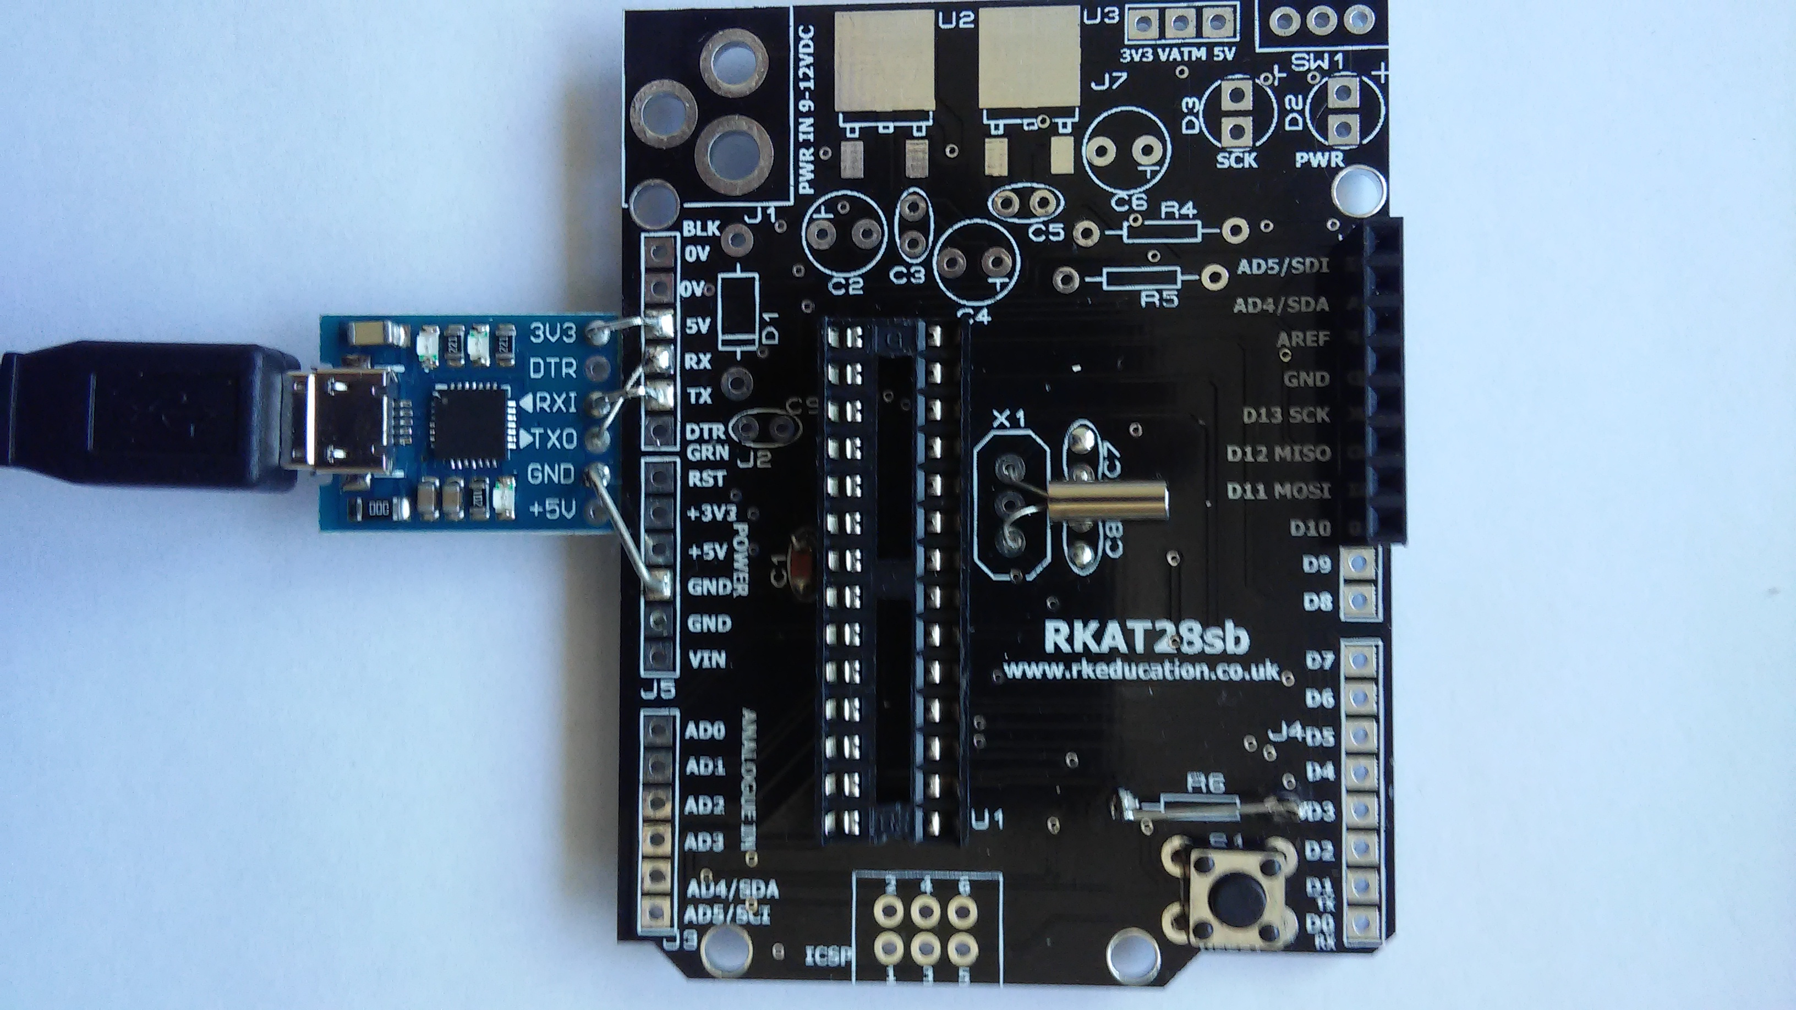 | Consists of an RKAT28sb Arduino shield  plus  CP2102 micro USB bridge.  Both available on ebay.  18pF trimmer capacitors are used with the watch crystal.

A device having been programmed on the UNO programmer HW was transferred to the test jig where it functioned satisfactorily. A crystal was also added to confirm that the user calibration byte obtained using breadboard was compatible with a double sided pcb.

NOTE: if reloading the UNO_programmer the target device Rx/Tx ports will usually have to be temporarily disconnected.

Devices with which the UNO_programmer has been tested

Atmega 328/P
Atmega 168/P
Introducing the Atmeg644 a 40 pin version of the Atmega 328 with 64K of flash.

The UNO pcb plus Atmega328 loaded with the Arduino bootloader: A great combination for getting to grips with the C programming language and microcontrollers.

But what comes next, where do we progress to from there. Entrance the 40 pin Atmega 644 with its massive 64Kb of flash and 2kB of EEPROM, the UNO programmer and Atmel Studio 7.

For many of us 64Kof flash is probably like playing table tennis on a football field.

But the extra IO could easily come in really useful.

The 328 has 23 IO lines some of which may be reserved for other things like a crystal or reset.

The 644 has 32 IO lines plus dedicated ports for reset and crystal.

It is surprising how quickly IO gets used up especially for keypads, user switches, displays, analogue inputs and outputs (one of these can consume up to 10 digital outputs).

28 of its IO lines could be used to drive a four digit 7 segment led display (at least in theory). A transistor may be required to buffer each of the IO lines. Alternatively some sort of multiplexing could be used to limit the current drain to an amount within the 644 capability.

There are three steps in the migration from Arduino and the Atmega 328 to the 644.

The first is a programmer, the second is a compiler and the third is an evaluation pcb.

A programmer is introduced here. It is an Arduino project that is uploaded to a UNO in the normal way. It does not come with its own user interface, instead it uses a terminal program a number of which can be downloaded from the web. Bray++ is the one recommended here.

For the compiler Atmel Studio 7 is recommended. Its look and feel is very similar to that of the Arduino. There are however two important differences. On the plus side Studio 7 can compile projects for many AVR devices rather than just for the Atmega 328. However on the minus side it does not appear come with an easy interface to bootloader code in the way that Arduino does.

The evaluation pcb can initially be as simple as piece of solder-less breadboard especially if the device is running off its internal RC clock. Connection to a PC can easily be provided using an evaluation pcb for a USB to UART bridge.

A good one can be obtained from ebay by searching on “Micro-USB to UART TTL Module 6Pin Serial Converter CP2102 STC I6S3”. It can also act as a power supply rated up to several hundred mA at 3.3V. Having connected a module to a PC it seems to have no trouble automatically finding and installing its drivers from the web.

Having got this working how about migrating to the free Eagle pcb design tool. Having mastered it everything is so much easier and quicker. FTDI do a friendly USB bridge that can be hand soldered. Remember though the eagle footprints are not necessarily suitable for hand soldering. Extra copper is required to transfer heat and solder from the iron to the pad. Also remember that solder (especially lead free) is pretty toxic stuff. Follow the safety advice!

It is possible to program the flash with hex and text strings, the EEPROM with text and numeric data and also to program the configuration bytes. The 64kB of flash will have plenty of space for storing all sorts of information about the project for example, what is its purpose, how to operate it and anything else that users might need to know about it. Three subroutines are provided that the user code can call upon to read text strings out of the flash. The first counts the number of strings. The second prints out any string requiring only its number and the third executes the lpm (load program memory) command that actually reads a location in flash. Text is stored starting at location 7FFF and working towards location zero. Hex is stored starting at location zero.

In addition to the Atmega 644, other Atmega devices can also be programmed. Tests have been carried out with the 48, 88, 168 and 328 devices.

Arduino pcbs

Yun
Uno

