PCB_111000_1 Set Up

The PCB_111000_1 project hard ware consists of two programming pcbs and the PCB11100_1 project pcb.

The Programming PCB’s

PCB-1: The USBasp programming pcb which consists of
Plug-in solderless breadboard USBasp programmer
CP2102 micro USB bridge A watch crystal

The CP2102 micro USB bridge and USB programmer were purchased from E-bay. To identify them search in Ebay under
6 Pin CP2102 Micro USB To UART TTL Module Serial Converter STC For Arduino and
USBASP USB ISP Programmer AVR ATMEL ATMega8 Download Pin IDC Cable 3.3V 5V UK

PCB-2: A modified project pcb:
the displays have not been loaded
The Atmega 328 is permanently connected
A DIL socket is provided for the Atmega 168.
An additional watch crystal is provided for the Atmega 168
The crystal shares in IO pin with the middle of the 3 user switches.
A track has been cut isolating the switch. (Alternatively the switch could be omitted))
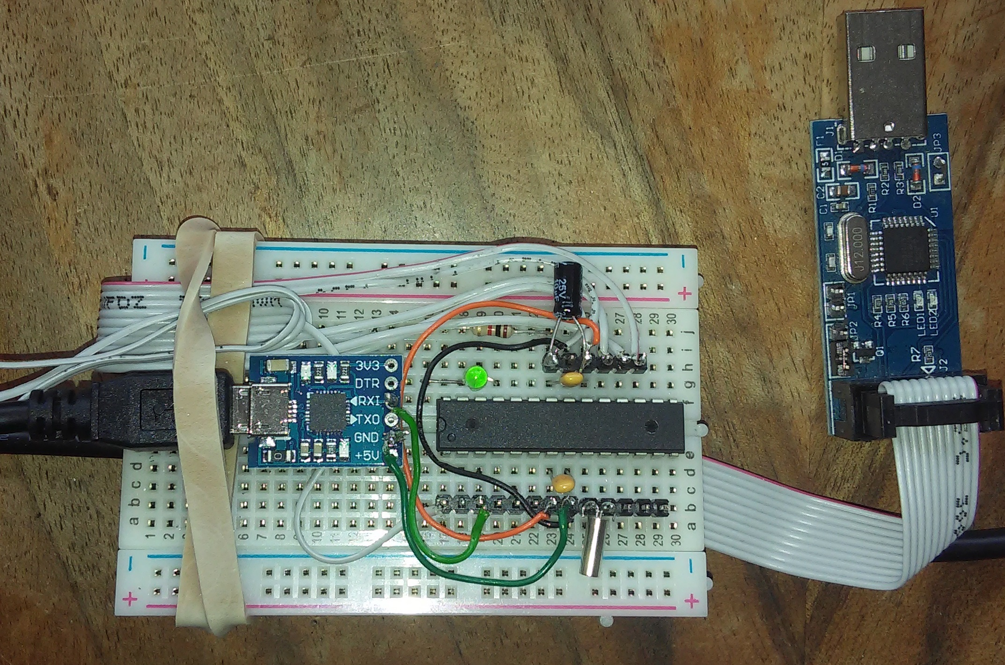 | Top USBasp programmer with target device
Bottom left
Top side of PCB111000_1 programmer or project pcb.
DIL socket is used for programmer.
Bottom right
Underside of PCB111000_1 programmer or project PCB showing ATMEGA 328
No DIL socket (also shows additional crystal)
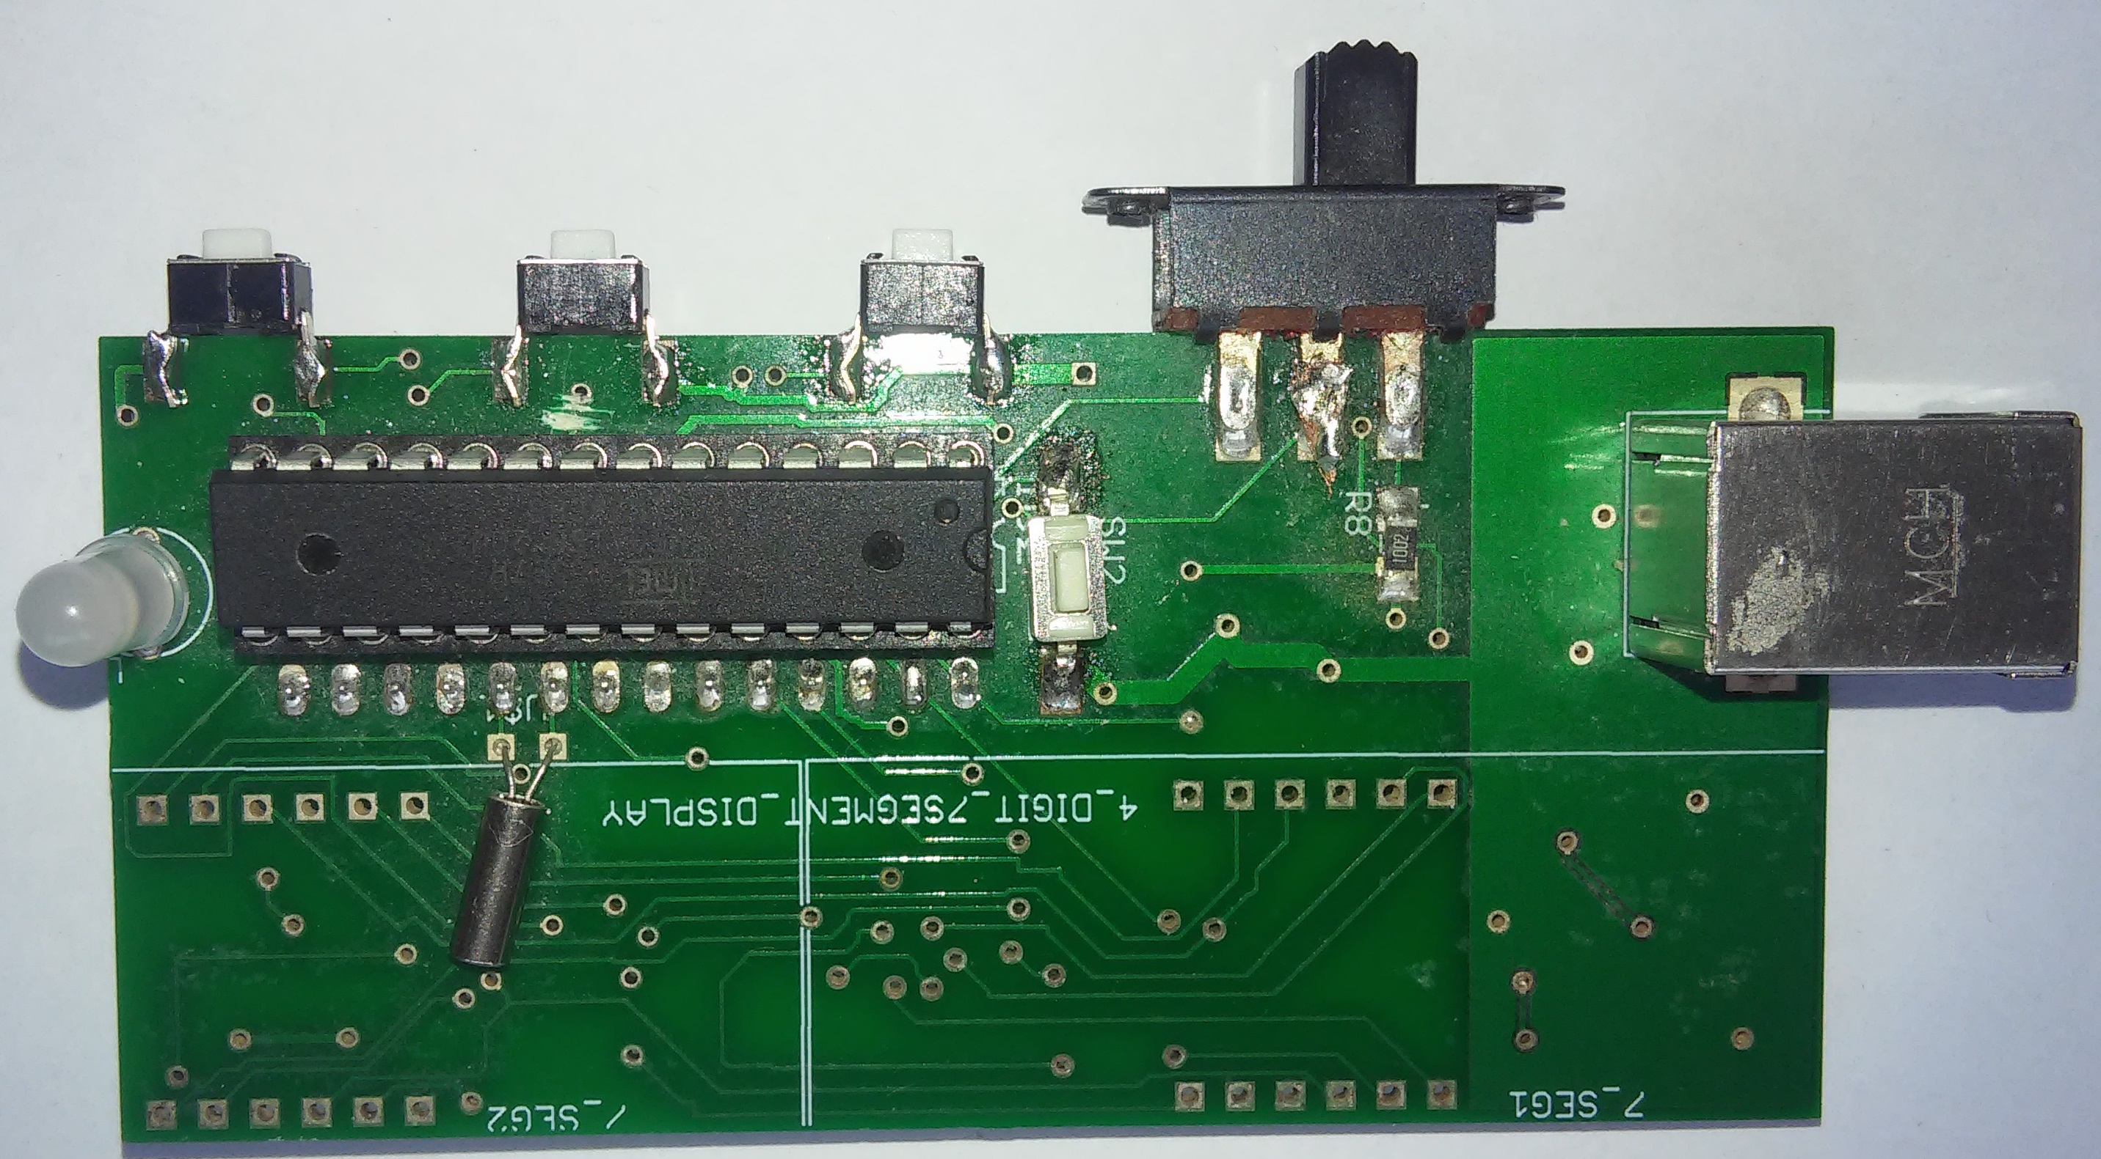 | 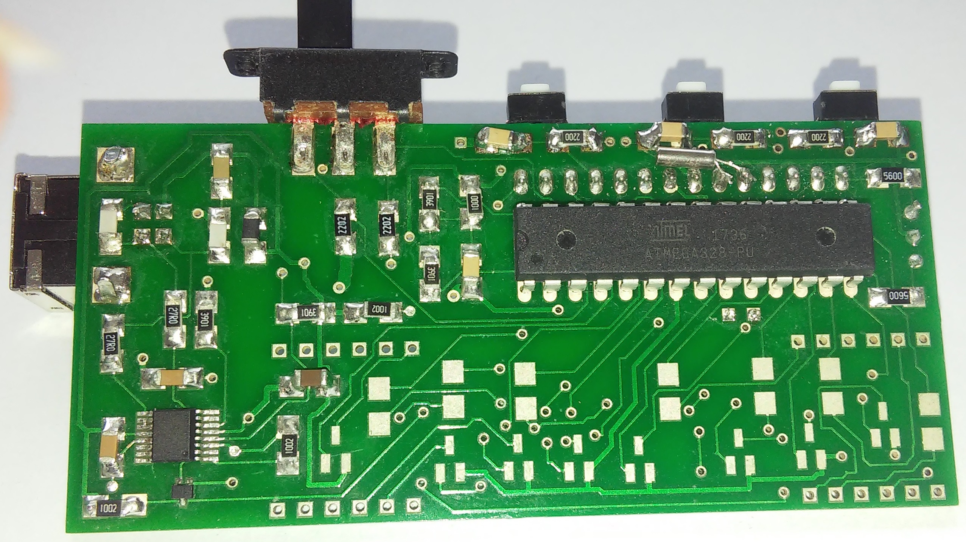
Note: USBasp is set to 5V operation, low speed clock. It powers the target device.
CP2102 is a 3V device and is only used to send data from the target device to the PC.

System Soft ware:

Programmer “4_Project_pcb_168_V2.30B”:
Resides on the Atmega 168
Programs the Atmega 328 with the mini-OS and bootloader
Utility to delete the Atmega 168 calibration bytes
Text file containing user prompts required by “4_Project_pcb_168_V2.30B”

Mini-OS/bootloader
Drives the 8 digit 7 segment displays
Programs the Atmega 168 with the user projects
Provides OS services for use by thee user projects

Setting up a new project pcb using the usbasp programmer

The USBasp programmer requires two USB sockets.

Down load the “4_Project_pcb_168_V2.30B” hex file to an Atmega 168.
Assuming a new device it automatically calibrates itself when it first runs
(If it is not new EEPROM locations 0x1FD, E and F should be deleted.)

Solder the device into a Project PCB along with an Atmega 328.
Switch the PCB DPDT slider to the left so that the Atmega 168 runs.
Connect it to a PC running a terminal program
At the “P…….P…….” user prompt press S and download the user prompts to the Atmega168 EEPROM.
When the “P…….P…….” user prompt returns press:
E to program the Atmega 328 EEPROM with a “hello world text file”
P to program the Atmega 328 flash with the mini-OS and bootloader.
The Atmega328 automatically calibrates itself the first time that it runs
Switch the DPDT switch to the right to get the “p/r…..p/r…….” use prompt.
Press “p” to program a user project and “r” to run it.

Setting up a new project pcb using the PCB111000_1 programmer programmer

Program the ATMEGA 328 with the “mini-OS and bootloader” as described above.
Replace the original ATMEGA168 containing the “4_Project_pcb_168_V2.30B” hex file with a new device.
Use the bootloader to put “4_Project_pcb_168_V2.30B” onto the new device.
It will automatically calibrate itself the first time that it runs.
Press “S” at the “P…….P…….” user prompt and download the text file containing the remaining user prompts.

Recalibrating the devices:

Switch the DPDT left and hold SW3 down while powering the pcb. At the “R…….R…….” user prompt press “R” and the Atmega auto cal routine will run.

Load the Atmega168 auto cal or manual cal user projects to recalibrate the Atmega 168.

