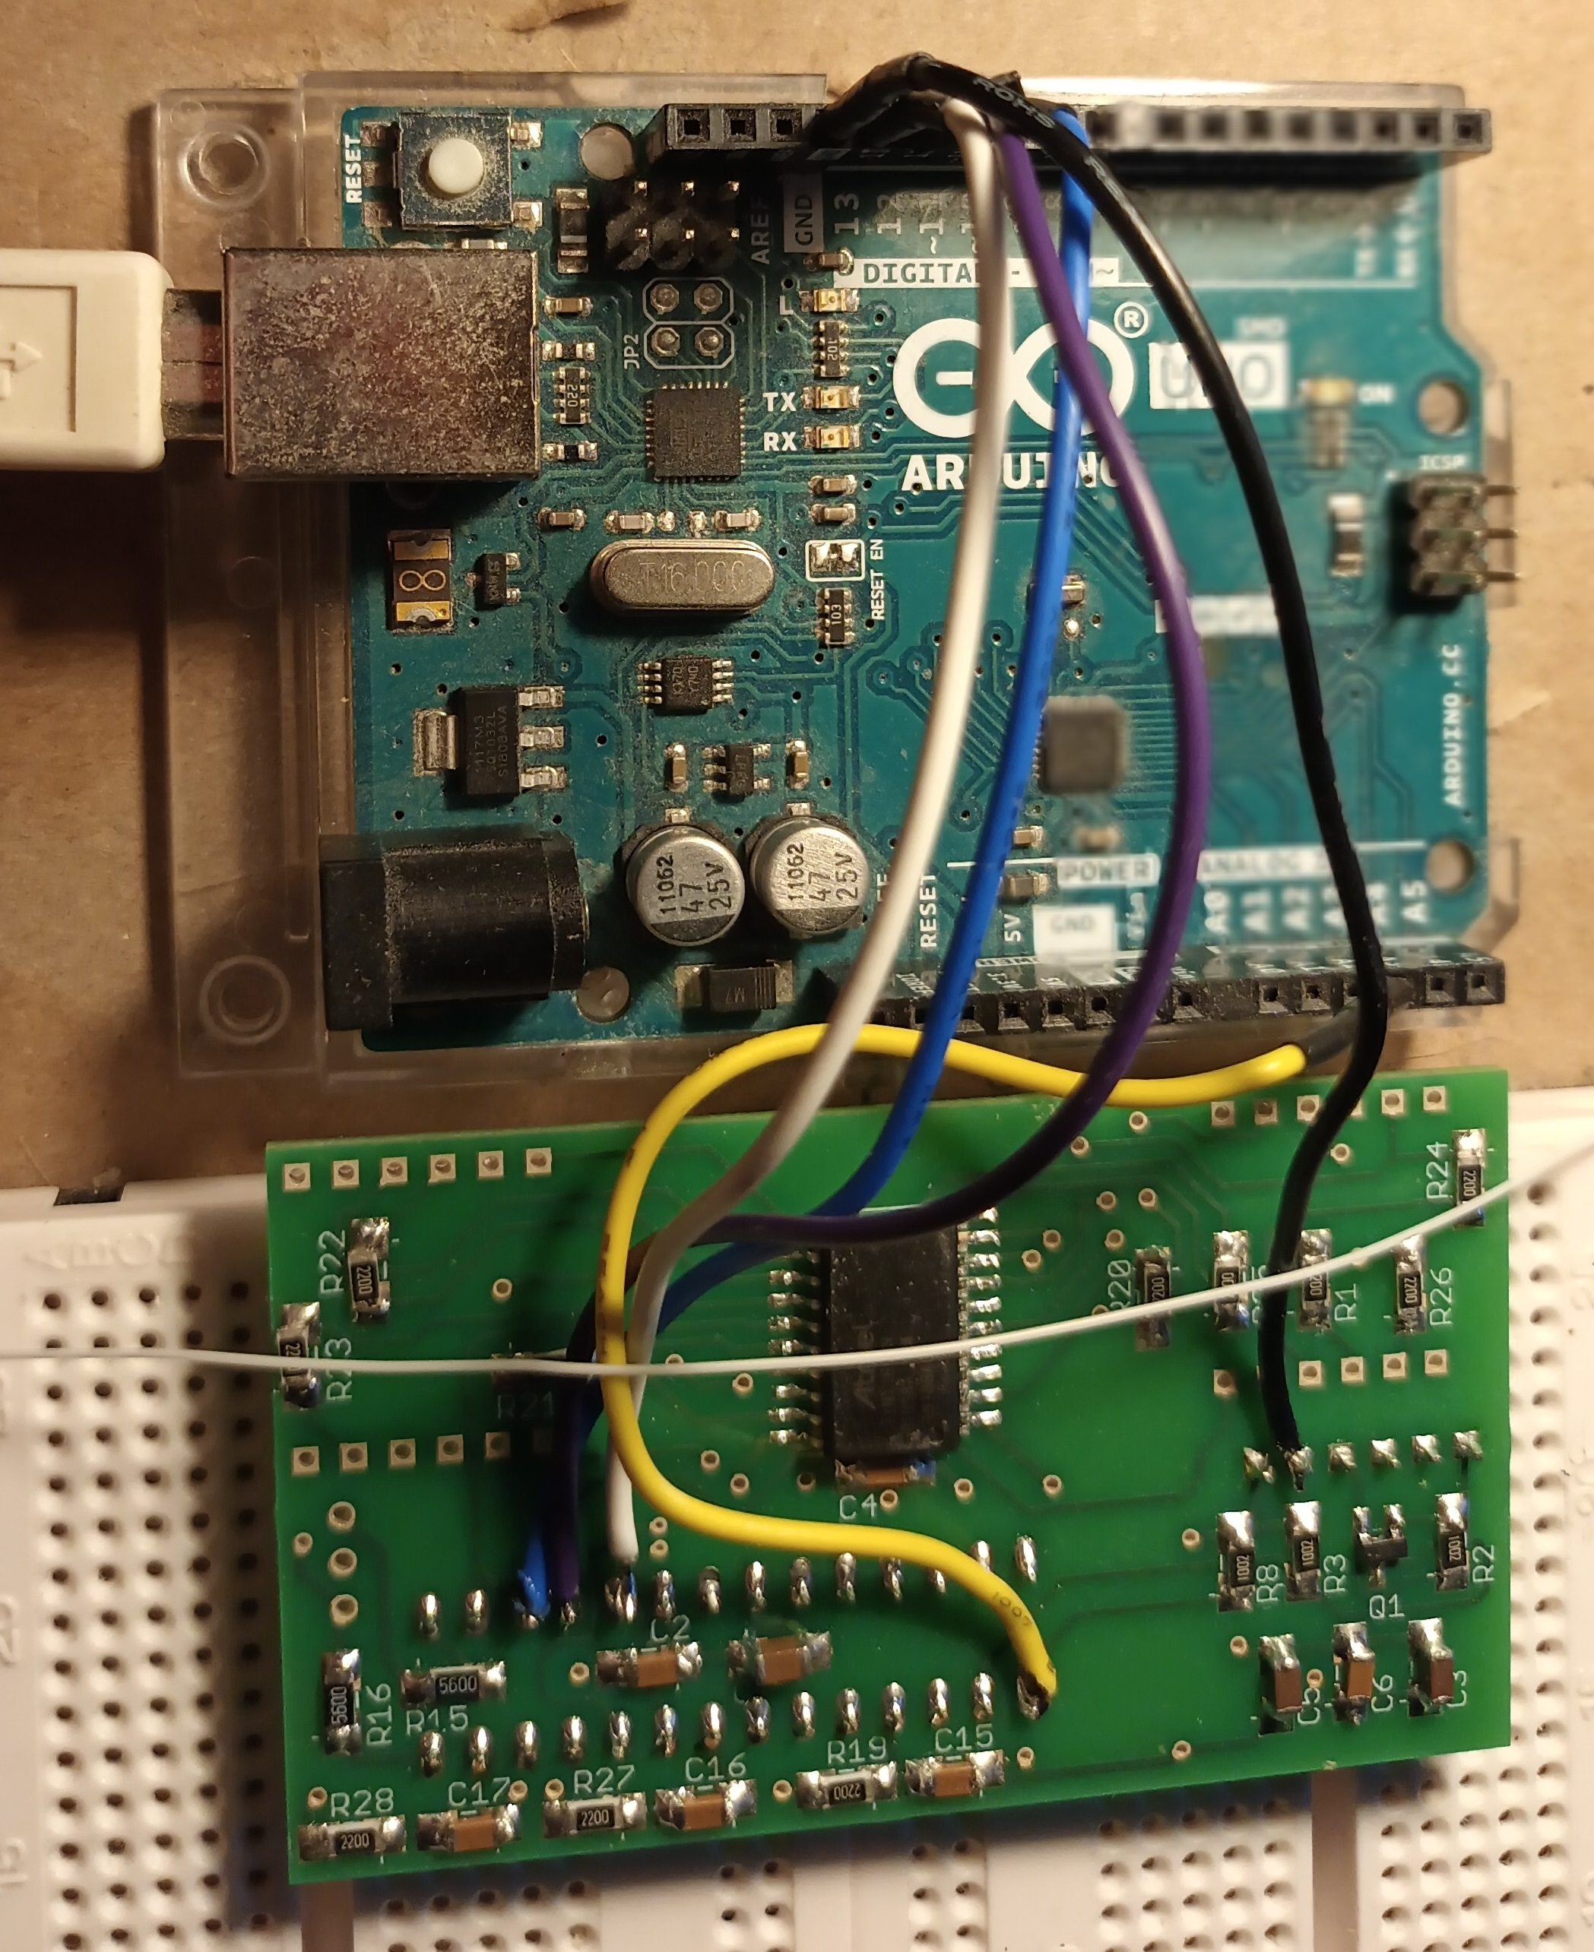 | 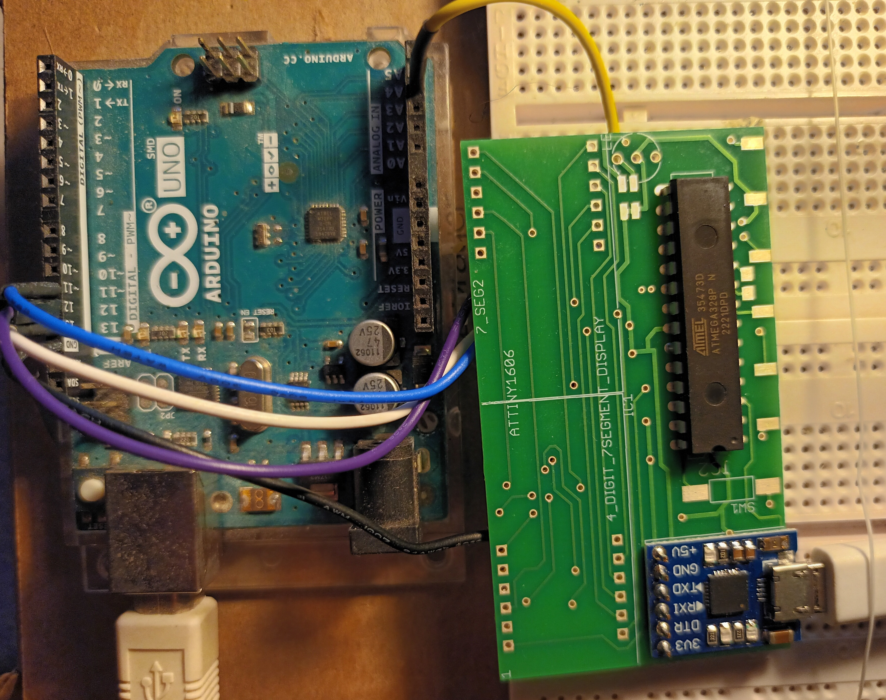
 | Interconnections
 | Colour | UNO pin | PCB: Atmega pin
 | Yellow | A3 | 1
 | White | 13 | 19
 | Mauve | 12 | 18
 | Blue | 11 | 17
 | Black | GND | 0V
Fig 1 UNO and PCB111000_CP2102 configured to upload the mini_OS and bootloader and calibrate the Atmega328 internal RC clock and one wire comms link.

