Introducing PCB111000_CP2102

PCB111000_CP2102 is a cut down version of PCB_111000_UNO posted by osbornema on 18 July 2020. It is designed to provide an introduction to C programming for AVR devices and consists of:
A CP2102 module with Rx/Tx and power provided on a 6 pin header
An Atmeg328 for user programs
An ATtiny 1606 that drives an 8 digit seven segment display.

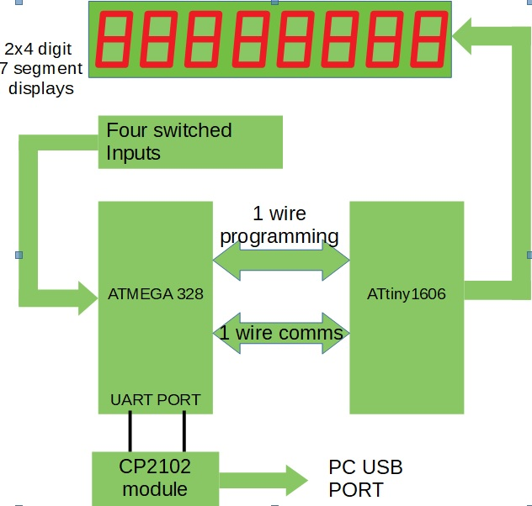 | System diagram for PCB111000_CP2102  The Atmega 328 hosts:  A Hex/text bootloader  An optional UPDI programmer  User programs  Text commentary for several sample  programs.  A default program provided for test  purposes.  The ATtiny1606  Drives the display  Provides resources for the user projects  One of the switches controls reset and display intensity. The others are or data entry.

System projects

 | Name | Compiler | Platform | Task
1 | UNO_programs_328 | Arduino | UNO | Uploads bootloader and provides time standard for Atmega 328 calibration.
2 | UNO_Calibrates_328 | Arduino | Atmega328 | Calibrates 328 against the UNO crystal
3 | CP2102_UPDI_Programmer | Arduino | Atmega328 | Uploads mini-OS to ATtiny1606
4 | CP2102_mini-OS | Studio 7 | ATtiny1606 | Drives display and provides user services
5 | cal_one_wire_comms | Arduino | Atmega328 | Matches 328/1606 baud rates
6 | CP2102_bootloader | Studio 7 | Atmega328 | Loads user projects and reads the commentary
7 | FP_arithmetic | Arduino | Atmega328 | Test project
8 | Recal_328_using_crystal | Arduino | Atmega328 | Check calibration post pcb assembly

Note: All projects are closely based on previous versions already posted on AVR freaks.

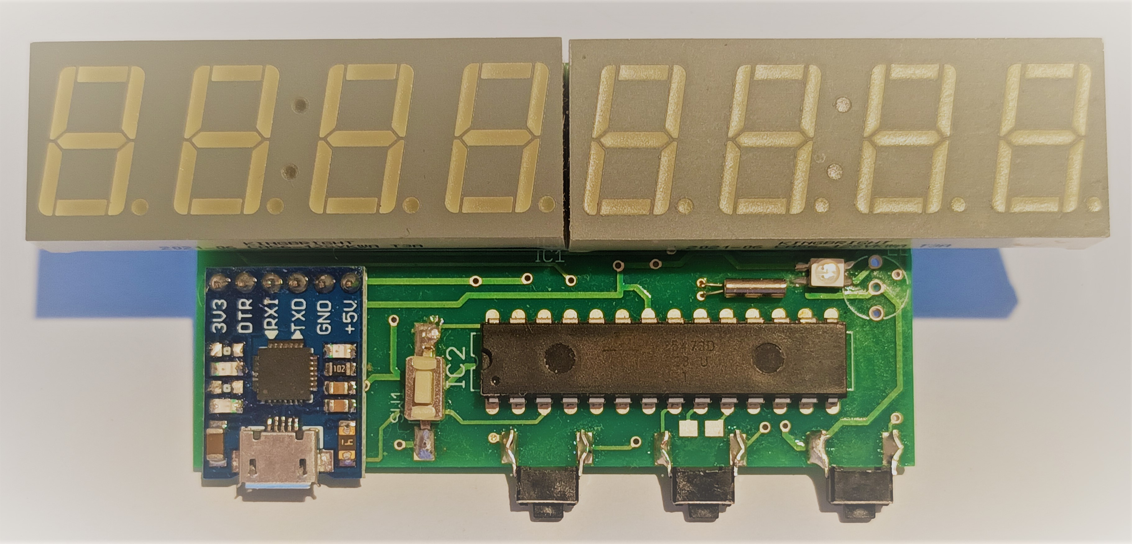 | Fig 1  Photos of PCB111000_CP2102  Note that tracks are provided for either surface mount or leaded  Red/Green LED and  watch crystal  The vertical switch is the reset control switch.  The horizontal switches are user switches sw1, sw2 and sw3  counting from the middle of the pcb.  RX/Tx leds on the CP2102 module can be disabled if they are found to be too bright by removing their series resistors as in the photograph.
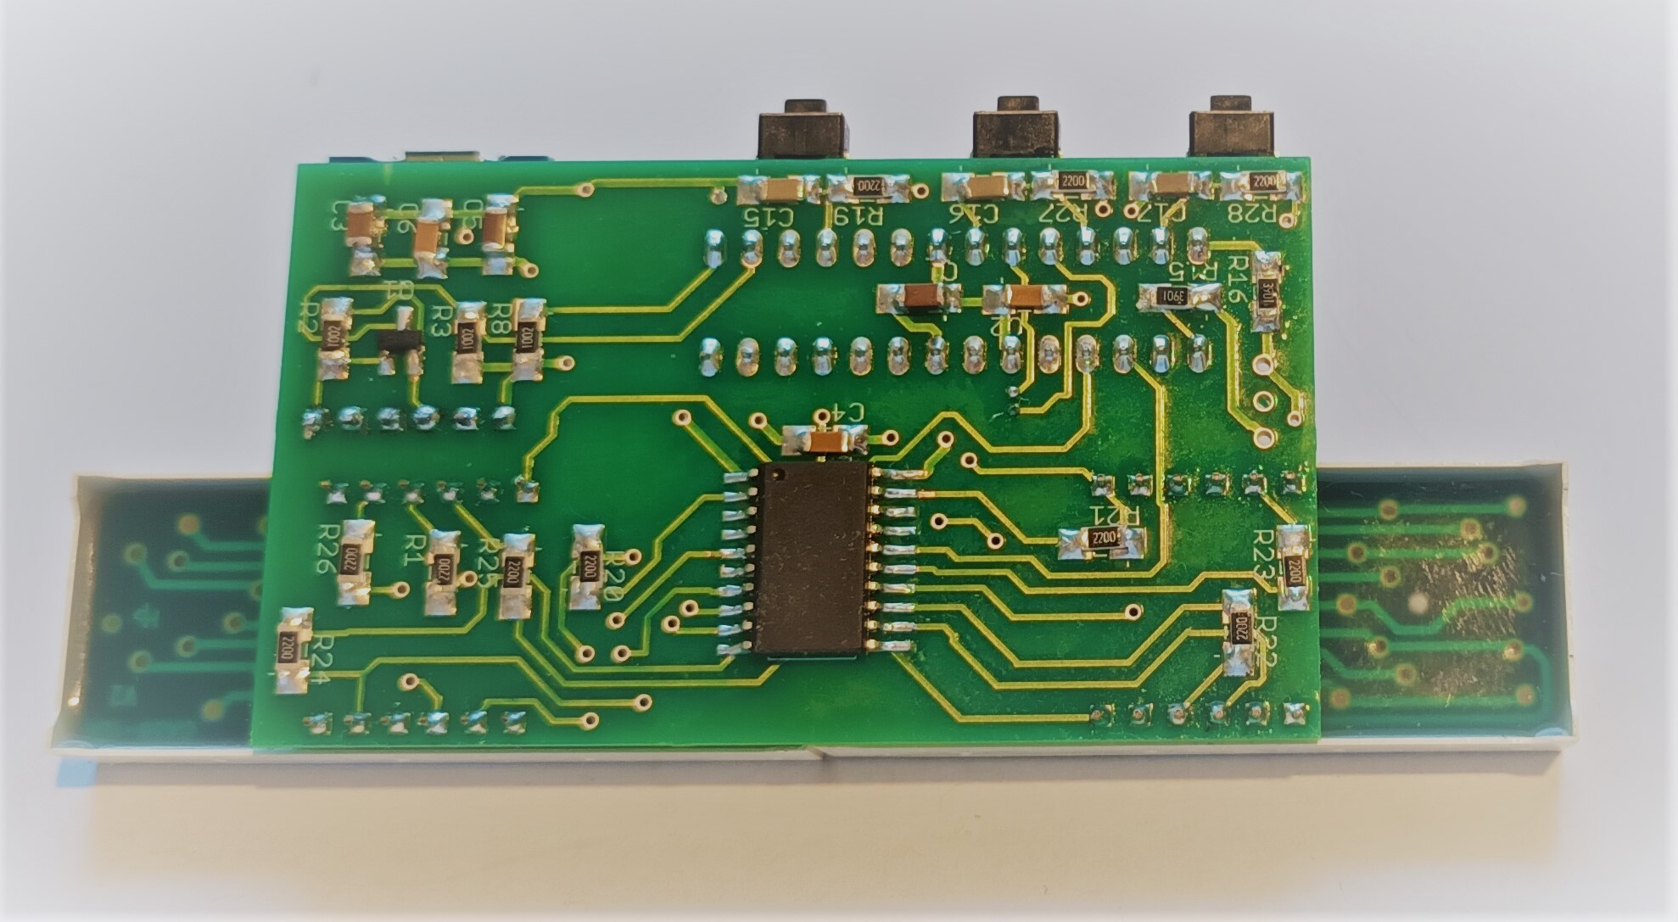

The Project PC

There are two essential software applications that must be downloaded onto this PC. They are:
The Arduino development environment. Go to https://www.arduino.cc/en/software and download it from the Microsoft store.

Bray++ version 20130820 which can be downloaded from https://www.sites.google.com/site/terminalbpp/

Almost as important are

The portable version of Programmers notepad which can be downloaded from
http://www.pnotepad.org/download/.

An excellent text written by Joe Pardue that can be downloaded from
https://epdf.pub/c-programming-for-microcontrollers.html

The Atmega data sheet that can be downloaded from
https://www.docdroid.net/Q6jfzd3/atmega48a-pa-88a-pa-168a-pa-328-p-ds-ds40002061a-pdf

PCB manufacture: Generating the Gerber files

The Eagle pcb design tool must first be downloaded.
A free version is available from Autodesk which can be used to process two layer boards of a limited size. Go to https://www.autodesk.com/products/eagle/free-download
Place the Eagle board and schematic files in any suitable folder (to be referred to as the Project directory).
Open the Eagle control panel
Click on CAM Jobs then examples and double click on example_2_layer.cam
Tick the Export to Project Directory box
Click on Select board
Navigate to the project directory and open the board file
Click on Process Job then Open folder
A CAMOutputs folder should have been added to the project directory. This will contain the Gerber and drill files needed to get the pcb manufactured.

Recommended PCB assembly steps

Solder on all SM resistors, caps, the FET and the ATtiny 1606 to the pcb underside.
Check the CP2102 module by connecting it to a PC and detecting it in “device manager” then add it to the pcb as follows

Solder a 6 pin vertical header to the upper surface
Slide off the plastic spacer
Trim the vertical pins to a length of several mm
Attach the CP2102 module via the header pins
Place a piece of fine card between the module and pcb
Solder on the module and remove the card.
Discard the right angled header

Add remaining components. Note however: addition of the displays and user switches can be delayed until the mini-OS has successfully been uploaded to the ATtiny.
Continuously examine pcb for solder splashes, dry joints and other damage.

Setting up a new PCB111000_CP2102

Having completed assembly minus the display and user switches use jumper wires (Radio Spares 791-6463) to connect the PCB to a UNO as shown below and connect both the UNO and CP2102 module to the project PC.

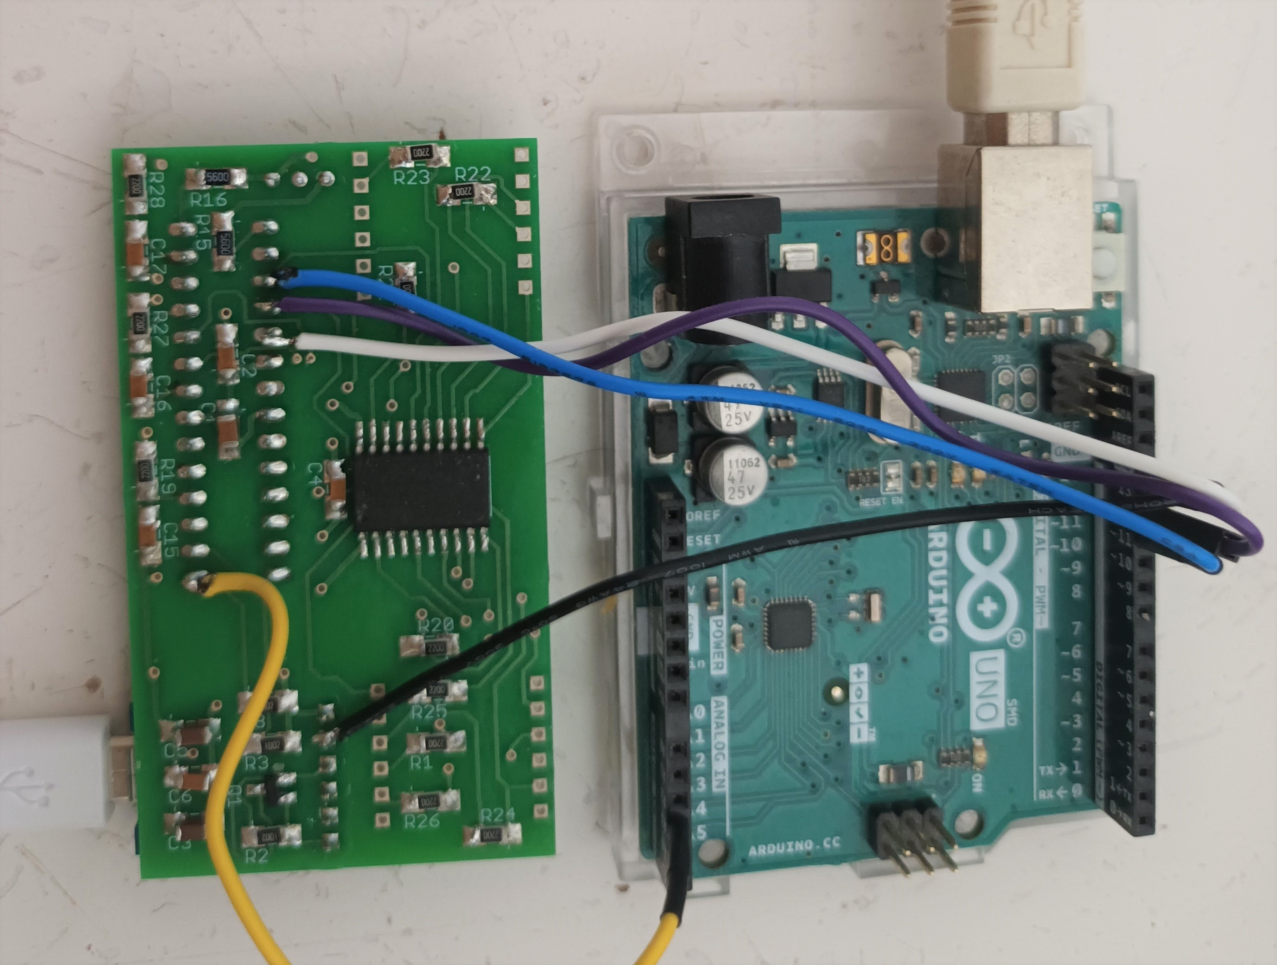 | Interconnections
 | Colour | UNO pin | PCB: Atmega pin
 | Yellow | A3 | 1
 | White | 13 | 19
 | Mauve | 12 | 18
 | Blue | 11 | 17
 | Black | GND | 0V
Fig 2 UNO and PCB111000_CP2102 configured to upload the mini_OS and bootloader and calibrate the Atmega328 internal RC clock and one wire comms link.
Setup Steps:

1. Program the UNO
Open the Arduino project “UNO_programs_328” and upload it to the UNO.
Close “UNO_programs_328” and open two instances of the Br@y++ terminal program.
Use them to connect to the UNO and CP2102 modules at speeds of 38.4 kBaud (otherwise use default settings).
The UNO generates prompt “s s s…….”
Keypress ‘s’ generates the following response:
Atmega 328P detected.

To program flash: press -P- for bootloader or -p- for other routines,
Press -t- to run 328 calibration routine,
Press -r- for other routines,
Press -V- to read flash or -x- to escape.

2. Calibrate the Atmega 328

Press -p- and upload “UNO_Calibrates_328”
Press -t- to run the calibration routine.
See Fig 3 below for typical terminal dialogues

Fig 3 Terminal dialogues generated when the Atmega328 is calibrated. Settings are: 8 data bits, 1 stop bit, no parity and no handshaking

3. Upload the mini-OS

Press the UNO reset button to restore the “s s s…….” prompt.
Upload and run “CP2102_UPDI_Programmer”
Power cycle the CP2102 module and reduce its baud rate to 14.4k.
In response to user prompt “R R R ….” press -r-, -a-, -y-, -y- and upload “CP2102_miniOS”
See Fig 4 for a typical terminal dialogue.

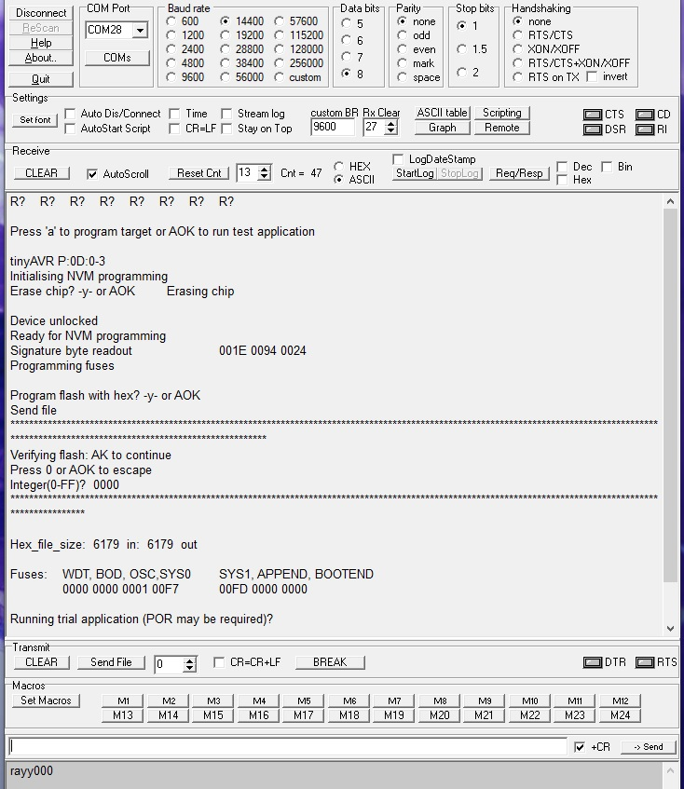
Fig 4 Terminal dialogue: Using “CP2102_UPDI_Programmer” to upload “CP2102_miniOS”

4. Remaining steps

Set CP2102 baud rate to 57K
Upload and run “calibrate the one wire comms”

Upload “Bootloader_Full_hex” (be sure to use key press -P- in place of -p- to initiate upload).
Pulse the reset control switch and check for the p/r/t/D user prompt

Disconnect the UNO

Upload and run “Recal_328_using_crystal”. Result should be within +/- 2 of that already obtained.

Power cycle the CP2102 module with the reset control switch pressed to restore the “p/r/t/D...” prompt.

Upload and run FP_arithmetic.ino.standard

Unsolder flying leads and fit display modules and users witches.
At p/r/t/D prompt press -D- to obtain the default application and check display.
Press and hold the reset control switch to toggle the brightness.
POR to restore low brightness.

Upload and run “Project 6F_FPN_from_IO” to check operation of switches.

At p/r/t/D prompt press -T- and upload the commentary.
Upload and run “Project 5E_e_power_series” then check that the commentary has not been corrupted.

Operation of the reset control switch

When power is applied program control will jump to the user project.

To restore the “p/r/t/D...” prompt
power cycle PCB111000_CP2102 with the reset control switch pressed
or
pulse the reset control switch which is usually sufficient

To reset the user project hold the reset control switch down until the dual led illuminates.
Display intensity can also be changed by holding the reset control switch down until the dual led extinguishes.

User projects

These are all composed using Arduino.
Click on Sketch/Export compiled Binary/ rather than Sketch/Upload.

For each project two files are generated, for example
8B_Pulse_train_generator.ino.standard
and
8B_Pulse_train_generator.ino.with_bootloader.standard

take care to delete the bootloader version and upload the other one at the “p/r/t/D...” prompt as described above pressing -p- to upload it and -r- to run it and using a baud rate of 57.6K.

Reading the commentary

Press -t- at the p/r/t/D prompt
Key in page number 1 to 12.
Press any key to scroll through the page until the p/r/t/D prompt is restored.

Commentary index

Page number | Projects
1 | 1_first_project
2 | 1_first_project
3 | 2_Receiver_Transmitter_Basic
4 | 2_Receiver_Transmitter_Basic
5 | 2_Receiver_Transmitter_Basic
6 | 3_Interrupts_and_switches
7 | 4_binary_and_bit_operations
8 | 5_Arduino_PC_comms_library
9 | 6_The_8_digit_display_and_IO
10 | 7_Timers
11 | 8_Resets
12 | Concluding remarks

