Introducing PCB111000_CP2102

PCB111000_CP2102 is a cut down version of PCB_111000_UNO published by osbornema on 18 July 2020. It is designed to provide an introduction to C programming for AVR devices and consists of:
A CP2102 module with Rx/Tx and power provided on a 6 pin header
An Atmeg328 for user programs
An ATtiny 1606 that drives an 8 digit seven segment display.

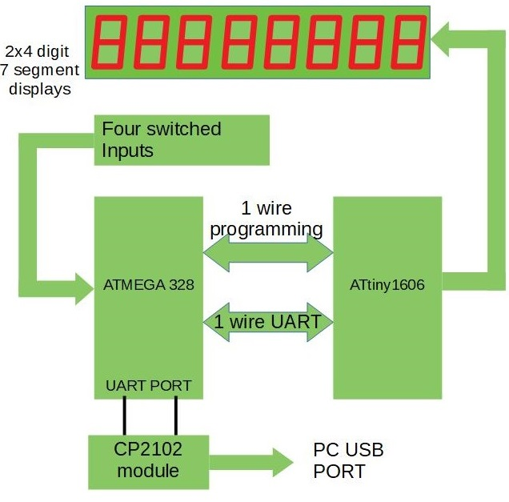 | System diagram for PCB111000_CP2102  The Atmega 328 hosts:  A Hex/text bootloader  An optional UPDI programmer  User programs  Text commentary for several sample  programs.  A default program provided for test  purposes.  The ATtiny1606  Drives the display  Provides resources for the user projects  One of the switches controls reset and display intensity. The others are or data entry.
System projects

 | Name | Compiler | Platform | Task
1 | UNO_programs_328 | Arduino | UNO | Calibrates Atmega328  Uploads bootloader
2 | UNO_Calibrates_328 | Arduino | Atmega328 | Calibrates 328 against the UNO crystal
3 | CP2102_UPDI_Programmer | Arduino | Atmega328 | Uploads mini-OS to ATtiny1606
4 | CP2102_mini-OS | Studio 7 | ATtiny1606 | Drives display and provides user services
5 | cal_one_wire_comms | Arduino | Atmega328 | Matches 328/1606 baud rates
6 | CP2102_bootloader | Studio 7 | Atmega328 | Loads user projects
7 | Cal Atmega328 | Studio 7 | Atmega328 | Calibrates the 328 against a watch crystal
8 | FP_arithmetic | Auduino | Atmega328 | Test application

Note: All projects are closely based on others that have already been posted on AVR freaks.
Checking out the operation of the system projects

Operation can be checked out using the prototype system shown below rather than manufacturing and loading a pcb.
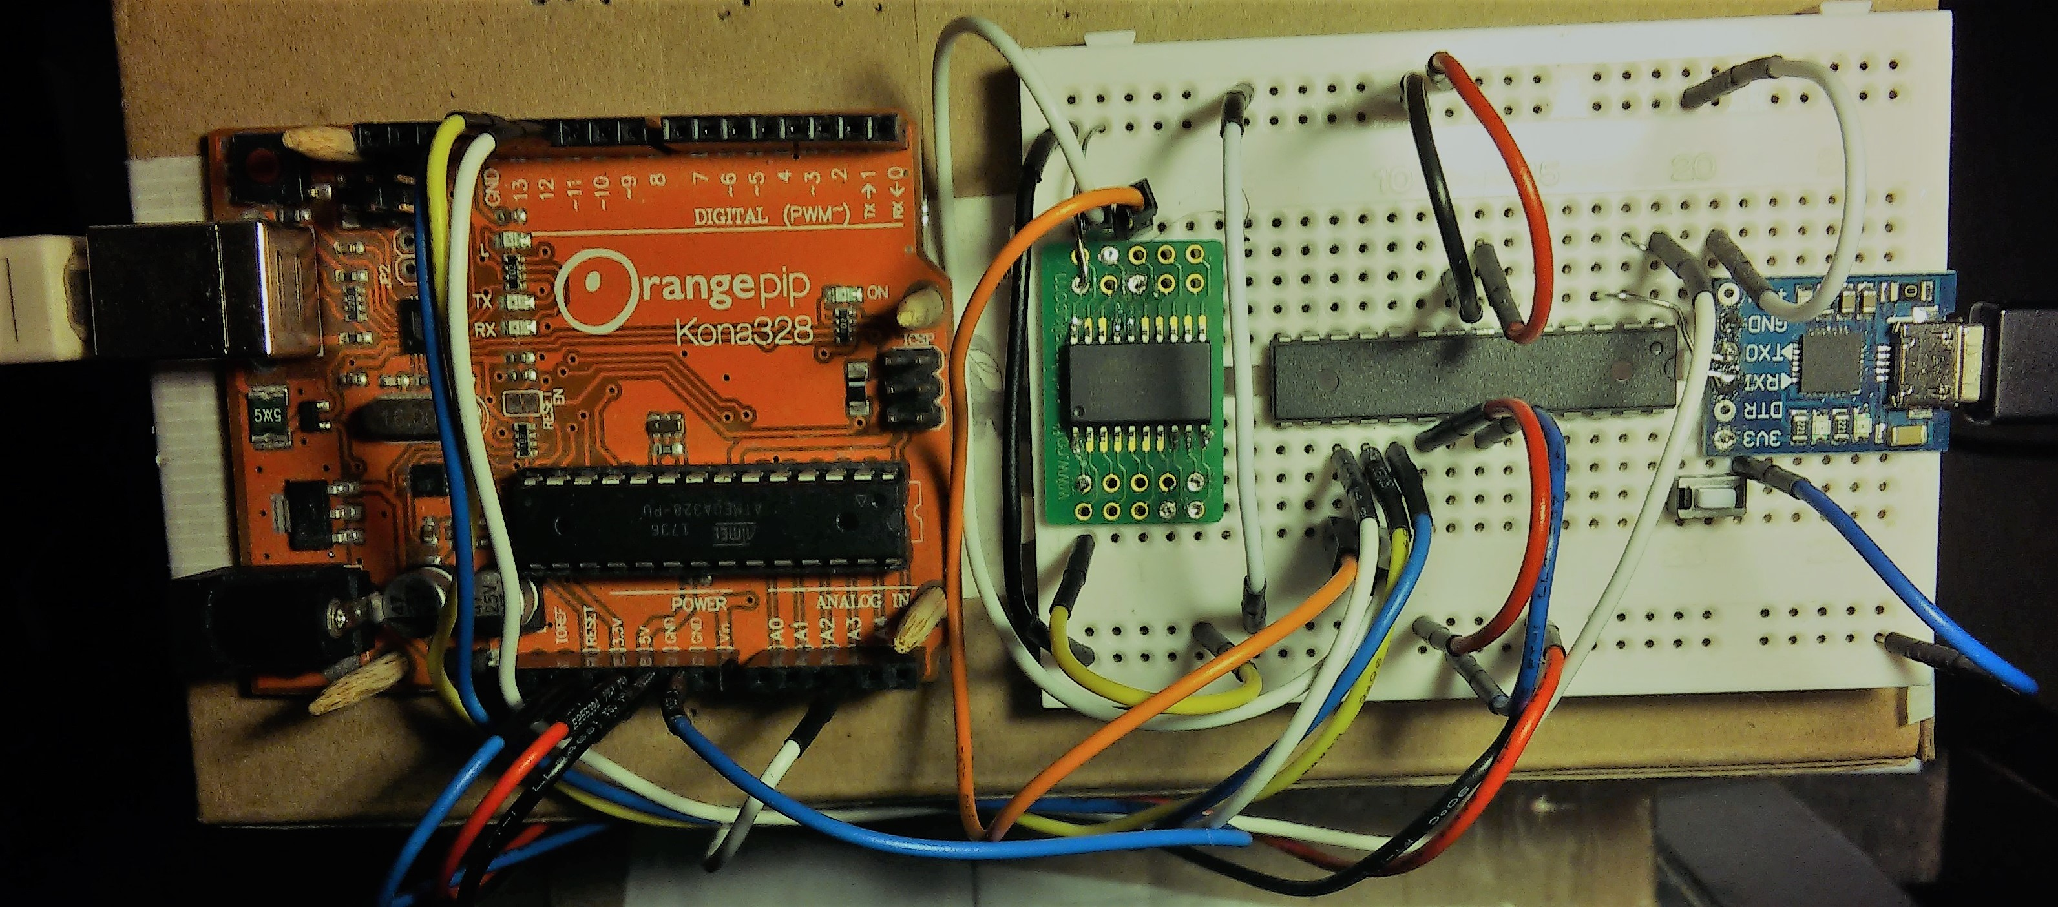
Wiring of the prototype system was as follows
(Note photo has error. It shows connection to ATtiny pin 17 instead of pin 18)
UNO |  | Atmega328 |  | ATtiny1606 |  | CP2102
UNO programs the Atmega328
Pin | Port | Pin | Port | Pin | Port | Port
11 | PB3 (MOSI) | 17 | MOSI
12 | PB4 MISO | 18 | MISO | Note: The CP2102 provides 3.3V logic  However it works with 5V logic  With no load on the 3V3 DC output  the logic is closer to 4V
13 | PB5 SCK | 19 | SCK
A3 | PC3 | 1 | Reset
9 | PB1 | 15 | Optional LED + 1K detects data download
Atmega328 programs ATtiny1606
17 | PB3 (MOSI) |  |  | 16 | Reset
Atmega328/ATtiny1606 one wire comms
18 | PB4 MISO |  |  | 18 | PA2
Atmega 328 comms
2 | RXD |  |  |  |  | Tx
3 | TXD |  |  |  |  | Rx
Atmega 328 control 28 PC5 to 0V via push button switch (the reset switch)
Plus optional LED plus 1K between pin 14 and 0V
Optional UNO control Reset to GND via temporary wire link
UNO +5V: connected to Atmeg328 and ATtiny1606 5V pins
Note: the ATtiny 1606 +5V pin can temporarily be disconnected to reset the device
UNO 0V: connected to the Atmeg328, ATtiny1606 and CP2102 module 0V pins.
CP2102 3.3/5V: No connection
Tests carried out on the prototype system

Connect the UNO to a PC.
Open the UNO app UNO_programs_328 and upload it to the UNO
Open a terminal program and connect (38.4KB)
User prompt s s s s……… should be generated
Connect the CP2102 to the same PC, open a second terminal program and connect (38.4KB).
Operation | User IO
Operation | UNO terminal program | CP2102 terminal program
Calibrate Atmega328  (UNO generates Pin Change Interrupt every 8.192mS) | Upload  UNO_Calibrates_328.  Send ‘t’ to make program run | Enter User value for OSCCAL when requested
Upload mini-OS to ATtiny1606 | Upload and run  CP2102_UPDI_Programmer | POR ATtiny1606  Change baud rate to 14.4K  Send ‘r’, ‘a’, ‘y’, ‘y’  ¹Upload mini-OS
Calibrate the Atmega328 one wire comms clock | Upload and run  cal_one_wire_comms.hex | Change baud rate to 57.6K and press ‘r’ at the user prompt Enter cal correction factor when requested
Upload bootloader to Atmega328 | Upload and run  bootloader.hex  Send P rather than p | Get user prompt  p/r/t/D
Upload and run  Floating_point_numbers: Checks operation of the one-wire link. |  | Press ‘p’ and send hex file  Keypress ‘r’ to start then ‘f’ and follow instruction  Press switch on breadboard to reinstate p/r/t/D prompt
Upload commentary |  | Press T at p/r/t/D prompt  send test.txt
Read commentary |  | Press t at p/r/t/D prompt  Enter page number then AK
Notes:
The UNO is used to upload programs to the Atmega328 as follows
Reset the UNO. At the user prompt send ‘s’ then ‘p’ to upload the program and ‘r’ to make it
run unless otherwise stated.

All programs running on the Atmega 328 communicate with the PC via the CP2102.

The ATtiny1606 can only be programmed using CP2102_UPDI_Programmer running on the Atmega328.

Every test can be rerun by resetting the UNO and pressing r or t as required.

1 Trial application requires the display and only works if the one_wire_comms calibration is adequate.

Terminal sessions generated while calibrating the Atmega328 are shown below.
Terminal settings are: 8 data bits, 1 stop bit, no parity and no handshaking
Setting up a new PCB111000_CP2102
Before assembling the pcb calibrate the Atmega328 and load it with the bootloader as described above.
Having assembled the pcb:
Connect the pcb to a PC with the vertical switch pressed.
Start a terminal session with the baud rate set to 57.6K.
Check for the presence of the p/r/t/D user prompt

Press ‘p’ and upload CP2102_UPDI_Programmer.
Upload mini-OS (Note POR is not required)
Default user application will run if the one_wire_comms calibration is adequate.

Pulse the vertical switch to restore the p/r/t/D user prompt
Press ‘p’ and upload cal_one_wire_comms.hex
Press ‘r’, ‘r’ to run the program and select a calibration correction factor.
When the program resets press ‘R’ to test the one wire link

Press and hold the vertical switch
Release it while the LEDs are on to reset the program
Release it after the LEDs have gone off to change the display intensity and reset the program.

Setting up a new PCB111000_CP2102

Load a UNO with project “UNO_AVR_programmer”.
Use some solderless breadboard to connect the UNO to an Atmega328.
Program the Atmega328 with the calibration routine and let it run
Program the Atmega328 with the CP2102_bootloader.

Solder the Atmega 328 onto the pcb.

Apply power with the vertical surface mount switch pressed
At the p/r/t prompt press p.
Upload the UPDI programmer
At the p/r/t prompt press r and upload the mini-OS.
Run the test project (appended to the UPDI programmer)
Press the vertical switch (briefly) to obtain the p/r/t prompt

Upload a user project (overwrites the UPDI programmer)
Press the vertical switch releasing it when the led shines to reset both devices
Hold it down until the led goes out to change the intensity.

PCB control

The vertical white surface mount switch controls reset and display intensity as follows:

For a new pcb in which only the bootloader has been programmed power the board with the switch pressed to operate the bootloader.

Test steps

Connect both USB ports to the PC.
Remove reset from the UNO
Open the Arduino sketch “UNO_programs_328_bootloader” .
Upload it to the UNO

Open two terminal programs with default port settings
(8 data bits, no parity 1 stop bit and no flow control).
Change the baud rate to 38.4KB
For each one click on Recsan and connect.
One talks to the UNO and the other the Atmega 328.

The UNO responds by generating the user prompt s s s s s s……..

Press ‘s’ and the programmer should respond with
Atmega 328 detected.
Plus
a number of options.

Calibrating the Atmega328
The Atmega RC clock is calibrated against the UNO crystal.

Press ‘p’ and upload the hex file “UNO_Calibrates_328.ino.standard”
Press ‘t’ to tun the calibration routine
After several seconds the Atmega responds with a number of suitable values for OSCCAL.
Select one from the group with most values registering an error of 0%, i.e. < 1%.

Press the UNO reset button to repeat.

Loading the mini-OS

Change the baud rate of the Atmega 328 terminal program to 14.4KB
Press the UNO reset button
Using the UNO terminal program
Enter ‘s’ then ‘p’ and upload “CP2102_UPDI_Programmer.ino.standard”

Following verification press ‘r’
The Atmega responds with user prompt R? R? R?……….
Enter ‘r’ then ‘a’ the response may be “Power Cycle Required”

If so just
If so press the UNO reset button and use the UNO terminal to enter ‘s then ‘r’
Then power cycle just the ATtiny1606 .
This time use the Atmega terminal program to enter ‘r’, ‘a’, ‘y’, ‘y’ and
upload “CP2102_miniOS” (a Studio 7 file);
Press ‘0’, ‘0’, ‘0’ at the verification phase.

Calibrating the one wire comms link
Both Atmega328 and ATtiny1606 run off free running oscillators.
However no attempt is made to adjust the frequency of the ATtiny1606.
Rather the Atmega328 timer used to generate its comms clock is adjusted to minimise the discrepancy between the two devices. The result is saved to the Atmega328 EEPROM.

Press the UNO reset button and upload “cal_one_wire_comms.standard”

Restore the Atmega terminal baud rate to 38.4KB
and press ‘r’, ‘r’ at the user prompt.

Save the most suitable result.

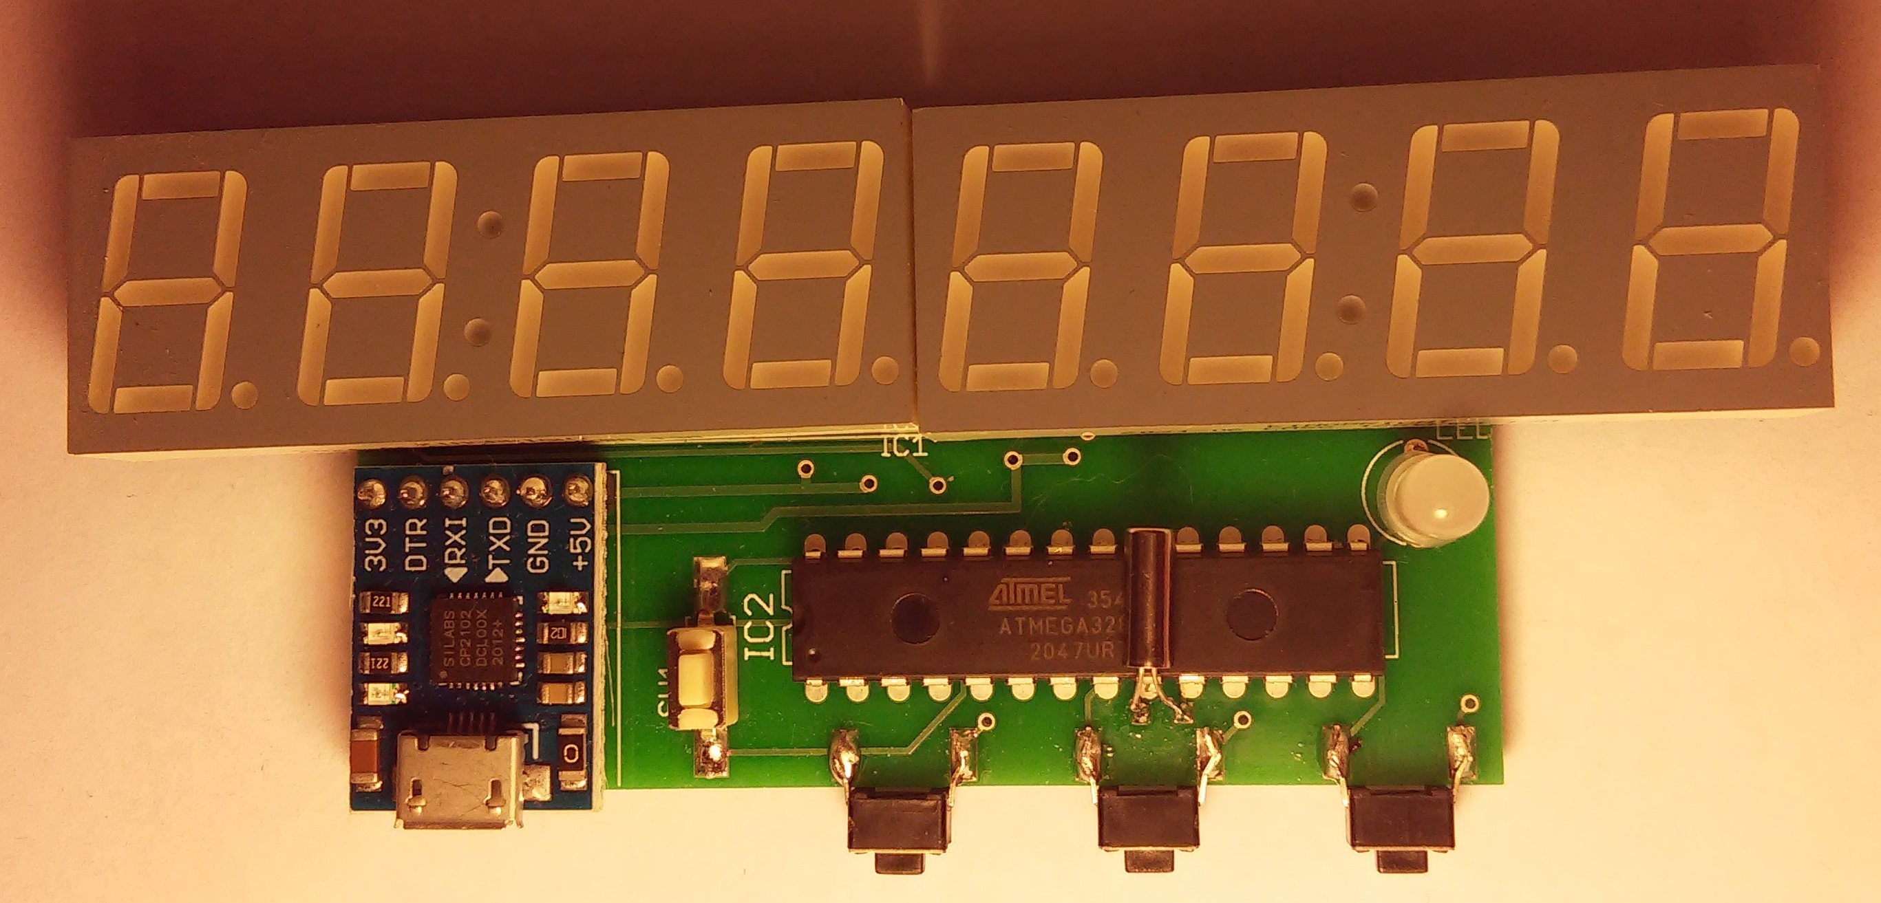 | Always use manufacturing drawings stored on Github when ordering new boards.  Crystal moved to other side if IC and improved power supply wiring and increased separation between pins 11 and 12 of ATtiny1606
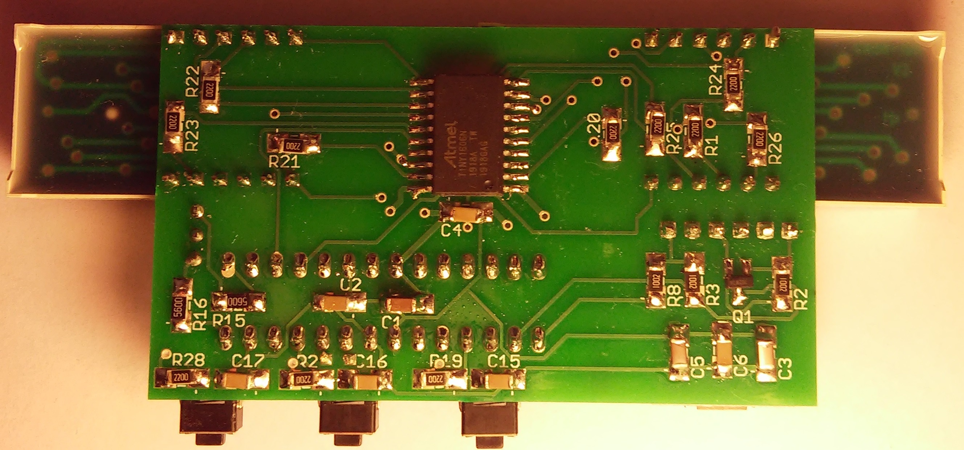 | Reset switch

PCB11000_CP2102

ATtiny 1606 |  |  | Atmega328
A0 (Reset) | 328 PB3 |  | B0 | Led
A1 | Dig 7 |  | B1 | Led
A2(Comms) | 328 PB4 |  | B2 | n/c
A3 | Seg E |  | B3 | Prog output
A4 | Seg B |  | B4 | Comms
A5 | Dig 3 |  | B5 | n/c
A6 | Dig 0 |  | B6 | n/c Xtal
A7 | Dig 1 |  | B7 | n/c/Xtal
B0 | Dig 4 |  | C0 | n/c
B1 | Seg A |  | C1 | n/c
B2 | Seg D |  | C2 | n/c
B3 | Seg DP |  | C3 | n/c
B4 | Dig 2 |  | C4 | n/c
B5 | Seg C |  | C5 | Switch to 0v
C0 | Dig 5 |  | D0 | RX
C1 | Seg F |  | D1 | TX
C2 | Dig 6 |  | D2 | SW1
C3 | Seg G |  | D3 | n/c
 |  |  | D4 | n/c
 |  |  | D5 | SW2
 |  |  | D6 | n/c
 |  |  | D7 | SW3

Reset control

POR Jump to 0x0000: also resets ATtiny 1606
Short keypress: Change intensity
Long keypress: Run bootloader

WDT Jump to 0x0000 or 0x7000 depending on eeprom setting
Switch Post User Prompt: Long press: Run bootloader
Short press: Same as POR

Bootloader

Load hex/text programmer at 0x7000.
Load hex verification/text reader at bottom of application partition.

At p/r prompt
Press p to program hex, then jump to hex verification routine, them restore the p/r prompt
Could use wdtout or jump to restore p/r prompt

Press t to program text, then jump to text reader, them restore the p/r prompt
Could use wdtout or jump to restore p/r prompt

Press r to jump to 0x0000.
If 0x0000 contains 0xFFFF jump to default apps.

Issues
Note: pages are erased one at a time just before they are written
Pressing p with erase the first page of the previous application
This should probably be avoided, i.e. wait until hex file down load starts.

Bootloader must be transferred to a Studio application

Jobs

Transfer basic bootloader to Studio app.
Get reset op working as required.
Enhance bootloader to include test and verification.

Tests

In the prototype project “Bootloader_test”:

All resets take program control to location 0x7000.
The setup_HW macro initiates the WDT (clearing the WDRF, bit 3 of MCUSR)
If the POR flag is set control jumps to location 0x0000 (the User application).
If the EXRF is set control continues with the bootloader app.

Project CP2102_bootloader development:

For project CP2102_bootloader:
All resets must take program control to location 0x7000.
If the POR flag is set control must jump to location 0x0000 (the User application).

All resets take control to 0x7000

Post Ext reset: There is no external reset.

Post WDT Read WDT flag:
If set: will run bootloader
If clear: Jump to 0x0000.
Post POR{
Clear PORF flag (in MCUSR)
Check SW1
If up: Do nothing;
If down set WDT flag. (Will run bootloader.)
Initiate WDTout.}

Continue with bootloader
At h/t/r prompt if r is pressed clear WDT flag and initiate WDTout
Clear WDT flag when bootloader completes
Initiate WDTout.

Use of SW1 during execution of user app.
Jump to pin change ISR
Start timer
If short set intensity flag.
If long set WDT flag
Initiate WDTout (to reset 328 or run bootloader)

User App setup_HW macro

Always issues a 1606 reset command and changes intensity if flag is set
Issues intensity command if flag is set
Reset both flags

1606 Reset
POR sets intensity low
Reset command: Issues a WDTout
Intensity command is only active at this moment

328 EEPROM

0x3FF cal
0x3FE cal
0x3FD cal
0x3FC
bit 0 WDT flag 1 for clear and 0 for set
bit 1 Intensity flag

Bug reports

1 See subroutine “ send_int_num()” in
UNO_template_V2\Resources_Template_V2\One_wire_transactions

void send_int_num(long num){
One_wire_Tx_char = 'C';
UART_Tx_1_wire();
for(int m = 0; m <= 3; m++){
One_wire_Tx_char = Long_Num_to_UNO >> (8 * (3 - m));
UART_Tx_1_wire();}}

This should be
void send_int_num(long num){
One_wire_Tx_char = 'C';
UART_Tx_1_wire();
for(int m = 0; m <= 3; m++){
One_wire_Tx_char = num >> (8 * (3 - m));
UART_Tx_1_wire();}}

2 UNO_ARV_Programmer\UNO_AVR_programmer_intro.pdf

See section
UNO_AVR_ programmer Hard Ware:
UNO Tx pin should be connected to Atmega168 pin 3 (USART TXD) and
UNO Rx pin should be connected to Atmega168 pin 2 (USART RXD)

