Introducing PCB111000_CP2102

PCB111000_CP2102 is a cut down version of PCB_111000_UNO posted by osbornema on 18 July 2020. It is designed to provide an introduction to C programming for AVR devices and consists of:
A CP2102 module with Rx/Tx and power provided on a 6 pin header
An Atmeg328 for user programs
An ATtiny 1606 that drives an 8 digit seven segment display.

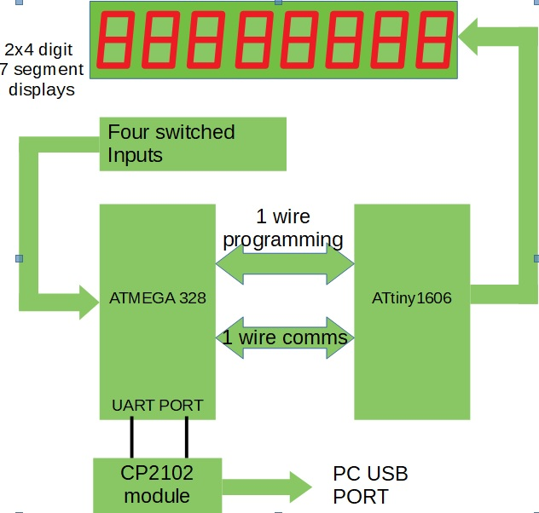 | System diagram for PCB111000_CP2102  The Atmega 328 hosts:  A Hex/text bootloader  An optional UPDI programmer  User programs  Text commentary for several sample  programs.  A default program provided for test  purposes.  The ATtiny1606  Drives the display  Provides resources for the user projects  One of the switches controls reset and display intensity. The others are or data entry.

System projects

 | Name | Compiler | Platform | Task
1 | UNO_programs_328 | Arduino | UNO | Uploads bootloader and provides time standard for Atmega 328 calibration.
2 | UNO_Calibrates_328 | Arduino | Atmega328 | Calibrates 328 against the UNO crystal
3 | CP2102_UPDI_Programmer | Arduino | Atmega328 | Uploads mini-OS to ATtiny1606
4 | CP2102_mini-OS | Studio 7 | ATtiny1606 | Drives display and provides user services
5 | cal_one_wire_comms | Arduino | Atmega328 | Matches 328/1606 baud rates
6 | CP2102_bootloader | Studio 7 | Atmega328 | Loads user projects
7 | FP_arithmetic | Arduino | Atmega328 | Test project
8 | Recal_328_using_crystal | Arduino | Atmega328 | Check calibration post pcb assembly

Note: All projects are closely based on previous versions already posted on AVR freaks.
Checking out the operation of the system projects

Operation can be checked out using the prototype system shown below rather than manufacturing and loading a pcb.
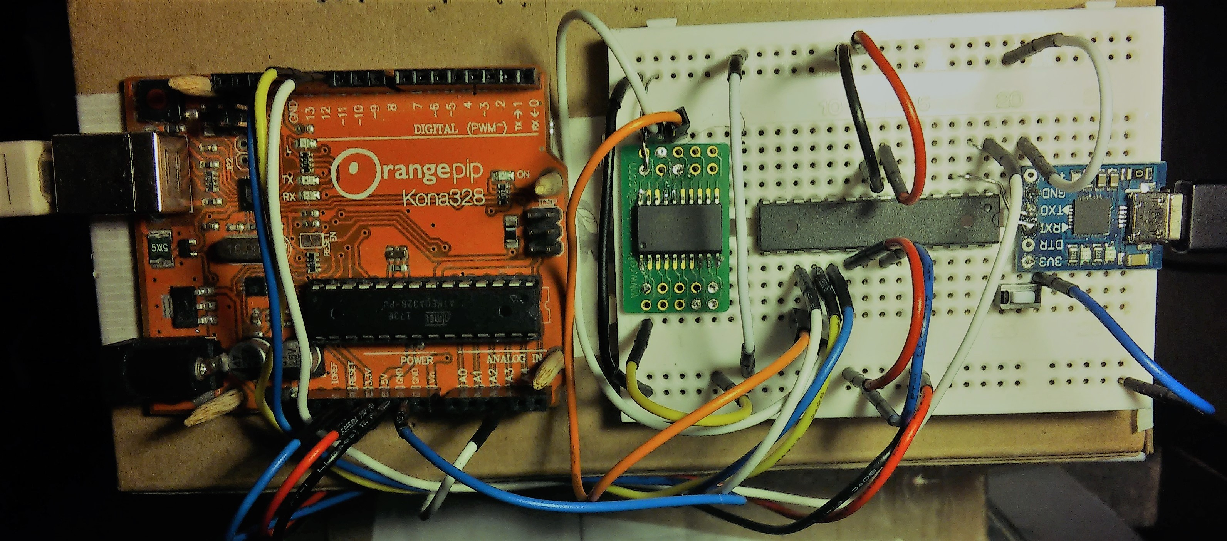
Wiring of the prototype system was as follows
(Note photo has error. It shows connection to ATtiny pin 17 instead of pin 18)
UNO |  | Atmega328 |  | ATtiny1606 |  | CP2102
UNO programs the Atmega328
Pin | Port | Pin | Port | Pin | Port | Port
11 | PB3 (MOSI) | 17 | MOSI
12 | PB4 MISO | 18 | MISO | Note: The CP2102 provides 3.3V logic  However it works with 5V logic  With no load on the 3V3 DC output  the logic is closer to 4V
13 | PB5 SCK | 19 | SCK
A3 | PC3 | 1 | Reset
9 | PB1 | 15 | Optional LED + 1K detects data download
Atmega328 programs ATtiny1606
 |  | 17 | PB3 (MOSI) | 16 | Reset
Atmega328/ATtiny1606 one wire comms
 |  | 18 | PB4 MISO | 18 | PA2
Atmega 328 comms
 |  | 2 | RXD |  |  | Tx
 |  | 3 | TXD |  |  | Rx
Atmega 328 control Pin 28 PC5 to 0V via push button switch (the reset control switch)
Plus optional dual LED plus 1K resistors between UNO pins 8 or 9 and 0V
Optional UNO control Reset to GND via temporary wire link (Holds UNO in reset)
UNO +5V: connected to Atmeg328 and ATtiny1606 5V pins
Note: the ATtiny 1606 +5V pin can temporarily be disconnected to reset the device
UNO 0V: connected to the Atmeg328, ATtiny1606 and CP2102 module 0V pins.
CP2102 3.3/5V: No connection
Tests carried out on the prototype system

Connect the UNO to a PC.
Open the UNO app UNO_programs_328 and upload it to the UNO
Open a terminal program and connect (38.4KB)
User prompt s s s s……… should be generated
Connect the CP2102 to the same PC, open a second terminal program and connect (38.4KB).

Operation | User IO
Operation | UNO terminal program | CP2102 terminal program
Calibrate Atmega328  (UNO generates Pin Change Interrupt every 8.192mS) | Upload  UNO_Calibrates_328.  Send ‘t’ to make program run | ¹Enter User value for OSCCAL when requested
Upload mini-OS to ATtiny1606 | Upload and run  CP2102_UPDI_Programmer | ²POR ATtiny1606  Change baud rate to 14.4K  Send ‘r’, ‘a’, ‘y’, ‘y’  ³Upload mini-OS
Calibrate the Atmega328 one wire comms clock | Upload and run  cal_one_wire_comms.hex | Change baud rate to 57.6K and press ‘r’ at the user prompt ¹Enter cal correction factor when requested
Upload bootloader to Atmega328 | Upload and run bootloader.hex  Use keypress P rather than p | ⁴Get user prompt p/r/t/D
Upload and run  Floating_point_numbers: Checks operation of the one-wire link. |  | Press ‘p’ and send hex file.  Keypress ‘r’ to start then ‘f’ and follow instructions. Press reset control switch on breadboard to reinstate p/r/t/D prompt
Upload commentary |  | Press T at p/r/t/D prompt  send test.txt
Read commentary |  | Press t at p/r/t/D prompt  Enter page number then AK
The UNO is used to upload programs to the Atmega328 as follows
Reset the UNO. At the user prompt send ‘s’ then ‘p’ to upload the program and ‘r’ to make it
run unless otherwise stated.
All programs running on the Atmega 328 communicate with the PC via the CP2102.
The ATtiny1606 can only be programmed using CP2102_UPDI_Programmer running on the Atmega328.
Every test can be rerun by resetting the UNO and pressing r or t as required.

1 Back space not supported
2 Power on Reset
3 Trial application requires the display and only works if the one_wire_comms calibration is adequate.
4 For previously unused devices it may be necessary to pulse the reset control switch or even repeat the bootloader upload.

Terminal sessions generated while calibrating the Atmega328 are shown below.
Terminal settings are: 8 data bits, 1 stop bit, no parity and no handshaking

Recommended PCB assembly steps

Use a UNO to calibrate the Atmega328 and load it with the bootloader. This requires the test jig shown above but without the CP2102 module. Check that the p/r/t/D prompt is generated.

Solder on all SM resistors, caps, the FET and the ATtiny 1606 (see photographs below) to the pcb underside.
Check the CP2102 module by connecting it to a PC and then add it to the pcb as follows

Solder a 6 pin vertical header to the upper surface
Slide off the plastic spacer
Trim the vertical pins to a length of several mm
Attach the CP2102 module via the header pins
Place a piece of folder paper between the module and pcb
Solder on the module and remove the paper.
Discard the right angled header

Add remaining components. Note however: addition of the displays and user switches can be delayed until the mini-OS has successfully been uploaded to the ATtiny.
Continuously examine pcb for solder splashes, dry joints and other damage.
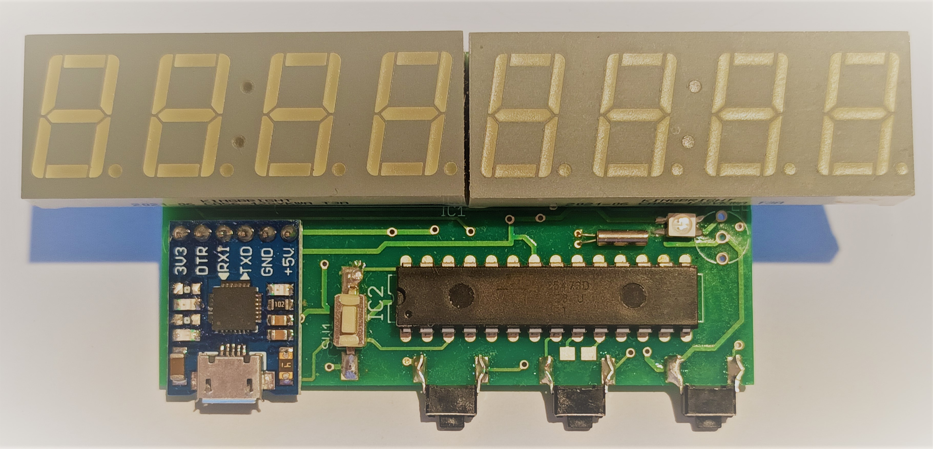 | Photos of PCB111000_CP2102  Note that tracks are provided for either surface mount or leaded  Red/Green LED and  watch crystal  The vertical switch is the reset control switch.  The horizontal switches are user switches sw1, sw2 and sw3  counting from the middle of the pcb.  RX/Tx leds on the CP2102 module can be disabled if they are found to be too bright by removing their series resistors as in the photograph.
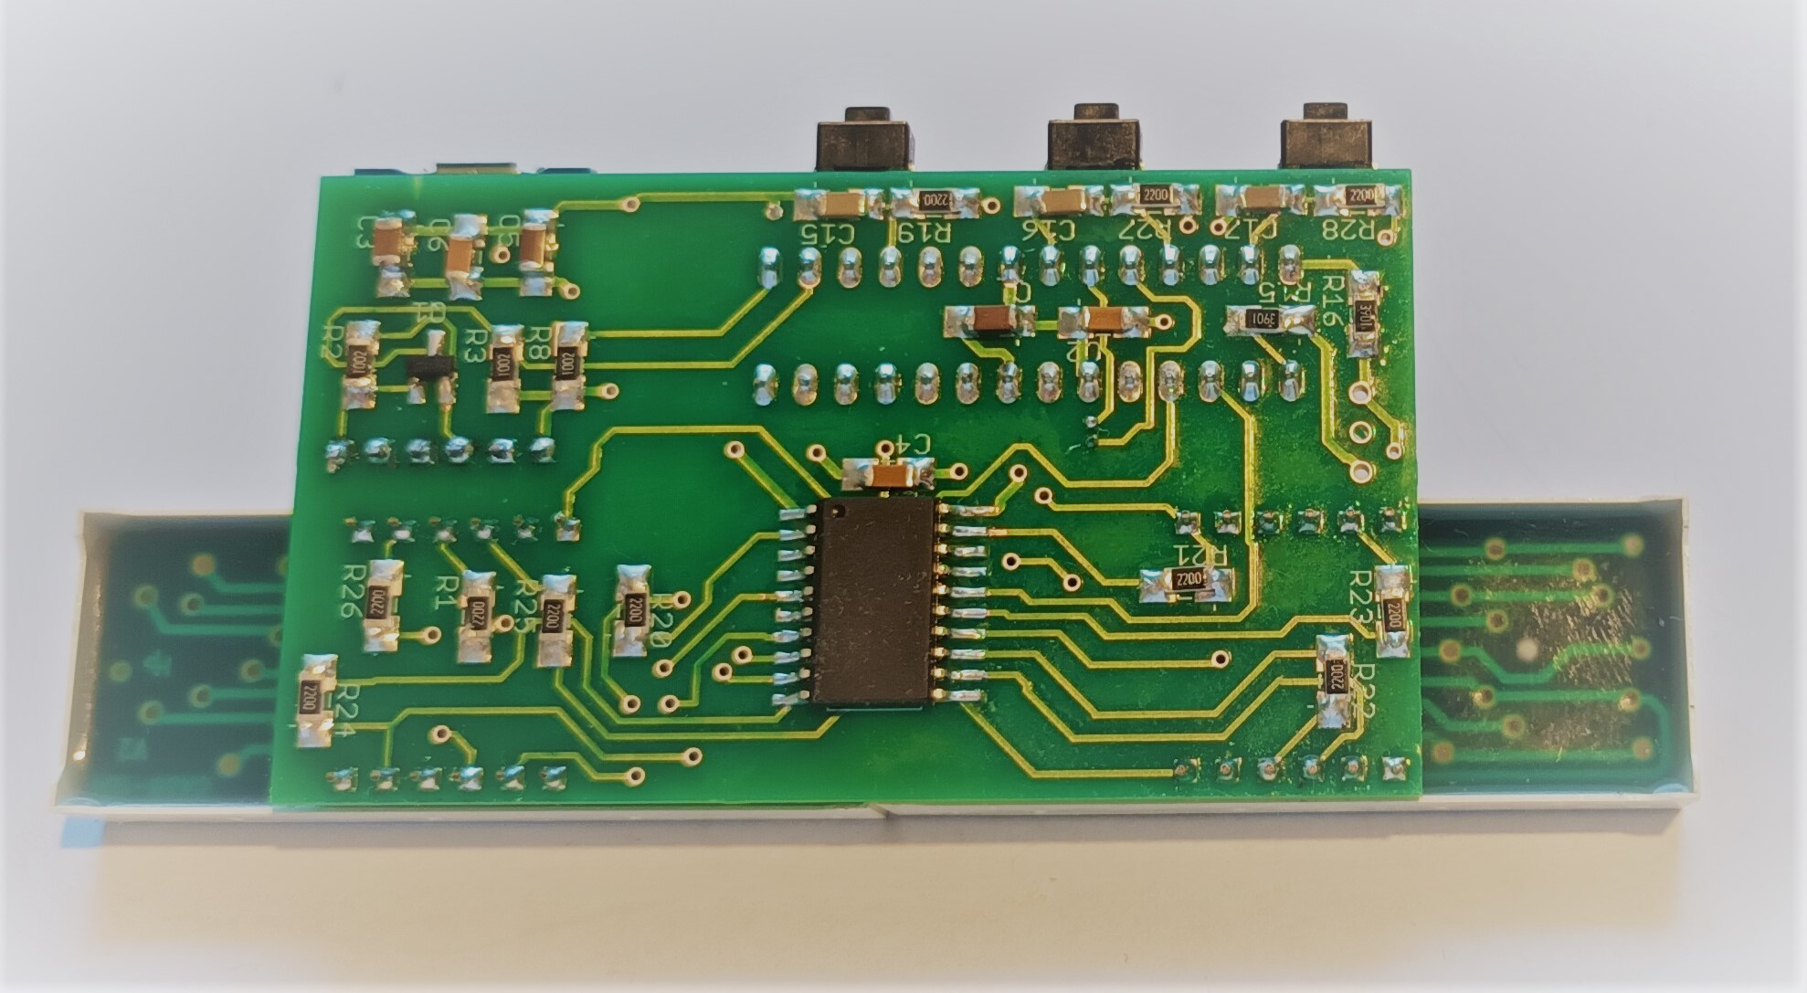

Setting up a new PCB111000_CP2102 (programs)

Having completed assembly minus the display and user switches

Connect the pcb to a PC with the vertical switch pressed.
Start a terminal session with the baud rate set to 57.6K.
Check for the presence of the p/r/t/D user prompt

Press ‘p’, upload CP2102_UPDI_Programmer and use it to upload the
mini-OS to the ATtiny1606 (baud rate of 14.4kB required).

Pulse the vertical switch to restore the p/r/t/D user prompt (reset 57.6K baud rate)
Press ‘p’ and upload cal_one_wire_comms.hex
Press ‘r’, ‘r’ to run the program and select a calibration correction factor.

At this point the remaining components should be added to the pcb.

Reconnect the pcb to the PC and reconnect the terminal program to restore the “r r...” user prompt.
Press ‘R’ to test the one wire link and the display.
Press and hold the vertical switch
Release it while the LED is on to reset the program
Release it after the LED has gone off to change the display intensity and reset the program.
Note: both red and green elements should be active.

Upload “FP_arithmetic.ino.standard” to check the operation of PCB11100_CP2102.

Pulse the reset control switch to get the p/r/t/D prompt and load Recal_328_using_crystal.ino.standard
Check calibration factor agrees with that already obtained plus or minus 1
Power cycle with reset control switch pressed to get the p/r/t/D prompt and press D to get the default application.
Power cycle and the default application should run with a low intensity display.

Setting up a new PCB111000_CP2102 (commentary)

With the exception of the user switches all components and system firmware have now been tested and the pcb is ready for use.

