Introducing PCB111000_CP2102

PCB111000_CP2102 is a cut down version of PCB_111000_UNO published by osbornema on 18 July 2020. It is designed to provide an introduction to C programming for AVR devices and consists of:
A CP2102 module with Rx/Tx and power provided on a 6 pin header
An Atmeg328 for user programs
An ATtiny 1606 that drives an 8 digit seven segment display.

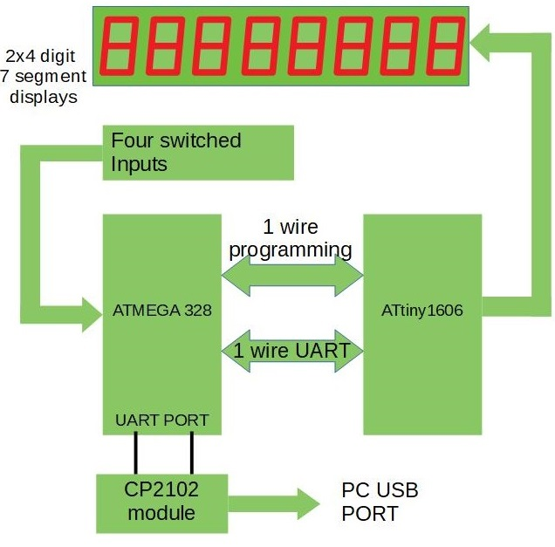 | System diagram for PCB111000_CP2102  The Atmega 328 hosts:  A Hex/text bootloader  An optional UPDI programmer  User programs  Text commentary for several sample  programs.  Two default programs provided for test  purposes.  The ATtiny1606  Drives the display  Provides resources for the user projects  One of the switches controls reset and display intensity. The others are or data entry.
This project up makes use of the following projects that I have already posted to AVR freaks.
Calibrating the Atmega328 internal RC clock
UNO_AVR programmer
UNO as UPDI programmer
The bootloader used in PCB_111000_UNO
New copies are included in this posting as each project has been modified slightly to fit this application.

For many newcomers to C and microcontroller programming the UNO has probably been an indispensable tool. It is supported by the Arduino development environment and provides:
Communication with a PC
A bootloader for projects
Access to all the IO of an Atmega 328
For me it also provides an easy way of programming and calibrating a number of AVR devices.

However the CP2102 module can also be used to provide communication with a PC. This provides a real incentive to use one of the free PCB design tools and do our designs from scratch. An Atmega preloaded with the Arduino bootloader can be used so nothing else need change. However for project PCB111000_CP2102:
Arduino is used to compile and export user projects
The bootloader is based on the UNO_AVR programmer
A UPDI programmer based on the UNO version is used to program the ATtiny1606
PC communication is made via a terminal program rather than the Arduino GUI.

Checking out the software

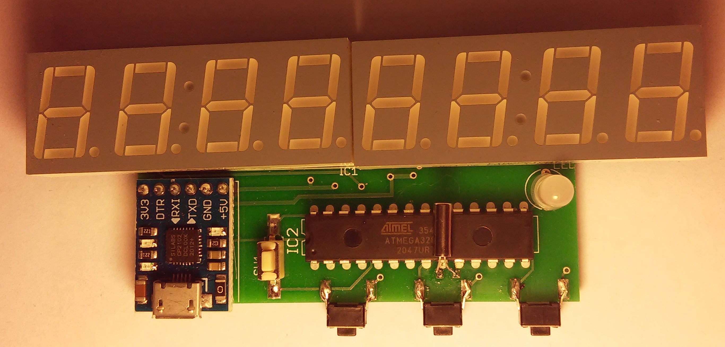 | Always use manufacturing drawings stored on Github when ordering new boards.  Crystal moved to other side if IC and improved power supply wiring and increased separation between pins 11 and 12 of ATtiny1606
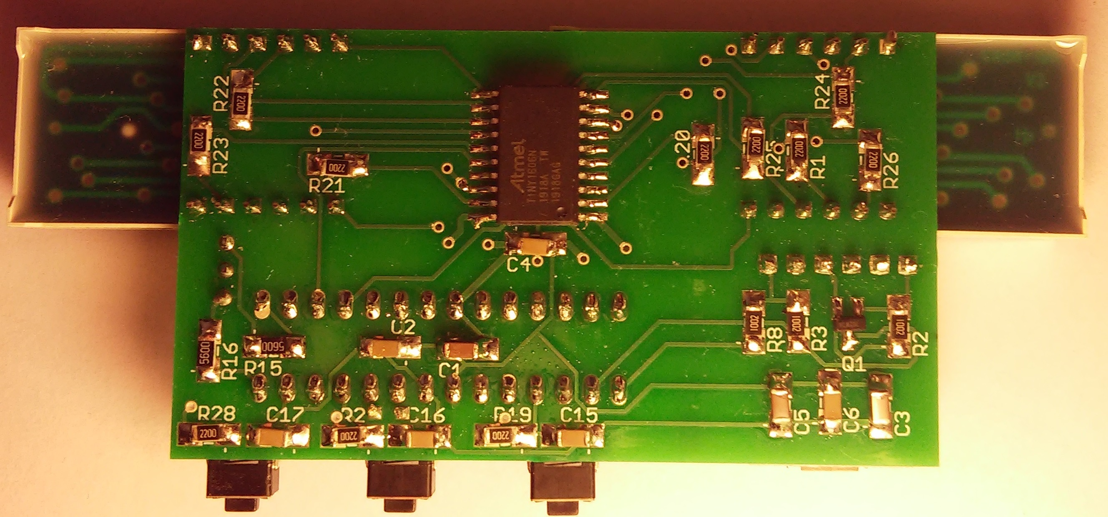

PCB11000_CP2102

ATtiny 1606 |  |  | Atmega328
A0 (Reset) | 328 PB3 |  | B0 | Led
A1 | Dig 7 |  | B1 | Led
A2(Comms) | 328 PB4 |  | B2 | n/c
A3 | Seg E |  | B3 | Prog output
A4 | Seg B |  | B4 | Comms
A5 | Dig 3 |  | B5 | n/c
A6 | Dig 0 |  | B6 | n/c Xtal
A7 | Dig 1 |  | B7 | n/c/Xtal
B0 | Dig 4 |  | C0 | n/c
B1 | Seg A |  | C1 | n/c
B2 | Seg D |  | C2 | n/c
B3 | Seg DP |  | C3 | n/c
B4 | Dig 2 |  | C4 | n/c
B5 | Seg C |  | C5 | Switch to 0v
C0 | Dig 5 |  | D0 | RX
C1 | Seg F |  | D1 | TX
C2 | Dig 6 |  | D2 | SW1
C3 | Seg G |  | D3 | n/c
 |  |  | D4 | n/c
 |  |  | D5 | SW2
 |  |  | D6 | n/c
 |  |  | D7 | SW3

Reset control

POR Jump to 0x0000: also resets ATtiny 1606
Short keypress: Change intensity
Long keypress: Run bootloader

WDT Jump to 0x0000 or 0x7000 depending on eeprom setting
Switch Post User Prompt: Long press: Run bootloader
Short press: Same as POR

Bootloader

Load hex/text programmer at 0x7000.
Load hex verification/text reader at bottom of application partition.

At p/r prompt
Press p to program hex, then jump to hex verification routine, them restore the p/r prompt
Could use wdtout or jump to restore p/r prompt

Press t to program text, then jump to text reader, them restore the p/r prompt
Could use wdtout or jump to restore p/r prompt

Press r to jump to 0x0000.
If 0x0000 contains 0xFFFF jump to default apps.

Issues
Note: pages are erased one at a time just before they are written
Pressing p with erase the first page of the previous application
This should probably be avoided, i.e. wait until hex file down load starts.

Bootloader must be transferred to a Studio application

Jobs

Transfer basic bootloader to Studio app.
Get reset op working as required.
Enhance bootloader to include test and verification.

Tests

In the prototype project “Bootloader_test”:

All resets take program control to location 0x7000.
The setup_HW macro initiates the WDT (clearing the WDRF, bit 3 of MCUSR)
If the POR flag is set control jumps to location 0x0000 (the User application).
If the EXRF is set control continues with the bootloader app.

Project CP2102_bootloader development:

For project CP2102_bootloader:
All resets must take program control to location 0x7000.
If the POR flag is set control must jump to location 0x0000 (the User application).

All resets take control to 0x7000

Post Ext reset: There is no external reset.

Post WDT Read WDT flag:
If set: will run bootloader
If clear: Jump to 0x0000.
Post POR{
Clear PORF flag (in MCUSR)
Check SW1
If up: Do nothing;
If down set WDT flag. (Will run bootloader.)
Initiate WDTout.}

Continue with bootloader
At h/t/r prompt if r is pressed clear WDT flag and initiate WDTout
Clear WDT flag when bootloader completes
Initiate WDTout.

Use of SW1 during execution of user app.
Jump to pin change ISR
Start timer
If short set intensity flag.
If long set WDT flag
Initiate WDTout (to reset 328 or run bootloader)

User App setup_HW macro

Always issues a 1606 reset command and changes intensity if flag is set
Issues intensity command if flag is set
Reset both flags

1606 Reset
POR sets intensity low
Reset command: Issues a WDTout
Intensity command is only active at this moment

328 EEPROM

0x3FF cal
0x3FE cal
0x3FD cal
0x3FC
bit 0 WDT flag 1 for clear and 0 for set
bit 1 Intensity flag

Bug reports

1 See subroutine “ send_int_num()” in
UNO_template_V2\Resources_Template_V2\One_wire_transactions

void send_int_num(long num){
One_wire_Tx_char = 'C';
UART_Tx_1_wire();
for(int m = 0; m <= 3; m++){
One_wire_Tx_char = Long_Num_to_UNO >> (8 * (3 - m));
UART_Tx_1_wire();}}

This should be
void send_int_num(long num){
One_wire_Tx_char = 'C';
UART_Tx_1_wire();
for(int m = 0; m <= 3; m++){
One_wire_Tx_char = num >> (8 * (3 - m));
UART_Tx_1_wire();}}

2 UNO_ARV_Programmer\UNO_AVR_programmer_intro.pdf

See section
UNO_AVR_ programmer Hard Ware:
UNO Tx pin should be connected to Atmega168 pin 3 (USART TXD) and
UNO Rx pin should be connected to Atmega168 pin 2 (USART RXD)

