Introducing PCB111000_CP2102

PCB111000_CP2102 is a cut down version of PCB_111000_UNO published by osbornema on 18 July 2020. It is designed to provide an introduction to C programming for AVR devices and consists of:
A CP2102 module with Rx/Tx and power provided on a 6 pin header
An Atmeg328 for user programs
An ATtiny 1606 that drives an 8 digit seven segment display.

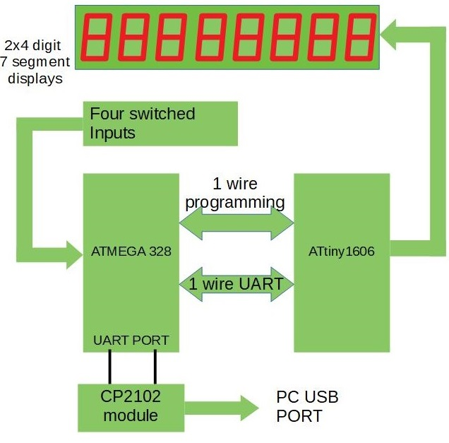 | System diagram for PCB111000_CP2102  The Atmega 328 hosts:  A Hex/text bootloader  An optional UPDI programmer  User programs  Text commentary for several sample  programs.  A default program provided for test  purposes.  The ATtiny1606  Drives the display  Provides resources for the user projects  One of the switches controls reset and display intensity. The others are or data entry.

System projects

 | Name | Compiler | Platform | Task
1 | UNO_programs_328 | Arduino | UNO | Calibrates Atmega328 and  Uploads bootloader
2 | UNO_Calibrates_328 | Arduino | Atmega328 | Calibrates 328 against the UNO crystal
3 | CP2102_UPDI_Programmer | Arduino | Atmega328 | Uploads mini-OS to ATtiny1606
4 | CP2102_mini-OS | Studio 7 | ATtiny1606 | Drives display and provides user services
5 | cal_one_wire_comms | Arduino | Atmega328 | Matches 328/1606 baud rates
6 | CP2102_bootloader | Studio 7 | Atmega328 | Loads user projects
7 | FP_arithmetic | Arduino | Atmega328 | Test application
8 | Recal_328_using_crystal | Arduino | Atmega328 | Check calibration post pcb assembly

Note: All projects are closely based on previous versions already posted on AVR freaks.
Checking out the operation of the system projects

Operation can be checked out using the prototype system shown below rather than manufacturing and loading a pcb.
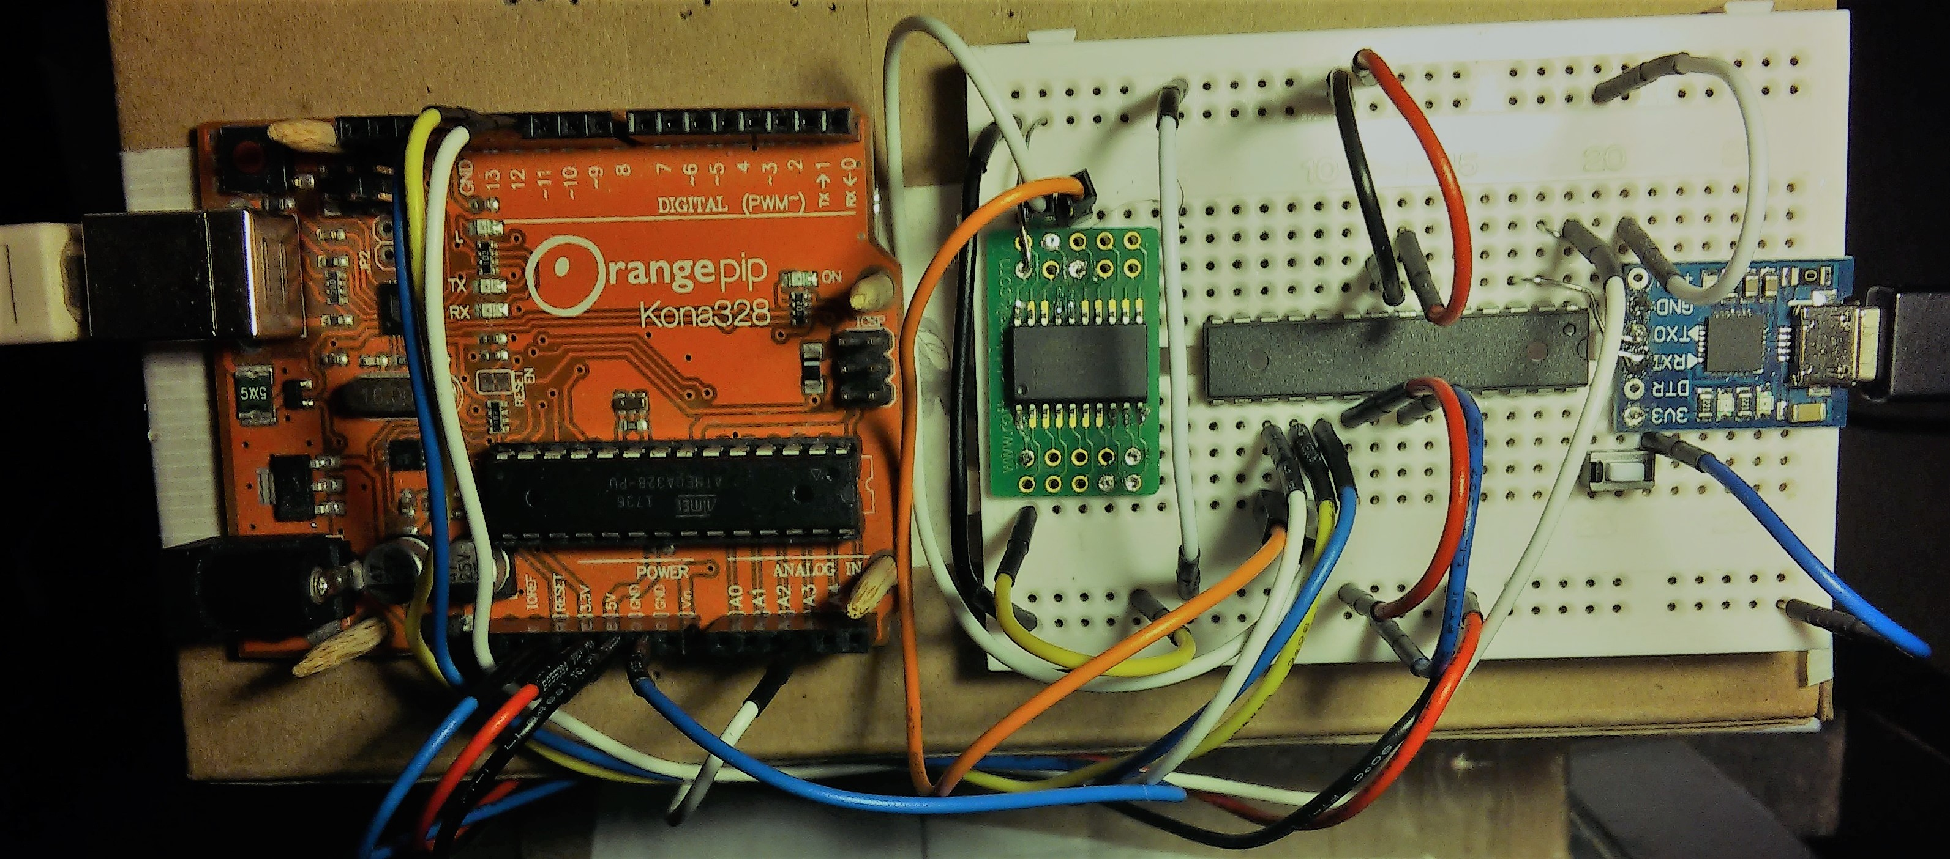
Wiring of the prototype system was as follows
(Note photo has error. It shows connection to ATtiny pin 17 instead of pin 18)
UNO |  | Atmega328 |  | ATtiny1606 |  | CP2102
UNO programs the Atmega328
Pin | Port | Pin | Port | Pin | Port | Port
11 | PB3 (MOSI) | 17 | MOSI
12 | PB4 MISO | 18 | MISO | Note: The CP2102 provides 3.3V logic  However it works with 5V logic  With no load on the 3V3 DC output  the logic is closer to 4V
13 | PB5 SCK | 19 | SCK
A3 | PC3 | 1 | Reset
9 | PB1 | 15 | Optional LED + 1K detects data download
Atmega328 programs ATtiny1606
 |  | 17 | PB3 (MOSI) | 16 | Reset
Atmega328/ATtiny1606 one wire comms
 |  | 18 | PB4 MISO | 18 | PA2
Atmega 328 comms
 |  | 2 | RXD |  |  | Tx
 |  | 3 | TXD |  |  | Rx
Atmega 328 control Pin 28 PC5 to 0V via push button switch (the reset control switch)
Plus optional dual LED plus 1K resistors between pins 14/15 and 0V
Optional UNO control Reset to GND via temporary wire link (Holds UNO in reset)
UNO +5V: connected to Atmeg328 and ATtiny1606 5V pins
Note: the ATtiny 1606 +5V pin can temporarily be disconnected to reset the device
UNO 0V: connected to the Atmeg328, ATtiny1606 and CP2102 module 0V pins.
CP2102 3.3/5V: No connection
Tests carried out on the prototype system

Connect the UNO to a PC.
Open the UNO app UNO_programs_328 and upload it to the UNO
Open a terminal program and connect (38.4KB)
User prompt s s s s……… should be generated
Connect the CP2102 to the same PC, open a second terminal program and connect (38.4KB).
Operation | User IO
Operation | UNO terminal program | CP2102 terminal program
Calibrate Atmega328  (UNO generates Pin Change Interrupt every 8.192mS) | Upload  UNO_Calibrates_328.  Send ‘t’ to make program run | Enter User value for OSCCAL when requested
Upload mini-OS to ATtiny1606 | Upload and run  CP2102_UPDI_Programmer | POR ATtiny1606  Change baud rate to 14.4K  Send ‘r’, ‘a’, ‘y’, ‘y’  ¹Upload mini-OS
Calibrate the Atmega328 one wire comms clock | Upload and run  cal_one_wire_comms.hex | Change baud rate to 57.6K and press ‘r’ at the user prompt Enter cal correction factor when requested
Upload bootloader to Atmega328 | Upload and run  bootloader.hex  Send P rather than p | Get user prompt  p/r/t/D
Upload and run  Floating_point_numbers: Checks operation of the one-wire link. |  | Press ‘p’ and send hex file  Keypress ‘r’ to start then ‘f’ and follow instruction  Press switch on breadboard to reinstate p/r/t/D prompt
Upload commentary |  | Press T at p/r/t/D prompt  send test.txt
Read commentary |  | Press t at p/r/t/D prompt  Enter page number then AK
Notes:
The UNO is used to upload programs to the Atmega328 as follows
Reset the UNO. At the user prompt send ‘s’ then ‘p’ to upload the program and ‘r’ to make it
run unless otherwise stated.

All programs running on the Atmega 328 communicate with the PC via the CP2102.

The ATtiny1606 can only be programmed using CP2102_UPDI_Programmer running on the Atmega328.

Every test can be rerun by resetting the UNO and pressing r or t as required.

1 Trial application requires the display and only works if the one_wire_comms calibration is adequate.

Terminal sessions generated while calibrating the Atmega328 are shown below.
Terminal settings are: 8 data bits, 1 stop bit, no parity and no handshaking
Setting up a new PCB111000_CP2102
Before assembling the pcb calibrate the Atmega328 and load it with the bootloader as described above.
Having assembled the pcb:
Connect the pcb to a PC with the vertical switch pressed.
Start a terminal session with the baud rate set to 57.6K.
Check for the presence of the p/r/t/D user prompt

Press ‘p’ and upload CP2102_UPDI_Programmer.
Upload mini-OS (Note POR is not required)
Default user application will run if the one_wire_comms calibration is adequate.

Pulse the vertical switch to restore the p/r/t/D user prompt
Press ‘p’ and upload cal_one_wire_comms.hex
Press ‘r’, ‘r’ to run the program and select a calibration correction factor.
When the program resets press ‘R’ to test the one wire link

Press and hold the vertical switch
Release it while the LEDs are on to reset the program
Release it after the LEDs have gone off to change the display intensity and reset the program.
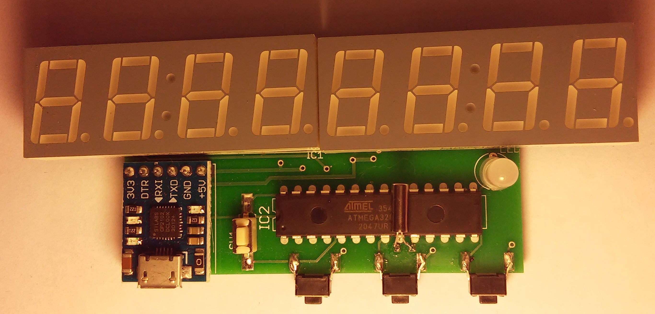 | Always use manufacturing drawings stored on Github when ordering new boards.  Crystal moved to other side if IC and improved power supply wiring and increased separation between pins 11 and 12 of ATtiny1606
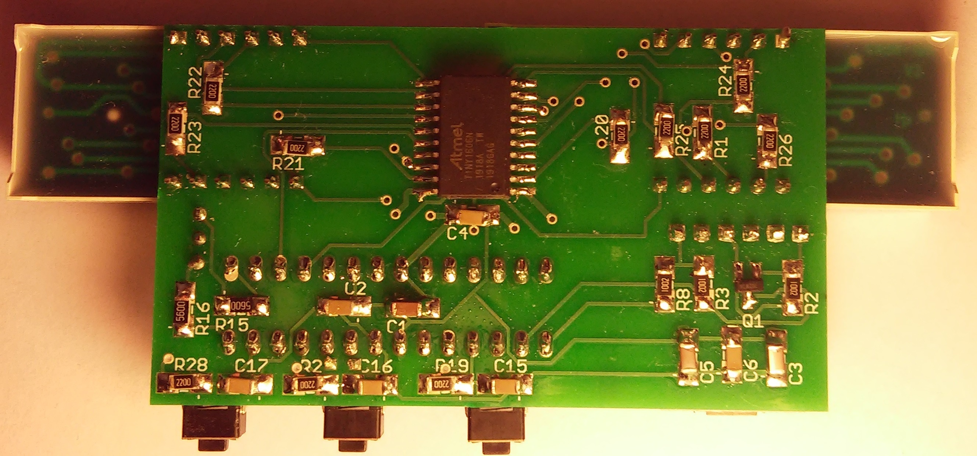 | Reset switch

