**Minutes of Parkwood Residents Association Meeting, June 11, 2018**

Kira Lueders, president, opened the meeting at 7:35 p.m. Twenty-two members were present. Attendees were invited to introduce themselves and tell their street name and number of years they have resided in Parkwood. Length of residency ranged from 52 years to “just bought the house, haven’t moved in yet.”

**PRA Business**

Election of Officers

Peter Mansbach in the role of parliamentarian called for additional nominations for executive committee positions. As there were none, the current slate of officers was elected by unanimous consent. Chris Dewey, list serve administrator, is leaving the area and stepping down from his position. Alex Clark, webmaster, has agreed to take over Chris’ role.

The minutes of the February 26, 2018 PRA meeting (on PRA Website and in Spring Newsletter) were approved.

Proposed Development at Knowles Near Connecticut Ave.

Kira described a building proposed for construction on Knowles Ave. across from Strosnider’s. It would be a six-story residence with 126 units for low-income seniors. Concern was raised about traffic and parking. The proposal provides for only 56 parking spaces under the building. There would also be a pull-off space in front of the building for buses, etc. Residents will have the opportunity to comment on this development once final plans are submitted to Park and Planning in the fall.

Neighborhood Security

Jeffrey Griffith, vice president, reminded us that although Parkwood is a safe community, incidents do happen. He suggested that if someone knows of an incident, it may be helpful to others to report it on the list serve (after notifying authorities). The most common law-breaking incidents concern thefts from automobiles. The obvious answer, which we sometimes forget is: Always lock your car!

**Program: Fire and Emergency Medical Help**

Steven Semler and Norman Jones discussed the history, mission, and operation of the Kensington Volunteer Fire Station 5. Mr. Semler is an EMT and past president of the KVFD; Mr. Jones is an EMT and firefighter. (All firefighters are also EMTs but not all EMTs are firefighters.)

The Kensington Volunteer Fire Department was founded in 1925 as an all-volunteer fire department for Kensington. Its volunteer heritage is the strongest in the county. 75% of its shifts are staffed 100% by volunteers. It owns all of its fire engines, ambulances, paramedic cars and command vehicles. No other VFD in County matches this. All riding members receive the same training and test to the same State certification as career firefighters. KVFD is supported by administrative support volunteer members. It is funded by community donations as well as State and County grants.

Mr. Semler used slides to “Help Us Help You!” The first slide pictured the Kensington Volunteer Fire Dept. shield. Whenever anyone from the KVFD comes to your home, you will see this shield. 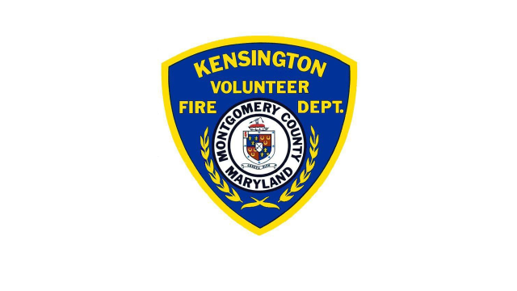Mr. Semler reminded us that when an EMT is needed most, for example when a patient is unconscious or has a serious health emergency, they are unable to communicate. In these situations, the “Vial of Life” is invaluable. The “Vial of Life” is a form listing medical history, medicines, allergies, etc., thereby giving clues to speed, care, and transport decisions. The completed form is put in a vial or envelope and placed on refrigerator or bed headboard. This form is available on the web at VialofLife.com.

Another way persons can “Help Us Help You” is by using large, illuminated, unobscured house numbers. Numbers on a curb are effective only if not blocked by a car. Large reflective numbers on a mailbox work if there is a source of light to reflect.

Mr. Semler also discussed the “Do Not Resuscitate” (DNR) policy, which was created by   
State legislature. (The KVFD does not take a position on DNR.) The State uses the MOLST form. It addresses DNR options regarding the level of the EMS response **only** when the **heart stops**. There are two options: A: Full aggressive interventions such as CPR, shocks, and intubation to attempt to prevent heart stoppage; B: Limit pre-heart stoppage interventions to basic support such as oxygen and pain meds but no heroic interventions if heart stops. The MOLST form must be signed by patient and health care provider. The EMT must see the form immediately (place it on refrigerator or bed headboard) or see a MOLST-logo bracelet worn by the patient. Advance Directive forms and verbal DNR’s will not be recognized by EMT. The MOLST form and additional information can be found at Marylandmolst.org.

Calls for EMT assistance do not necessarily involve life-threating emergencies. Firefighters and EMTs often visit homes for I’ve-fallen-and-can’t-get-up calls. They are happy to provide this type of non-emergency service and will go immediately to the home without lights and siren. Mr. Semler said that he will also do a complete rapid medical check to rule out broken bones or other serious medical issues.

In answer to a question: How do you get into a locked home? Mr. Semler said that EMTs have specialized equipment and fire trucks have even more options such as wedges and pneumatic pumps for entry.

Mr. Norman Jones, a firefighter for 23 years, spoke about fire safety and fire-fighter response to 911 calls. He said the KVFD gets approximately 4700 calls per year. He offered the following safety advice:

* Make sure your chimney is cleaned regularly.
* If a smoke or carbon monoxide (CO) alarm goes off, get out of your house and call 911 immediately. Carbon monoxideis a silent killer.
* Notify firefighters of special-needs children (placards are available) or other issues such as a person on oxygen.
* When calling 911 give as much information as possible.
* If you’re in an apartment fire, do not open a door into hall and do not open a window, except possibly a crack to wave a cloth to mark your location.

Mr. Jones brought firefighting equipment and gear with him to demonstrate. Jeff volunteered to try it on and reported that it is HEAVY. It is also very expensive, costing about $1700. It can protect up to 300 degrees.

The KVFD service area is not limited to the town of Kensington. The geographic area is divided into 23 regions. All fire departments serve surrounding areas as needed. 911 will screen calls so that the appropriate response is sent from the closest available station. NIH and Navy can send trucks off campus.

**Additional PRA Business**

Proposed Bike Lane on Cedar Lane

Jeff Griffith reported that the County has completed its Master Bikeway plans. The current plans call for putting a separated bikeway on Cedar Lane on one side of the street. It’s likely that parking on that side of Cedar would be affected, which could be a serious inconvenience for residents on that side. The plan is not yet finalized. It has to go to planning committees and then to the Council. Jeff will put a link on the list serve to keep residents informed.

In answer to a question: The Summit Ave. extension is no longer being considered. It was determined that it would have a limited effect on traffic congestion.

The meeting was adjourned at 9:00 p.m.

Respectfully submitted,

Judith Dighe, Secretary