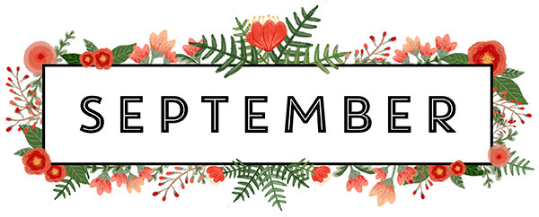

**Howard Team Birthdays!!!**

**Rita W. 9/6 Michelle L. 9/7**

**Ryan B. 9/8**

**Matt E. 9/17 Bert L. 9/21**

**Howard Team Anniversaries!!!**

**Bert L. 9/3**

**Alyssa S. 9/28**

**Let’s join together to wish our fellow team member the**

**Very Best on Their Birthdays & Anniversaries!**

**And May We Never Forget…**

**9/11/01 – 9/11/21**

**20th Anniversary**

