LPG Niyojan
Manager / Owner Application

User Manual
Document Version | 1.0
Prepared For | Client Delivery / User Training
Platform | Android Mobile Application
Module | Manager & Owner
Date | May 2026
Confidentiality | Confidential

Document Revision History

Date | Version | Changes | Author
May 2026 | 3.8 | Current release — Manager/Owner User Manual | Aadyam Infotech

0. App Installation & Setup

0.1 System Requirements
Android Version | Android 7.0 (Nougat) or higher
Storage | Minimum 50 MB free space
Internet | Mobile data (3G/4G/5G) or Wi-Fi — required for all features
Mobile Number | Registered number with OTP issued by Web Admin
Simultaneous Logins | One active session per device — logging in on a second device invalidates the first session

0.2 Installation Steps
The LPG Niyojan app is distributed as an APK file. Follow these steps to install it on your Android device:

- Download the LPG Niyojan APK file shared by your system administrator (via WhatsApp, email, or direct link).
- On your Android device, open Settings → Security (or Privacy).
- Enable the option Install from Unknown Sources (or Allow from this source) — this allows APK installation outside the Play Store.
- Open your file manager and navigate to the folder where the APK was downloaded (usually Downloads).
- Tap the LPGNiyojan.apk file.
- Tap Install on the confirmation screen.
- Wait for the installation to complete, then tap Open.
- The LPG Niyojan app icon appears on your home screen. The app is ready to use.

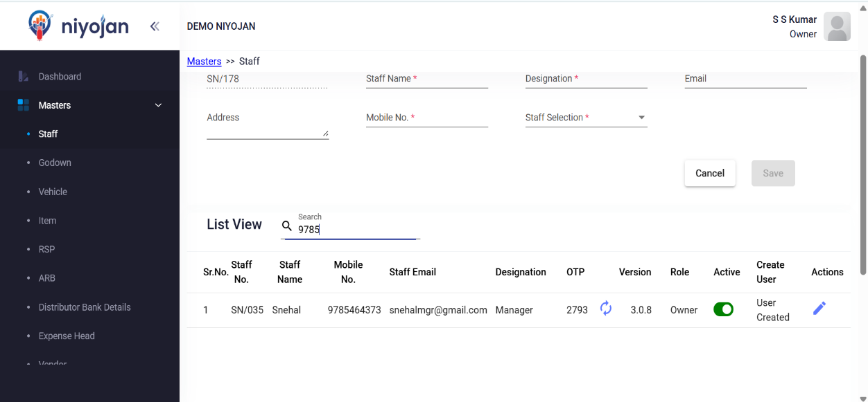

0.3 First-Time Launch
After installation, open the app for the first time:
- Tap the LPG Niyojan icon on your home screen.
- The Splash Screen appears for 2–3 seconds while the app loads.
- You are taken to the Login screen automatically.
- Proceed to Section 2 (Login & Authentication) to log in.

App Navigation Overview
The LPG Niyojan app uses a bottom navigation bar with 4 tabs. Every major feature is reachable from one of these tabs. The diagram below shows how all screens connect.

Bottom Navigation Bar
┌─────────────┬─────────────┬─────────────┬─────────────┐
│ Dashboard │ DSR │ Delivery │ More │
└─────────────┴─────────────┴─────────────┴─────────────┘
Dashboard tab:
→ KPI Cards (Needs Attention, Financial, Stock, Bookings, Performance)
→ Unsettled Sales details (tap Unsettled card)
→ Trans Mode Filter (Today's / This Month / Financial Year)
DSR tab:
→ 6 DSR Tabs: Revenue | DM Sale | Expenses | SV & TV | CDCMS Stock | Cash
Delivery tab:
→ Delivery Boy Wise List → Update Sales Summary
→ Cash Updation Screen | Submit All Sales (FAB)
More tab:
Daily Transactions → SV Sale | TV Receipt | Payments Receipt
Update Payments | Salary Payments
Cash Handover / Bank Deposit | Receipt Defective Regulator
ARB → ARB Purchase | ARB Purchase Return | ARB Sale
Admin Settings → Configuration (Owner Only)
Account → Logout

Manager vs Owner — Role Comparison
The app supports two roles: Manager and Owner. Both roles share most features, but the Owner has additional administrative privileges. The table below shows the complete comparison.

Feature / Screen | Manager | Owner
Dashboard (all cards & KPIs) | ✔ Yes | ✔ Yes
DSR (Daily Sales Report) | ✔ Yes | ✔ Yes
Delivery / Update Sale | ✔ Yes | ✔ Yes
SV Sale | ✔ Yes | ✔ Yes
TV Receipt | ✔ Yes | ✔ Yes
Payment Receipt | ✔ Yes | ✔ Yes
Update Payments | ✔ Yes | ✔ Yes
Salary Payments | ✔ Yes | ✔ Yes
Cash Handover / Bank Deposit | ✔ Yes | ✔ Yes
ARB Module (Purchase / Return / Sale) | ✔ Yes | ✔ Yes
Receipt Defective Regulator | ✔ Yes | ✔ Yes
More → Account → Logout | ✔ Yes | ✔ Yes
More → Admin Settings → Configuration | ✘ Not visible | ✔ Yes (Owner only)

ℹ To change a user's role (from Manager to Owner or vice versa), contact your system administrator to update the role in the Web Admin portal.

Table of Contents

# | Module | Page
1 | Introduction | 4
2 | Login & Authentication | 4
 | 2.1 Splash Screen | 4
 | 2.2 Mobile Number Login | 5
 | 2.3 OTP Verification | 6
 | 2.4 Web Admin OTP Process | 7
3 | Dashboard Module | 8
 | 3.1 Manager Dashboard | 8
 | 3.2 Dashboard Cards | 9
 | 3.3 Trans Mode Filter | 24
4 | DSR (Daily Sales Report) Module | 25
 | 4.1 DSR Screen Overview | 25
 | 4.2 DSR Tabs | 25
 | 4.3 Date Selection & Show DSR | 26
5 | Delivery / Update Sale Module | 28
 | 5.1 Delivery Boy Wise List | 28
 | 5.2 Update Sales Summary | 28
 | 5.3 Cash Updation Screen | 30
 | 5.4 Submit All Sales | 31
6 | SV Sale Module | 33
7 | TV Receipt Module | 33
8 | Payment Receipt Module | 34
9 | Update Payments Module | 35
10 | Salary Payments Module | 36
11 | Cash Handover / Bank Deposit Module | 37
12 | ARB Module | 38
 | 12.1 ARB Purchase | 38
 | 12.2 ARB Purchase Return | 39
 | 12.3 ARB Sale | 40
13 | Receipt Defective Regulator Module | 41
14 | More Options (Menu) | 42
15 | Configuration Screen (Owner Only) | 44
16 | Logout | 44
17 | Validations & Error Messages | 45
18 | Important Notes | 46
© Aadyam Infotech | All Rights Reserved

1. Introduction
LPG Niyojan is a mobile application designed for LPG distributors to manage daily operations from a smartphone.
The Manager/Owner module provides complete control over:
- Daily cylinder sales and collection
- DSR (Daily Sales Report) generation
- Delivery boy performance tracking
- Expense management
- ARB (Additional/Returnable Bottle) operations
- Cash handover and bank deposit records
- Salary and vendor payment tracking
- TV/SV receipt management

Prerequisites
Before you can use the app, ensure the following are in place:

Active internet connection | Required for all screens. Mobile data (3G/4G/5G) or Wi-Fi both work.
Registered mobile number | Your 10-digit number must be registered by your system administrator in the Web Admin portal.
OTP from Web Admin | The one-time password is not sent by SMS. Your Web Admin must generate and share it with you (see Section 2.4).
Android version | Android 7.0 or higher (see Section 0 — App Installation).
Storage space | Minimum 50 MB free storage on the device.
Single-user session | Only one active session per device is supported at a time.

2. Login & Authentication Module

2.1 Splash Screen
When you open the app, the Splash Screen appears first. The app logo and name are displayed while the app checks for an existing active session. If already logged in, the app navigates directly to the Dashboard — otherwise it takes you to the Login screen.
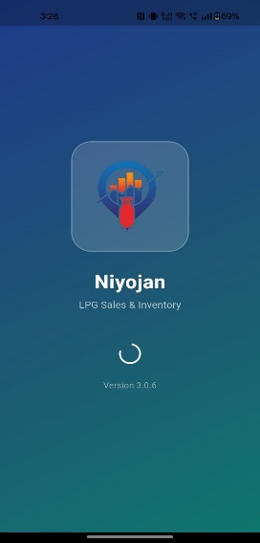

2.2 Mobile Number Login
Screen: Login Screen
Steps:
- Enter your registered 10-digit mobile number.
- Tap Submit / Send OTP.
- The system validates the number against the database.
- On success, you are taken to the OTP verification screen.

Validations:
- Mobile number is mandatory.
- Must be exactly 10 digits.
- Number must be registered in Web Admin.

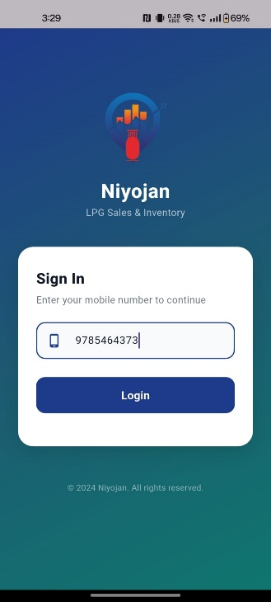

2.3 OTP Verification
Screen: Verify OTP
Steps:
- Enter the OTP provided by your Web Admin.
- Tap Verify.
- On success, the app loads your role-based dashboard.

Note | Details
OTP source | OTP is NOT sent via SMS — it is generated in Web Admin
OTP type | Role-based and time-limited
Wrong OTP | Error message shown on screen

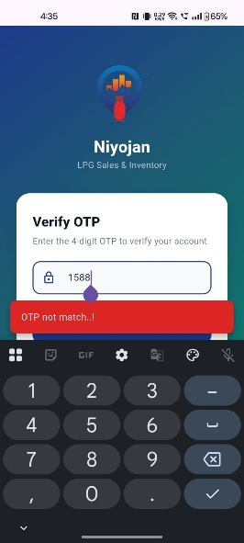 | 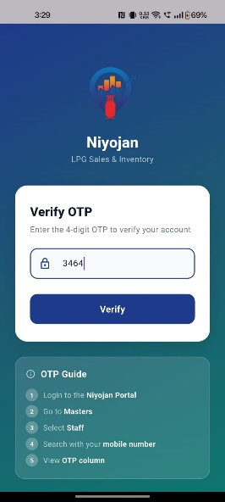

2.4 How to Get OTP from Web Admin
The OTP is not sent by SMS. It must be obtained directly from the Web Admin panel and shared with the staff member who needs to log in.
Steps:
- Log in to the LPG Niyojan Web Admin Panel.
- Navigate to Staff Master.
- Find the staff member who needs to log in.
- Click on their record to view the OTP.
- Share the OTP with the staff member for mobile login.

3. Dashboard Module

3.1 Manager Dashboard Screen
After login, the Manager Dashboard is the main home screen. It greets you with a time-based message (Good Morning / Afternoon / Evening), displays today's date, and gives a complete overview of the day's operations at a glance.
What you see on the dashboard:
- Hero header strip with greeting and your name
- Today's date
- summary cards organised by category
- Delivery men count and performance section
- Revenue, Gross Profit, and Net Profit section
- Cash and settlement summaries
- Cylinder stock progress section
- Bottom navigation bar (Dashboard | DSR | Delivery | More)

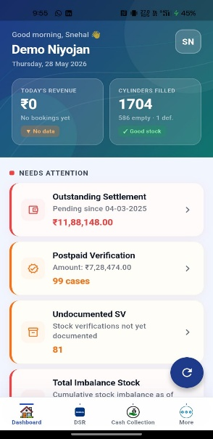

3.2 Dashboard Cards
The dashboard is organised into sections. Tap any card to open the detailed screen for that data.

Needs Attention
This section highlights items that require immediate action — outstanding amounts, pending verifications, stock issues, and vendor dues.

Card | Outstanding Settlement
Description | Shows the total pending settlement amount with the date range since which it has been pending. Tap to view the full list of pending settlements.

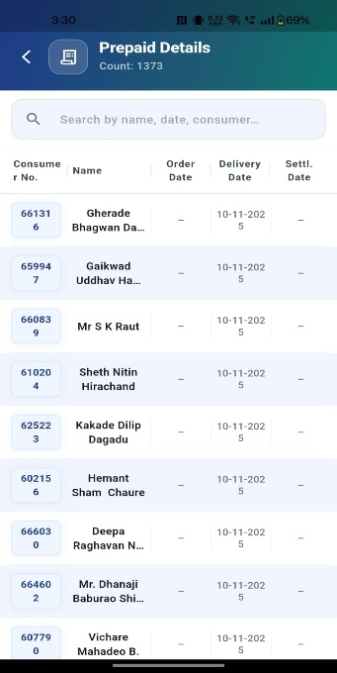
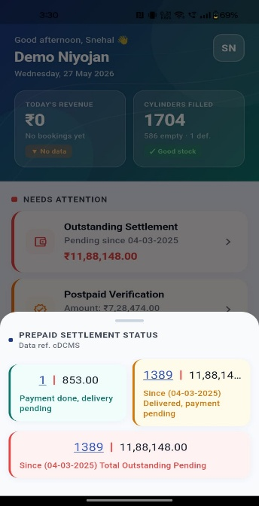

Card | Postpaid Verification
Description | Displays the number of postpaid cases pending verification. These are credit sales that need to be verified before finalisation. Tap to open the postpaid verification list.

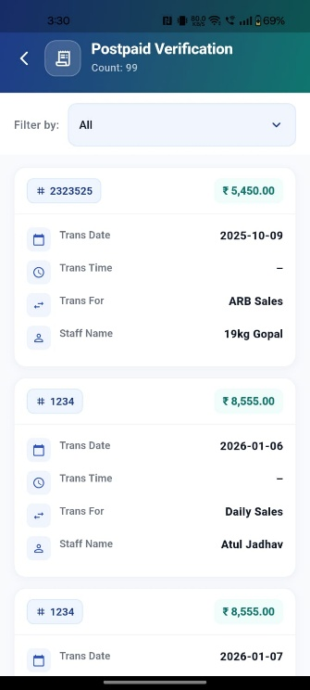

Card | Undocumented SV
Description | Shows the count of Special Voucher (SV) stock verifications not yet documented in the system. Tap to view and document the pending SV entries.

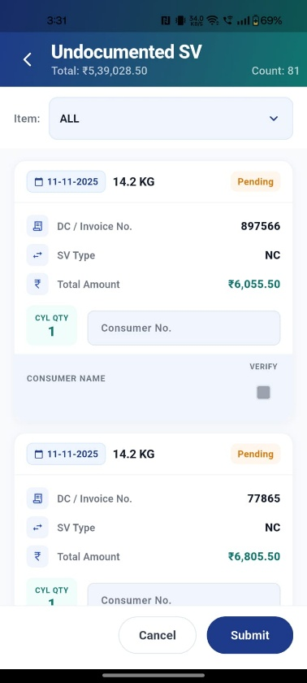

Card | Total Imbalance Stock
Description | Displays the current cylinder stock imbalance count as of today. An imbalance occurs when the system count does not match the physical count. Tap to view imbalance details.

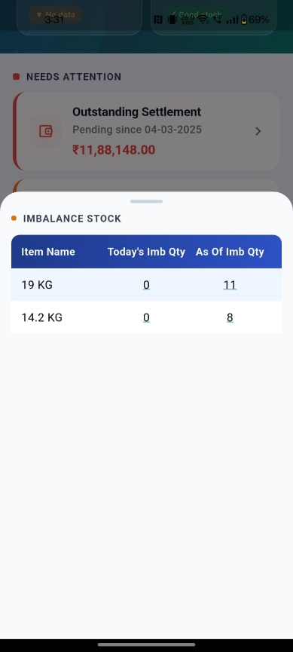 | 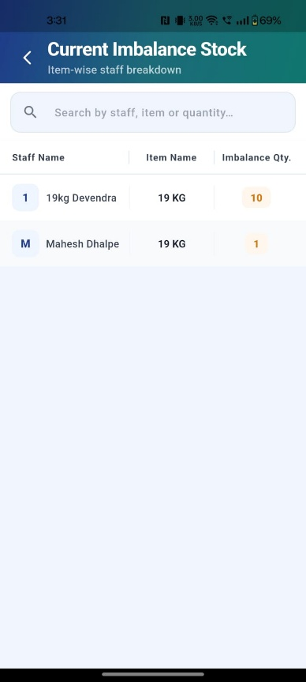

Card | Vendor Payment Due
Description | Shows the cumulative vendor payment due amount — the total outstanding amount owed to vendors. Tap to view the vendor-wise payment due list.

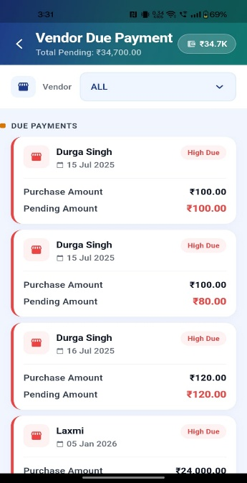

Financial Overview
This section summarises today's financial activity — expenses, on-account collections, cumulative balances, and outstanding credit.

Card | Today's Expenses
Description | Shows the total expenses recorded for today across all expense categories. Tap to view the expense breakdown by category.  Tapping the Chart toggle displays the Revenue vs. Expense comparison for the previous year and the current year.

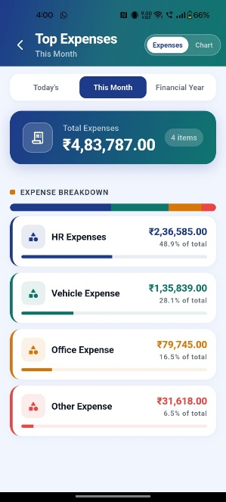 | 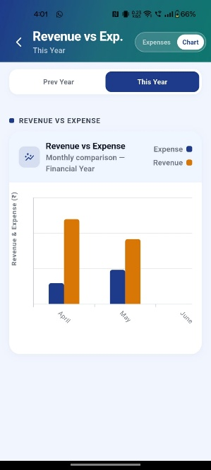

Card | Today's On Account
Description | Displays the total cash collected on account today. On-account collections are payments received against outstanding balances. Tap to view on-account transaction details.

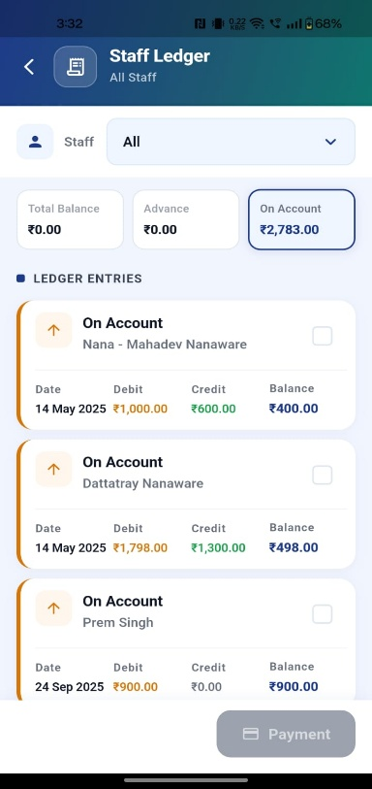

Card | Total On Account (Cumulative)
Description | Shows the cumulative outstanding on-account balance — the total amount collected on account but not yet fully settled. Tap to see the full transaction history.



Card | Credit Sale Outstanding
Description | Displays the total outstanding credit sale amount — the amount owed by customers who purchased on credit. Tap to view the credit ledger and customer-wise outstanding amounts.

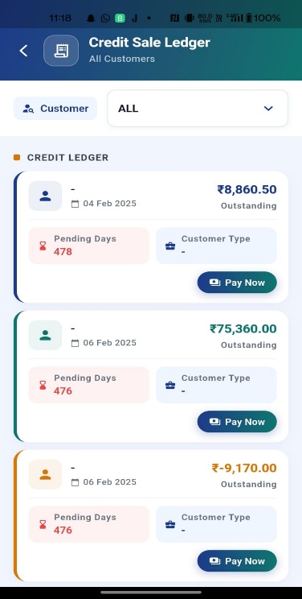

Inventory & Stock
This section gives a real-time overview of cylinder stock levels and CDCMS comparison data.

Card | Cylinder Stock Status
Description | Shows the current Filled, Empty, and Defective cylinder counts for the selected cylinder type (e.g. 19 KG). Also displays today's imbalance units and total imbalance count. Use the dropdown to switch between cylinder types.

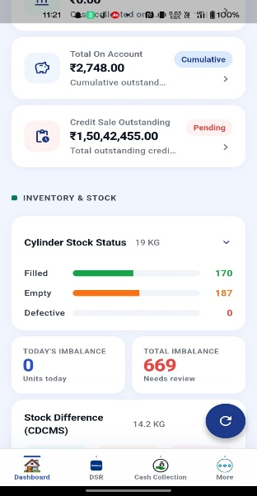 | 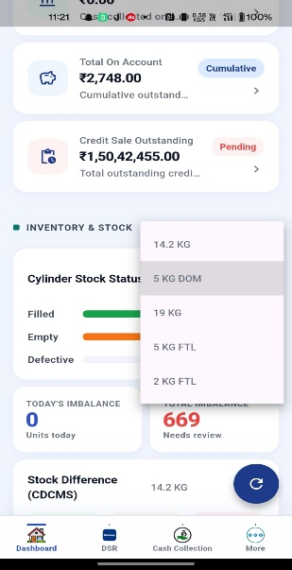

Card | Stock Difference (CDCMS)
Description | Displays the CDCMS stock comparison — Filled, Empty, and Defective counts as per CDCMS records. Tap to view the detailed stock difference report and identify discrepancies.

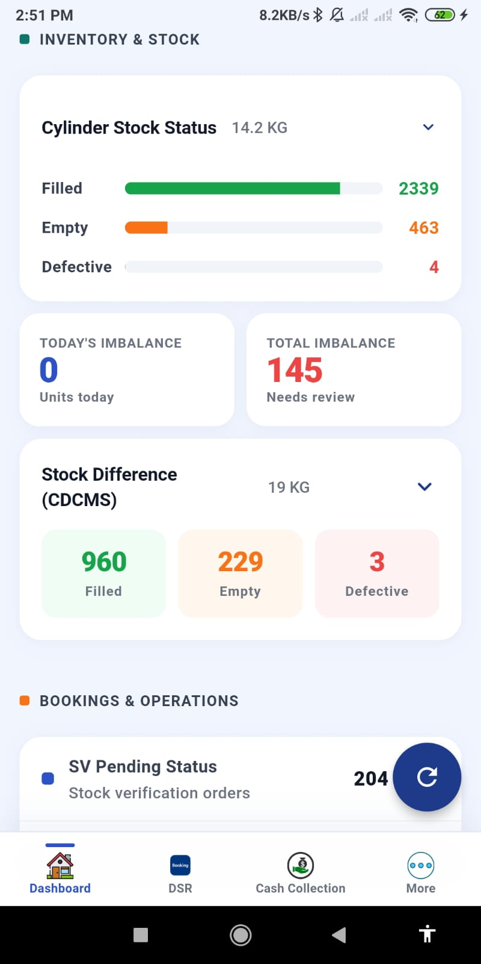
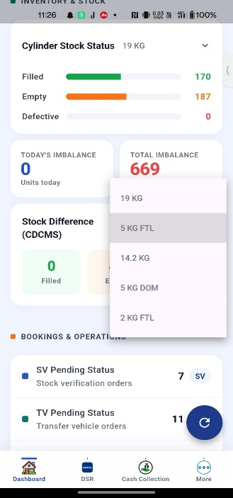

Bookings & Operations
This section tracks the operational status of SV, TV, unsettled sales, and prepaid punching activity.

Card | SV Pending Status
Description | Shows the count of pending SV (Special Voucher) stock verification orders not yet processed. Tap to view the list and act on pending SVs.

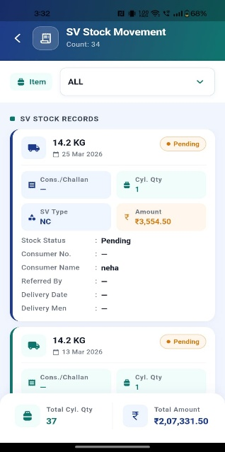

Card | TV Pending Status
Description | Displays the count of pending TV (Transfer Voucher) orders not yet receipted. Tap to view the list and process pending TVs.

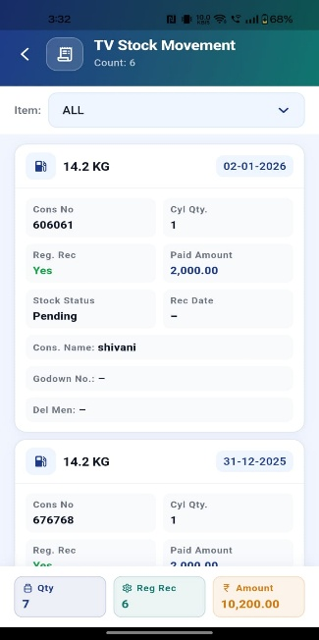

Card | Unsettled Sales
Description | Shows the count of unsettled sale entries and the DMR amount. These are sale records where cash has not yet been updated. Tap to view unsettled sales and settle them.

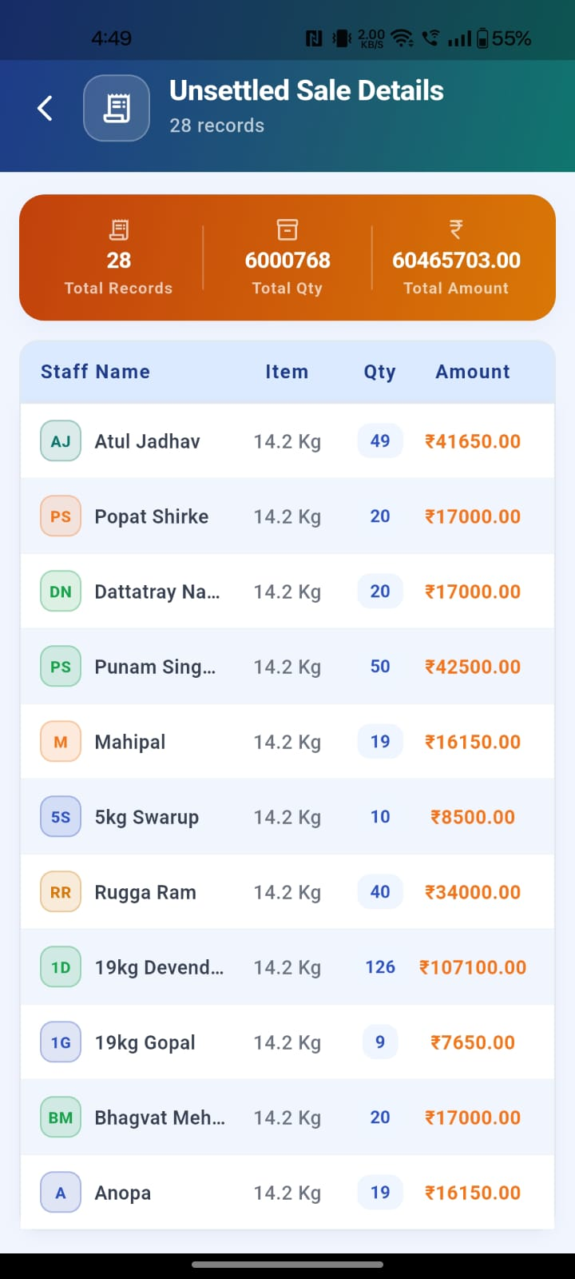
Card | Prepaid Punching — Today
Description | Displays the number of prepaid bookings punched today. Prepaid punching records when a customer's prepaid booking has been dispatched. Tap to view today's punching details.

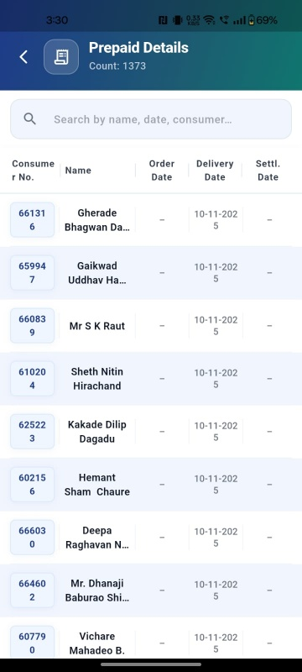 | 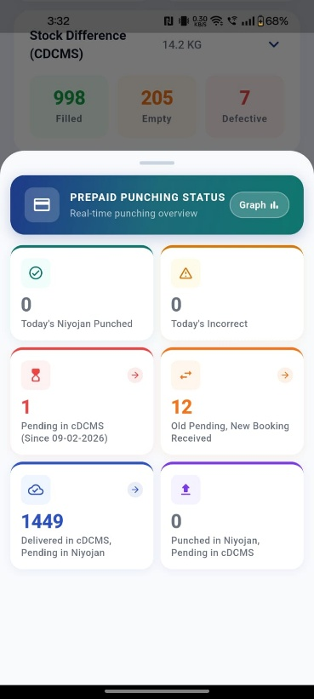

Card | Refill Booking & Cashmemo Punching
Description | Shows the count of refill bookings and cashmemo punching entries for the day. Tap to view the detailed punching summary and verify entries.

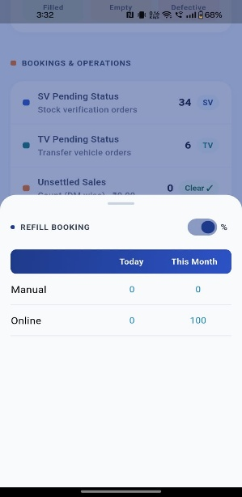 | 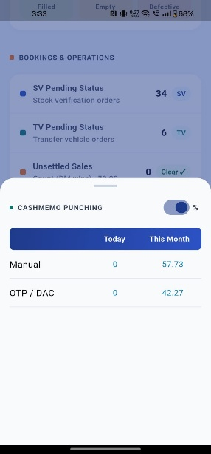

This Month's Performance
This section summaries the month's business performance across all product categories — gross revenue, gross profit, expenses, and net profit.

Card | NC Revenue
Description | Shows the Gross Revenue and Gross Profit from NC (New Connection) cylinder sales for the current month.

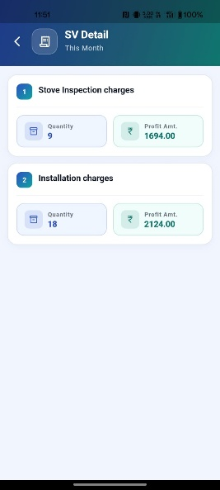

Card | Refill Revenue & ARB Revenue
Description | Shows the Gross Revenue and Gross Profit from Refill cylinder sales and ARB (Additional Returnable Bottle) sales for the current month. Combined view for quick monthly comparison.

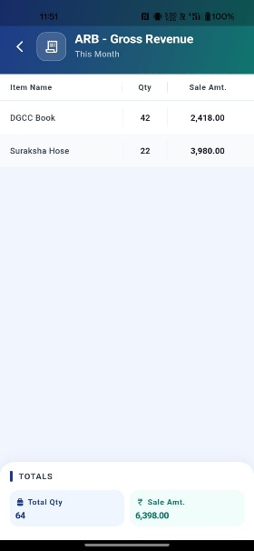 | 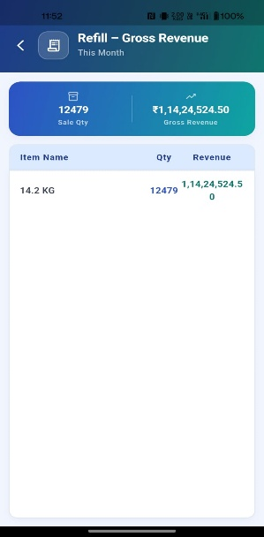

Stock Status
This section shows the Stock Status section displays the Opening Stock, Current Stock, Inward Stock, and Outward Stock detail summary.
Card | Stock Status
Description | The Stock Status section displays the Opening Stock, Current Stock, Inward Stock, and Outward Stock detail summary.

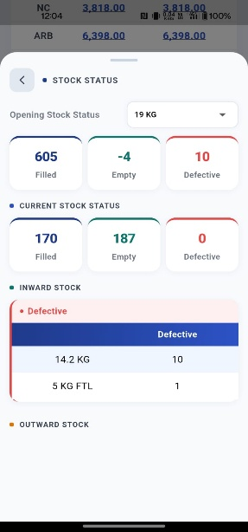

Sales Comparison

Card | Sales Comparison
Description | Here we can see the sales comparison for the item between this month, last month, last year same month
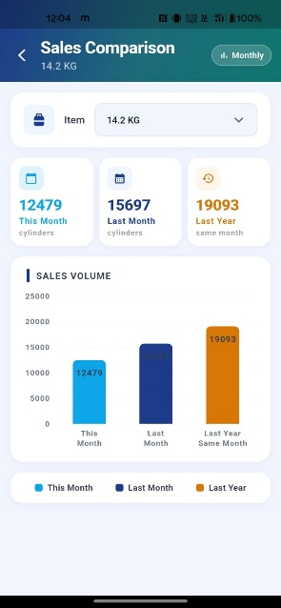

3.3 Trans Mode Filter
The filter at the top of the dashboard controls which time period data is shown for. Tap any filter chip and the dashboard refreshes automatically.
Option | Shows data for
Today's | Current date only
This Month | Current calendar month (default)
Financial Year | Full financial year

4. DSR (Daily Sales Report) Module

4.1 DSR Screen Overview
Access: Tap DSR in the bottom navigation bar.
The DSR screen provides a complete daily summary of all transactions for the selected date. By default it loads today's data automatically. The top section shows the current date, a date picker to change the date, and a Show DSR button to reload data.
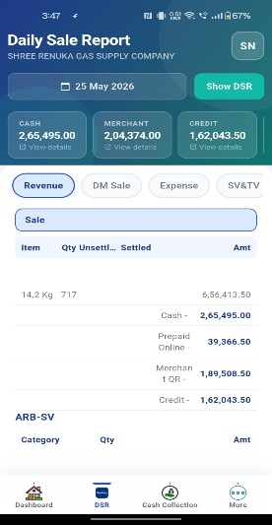

4.2 DSR Tabs
The DSR screen contains 6 tabs. Tap any tab to view that section. Tapping any row within a tab opens a detailed transactions screen for that entry.
Tab | What It Shows
Revenue | Income from sales — settled and unsettled breakdown by delivery man
DM Sale | Delivery man-wise sale summary showing quantity and amount
Expenses | All recorded expenses for the day by category
SV & TV | Special Voucher and Transfer Voucher details for the day
CDCMS Stock | Current cylinder stock status compared with CDCMS records
Cash | Cash-in-hand summary and denomination-wise cash details

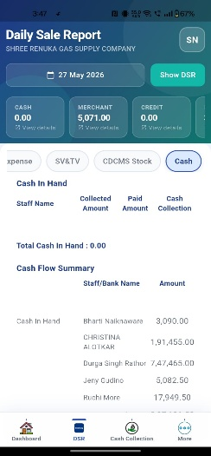 | 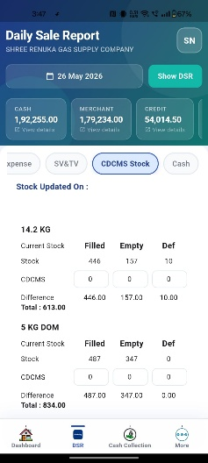 | 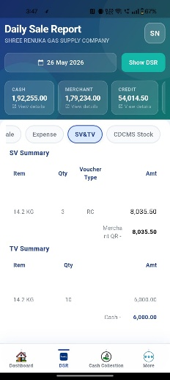

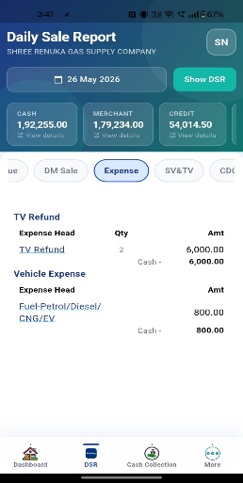 | 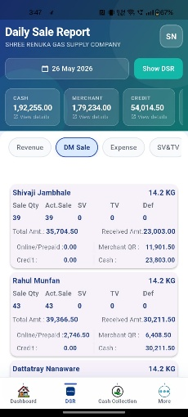 | 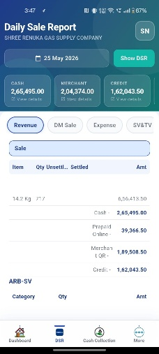

4.3 Date Selection & Show DSR
To view DSR for a different date:
- Tap the Select Date option.
- Choose a date from the calendar (future dates are disabled).
- Tap Show DSR.
- All 6 tabs refresh with data for the selected date.

Note: By default, today's data is shown automatically when you open the DSR screen.

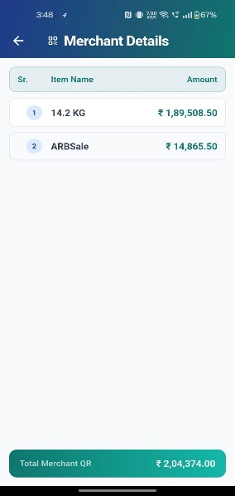 | 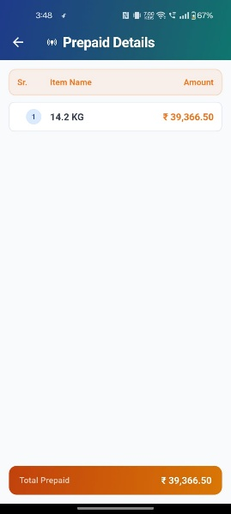 | 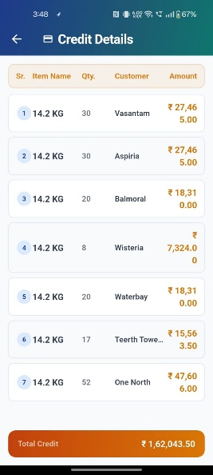

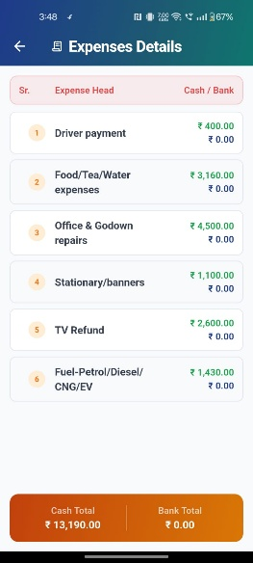 | 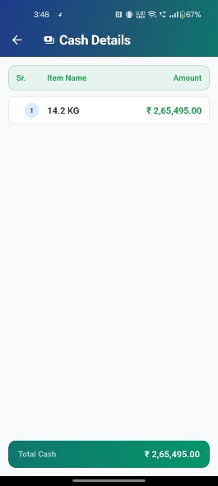

5. Delivery / Update Sale Module

5.1 Delivery Boy Wise List
Access: Tap Delivery in the bottom navigation bar.
This screen displays a list of all delivery men who have active sales for the day. Each card shows the staff name, vehicle number, receipt date, and sale GK ID. Tap any card to open that delivery man's sale details.
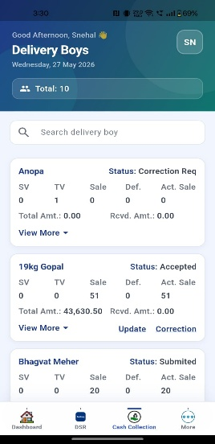

5.2 Update Sales Summary
Access: Tap a delivery man card from the Delivery screen.
This screen shows all sale items for the selected delivery man. A top info card displays the Receipt Number, Receipt Date, Delivery Man name, Vehicle Number, and Total Expense Amount.
Each sale item card shows:
Field | Description
Item Name | Product type (e.g. 14.2 KG)
User Name | Delivery man assigned to this item
Sale | GD Filled Sale quantity dispatched
Act. Sale | Actual Sale quantity confirmed
TV | Transfer Voucher quantity
SV | Special Voucher quantity — tap to view consumer details
Def. | Defective cylinder quantity
Amount | Total sale amount for this item
Received Amt. | Cash denomination amount received

Tap View More / View Less on any item to expand or collapse the payment breakdown (Cash / Online-Prepaid / Merchant QR / Credit).

Action Buttons on each item:
Button | Condition | Action
Update | No payment entered yet, actual sale > 0 | Opens Cash Updation in Add mode
Edit | Payment already entered | Opens Cash Updation in Edit mode
No Cash | Actual sale = 0 or SV-only item | Opens settle confirmation dialog

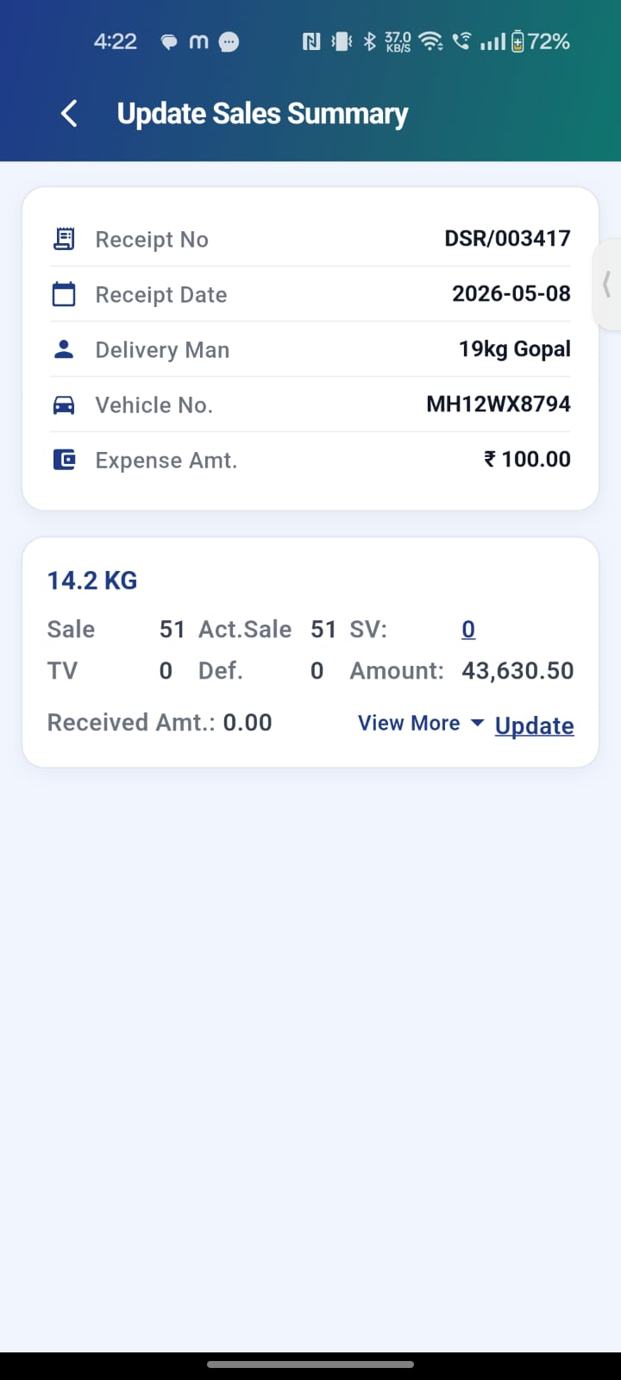

5.3 Cash Updation Screen
Access: Tap Update or Edit on a sale item.
This screen is where you record how a delivery man collected payment for a sale — splitting it across Cash, Prepaid/Online, Merchant QR, and Credit modes.
Section | Details
Sale Info | Item name, delivery man, quantities (Sale / SV / TV / Def)
Payment Mode Split | Enter quantity and amount for: Cash, Prepaid/Online, Merchant QR (Postpaid), Credit
Cash Denomination | If Cash mode is selected — enter denomination-wise cash received (₹500, ₹200, ₹100, etc.)
Balance Calculation | Auto-calculated: Expected Amount vs Received Amount vs Balance
Save / Update Button | Submit the entered payment details to settle the item

Validations:
- Total of all mode quantities must equal the actual sale quantity.
- Cash denomination total must exactly match the cash amount entered.
- Amount fields accept decimal values only.

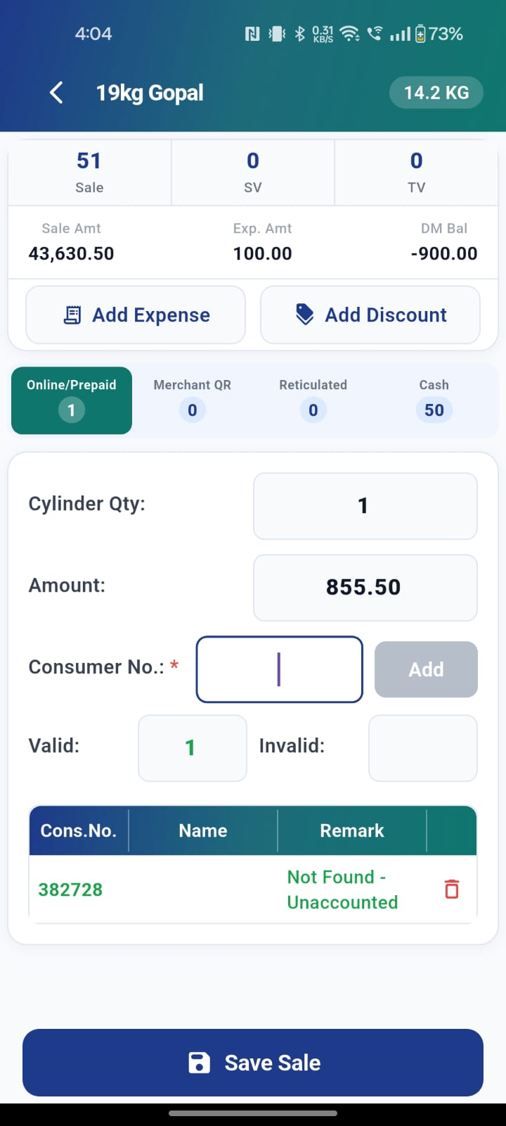

5.4 Submit All Sales (FAB Button)
Purpose: Settle all pending SV-only sale items in one tap — items where there is no cash payment to collect.
How to use:
- On the Update Sales Summary screen, locate the floating action button at the bottom-right.
- The button shows: Submit All (N) — where N is the number of unsettled items.
- Tap the button.
- A confirmation dialog appears showing the item count and delivery man name.
- Tap Yes, Submit — all unsettled items are marked as settled.
- On success, the app navigates back to the main screen with a success message.

State | Label | Color / Style
Items pending | Submit All (N) | Blue — active
All settled | All Settled | Grey — disabled
Processing | Submitting… | Blue with spinner

Validation messages shown if:
- No items are loaded yet.
- Some items have payment details entered but not yet saved (use Edit → Save first).
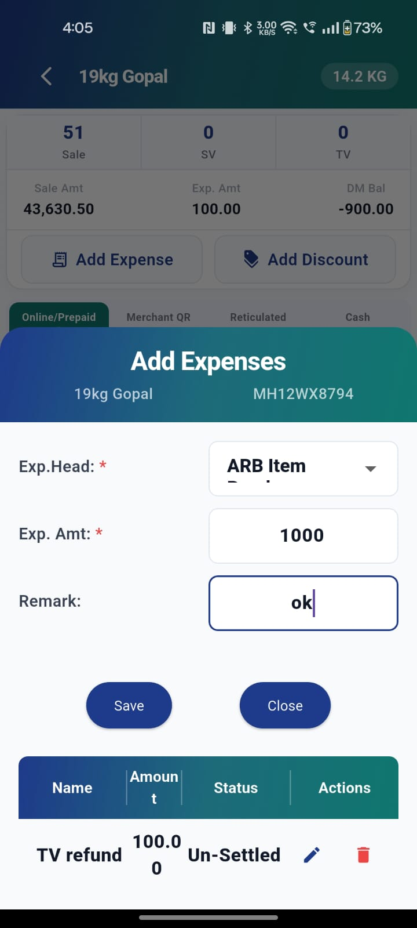
- All items are already settled.
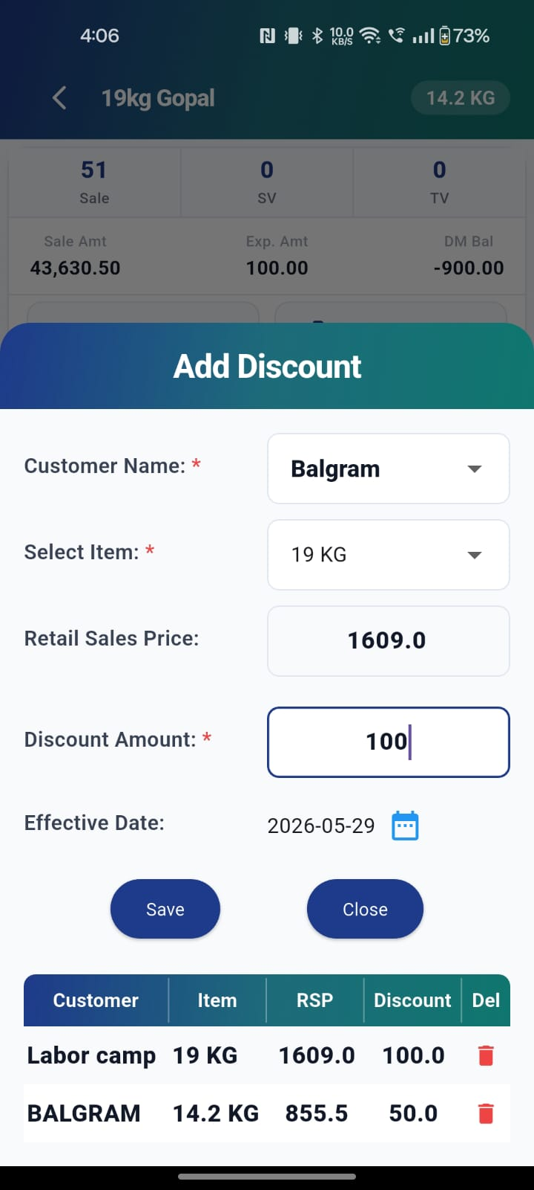

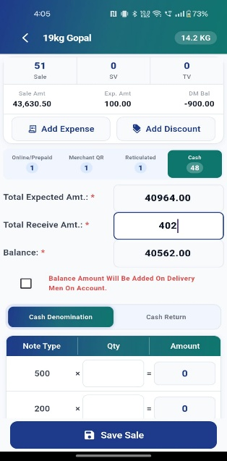
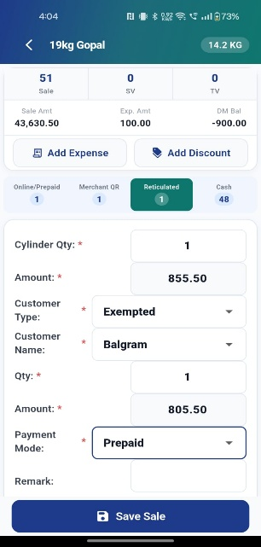
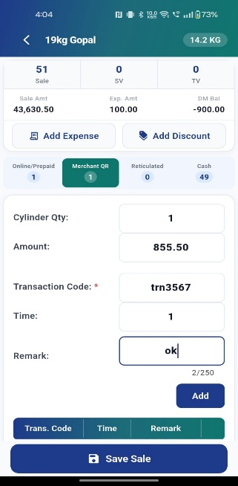
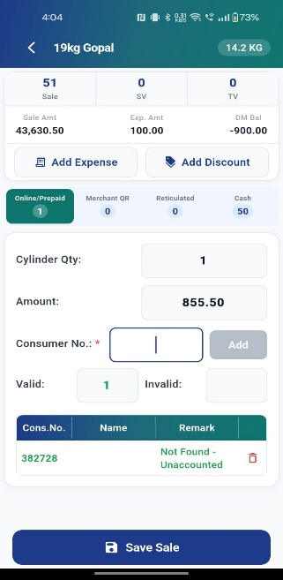

5.5 Unsettled Sale Details
Access: Dashboard → Unsettled Sales card.
This screen lists all sale entries where cash has not yet been collected or updated. It gives the Manager a consolidated view of pending settlements across all delivery staff.
Summary Banner
Field | Description
Total Records | Count of unsettled sale records across all delivery staff.
Total Qty | Total cylinder quantity pending settlement across all records.
Total Amount | Cumulative sale amount (₹) pending cash collection across all records.
Record List
Each row in the list represents one delivery staff member’s unsettled sale entry and shows the following columns:
Column | Description
Staff Name | Name of the delivery staff member with an unsettled sale. An avatar with initials is shown to the left of the name.
Item | Cylinder type for the unsettled sale (e.g. 14.2 Kg).
Qty | Number of cylinders in this staff member’s unsettled sale.
Amount | Sale amount (₹) pending collection for this staff member.
Tap any row to open that delivery staff member’s Update Sales Summary screen where cash can be updated and the sale settled.

6. SV Sale Module
Access: More → Daily Transaction → SV Sale
Purpose: Record sale entries for Special Voucher (SV) cylinders. SV sales are transactions where the cylinder is supplied against a government-issued voucher rather than a standard booking.
Field | Description
Staff | Select the delivery man handling this SV sale
Consumer No. | Enter the SV consumer number as per the voucher
Transaction Mode | Cash / Merchant QR / Partial payment
Transaction Account | NC (New Connection) / RC (Regular Customer) / DBC
Stamp Duty | Enter the applicable stamp duty amount for this transaction
Cash Denomination | Denomination-wise cash entry — available when Cash mode is selected

List View actions on each record:
- Edit — pre-fills the form with existing data for correction.
- Delete — shows a confirmation popup, then removes the record.

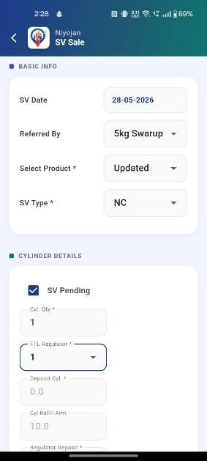

7. TV Receipt Module
Access: More → Daily Transaction → TV Receipt
Purpose: Record TV (Transfer Voucher) cylinder receipts from the oil company. A TV receipt is created when a consumer returns a cylinder connection and the cylinder is transferred back to the distributor.
Field | Description
Consumer No. | The consumer's registered number
Consumer Name | Full name of the consumer returning the cylinder
Cyl. Holding Qty | The number of cylinders currently held by the consumer
Payment Amount | The amount received from the consumer (if applicable)
Regulator Received | Yes / No — whether the gas regulator was also returned
Transaction Mode | Cash / Online payment mode
Transaction Code | Reference or transaction ID for the payment

List View: All saved TV receipt records are listed below. Edit and Delete actions are available on each record.

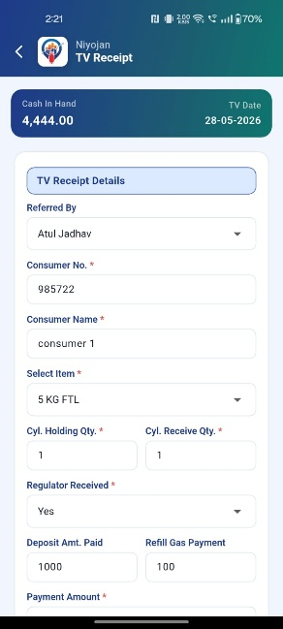

8. Payment Receipt Module
Access: More → Daily Transaction → Payments Receipt
Purpose: Record cash or bank payment receipts from customers, staff, or distributors. Use this module whenever a payment is received that needs to be formally receipted in the system.
Field | Description
Transaction Mode | Cash / Cheque / Online Transfer / Bank Transfer
Staff Mode | Staff / Reticulated / Other — identifies the type of payer
Customer Mode | Exempted / ND (Non-Domestic) / POS
Bank | Select the relevant bank for cheque or transfer payments
Receipt No. | Auto-generated by the system on save
Cash Denomination | If Cash mode is selected — enter denomination-wise cash received

List View: All payment receipt records are listed below, with Edit or Delete on each record.

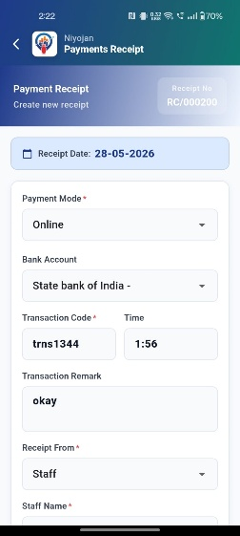

9. Update Payments Module
Access: More → Daily Transaction → Update Payments
Purpose: Record and update outgoing payment entries — amounts paid out to vendors or staff. Use this module to track all payments made from the distributor's cash or bank account.
Field | Description
Payment Against | Staff / Vendor — who the payment is being made to
Staff / Vendor Name | Select from the dropdown list
Balance | Auto-populated from the system based on outstanding balance
Transaction Code | Reference number or transaction ID for the payment
Transaction Mode | Cash / Online — how the payment was made
Cash Denomination | If Cash mode — enter denomination-wise cash paid out
Remark | Optional note or description for this payment entry

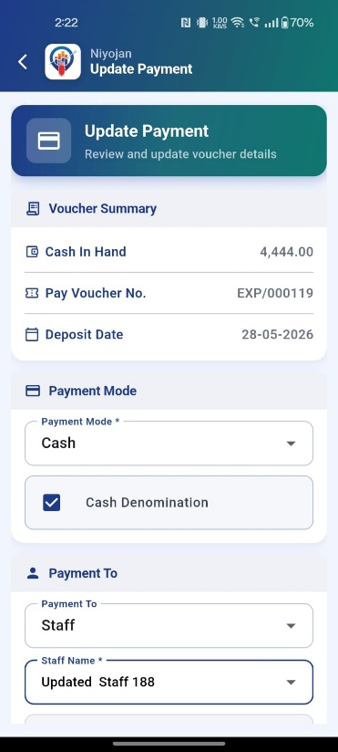

10. Salary Payments Module
Access: More → Daily Transaction → Salary Payments
Purpose: Record salary, commission, incentive, or advance payments made to staff members. This module keeps a formal record of all staff-related financial disbursements.
Field | Description
Paid Against | Commission / Salary / Incentive / Advance — type of payment
Staff | Select the staff member receiving the payment
Transaction Mode | Cash / Online — method of payment
Vendor Name | If the payment is being made through or to a vendor
Remark | Optional note (e.g. month, reason, reference)
Cash Denomination | If Cash mode — enter denomination-wise cash paid out

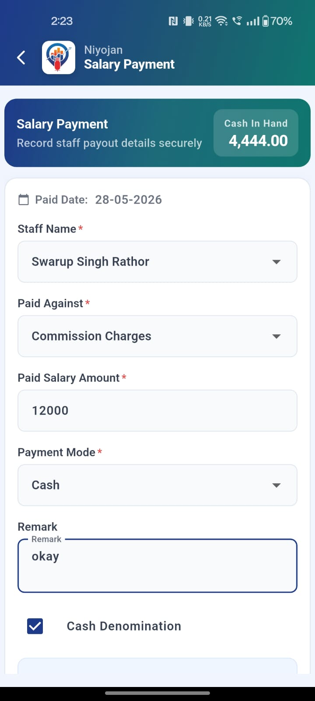

11. Cash Handover / Bank Deposit Module
Access: More → Daily Transaction → Cash Handover-Bank Deposit
Purpose: Record cash being physically handed over to the bank via ATM or branch deposit. This creates an audit trail of all cash deposits made from the day's collections.
Field | Description
Staff | Select the staff member making the deposit
Bank | Select the bank where the deposit is being made
Mode | ATM Deposit / Branch Deposit — type of deposit
Date | Select the deposit date (defaults to today)
Denomination | Enter denomination-wise cash being deposited
Total | Auto-calculated from the denomination entries entered

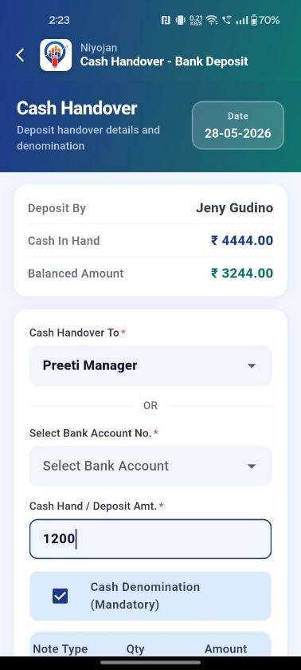

12. ARB Module
ARB stands for Additional Returnable Bottle — operations related to non-standard cylinder transactions such as buying, returning, and selling additional cylinders.

12.1 ARB Purchase
Access: More → ARB → ARB Purchase
Purpose: Record purchases of ARB items from vendors. Use this when additional cylinders or returnable bottles are purchased for the agency's stock.
Field | Description
Invoice Number | Purchase invoice reference number from the vendor
Vendor | Select the vendor from the registered vendor list
Mobile No. | Vendor's contact mobile number (auto-filled on vendor selection)
Item | Select the ARB item being purchased
Transaction Mode | Cash / Online — payment method for this purchase
Basic Amount | Base price of the item before taxes
Tax Amount | Applicable GST or other tax on this purchase
Net Amount | Auto-calculated: Basic Amount + Tax Amount
Date | Date of the purchase transaction

Tap Add Payment to record multiple payment entries against the same purchase invoice — useful for partial payments.

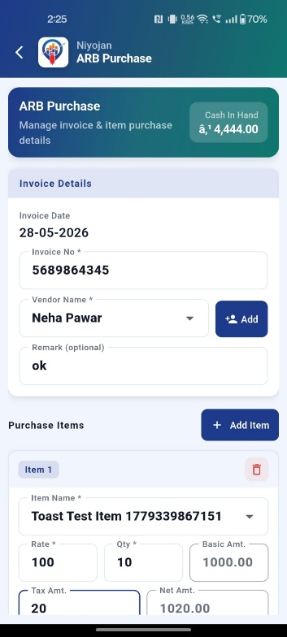

12.2 ARB Purchase Return
Access: More → ARB → ARB Purchase Return
Purpose: Record the return of ARB items to a vendor — when cylinders or bottles are sent back due to damage, surplus, or other reasons.
Field | Description
Vendor | Select the vendor from the dropdown
Item | Select the ARB item being returned
Quantity | Number of items being returned
Return Date | Date on which the return is being made

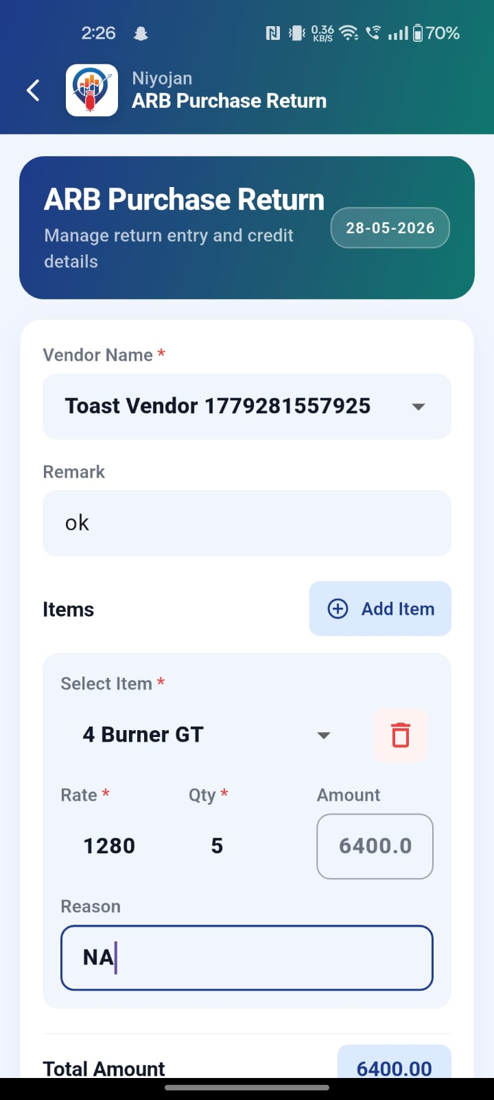

12.3 ARB Sale
Access: More → ARB → ARB Sale
Purpose: Record sales of ARB items to customers — when additional cylinders or returnable bottles are sold from the agency's stock.
Field | Description
Item | Select the ARB item being sold
Customer | Select the customer from the registered list
Quantity | Number of items being sold
Transaction Mode | Cash / Online — how the customer is paying
Amount | Total sale amount for this transaction

List View: All ARB sale records are listed below. Edit and Delete actions are available on each record.

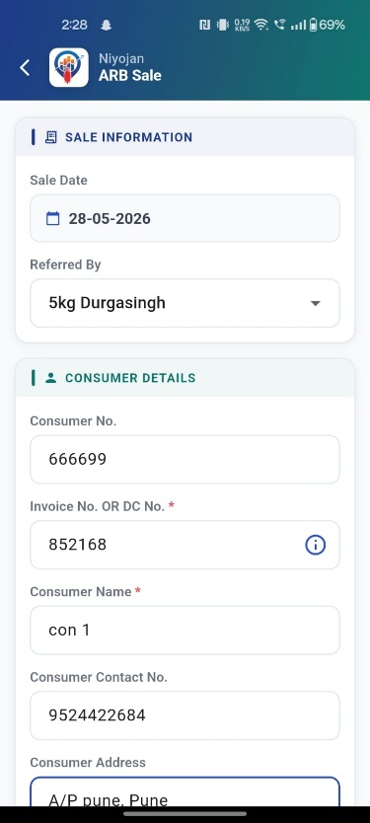

13. Receipt Defective Regulator Module
Access: More → Daily Transaction → Receipt Defective Regulator
Purpose: Record the receipt of defective regulators returned from the field. Keeping this record helps track regulator inventory and replacements.
Field | Description
Staff | Select the delivery man returning the defective regulator
Regulator Item | Select the regulator item type from the list
Consumer No. | Consumer number associated with the returned regulator
Payment Amount | Amount received from the consumer (if any exchange payment applies)
Regulator Received | Yes / No — confirm whether the regulator was physically received
Transaction Mode | Cash / Online — if a payment was received

List View: All defective regulator receipt records are listed below, with an Edit option on each record.

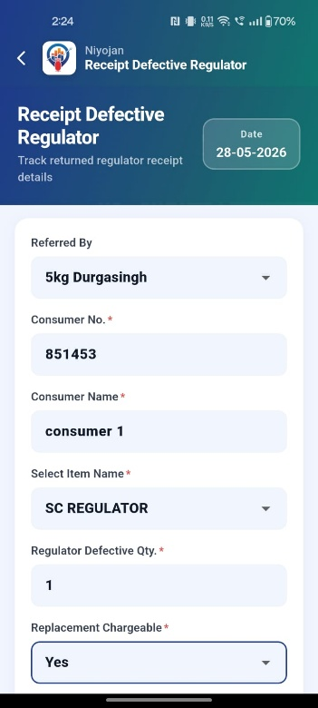

14. More Options Menu
Access: Tap More in the bottom navigation bar. The More screen is organised into sections for quick navigation to all daily transaction and admin features.

Admin Settings (Owner role only)
Menu Item | Action
Configuration | Opens system configuration settings — visible to Owner role only

Daily Transaction
Menu Item | Navigates To
SV Sale | SV Sale entry screen
TV Receipt | TV Receipt entry screen
Payments Receipt | Payment Receipt screen
Update Payments | Update Payments screen
Salary Payments | Salary Payment screen
Cash Handover-Bank Deposit | Cash Handover / Bank Deposit screen
Receipt Defective Regulator | Defective Regulator screen

ARB
Menu Item | Navigates To
ARB Purchase | ARB Purchase entry screen
ARB Purchase Return | ARB Purchase Return screen
ARB Sale | ARB Sale entry screen

Account
Menu Item | Action
Logout | Shows logout confirmation popup

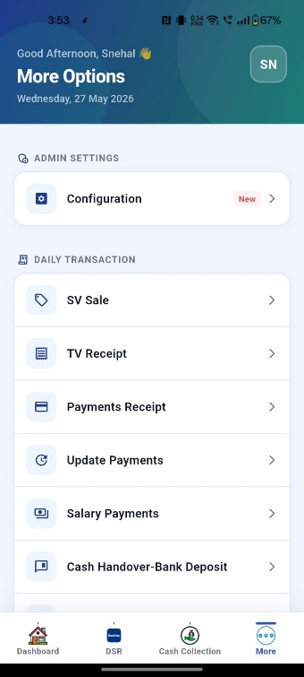

15. Configuration Screen (Owner Only)
Access: More → Admin Settings → Configuration
This screen is visible only when you are logged in with the Owner role. It allows the Owner to manage system-level settings for the distributor account.

Access | Owner role only — Managers do not see this menu item
Purpose | Manage system-level settings configured and enabled by your system administrator
What settings appear | Specific configuration options depend on what your system administrator has enabled for your distributor account. Contact your admin for the full list of available settings.
How to reach it | Tap More → scroll to Admin Settings → tap Configuration
What to do if settings are missing | If no options appear, contact your system administrator to enable the relevant configuration options for your account.

ℹ Configuration settings affect the entire distributor account. Make changes here only if instructed by your system administrator.

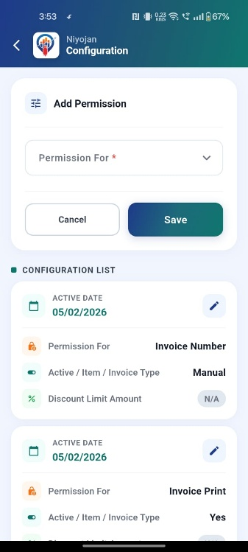

16. Logout
Access: More → Account → Logout
Steps:
- Tap Logout (shown in red).
- A confirmation popup appears: "Are you sure you want to logout?"
- Tap Cancel to stay on the More screen.
- Tap Logout (red button) to log out and return to the Login screen.

What happens on logout:
- App deactivates the device notification token.
- Session data is cleared from the app.
- App navigates to the Splash / Login screen.

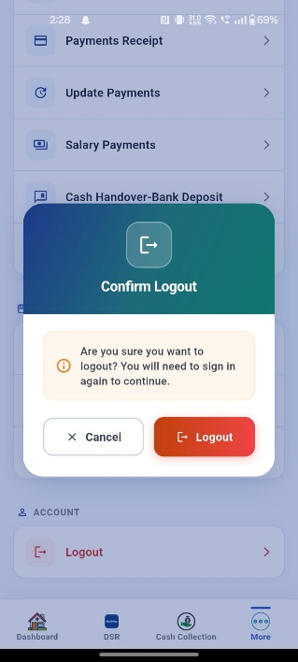

17. Validations & Error Messages
The table below lists all error messages you may encounter in the app, along with the resolution step for each scenario.

Scenario | Message Shown | What to Do
No internet connection | No internet connection. Please check your network. | Turn on mobile data or connect to Wi-Fi, then retry.
Bearer token missing / expired | Session expired. Please login again. | Go to More → Logout, then log in again with your credentials and OTP.
API request failed | Request failed. Please try again. | Check your internet connection and tap Retry or reopen the screen.
API returns 0 / unexpected response | Something went wrong. Please try again. | Wait a few seconds and retry. If the issue persists, contact your system administrator.
Sale item list empty | No sale items loaded. Please wait for data to load. | Wait for data to load. If the list stays empty, check internet and pull to refresh.
Submit with pending edits | Some items have payment details entered but are not yet settled. Please tap Edit on each item and save before submitting all. | Tap Edit on each flagged item, verify the details, and tap Save before using Submit All.
All items already settled | All sale items are already settled. Nothing to submit. | All sales for this delivery man are complete. No further action needed.
Data list fetch failed | Failed to get list. | Pull to refresh the screen. If it fails again, check your internet connection.
Required fields empty | Field-level validation message shown inline | Fill in all required fields (marked with *) before tapping Save.
Wrong OTP | OTP verification error shown on screen | Re-enter the OTP exactly as given by your Web Admin. Ask for a fresh OTP if it has expired.

18. Important Notes
# | Note
1 | An active internet connection is required for all screens — all data loads from live APIs.
2 | The OTP is not sent via SMS — obtain it directly from the Web Admin portal (see Section 2.4).
3 | Only registered mobile numbers can log in. Contact your system administrator to register a new number.
4 | The Configuration menu is visible only to the Owner role — Managers do not see this option.
5 | Cash Denomination total must exactly match the cash amount entered before you can save.
6 | Submit All Sales only settles SV-only items (no-cash sales). Items with entered payment must be saved individually using Edit → Save.
7 | The DSR screen auto-loads today's data. After changing the date, always tap Show DSR to reload.
8 | The back button on most screens returns to the main navigation bar, not the previous screen.
9 | Contact your system administrator if login fails or an OTP is unavailable.
10 | All financial amounts are displayed in Indian Rupee (₹) format.

19. Glossary
The following abbreviations and terms are used throughout this manual.

ARB | Additional Returnable Bottle — non-standard cylinders purchased, returned, or sold separately from regular refill operations.
ATM Deposit | Cash deposited at an ATM kiosk (as opposed to a branch deposit).
CDCMS | Cylinder Distribution and Control Management System — the government's official cylinder tracking system.
DBC | Domestic-Bulk Consumer — a customer category for domestic bulk gas usage.
DM | Delivery Man — the field staff member who delivers cylinders to consumers.
DMR | Daily Movement Register — a record of cylinder movement for the day.
DSR | Daily Sales Report — a comprehensive summary of all transactions for a selected date.
FAB | Floating Action Button — the circular button at the bottom-right of a screen used for quick primary actions.
GK ID | Godown Keeper ID — a unique identifier assigned to each sale receipt.
NC | New Connection — a transaction or revenue category for new cylinder connections.
OTP | One-Time Password — a temporary code generated by the Web Admin used for secure login.
RC | Regular Customer — an existing customer with an active cylinder connection.
SV | Special Voucher — a government-issued voucher entitling a consumer to receive a subsidised cylinder.
TV | Transfer Voucher — a document recording the transfer of a cylinder connection back to the distributor when a consumer surrenders it.
Web Admin | The LPG Niyojan Web Administration Portal — the back-end system used by administrators to manage staff, roles, and OTPs.

20. Frequently Asked Questions (FAQ)

Q: What if I don't receive an OTP?
A: The OTP is not sent by SMS. You must ask your Web Admin to log in to the LPG Niyojan Web Admin Panel, go to Staff Master, find your record, and share the OTP with you. See Section 2.4 for the full process.
Q: What if the delivery man's list is empty on the Delivery screen?
A: An empty list means no sales have been assigned to any delivery man for today, or the data has not yet loaded. Check your internet connection and pull to refresh the screen. If the issue persists, contact your system administrator.
Q: Can I edit a sale after it has been submitted?
A: Once a sale item is marked as settled (submitted), it cannot be reversed from the app. Contact your system administrator or use the Web Admin portal to make corrections.
Q: Can two users log in on the same device at the same time?
A: No. Only one active session is supported per device. Logging in with a second account on the same device will end the first session.
Q: What if I accidentally tap Submit All and settle all items?
A: Submit All only settles SV-only items (items with no cash collection). It does not settle items that have payment details entered. If items were incorrectly settled, contact your system administrator.
Q: Why is the Configuration menu not visible to me?
A: The Configuration option is visible only to users with the Owner role. If you are logged in as a Manager, this menu item is hidden by design.
Q: What if the app crashes or freezes?
A: Force-close the app and reopen it. Ensure your internet connection is active. If the problem continues, try clearing the app cache in your device settings or reinstall the APK (see Section 0).
Q: Is Wi-Fi required, or does mobile data work?
A: Both Wi-Fi and mobile data (3G/4G/5G) are supported. An active internet connection of either type is required for all screens.

21. Support & Contact Information
If you face issues that are not covered in this manual, contact your system administrator or reach out to Aadyam Infotech support:

Company | Aadyam Infotech
Support Email | support@aadyaminfotech.com
Support Phone | Contact your system administrator for the helpdesk number
Web Admin Portal | Contact your system administrator for the portal URL
Support Hours | Monday – Saturday, 9:00 AM – 6:00 PM IST
Before contacting support | Have your distributor name, registered mobile number, and a description of the issue ready.

ℹ For urgent issues — such as inability to log in or data not loading — first check your internet connection and try force-closing and reopening the app before contacting support.

End of Document
LPG Niyojan — Manager/Owner User Manual | Version 1.0 | © Aadyam Infotech | Confidential

