
ACTIVITY REPORT
ON

CTRL+ALT+CREATE
- Name of the club: BMSCE ACM STUDENT CHAPTER
- Name of the Activity: CTRL+ALT+CREATE
- Objectives: CTRL+ALT+CREATE was a web design challenge consisting of 4 rounds, each with specific time limits and points weighting. Participants were tasked with adding specific elements to their webpage within given timeframes. The team with the highest points at the end was declared the winner.
- Date, Time Venue of the Activity:
TOPIC | Webpage Designing and Coding
DATE/DAY | Friday, 14th June, 2024
MODE | Offline
VENUE | PG Lab 2, PJA Block 4h Floor, Dept of CSE
DURATION | 11:00AM to 1:00PM
- Name and details of collaborating agency (if it is collaborative/joint activity): BMSCE IEEE PES AND SENSORS COUNCIL
- Brief summary of the Programme: The CTRL+ALT+CREATE web design challenge, hosted by BMSCE ACM Student Chapter in collaboration with IEEE PES and SC, aimed to enhance participants' skills in HTML, CSS, and JavaScript. This event, conducted on 14th June 2024, challenged teams of two to create static web pages focusing on Electric Vehicles (EVs), which was the theme for PES Day. The competition featured four rounds, each with specific tasks such as designing a sticky navigation bar, implementing image and text transitions, creating accordion menus, and developing detailed footer sections. Participants were evaluated based on creativity, adherence to guidelines, and functionality of their designs. The event not only fostered technical proficiency but also encouraged teamwork and innovation.
- Outcomes: Outcomes: CTRL+ALT+CREATE was highly successful, showcasing participants' enhanced proficiency in web development fundamentals, creativity in design, and problem-solving abilities under time constraints. The event not only bolstered participants' technical skills but also fostered teamwork and collaboration among students interested in web design.
- Number of participants:
Number of Faculty | Number of  Non-Teaching Staff | Number of  External Participants | Number of Students
0 | 0 | 0 | 29

Two or three relevant Photographs of the activity: (Geo-tagged photos are preferable)
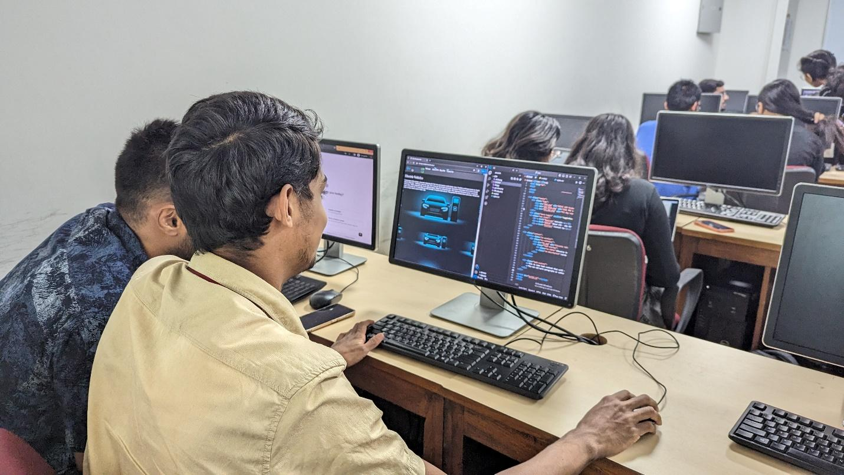
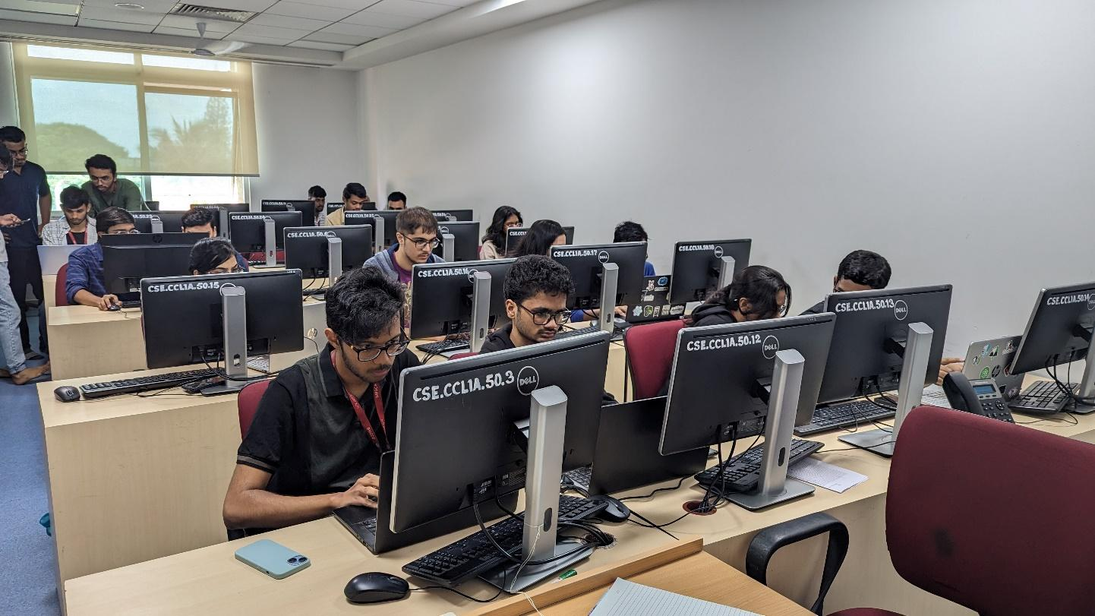

Supporting Documents
a) Attendance sheet
b) Circulars/Brochures
c) Certificates

