Stock Forecasting Model
Retraining Results
  - Current company lists with historical tests from 2022 to 2025
We completed 648 model training runs using the current NASDAQ-100 and the 100 largest NYSE-listed companies. A model learns patterns from earlier prices to rank stocks by expected returns. Coverage improved substantially. None of the 4 main tests established a Sharpe advantage after trading costs over SPY and the relevant cohort benchmark (passive NYSE basket or QQQ), within the estimated uncertainty ranges. All declared models are reported below.
These results describe a retrospective study of today’s large companies. Selecting companies using their 2026 size or membership gives us information that would not have been available in 2022. Better coverage makes the sample easier to explain, but does not remove that bias.

Company coverage
Group | Companies chosen | Stocks chosen | Stocks with history | Eligible stocks in tests
NYSE top 100 | 100 | 100 | 100 | 99 to 100
NASDAQ 100 | 100 | 101 | 99 | 91 to 99

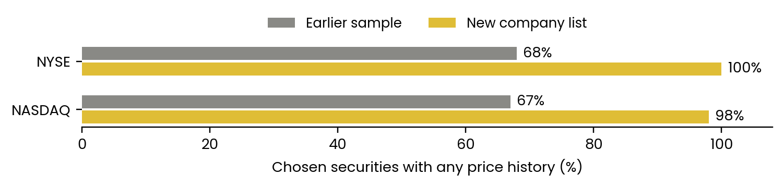
NASDAQ has 101 stocks because Alphabet has two included share classes. The 99 available stock histories represent 98 companies. The first available Yahoo prices for HONA and SPCX begin in June 2026, after the 2018–2025 training window. Recent listings and spin-offs also explain why fewer stocks qualify in earlier test years. We kept every chosen company and did not replace missing names.
NYSE selection uses company market value, removes preferred-share rows and duplicate companies, and uses Berkshire Class B. It includes foreign companies with NYSE-listed depositary shares. This is a custom group of the largest NYSE-listed companies, separate from the official NYSE 100 technology and growth index.

Returns after trading costs
Earlier validation selected each model and trading rule. Tables compare NYSE models with a passive basket of all eligible NYSE stocks, and NASDAQ models with QQQ. SPY provides broad-market context. These charts retain the original fund overlays.

Five day forecasts
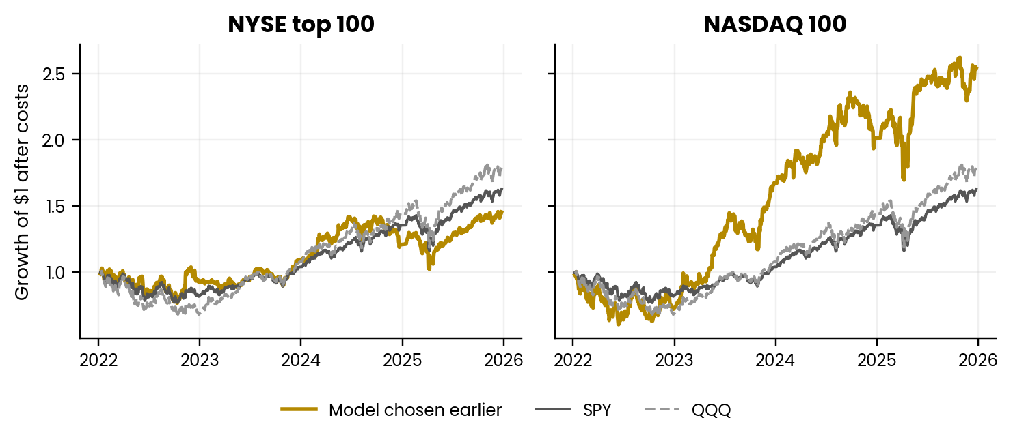

One day forecasts
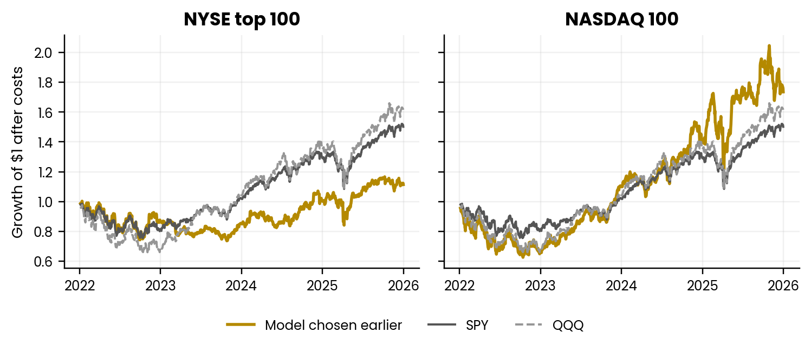
Each year starts a separate simulated account. These curves combine the annual percentage returns and omit untested boundary sessions. They are research summaries, rather than the record of one continuously held account.

How well forecasts ordered the stocks
A model tries to put stocks with higher future returns above stocks with lower future returns. This chart shows its average agreement with the actual order over the following five trading days. It includes every declared five-day neural model in both company groups.
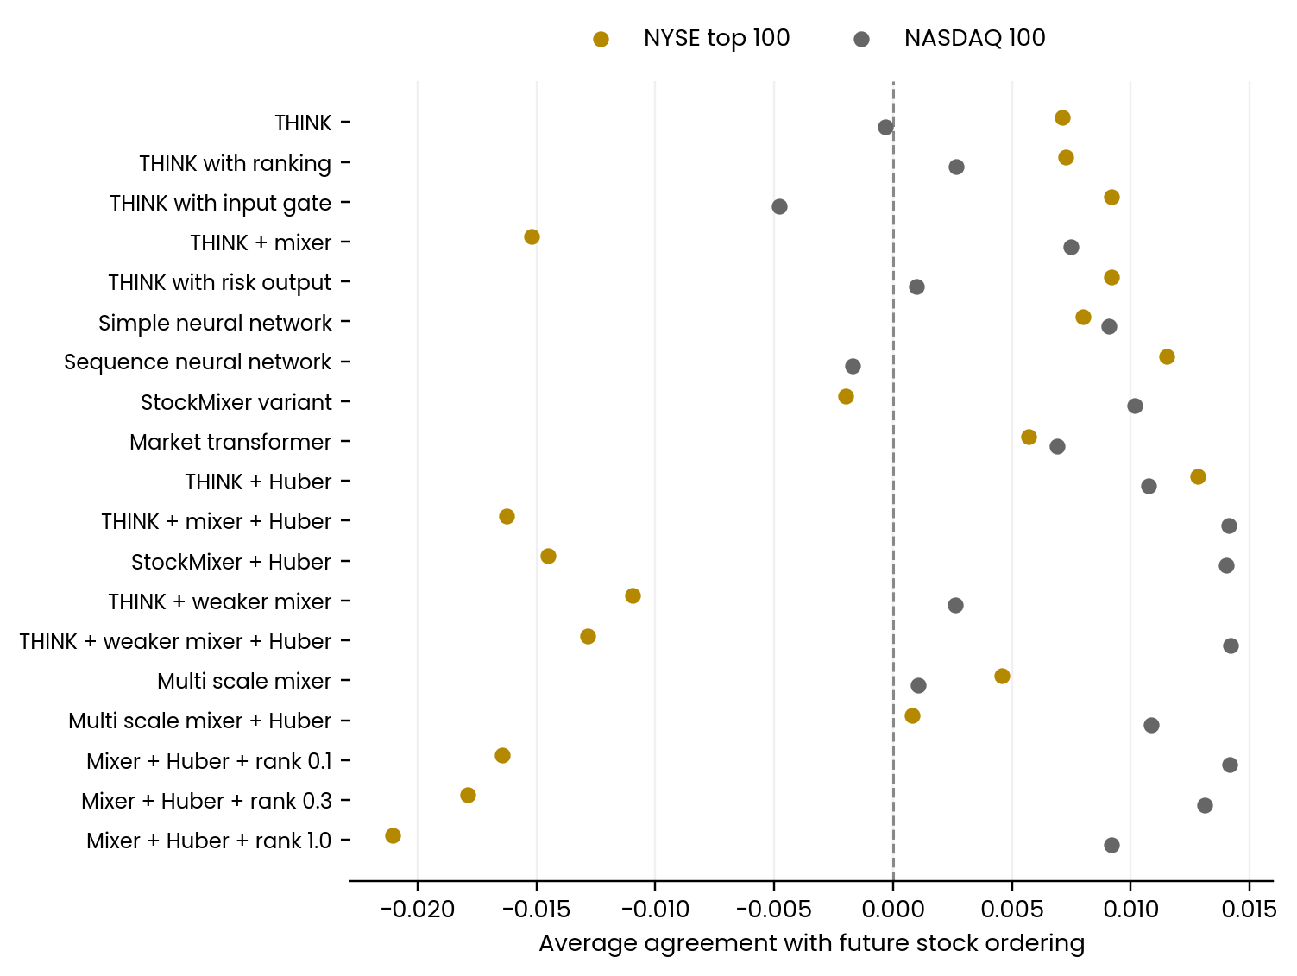
Zero means no consistent agreement. Positive scores mean the model tended to put future winners higher; negative scores mean it tended to reverse the order. The mathematical score ranges from minus one to plus one. It is a rank correlation, called RankIC, rather than the percentage of predictions that were correct.
Prediction quality and portfolio returns answer different questions. A portfolio holds only a subset of stocks, while this score evaluates the entire eligible group. Position weights, price variability and trading costs can change the investment outcome even when ordering scores look similar.

Performance of the model selection procedure
Sharpe measures return relative to how much returns fluctuate, after a fixed 3% annual hurdle. Higher is better within this study. A positive return alone does not mean that a model outperformed an index fund.
Group and forecast | Model Sharpe | SPY Sharpe | Benchmark Sharpe | Total return | Worst fall
NYSE top 100  Five day | 0.40 | 0.62 | 0.97 | 45.3% | -28.1%
NASDAQ 100  Five day | 0.78 | 0.62 | 0.63 | 153.6% | -39.6%
NYSE top 100  One day | 0.09 | 0.50 | 0.90 | 11.4% | -26.6%
NASDAQ 100  One day | 0.52 | 0.50 | 0.50 | 73.6% | -37.5%

Benchmark means the passive NYSE basket for NYSE and QQQ for NASDAQ. The basket is equally weighted at scheduled rebalances, with modeled costs. Total return combines annual folds; worst fall is the largest historical drop from an earlier high.

Uncertainty in the comparison
Group and forecast | Gain over SPY | 95% range | Gain over benchmark | 95% range
NYSE top 100  Five day | -0.22 | -0.79 to 0.35 | -0.57 | -1.13 to -0.02
NASDAQ 100  Five day | 0.16 | -0.31 to 0.67 | 0.15 | -0.34 to 0.69
NYSE top 100  One day | -0.40 | -0.93 to 0.11 | -0.81 | -1.29 to -0.35
NASDAQ 100  One day | 0.03 | -0.44 to 0.49 | 0.02 | -0.43 to 0.52

These ranges estimate uncertainty in the Sharpe difference using 1,000 resampled versions of the daily returns. A range that crosses zero does not establish an advantage. The resampling preserves blocks of 20 trading days within each year and uses the same dates for the model and benchmarks. It does not repeat model training or correct for testing many candidates.

How trading costs changed performance
At a fixed rule of ten equally weighted stocks, daily forecasts had higher net Sharpe in 12 of 88 matched model, group and year cases. These cases reuse the same companies and years; they are not independent experiments. Each horizon retains its saved test dates and annual boundary gaps.
The chart compares the amount of trading with the change in Sharpe caused by modeled costs. A trading value of ten means that annual transactions total about ten times the portfolio’s value. Yellow marks five-day forecasts; grey marks daily forecasts.
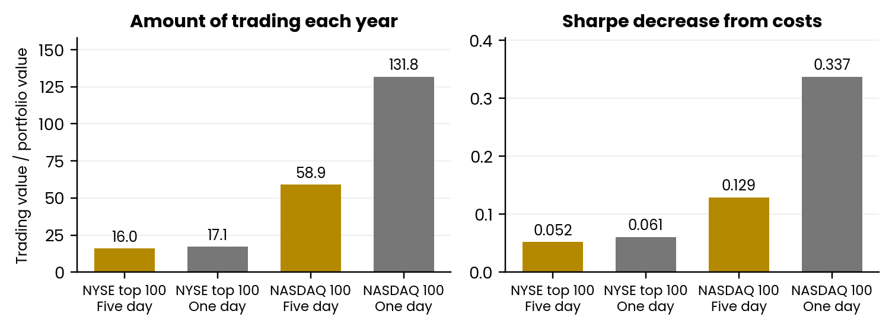
Group and forecast | Sharpe before costs | Sharpe after costs | Annual trading value divided by portfolio value
NYSE top 100  Five day | 0.46 | 0.40 | 16.0
NASDAQ 100  Five day | 0.91 | 0.78 | 58.9
NYSE top 100  One day | 0.15 | 0.09 | 17.1
NASDAQ 100  One day | 0.86 | 0.52 | 131.8

The before-and-after columns use the same holdings and trades. Turnover describes how much trading the strategy requires. More trading creates more opportunities for fees, spreads and price impact to consume a small prediction advantage.

Annual model choices
These choices were locked from prior validation scores before the new held-out performance statistics were computed. Each annual test uses the model and stock count listed below.
Group | Forecast | Test year | Chosen model | Target stocks
NASDAQ 100 | 1 day | 2022 | THINK + mixer + Huber | 20
NASDAQ 100 | 1 day | 2023 | Buy recent losers | 10
NASDAQ 100 | 1 day | 2024 | THINK + mixer + Huber | 10
NASDAQ 100 | 1 day | 2025 | THINK + mixer + Huber | 5
NYSE top 100 | 1 day | 2022 | THINK + mixer + Huber | 10
NYSE top 100 | 1 day | 2023 | THINK + mixer + Huber | 5
NYSE top 100 | 1 day | 2024 | THINK + mixer + Huber | 5
NYSE top 100 | 1 day | 2025 | THINK + mixer + Huber | 10
NASDAQ 100 | 5 day | 2022 | THINK + Huber | 5
NASDAQ 100 | 5 day | 2023 | THINK with risk output | 5
NASDAQ 100 | 5 day | 2024 | THINK + Huber | 5
NASDAQ 100 | 5 day | 2025 | THINK + Huber | 20
NYSE top 100 | 5 day | 2022 | THINK + weaker mixer | 5
NYSE top 100 | 5 day | 2023 | THINK + weaker mixer | 5
NYSE top 100 | 5 day | 2024 | Mixer + Huber + rank 1.0 | 5
NYSE top 100 | 5 day | 2025 | THINK + weaker mixer | 20

NYSE top 100 five day model results
Each model uses its own trading rule chosen on prior validation data. The table includes all declared five-day models, simple strategies and SPY and the relevant cohort benchmark. Rows retain the declared model order; the table does not hide unsuccessful variants.
Model or strategy | Net Sharpe | Total return | Worst fall | 95% Sharpe gain vs SPY
THINK | 0.95 | 119.9% | -22.7% | -0.18 to 0.82
THINK with ranking | 1.00 | 121.1% | -17.4% | -0.10 to 0.86
THINK with input gate | 0.71 | 79.9% | -21.7% | -0.34 to 0.46
THINK + mixer | 0.40 | 42.0% | -24.5% | -0.81 to 0.35
THINK with risk output | 0.99 | 138.8% | -23.8% | -0.16 to 0.85
Simple neural network | 1.03 | 153.2% | -21.1% | -0.15 to 0.94
Sequence neural network | 0.74 | 94.3% | -23.6% | -0.41 to 0.62
StockMixer variant | 0.34 | 36.7% | -23.1% | -0.79 to 0.20
Market transformer | 0.93 | 118.9% | -14.7% | -0.25 to 0.79
THINK + Huber | 0.66 | 74.3% | -24.4% | -0.47 to 0.64
THINK + mixer + Huber | 0.16 | 16.9% | -28.0% | -1.10 to 0.10
StockMixer + Huber | 0.38 | 41.7% | -27.9% | -0.83 to 0.29
THINK + weaker mixer | 0.66 | 82.0% | -25.7% | -0.48 to 0.53
THINK + weaker mixer + Huber | 0.45 | 49.0% | -25.7% | -0.81 to 0.40
Multi scale mixer | 0.89 | 122.2% | -25.5% | -0.28 to 0.78
Multi scale mixer + Huber | 0.35 | 37.1% | -23.5% | -0.82 to 0.27
Mixer + Huber + rank 0.1 | -0.06 | -2.5% | -32.1% | -1.34 to -0.09
Mixer + Huber + rank 0.3 | 0.02 | 3.2% | -33.0% | -1.27 to 0.06
Mixer + Huber + rank 1.0 | 0.19 | 20.0% | -30.1% | -1.04 to 0.10
Linear prediction model | 1.14 | 168.8% | -22.8% | -0.13 to 1.08
Buy recent winners | 0.85 | 93.0% | -19.6% | -0.42 to 0.83
Buy recent losers | 0.71 | 84.6% | -23.0% | -0.52 to 0.62
Buy and hold the group | 0.98 | 91.7% | -18.3% | -0.09 to 0.80
NYSE basket (passive) | 0.97 | 93.7% | -17.8% | -0.07 to 0.79
SPY | 0.62 | 62.7% | -23.4% | 0.00 to 0.00

Neural models are local adaptations. See the method section for definitions.

NASDAQ 100 five day model results
Each model uses its own trading rule chosen on prior validation data. The table includes all declared five-day models, simple strategies and SPY and the relevant cohort benchmark. Rows retain the declared model order; the table does not hide unsuccessful variants.
Model or strategy | Net Sharpe | Total return | Worst fall | 95% Sharpe gain vs SPY
THINK | 0.77 | 137.1% | -29.8% | -0.33 to 0.57
THINK with ranking | 0.75 | 130.9% | -29.4% | -0.33 to 0.59
THINK with input gate | 0.72 | 124.9% | -31.9% | -0.39 to 0.56
THINK + mixer | 0.51 | 76.7% | -41.0% | -0.59 to 0.34
THINK with risk output | 0.69 | 117.3% | -33.1% | -0.38 to 0.49
Simple neural network | 0.71 | 140.2% | -37.2% | -0.41 to 0.55
Sequence neural network | 0.38 | 48.2% | -31.9% | -0.66 to 0.15
StockMixer variant | 0.48 | 61.9% | -28.6% | -0.62 to 0.33
Market transformer | 0.62 | 78.8% | -27.8% | -0.49 to 0.45
THINK + Huber | 0.65 | 113.1% | -39.6% | -0.45 to 0.55
THINK + mixer + Huber | 0.85 | 145.0% | -29.5% | -0.16 to 0.70
StockMixer + Huber | 0.71 | 116.1% | -33.5% | -0.53 to 0.71
THINK + weaker mixer | 0.26 | 27.1% | -42.7% | -0.81 to 0.08
THINK + weaker mixer + Huber | 0.82 | 134.7% | -30.6% | -0.19 to 0.61
Multi scale mixer | 0.48 | 61.6% | -30.4% | -0.61 to 0.28
Multi scale mixer + Huber | 0.90 | 171.8% | -35.7% | -0.30 to 0.88
Mixer + Huber + rank 0.1 | 0.84 | 140.8% | -29.2% | -0.17 to 0.66
Mixer + Huber + rank 0.3 | 0.89 | 164.6% | -30.0% | -0.24 to 0.75
Mixer + Huber + rank 1.0 | 0.88 | 169.1% | -31.5% | -0.23 to 0.73
Linear prediction model | 1.06 | 277.8% | -30.9% | -0.18 to 1.05
Buy recent winners | 1.59 | 994.2% | -39.7% | 0.18 to 1.79
Buy recent losers | 0.62 | 99.1% | -34.1% | -0.43 to 0.48
Buy and hold the group | 0.95 | 136.4% | -28.0% | 0.05 to 0.62
Rebalance the full group | 0.85 | 117.5% | -27.5% | -0.00 to 0.43
SPY | 0.62 | 62.7% | -23.4% | 0.00 to 0.00
QQQ | 0.63 | 78.8% | -32.4% | -0.27 to 0.29

Neural models are local adaptations. See the method section for definitions.

One day model results
One-day forecasts use the same input features, three training seeds and prior-validation selection rules. Daily models use a larger training batch, so this comparison changes both horizon and batch size. Frequent transactions can also consume more of a small forecasting advantage.

NYSE top 100
Model or strategy | Net Sharpe | Total return | Worst fall
THINK | -0.40 | -21.3% | -38.7%
THINK + Huber | 0.09 | 12.5% | -30.8%
THINK + mixer | 0.24 | 26.0% | -28.0%
THINK + mixer + Huber | 0.09 | 11.4% | -26.6%
StockMixer variant | 0.34 | 38.7% | -30.2%
StockMixer + Huber | 0.02 | 4.0% | -28.0%
Multi scale mixer | 0.44 | 50.4% | -26.1%
Multi scale mixer + Huber | -0.05 | -0.7% | -27.5%
Linear prediction model | -0.57 | -35.7% | -49.7%
Buy recent winners | 0.86 | 98.7% | -18.7%
Buy recent losers | 0.50 | 56.6% | -18.9%
Buy and hold the group | 0.91 | 86.4% | -18.2%
NYSE basket (passive) | 0.90 | 87.4% | -18.0%
SPY | 0.50 | 50.2% | -24.5%

NASDAQ 100 one day model results
Model or strategy | Net Sharpe | Total return | Worst fall
THINK | 0.35 | 42.7% | -28.1%
THINK + Huber | 0.16 | 13.3% | -35.1%
THINK + mixer | 0.38 | 50.1% | -49.0%
THINK + mixer + Huber | 0.53 | 75.2% | -37.5%
StockMixer variant | 0.16 | 11.5% | -35.4%
StockMixer + Huber | 0.31 | 36.0% | -27.9%
Multi scale mixer | 0.40 | 53.9% | -40.3%
Multi scale mixer + Huber | 0.46 | 64.8% | -39.3%
Linear prediction model | 0.00 | -10.9% | -47.0%
Buy recent winners | 1.20 | 482.9% | -39.9%
Buy recent losers | 0.67 | 109.5% | -26.7%
Buy and hold the group | 0.83 | 114.9% | -28.8%
Rebalance the full group | 0.73 | 98.5% | -29.0%
SPY | 0.50 | 50.2% | -24.5%
QQQ | 0.50 | 60.5% | -34.0%

Comparison with the earlier company samples
For the 60 shared model and group comparisons with saved results, the new company lists increased net Sharpe in 58 cases at a fixed rule of ten equally weighted stocks. The rule and test dates are held constant. The universe, data download and CPU-to-GPU training backend differ, so the changes cannot be attributed solely to better coverage.
The table highlights four existing model families. It uses the same fixed ten-stock rule in both experiments. The earlier sample was selected by ticker hashes from historical research lists and had only 50–59 eligible Nasdaq securities or 56–63 eligible NYSE securities on test dates.

One day forecasts
Group | Model | Earlier Sharpe | New Sharpe | Change
NASDAQ 100 | Multi scale mixer + Huber | -0.68 | 0.16 | 0.85
NASDAQ 100 | StockMixer + Huber | -0.57 | 0.18 | 0.75
NASDAQ 100 | THINK | -0.52 | 0.12 | 0.63
NASDAQ 100 | THINK + mixer + Huber | 0.10 | 0.47 | 0.37
NYSE top 100 | Multi scale mixer + Huber | -0.84 | -0.72 | 0.12
NYSE top 100 | StockMixer + Huber | -0.84 | -0.32 | 0.52
NYSE top 100 | THINK | -0.62 | -0.71 | -0.10
NYSE top 100 | THINK + mixer + Huber | -0.17 | 0.06 | 0.23

Five day comparison with earlier samples
Group | Model | Earlier Sharpe | New Sharpe | Change
NASDAQ 100 | Multi scale mixer + Huber | 0.06 | 0.61 | 0.55
NASDAQ 100 | StockMixer + Huber | 0.19 | 0.91 | 0.72
NASDAQ 100 | THINK | 0.39 | 0.81 | 0.43
NASDAQ 100 | THINK + mixer + Huber | 0.53 | 0.91 | 0.38
NYSE top 100 | Multi scale mixer + Huber | 0.05 | 0.28 | 0.23
NYSE top 100 | StockMixer + Huber | -0.36 | 0.04 | 0.40
NYSE top 100 | THINK | -0.12 | 0.75 | 0.87
NYSE top 100 | THINK + mixer + Huber | 0.09 | 0.31 | 0.22

The full comparison is retained in the supporting CSV files. Model choices from prior validation and fixed-rule comparisons answer different questions: the former tests a selection procedure, while the latter helps compare forecasting models with the trading rule held constant.

Study method and interpretation
Each annual test freshly trains all neural models on earlier prices. The simple winner and loser rules use earlier prices directly. We used 16 trading days of input and five measurements: daily price change, price relative to its five-day and twenty-day averages, recent price variability, and trading activity. Models predict a price-change score used to rank eligible stocks.
Test year | Training signals | Validation year
2022 | 2019 to 2020 | 2021
2023 | 2019 to 2021 | 2022
2024 | 2019 to 2022 | 2023
2025 | 2020 to 2023 | 2024

THINK is the original model family. A mixer combines patterns across stocks; the weaker version reduces its influence. Huber reduces the influence of extreme forecast errors. Rank variants add a training objective for ordering future winners above losers. These are local adaptations, rather than official reproductions of the research papers.
We trained each neural configuration from three different starting weights, called seeds 7, 19 and 42. Predictions from these runs are combined by their ranks; we do not choose the seed with the best test return. Training makes at most thirty passes through the training data and stops after six passes without improvement in validation forecast error. The optimizer is AdamW with learning rate 0.001. Five-day models process batches of eight observations; daily models process forty. All 648 declared fits finished.
Portfolio selection tests five weighting or retention methods and holdings of five, ten or twenty stocks. It uses the median prior-validation half-year and seed Sharpe minus a variability penalty. The architecture choice for an annual test uses that year’s and earlier validation scores. The new five-day procedure also includes the three previously studied ranking-loss variants; the earlier main procedure had sixteen models.
The sixteen cohort, horizon and year folds passed saved-split, training-only scaling, mature-label and future-observation perturbation checks. Those checks support the chronology of the saved-data pipeline. They do not certify historical membership, unrevised vendor data or an independent confirmation test.

Trading rules and research limits
A stock qualifies only with forty consecutive observed prices, finite model inputs and at least $1 million of average daily trading value over twenty sessions. A score produced at today’s close trades at the next close. Each annual simulated account starts at $1 million. Normal orders are capped at 1% of lagged average daily trading value; forced year-end liquidations may exceed that cap. Per-side costs include a 2-basis-point commission, 5 basis points for spread and slippage, and participation-based impact. A basis point is 0.01 percentage points. Cash earns zero in the simulation, while Sharpe uses a fixed 3% annual hurdle. Days in this report mean trading days.
The buy-recent-winners baseline also needs a finite six-month price-change measurement. It excludes a newly listed stock until that history is available; the stock can still qualify for the neural models earlier. This causal availability check was added after an error during validation, before any new held-out performance metrics were computed.

Limits that remain
Current 2026 lists create future-universe selection and survivorship bias when applied to 2022–2025. The NASDAQ group is not a reconstruction of historical index membership, and the NYSE group is not reselected by historical size. Company businesses can change through restructurings. Price adjustments may include later revisions, and recent listings cannot provide earlier histories. The test years were already examined during prior research. Any apparent advantage remains conditional on this retrospective setup.
Before using the result as evidence of future trading performance, repeat the experiment with membership and company-size information available at each historical decision date, plus a genuinely new test period. The current report can support a presentation about exploratory results on clearly defined large-company groups.

Sources and supporting results
Company lists were frozen on 10 October 2026 before the new price download and before inspection of new test metrics. Complete ticker lists, company names, source snapshots, coverage counts, training checkpoints, validation choices and return paths are retained separately.
NYSE-listed company ranking
https://stockanalysis.com/list/nyse-stocks/
NASDAQ-100 component list
https://www.slickcharts.com/nasdaq100
Official NASDAQ-100 methodology
https://indexes.nasdaq.com/docs/Methodology_NDX.pdf
NYSE 100 definition
https://www.nyse.com/nyse-100-index
Price history provider
https://finance.yahoo.com/
Data download library
https://ranaroussi.github.io/yfinance/

Files retained with the study
The supporting data package includes full model results, paired confidence intervals, annual model choices, fixed ten-stock comparisons with the previous run, company membership and coverage. It also includes the secondary procedure that chooses between both forecast horizons using earlier validation scores. The training run retains per-seed histories and checkpoints. The original experiment and presentation files remain unchanged.
Forecast | Neural fits | Epochs completed
5 day | 456 | 6787
1 day | 192 | 2425

Report generated after the complete training and reporting batch. All figures and numeric tables come from saved simulated returns; no model was selected from the test charts.

