# Official logo of the Special Interest Group on the Design of Communication

# Introduction to DITA

Oliver Fischer

## Revision history (ACM-015)

|  |  |  |
| --- | --- | --- |
| **Date** | **Author** | **Revision summary** |
| TBD | Oliver Fischer | First public posting |

## What is DITA?

The Darwin Information Typing Architecture (DITA) is an XML-based architecture for authoring, producing, and delivering topic-oriented, information-typed content that can be reused and single-sourced in various ways. It is:

* XML-based
* Topic-oriented
* Content is reusable/can be single-sourced

The DITA standard is defined and maintained by the [OASIS DITA Technical Committee](https://www.oasis-open.org/committees/tc_home.php?wg_abbrev=dita).

## XML-based

* Extensible Markup Language
* Contains content and information about the structure of the document
* Encodes XML tags within XML tags and creates a hierarchical structure
* Elements can be retrieved independently from the document (content-based)
* Backbone of many structured authoring systems (including DITA)

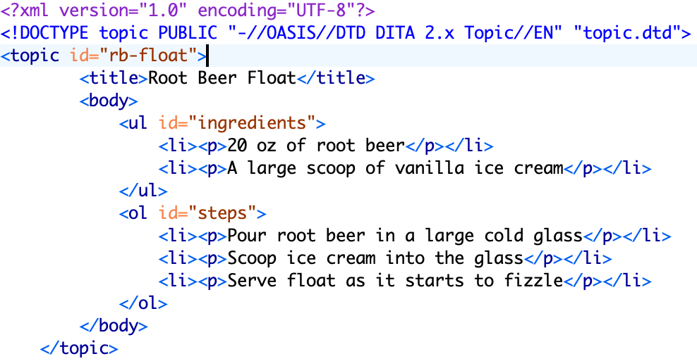

## Topic-oriented

The DITA authoring method has the following features.

* Involves creating modularized pieces of content (topics) that can stand on their own (non-linear)
* Allows for easy reuse and single-sourcing
* Caters to user needs by allowing for more specific documentation
* Allows documentation of products still under development
* Saves time by allowing SMEs to review only specific topics.

## Content is reusable/can be single-sourced

* Content comes from a single source and can be reused across multiple outputs.
* When the source is updated once, all outputs that use that source are also updated automatically.
* Eliminates duplicate work and increases consistency

## Important concepts and terms

|  |  |
| --- | --- |
| Element types | Delimited by angle brackets to distinguish from surrounding text. Example: <p>, <keyword> |
| DITA document | XML document that conforms to DITA. Must have one of the following elements:  <map>  <topic> (or a specialized topic type??)  <dita> |
| DITA topics | Unit of authoring and reuse. It can be generic or specialized (for example, <concept> or <task>). Uses .dita or .xml file extension. |
| DITA maps | Documents that organize topics and other resources. Creates a structured collection of information by specifying hierarchy and relationships between topics. Uses .ditamap file extension. |

## DITA topics

* Consists of content units that can be generic or specific
* Can be used/published in multiple contexts or on its own
* Information typing helps identify types of topics such as concept, reference, or task
* All topics have the same basic structure and use the <topic> base topic type

## Topic structure

|  |  |
| --- | --- |
| Root topic element | Holds required @id attribute. For example: <topic>, <task>,<reference>, or <concept>. |
| Title | Contains the topic subject. For example: <title>Configure our router</title> |
| Description/abstract | Short description of the topic.  For example: <shortdesc>You can configure your new router in multiple ways.</shortdesc> |
| Prolog | Container for topic metadata like change history or audience. |
| Body | Topic content like paragraphs, lists, etc. For example: <body>, <taskbody>, <refbody>, and <taskbody> |
| Related links | Links to other topics. For example:  <related-links>  <linklist>  <link href="schema.org" scope="external" format="html"/>  <link href="google.com" scope="external" format="html"/>  </linklist>  </related-links> |

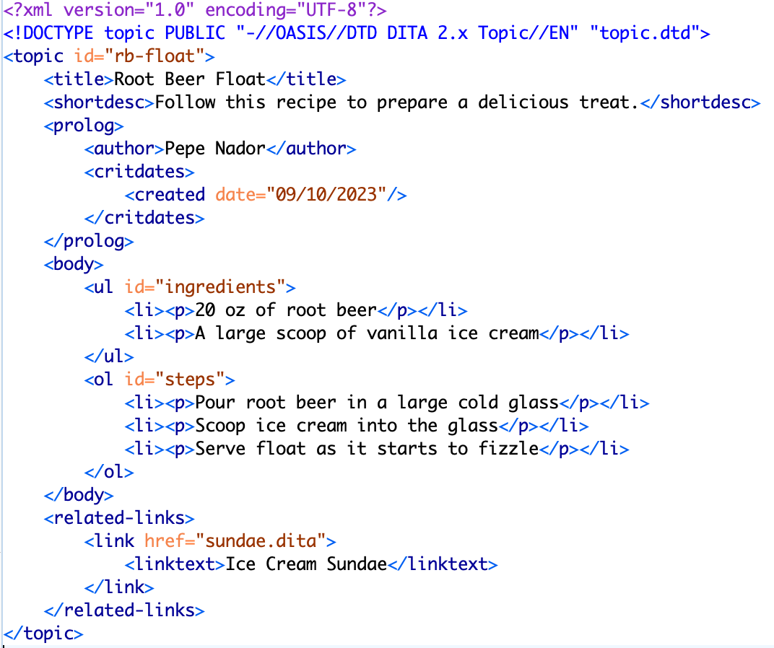

## Topic content

|  |  |
| --- | --- |
| Topic body | Contains all content except title and description/abstract |
| Sections/examples | Can contain elements such as titles, paragraphs, API names, etc. Some notable elements:   * <sectiondiv> (grouping of content within a section for reuse) * <bodydiv> (grouping of content within a section for reuse) * <div> (groups content within a topic) |
| Phrases/keywords | Elements that label parts of paragraphs with special meaning.  For example, <uicontrol> or <b>. |
| Multimedia | Use the <object> element to add (interactive) multimedia or <foreign> to add multimedia within topic content (such as vector graphics). |
| Images | Illustrations, diagrams, etc. |

## DITA maps

* DITA maps reference topics, maps, and other resources with the <topicref> element and can be nested to create relationships between them
* Creates architecture and context for a set of topics (allows topic reuse)
* Often represents a deliverable like a website or printed publication
* DITA maps define:
  + Information architecture
  + What topics to build for an output
  + Navigation
  + Related links
  + Authoring context
  + Keys/key scopes

Some important elements include:

* <topicref> (basic map elements that reference DITA topics, maps, or other resources)
* <reltable> (defines the relationship among DITA topics and/or other resources)
* <topicmeta> (metadata for maps)
* <topichead> (provides a navigation title)
* <navref> (pointer to another map)
* <mapref> (references an entire DITA map)

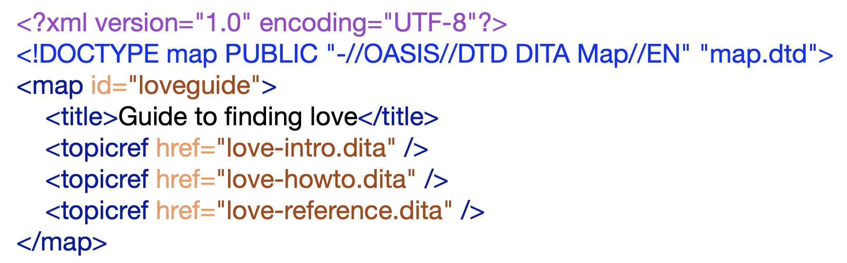

## How does it work?

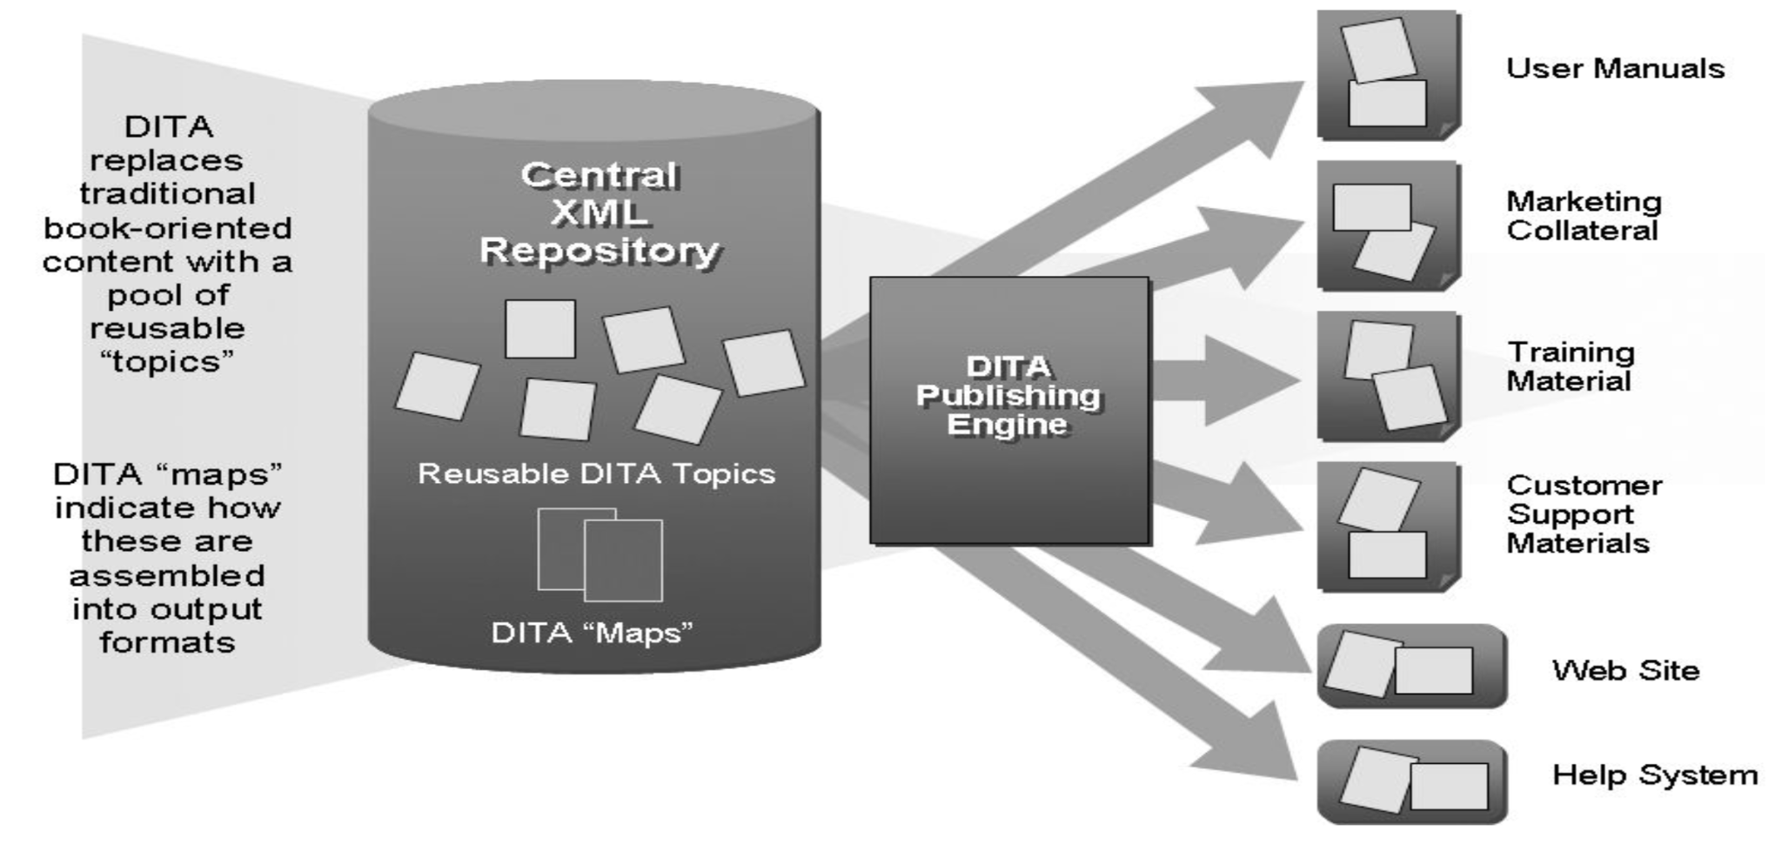

## Processing engine

The DITA Open Toolkit is the primary processing and publishing tool for DITA content. However, many commercial and open-source apps and platforms exist to make DITA workflows more user-friendly.

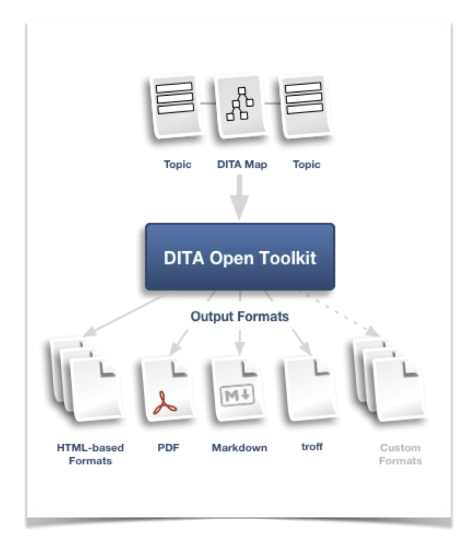

## Acknowledgements

* Scot Marvin - editorial review
* Rob Hanna - technical review
* Carlos Evia - instructional review

●

## Thank You!

See <https://acm-sigdoc-structured.org> to learn more about committee activities, available resources, and volunteer opportunities.

