Pimaster Chess

Project Team Members
Andrew Maurice
Cody Johnson
Lindsay Cason

Project Summary
The project program utilizes GUI python programming to enable two users to engage in a beginner friendly chess game. Visual aids such as highlighted possible moves and dynamically updated instructions are displayed on the GUI, along with an optional game timer and the ability to disable highlighting for more experienced players. The game is designed to run on the Raspberry Pi platform to utilize its multi-touch screen and GPIO capabilities.

Goals and Objectives
The goal of the project is to provide a two-player chess experience on the Raspberry Pi platform. The GUI is designed to display the chess board in the center of the screen with timers and labels for each player, along with sidebars containing other important information (pieces lost, instructions, options, etc.). The game will be able to assist the players by highlighting a piece’s possible moves, giving the players unlimited time, and displaying instructions in the information panel to guide the players. These features are designed to make the playing experience easy for beginners to the game, helping them to learn the rules. The program also offers the ability to turn some of these tutorial features off in order to test how well the players are learning the game mechanics.

Github Repository
This project's Github repository is located at: https://github.com/acm1264/PCIII-Final-RPi-Chess. Throughout development, a total of six branches were made from the master with over 100 commits overall between them to allow each member of the group to work on different structure ideas early in development. Upon completion, the master branch is the only branch remaining after taking necessary assets from the other branches. A total of X commits were made in the master branch.

Bill of Materials
The GPIO components used a Raspberry Pi GPIO extension board on a breadboard connected with a ribbon cable to a Raspberry Pi B v3, including the multitouch screen and speaker attached to the pi as well. Five RGB LEDS, ten long wires, seven short connecting wires, and fifteen 220Ω resistors were used on the board.

GPIO and GUI
GPIO was incorporated by wiring five RGB LEDs in a line to 10 broadcom pins to control the red and blue leads of the RGB LEDs. Using a list of player one’s (red) pieces in play and a list of player two’s (blue) pieces in play, scores for each player were calculated based of the value of their pieces in play. A pawn has a point value of 1; a rook, a bishop, and a knight have point values of 2; and a queen has a point value of 3. The king is not counted in the scores, thus has a point value of 0. The red and blue scores are then summed to get a total number of points in play. Using the total score and the red score, a red percent is calculated by determining the percent of red points out of the total points. Using this red percent, an LED is determined to be purple if the red percent falls in the range that the LED is responsible for. The LEDs are then lit up accordingly based on whether the LED is before or after the purple LED in the line of LEDS.

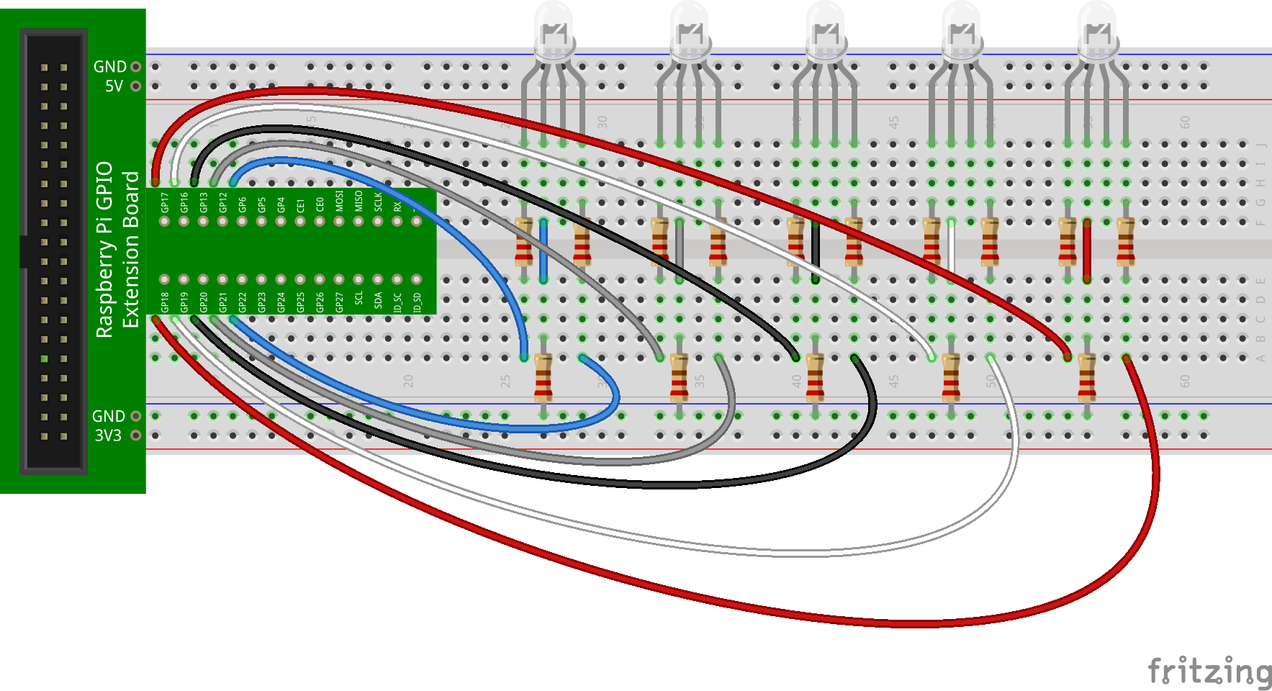
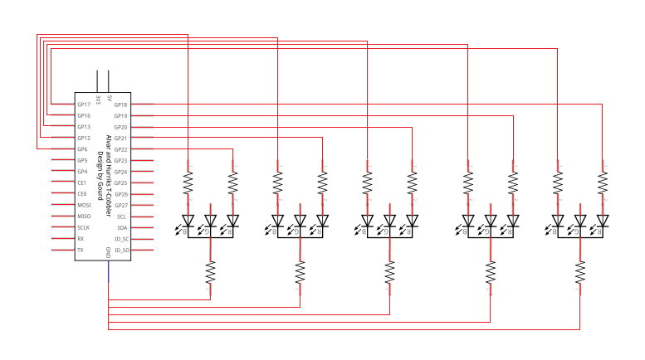

A python GUI was incorporated for the main game and two menu screens. The initial main menu displays to allow the player to view the instructions and select the type of timer they desire (blitz for 5 minutes, normal for 15 minutes, or no timer to count up instead). After play is clicked, the value for the timer selected by the player is sent to the new window for the main game. The main game window displays in full screen as shown in the screenshot below. The timer will dynamically change based on who is currently moving and whether it should go up or down. The board itself is setup using a dictionary to store the buttons with their appropriate tile locations. The pieces themselves are stored in a separate list with instance variables to allow for correlations to the actual tiles of their locations. To prevent errors and guide the player, an information section on the left is displayed. It will indicate whose turn it is, if a piece selected is valid, and so on. Any piece which is not valid to click will not be processed and display a message accordingly. When a valid piece to move is selected, it will highlight all possible moves, taking into account if the player is currently in check or would end up check as a result of a certain move. Green is the current piece trying to be moved, yellow is a possible move to a blank tile, and red is a possible overtake move, though if the highlight checkbox is turned off only the green highlight will display (highlight can be changed at any time with the box). Moving a piece will update the tile image and the piece’s position value. Overtaking a piece will set the location of it to 00 so it is invalid on the board and removing the image off the tile to make it seem gone, as well as removing it from the list of pieces and incrementing the right panel, which holds the values for each player for what has been overtaken. If a pawn swap (getting a pawn to the other end of the board) occurs, the player is able to select one of the side buttons (other than the pawn) to get a new instance of that piece, where clicking anywhere else will do nothing until a piece on the side is selected. One a win condition is met (checkmate or a timer runs out), a pop up window will display to indicate a victory. While the board can still be viewed, no processes work on it because the game has ended. The menu and game screen have buttons to completely close out of the program. The pop up window…

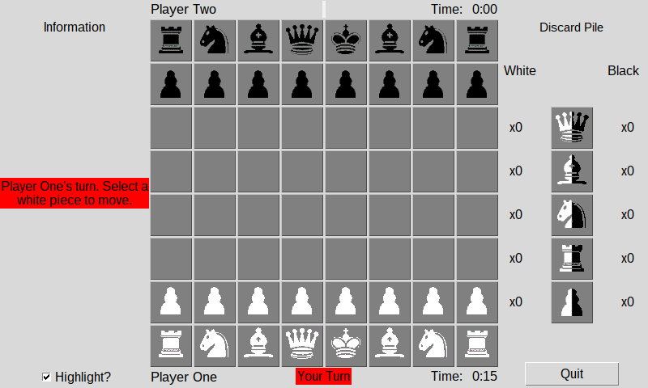

Gantt Chart
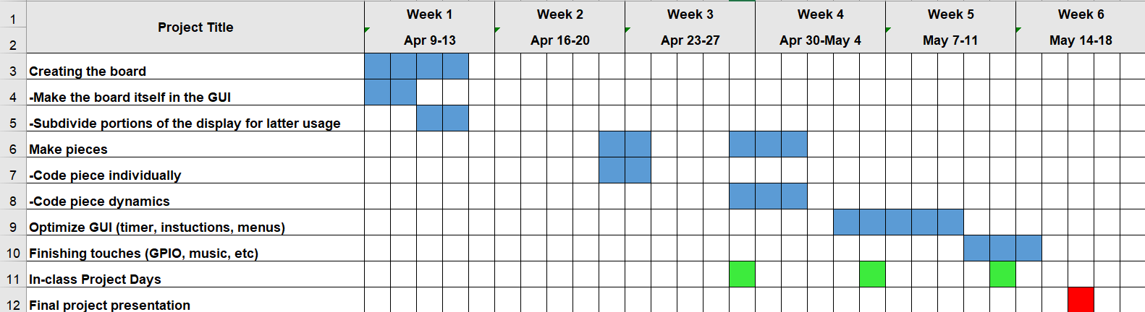
Overall, the schedule used when creating this project varied greatly from the initial intention. At the start of the project, a large amount of progress was made in setting up outlines for possible ways to organize the program. About a week later, the team met and discussed combining all the ideas into one streamlined program file in the master, though the implementation of this did not fully occur until around the end of the third week. In the meantime, some of the movement logic for the pieces was designed, and it was all finished shortly after the transition to the master. Optimizations for the GUI and implementing the GPIO were saved for the end to ensure the meat of the game functioned properly first. This chart varied from the original intent mostly with how much time was required for various tasks. The piece implementation, while optimizing was a challenge, did not take as long as expected. Making optimizations to various features in the GUI ended up requiring more attention than originally planned. Also, a large amount of work done early on led to some large gaps where the project was not worked on as much.

Future Development Plans
Further features and changes could be made to improve the user experience. The biggest addition which could be added into the game is a sort of AI support. The AI could play against the human player at a range of difficulty settings to allow a single user to practice and play chess even without another physical player with them. The implementation of the pieces could also be changed to utilize animations, such as showing a piece physically moving to its new point. A button to view a menu with all the chess rules mid-game would also be a nice addition to allow the players to read more detail about rules they may not understand without needing to look it up separately. Another addition could be to implement separate game modes for different scenarios, such as if the player wants to practice in preset chessboards for a different type of challenge against an AI. For GPIO, we could implement a seven segment LED to display the chess time next to the board for a nicer looking visual display of the time. Also, special move cases such as castling and en passant can be added to allow for a more advanced chess experience.

Lessons Learned
We learned a lot about python coding syntax and good programming practices in general. For python, we have a better understanding of how Tkinter windows work and interact with each other. We also learned various ways to optimize making the assets for the GUI, such as iteratively making the buttons for the board with all the necessary components. We additionally learned new ways to optimize code through low coupling and high cohesion, which proved to result in fewer things breaking as changes were made, as well as making adding new features easy because various functions were setup that were designed to do such simple tasks each that they could be repurposed for other uses. For general coding, we learned the usefulness of good coding style with working in a group, where having logical variable names and properly commented lines is crucial to effectively communicate what you are doing to your teammates, which will help in future courses. We also grew stronger in using recursion to make large numbers of variables or set up data structures to optimize the code and make it more readable. The experience helped us with general problem solving through forcing us to step back and think concepts through to find the most optimal (or just possible) way to solve the issues we had, such as figuring out the most efficient way to get pieces to move or working out how the complex logic associated with the king could be simplified enough to not slow down the flow of the game. All of the lessons learned relate back to the Living with Cyber curriculum because we had to use most of the skills we learned from the class and then some to create this program. The most important tie backs include the use of data structures, keeping low coupling and high cohesion for optimizing code, and the functionality of the python GUI with Tkinter among other things.

