FancyPrint Module
--------------------------------------------------------------------------------------------------------------------------------------------------------------------------
Screen Functions

clean() | It cleans the terminal and returns the cursor to home.
clear() | It clears the terminal and returns the cursor to home.
erase() | It erases the terminal and leaves the cursor in the current position.
dimensions() | It returns the dimensions of the terminal, cols and rows.
resize(rows=25, cols=80) | It resizes the terminal size.

Example: import fancyprint as fp
fp.clean()
r, c = fp.dimensions()
print(f"rows: {r}, Cols: {c}")
fp.resize(25, 120)

--------------------------------------------------------------------------------------------------------------------------------------------------------------------------
Internal Functions

bg_ansi_colors(bold=False, fg=-1, n_line=0)

This function displays all background colors available with ansi code. The following options are for a better visualization.
1.- The bold option for the font (True / False)
2.- The fg option to visualize the background colors with a specific foreground color.
3.- The n_line option to insert lines between the colors.

fg_ansi_colors(bold=False, bg=-1, n_line=0)

This function displays all foreground colors available with ansi code. The following options are for a better visualization.
1.- The bold option for the font (True / False)
2.- The bg option to visualize the background colors with a specific foreground color.
3.- The n_line option to insert lines between the colors.

ins_chr(n=1, unicode=” ”) → This function inserts n times the unicode provided, by default it is set to space.

ins_newline(n=1) → This function inserts n new lines.

terminal_bell() → This function makes the sound of the terminal bell.

reset_font() → This function resets the font attributes when we use the set_font() function.

set_font(bold=False, bg=-1, fg=-1, italic=False, underline=False, strike=False, blinking=False, dim=False, hidden=False, inverse=False) →
This function passes many attributes for the font. If passing all these arguments is a little annoying to you, you can use the Font Style Class for simplicity. The best way to use this function is to pass only the first 3 parameters like the example below.

Colors range goes from -1 to 256. To set the default color from the system use -1 or 256.

Example: import fancyprint as fp
print(fp.set_font(1,11,21) + " Python is " + fp.set_font(0,1) + " Wonderful."+fp.reset_font())
print(f"{fp.set_font(bold=0, bg=22, fg=0)} Python {fp.set_font(1,90,7)} Language.{fp.reset_font()}")

Note: These functions are being used by the FancyFormat Class. Feel free to ignore them if not useful to you.
--------------------------------------------------------------------------------------------------------------------------------------------------------------------------
Help Classes

Move → This class is used with the Cursor class and it contains 4 options.

Move.RIGHT Move.LEFT Move.UP Move.DOWN

Note: These options can be replaced for the original values as displays below:

Move.RIGHT = “right” = “r” Move.LEFT = “left” = “l”
Move.UP = “up” = “u” Move.DOWN = “down” = “d”

Align → This class is used with the FancyFormat class and FancyMessage class. It contains 4 options.

Align.RIGHT Align.LEFT Align.CENTER Align.JUSTIFY

Note: These options can be replaced for the original values as displays below:

Align.RIGHT = “right” = “r” Align.LEFT = “left” = “l”
Align.CENTER = “center” = “c” Align.JUSTIFY = “justify” = ”j”

Layout → This class is used with FancyFormat class and Pen class. It contains 2 options.

Layout.HORIZONTAL = “horizontal” Layout.VERTICAL = “vertical”

Length_bg → This class is used with FancyMessage class and contains 2 options.

ALL_ROW ONLY_WORD

Unicode → This class is to insert some unicode characters.
#-------------------------------------------------------------------------------------------------------------------------------------------------------------------------
# Lines Triangle -
#-------------------------------------------------------------------------------------------------------------------------------------------------------------------------
BOX_DRAWINGS_LIGHT_HORIZONTAL BLACK_UP_POINTING_TRIANGLE
BOX_DRAWINGS_LIGHT_VERTICAL_AND_RIGHT WHITE_UP_POINTING_TRIANGLE
BOX_DRAWINGS_LIGHT_VERTICAL_AND_LEFT BLACK_RIGHT_POINT_TRIANGLE
BOX_DRAWINGS_LIGHT_VERTICAL WHITE_RIGHT_POINT_TRIANGLE
BOX_DRAWINGS_LIGHT_DOWN_AND_HORIZONTAL BLACK_DOWN_POINTING_TRIANGLE
BOX_DRAWINGS_LIGHT_UP_AND_HORIZONTAL WHITE_DOWN_POINTING_TRIANGLE
BOX_DRAWINGS_LIGHT_VERTICAL_AND_HORIZONTAL BLACK_LEFT_POINTING_TRIANGLE
EM_DASH WHITE_LEFT_POINTING_TRIANGLE
#-------------------------------------------------------------------------------------------------------------------------------------------------------------------------
# Miscellaneous -
#-------------------------------------------------------------------------------------------------------------------------------------------------------------------------
BLACK_DIAMOND WHITE_DIAMOND
BLACK_CIRCLE WHITE_CIRCLE
FACE
For more reference → https://www.unicode.org/charts/nameslist/

Line_Style → This class is used with FancyFormat class and Pen class. There are 8 options.
Style_Line.CUSTOMIZED Style_Line.SINGLE
Style_Line.SINGLE_BOLD Style_Line.SINGLE_HEAVY
Style_Line.DOUBLE Style_Line.DASH
Style_Line.SQR_BRACKETS Style_Line.NONE
Note: These options can be replaced for the original value as displays below:

Style_Line.CUSTOMIZED → "customized" Style_Line.SINGLE → "single"
Style_Line.SINGLE_BOLD → "single_bold" Style_Line.SINGLE_HEAVY → "single_heavy"
Style_Line.DOUBLE → "double" Style_Line.DASH → "dash"
Style_Line.SQ_BRACKETS → "sq_brackets" Style_Line.NONE → "none"

--------------------------------------------------------------------------------------------------------------------------------------------------------------------------
Cursor Class
This class contains 4 methods. The difference between jump and move is that jump executes the code while move returns the code.

jumpTo(qty=0, direction=fp.Move.DOWN) → This method jumps rows or columns for the cursor in the terminal.

jumpxy(x=0, y=0) → This method jumps the cursor to specific coordinates in the terminal.

moveTo(qty=0, direction=fp.Move.DOWN) → This method moves rows or columns for the cursor in the terminal.

movexy(x=0, y=0) → This method moves the cursor to specific coordinates in the terminal.

Example: import fancyprint as fp
crs = fp.Cursor()
crs.jumpTo(4, “D”)

crs.jumpTo(qty=20, direction=fp.Move.RIGHT) ←.→ crs.jumpTo(qty=20, direction=”right”)
print(“Hello There…!”)

print(f”{crs.moveTo(qty=20, direction=fp.Move.RIGHT)}Hello There…!”)

print(f”{crs.movexy(0,10)}Col 10, row 1”)

--------------------------------------------------------------------------------------------------------------------------------------------------------------------------
FontStyle Class

This class contains 4 methods and the attributes and their default values are displays below.

bold = False bg = -1 fg = -1 italic = False
dim = False underline = False blinking = False inverse = False
hidden = False strike = False indent = False next_line = True

indent → this defines how far we want to start to print the message from the left.
next_line → this defines where we want to jump the line or not when printing the message.

print_style(msg) → This method will print the style with the defined attributes.

Example: import fancyprint as fp
fs = fp.FontStyle()
fs.bg = 21
fs.fg = 231
fs.print_style(msg = “ My Font Style ”)

# reset_style() → This method will reset the style to the default values.
fs.reset_style()
fs.print_style(“ My Font Style “)
# start_style() and stop_style() → These methods are used if we will be continuing using the style in many rows.
Example: import fancyprint as fp
fs = fp.FontStyle()
fs.bg = 21
fs.fg = 231
print(f”{fs.start_style()} Font Style Line 1 ”)
print(f” Font Style Line 2 ”)
print(f” Font Style Line 3 {fs.stop_style()}”)
fs.reset_style()
print(f”{fs.start_style()} Default Style {fs.stop_style()}”)

--------------------------------------------------------------------------------------------------------------------------------------------------------------------------
FancyMessage Class
#-------------------------------------------------------------------------------------------------------------------------------------------------------------------------
# Body Default Values -
#-------------------------------------------------------------------------------------------------------------------------------------------------------------------------
bg_body = 4 strike_body = False msg_body = "Body Msg
fg_body = 231 hidden_body = False right_indent = 2
bold_body = False inverse_body = False left_indent = 2
dim_body = False blinking_body = False top_lines = 1
italic_body= False underline_body = False bottom_lines = 1

help_lines = False length = Length_bg.ALL_ROW

# These two options work when length is Length_bg.ONLY_WORD. They don't do anything when length is Length_bg.All_ROW.
adj_bg_lines_to_right_indent = False
adj_bg_msg_to_space_available = False

Note: All the above variables are being used by both methods, print_fancy_message and print_fancy_note.

#-------------------------------------------------------------------------------------------------------------------------------------------------------------------------
# Note Attributes -
#-------------------------------------------------------------------------------------------------------------------------------------------------------------------------
msg_note = " Note: " align_note = Align.JUSTIFY blinking_note = False
bg_note = 231 strike_note = False underline_note = False
fg_note = 0 italic_note = False position_note = 1
bold_note = False inverse_note = False right_space_note = 2
dim_note = False hidden_note = False left_space_note = 2

#-------------------------------------------------------------------------------------------------------------------------------------------------------------------------
# Title Attributes -
#-------------------------------------------------------------------------------------------------------------------------------------------------------------------------
msg_title = “” align_title = Align.LEFT blinking_title = False
bg_title = 4 strike_title = False underline_title = False
fg_title = 231 italic_title = False title_indent = 2
bold_title = False inverse_title = False lines_title_body = 1
dim_title = False hidden_title = False

#-------------------------------------------------------------------------------------------------------------------------------------------------------------------------
# Footnote Attributes -
#-------------------------------------------------------------------------------------------------------------------------------------------------------------------------
msg_footnote = “” align_footnote = Align.RIGHT blinking_footnote = False
bg_footnote = 4 strike_footnote = False underline_footnote = False
fg_footnote = 231 italic_footnote = False footnote_indent = 2
bold_footnote = False inverse_footnote = False lines_body_footnote = 1
dim_footnote = False hidden_footnote = False
Example: paragraph = '''
Guido van Rossum, a Dutch programmer, created Python in the late 1980s
as a hobby project. He started working on it in December 1989 at Cent-
rum Wiskunde & Informatica (CWI) in the Netherlands.

Python was first released on February 20, 1991. Python was named after
the 1970s BBC comedy sketch series Monty Python's Flying Circus.
'''
import fancyprint as fp

msg = fp.FancyMessage()

msg.msg_title = "TITLE"
msg.msg_footnote = "FOOTNOTE"

msg.print_fancy_message(paragraph)

fp.ins_newline(2)

msg.msg_note = “Python”
msg.position_note = 4
msg.print_fancy_note(paragraph)

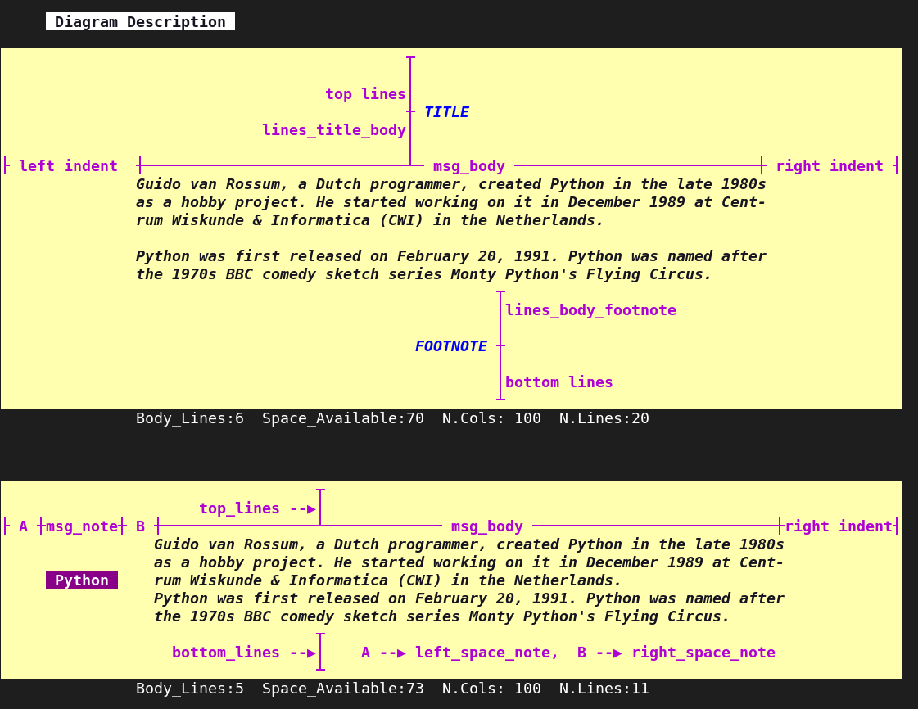

--------------------------------------------------------------------------------------------------------------------------------------------------------------------------
FancyFormat Class

This class contains two methods:
print_fancy_format(data, style) → Two arguments, the data to print and the line style.
reset_fancy_format() → It resets all the attributes to their default values.

Examples: import fancyprint as fp
tbl = fp.FancyFormat()

Case 1: Passing any type of variable. Case 2: Passing an empty list.
tbl.print_fancy_format("Hello World…!") tbl.print_fancy_format([])

Output: +--------------------+ Output: +---------+
| Hello World...! | | none |
+--------------------+ +---------+

Case 3: Passing single item in a list. Case 4: Passing single item in a row to a list.
my_list = ["Hello World...!"] my_list = [["hello there!"]]
tbl.print_fancy_format(my_list) tbl.print_fancy_format(my_list)

Output: +--------------------+ Output: +----------------+
| Hello World...! | | hello there! |
+--------------------+ +----------------+

Case 5: Passing a list.
my_list = [1,2,3,4] my_list = ["Terminology","hello there!", "I am Miguelito"]
tbl.print_fancy_format(my_list) tbl.print_fancy_format(my_list)

Output: +-----*-----*-----*-----+ +------------------*----------------*----------------+
| 1 | 2 | 3 | 4 | | Terminology | hello there! | I am Migue |
+-----*-----*-----*-----+ +------------------*----------------*----------------+

Case 6: Passing a list in a single row.
my_list = [[1,2,3,4]] my_list = [["Terminology","hello there!", "I am Hello"]]
tbl.print_fancy_format(my_list) tbl.print_fancy_format(my_list)

Output: +-----*-----*-----*-----+ +------------------*----------------*---------------+
| 1 | 2 | 3 | 4 | | Terminology | hello there! | I am Hello |
+-----*-----*-----*-----+ +------------------*----------------*---------------+

Case 7: Passing a list with a some combination of rows and cols.
my_list = [[5,"hello"],6,50,[45]] my_list1 = [10,[50],[250],["C"],["H"],10,20]
tbl.print_fancy_format(my_list) tbl.print_fancy_format(my_list)

Output: +----------------*-----*--------*---------+ +------*--------*---------*---------*---------*------*------+
| [5, 'hello'] | 6 | 50 | [45] | | 10 | [50] | [250] | ['C'] | ['H'] | 10 | 20 |
+----------------*-----*--------*---------+ +------*--------*---------*---------*---------*------*------+

Case 8: Passing a list with rows and one col.
my_list = [[10],[20],[30],[40]]
tbl.print_fancy_format(my_list)
Output: +---------+ +-----+
| R1C1 | | 10 |
| R1C2 | | 20 |
| R1C3 | | 30 |
| R1C4 | | 40 |
+---------+ +-----+

Case 9:
Passing a list with a some combination of rows and cols.
my_list = [["R1C1","R1C2","R1C3"], my_list = [["R1C1","R1C2","R1C3"],
["R2C1","R2C2","R2C3"], ["R2C1","R2C2","R2C3"],
["R3C1","R3C2","R3C3"]] ["R3C1","R3C2","R3C3"]]

tbl.print_fancy_format(my_list1) tbl.horizontal_line_under_header_on = True
tbl.middle_horizontal_line_on = True
tbl.print_fancy_format(my_list1)
Output: +---------+--------+---------+---------+ +---------+---------+---------+---------+
| R1C1 | R1C2 | R1C3 | R1C4 | | R1C1 | R1C2 | R1C3 | R1C4 |
| R2C1 | R2C2 | R2C3 | R2C4 | +---------+---------+---------+---------+
| R3C1 | R3C2 | R3C3 | R3C4 | | R2C1 | R2C2 | R2C3 | R2C4 |
| R4C1 | R4C2 | R4C3 | R4C4 | +---------+---------+---------+---------+
+---------+---------+---------+---------+ | R3C1 | R3C2 | R3C3 | R3C4 |
+---------+---------+---------+---------+
| R4C1 | R4C2 | R4C3 | R4C4 |
+---------+---------+---------+---------+

Note: Although the main idea is to use list type, print_fancy_format(tbl) accepts any type of variable. Refer to Demo 3 figure.

Attributes in FancyFormat Class:
#-------------------------------------------------------------------------------------------------------------------------------------------------------------------------
# General Use Section -
#-------------------------------------------------------------------------------------------------------------------------------------------------------------------------
adj → adjust

adj_top_margin = 0 adj_bottom_margin = 0 adj_indent = 2 set_fill_chr = “----” set_layout = Layout.HORIZONTAL
adj_top_space = 0 adj_bottom_space = 0 adj_space = 2 updata_list = False

adj_top_margin Lines to be added between the terminal ($) and the title. It only accepts int values.
adj_top_space Lines to be added between title and top list. It only accepts int values.

adj_bottom_margin Lines to be added between the end of the list or footnote to the terminal ($).
adj_bottom_space Lines to be added between the bottom of the list and the footnote. It only accepts int values.

adj_indent Space from the left terminal to the first character in the list to be printed. It only accepts int values.
adj_space Space from the left of the box to the first character in the list to be printed. It only accepts int values.

set_fill_chr When a list is not complete in the data, it will be filled out with some characters. fill_chr will be converted to string.

update_list Notice that every single element in the list being passed will be converted to string in a temporary internal list.
If you want to save this conversion to your original list then set to True. It only works with the list type of variable.

set_layout This option only works with set, frozenset or range type of variables.

Note: adj_top_space won’t work if the title is not set up. Also adj_bottom_space won’t work if the footnote is not set up.
Use adj_top_margin or adj_bottom_margin or ins_newline(n), or print(“\n”) if you need more space.

#-------------------------------------------------------------------------------------------------------------------------------------------------------------------------
# Title Section -
#-------------------------------------------------------------------------------------------------------------------------------------------------------------------------
msg_title = “” align_title = "justify" hidden_title = False
bold_title = False italic_title = False inverse_title = False
bg_title = -1 strike_title = False blinking_title = False
fg_title = -1 dim_title = False underline_title = False

msg_title The title name for the list. It only accepts string values, by defaults is empty.

bold_title It only accepts two int values 0 and 1, by defaults is set to 0.

bg_title and fg_title accepts int values from -1 to 256. Default value from the system are -1 and 256.

align_title It accepts 4 values, left (l), justify (j), center (c), and right (r).

#-------------------------------------------------------------------------------------------------------------------------------------------------------------------------
# Footnote Section -
#-------------------------------------------------------------------------------------------------------------------------------------------------------------------------
msg_footnote = “” align_footnote = "justify" hidden_footnote = False
bold_footnote = False italic_footnote = False inverse_footnote = False
bg_footnote = -1 strike_footnote = False blinking_footnote = False
fg_footnote = -1 dim_footnote = False underline_footnote = False

msg_footnote The title name for the list. It only accepts string values, by default is empty.

bold_ footnote It only accepts two int values 0 and 1, by defaults is set to 0.
bg_ footnote and fg_footnote accepts int values from -1 to 256. Default values from the system are -1 and 256.

align_footnote It accepts 4 values, left (l), justify (j), center (c), and right (r).

#-------------------------------------------------------------------------------------------------------------------------------------------------------------------------
# Data Section -
#-------------------------------------------------------------------------------------------------------------------------------------------------------------------------
align_data = "justify" hidden_data = False inverse_data = False
bold_data = False italic_data = False blinking_data = False
bg_data = -1 strike_data = False underline_data = False
fg_data = -1 dim_data = False bg_all_cell_data = True

bg_all_cell_data The bg color will affect the entire cell or just the data.

align_data It accepts 4 values, left (l), justify (j), center (c), and right (r).

bg_data and fg_data accepts int values from -1 to 256. Default values from the system are -1 and 256.

#-------------------------------------------------------------------------------------------------------------------------------------------------------------------------
# Horizontal Line Section -
#-------------------------------------------------------------------------------------------------------------------------------------------------------------------------top_horizontal_line_chr = "-" bottom_horizontal_line_chr ="-" middle_horizontal_line_chr = "-"
top_horizontal_line_on = True bottom_horizontal_line_on = True middle_horizontal_line_on = False
bold_horizontal_line = False bg_horizontal_line = -1 fg_horizontal_line = -1

middle_horizontal_line_on These are the lines below the data. Check Case 9: for reference.
bg_horizontal_line and fg_horizontal_line accepts int values from -1 to 256. Default values from the system are -1 and 256.

For more reference check Figure 1.
#-------------------------------------------------------------------------------------------------------------------------------------------------------------------------
# Vertical Line Section -
#-------------------------------------------------------------------------------------------------------------------------------------------------------------------------
bold_vertical_line = False left_vertical_line_chr = "|"
bg_vertical_line = -1 middle_vertical_line_chr = "|"
fg_vertical_line = -1 right_vertical_line_chr = "|"

middle_vertical_line_chr A string type. The char used to make the horizontal line. For more reference check Figure 2.
right_vertical_line_chr A string type. Refer to Figure 1.
left_vertical_line_chr A string type. Refer to Figure 1.
bg_vertical_line and fg_vertical_line Accepts int values from -1 to 256. Default values from the system are -1 and 256.

#-------------------------------------------------------------------------------------------------------------------------------------------------------------------------
# External Corner Section -
#-------------------------------------------------------------------------------------------------------------------------------------------------------------------------
top_left_corner_chr = "+" bottom_right_corner_chr = "+" bold_corner_chr = False
top_right_corner_chr = "+" bottom_left_corner_chr = "+" bg_corner_chr = -1
fg_corner_chr = -1

top_left_corner_chr A string type. For reference check Figure 1. By default set to “+”
top_right_corner_chr A string type. For reference check Figure 1. By default set to “+”

bottom_right_corner_chr A string type. For reference check Figure 1. By default set to “+”
bottom_left_corner_chr A string type. For reference check Figure 1. By default set to “+”

bg_corner_chr and fg_corner_chr Accepts int values from -1 to 256. Default values from the system are -1 and 256.

#-------------------------------------------------------------------------------------------------------------------------------------------------------------------------
# Middle Corner Section -
#-------------------------------------------------------------------------------------------------------------------------------------------------------------------------
bold_inner_corner_chr = False middle_top_corner_chr = "+" right_lateral_corner_chr = "+"
bg_inner_corner_chr = -1 middle_inner_corner_chr = "+" left_lateral_corner_chr = "+"
fg_inner_corner_chr = -1 middle_bottom_corner_chr = "+"

bg_corner_chr and fg_corner_chr Accepts int values from -1 to 256. Default values from the system are -1 and 256.

For reference check Figure 3 and 4.

#-------------------------------------------------------------------------------------------------------------------------------------------------------------------------
# Header Section -
#-------------------------------------------------------------------------------------------------------------------------------------------------------------------------
align_header = "justify" hidden_header = False inverse_header = False
bold_header = False italic_header = False blinking_header = False
bg_header = -1 strike_header = False underline_header = False
fg_header = -1 dim_header = False bg_all_cell_ header = True

bg_all_cell_data The bg color will affect the entire cell or just the header.
align_header It accepts 4 values, left (l), justify (j), center (c), and right (r).

bg_header and fg_header Accepts int values from -1 to 256. Default values from the system are -1 and 256.

Attributes for the header lines

bold_vertical_header_line_chr = False right_vertical_header_line_chr = "|"
bg_vertical_header_line_chr = -1 left_vertical_header_line_chr = "|"
fg_vertical_header_line_chr = -1 middle_vertical_header_line_chr = "|" For reference check Figure 3 and 4.
#-------------------------------------------------------------------------------------------------------------------------------------------------------------------------
# Header Under Line Section -
#-------------------------------------------------------------------------------------------------------------------------------------------------------------------------
Attributes for the line below the header text
bold_under_line_header = False horizontal_line_under_header_on = False
bg_under_line_header = -1 horizontal_line_under_header_chr = "-"
fg_under_line_header = -1

horizontal_line_under_header_on Horizontal lines between headers and the first data row.

bg_under_line_header and fg_under_line_header Accepts int values from -1 to 256. Default values from the system are -1 and 256.

Attributes for the header corners (left, middles and right)
bold_corner_under_line_header = False left_corner_under_line_header_chr = "+"
bg_corner_under_line_header = -1 right_corner_under_line_header_chr = "+"
fg_corner_under_line_header = -1 middle_corner_under_line_header_chr = "+"

For more reference see figure 3.

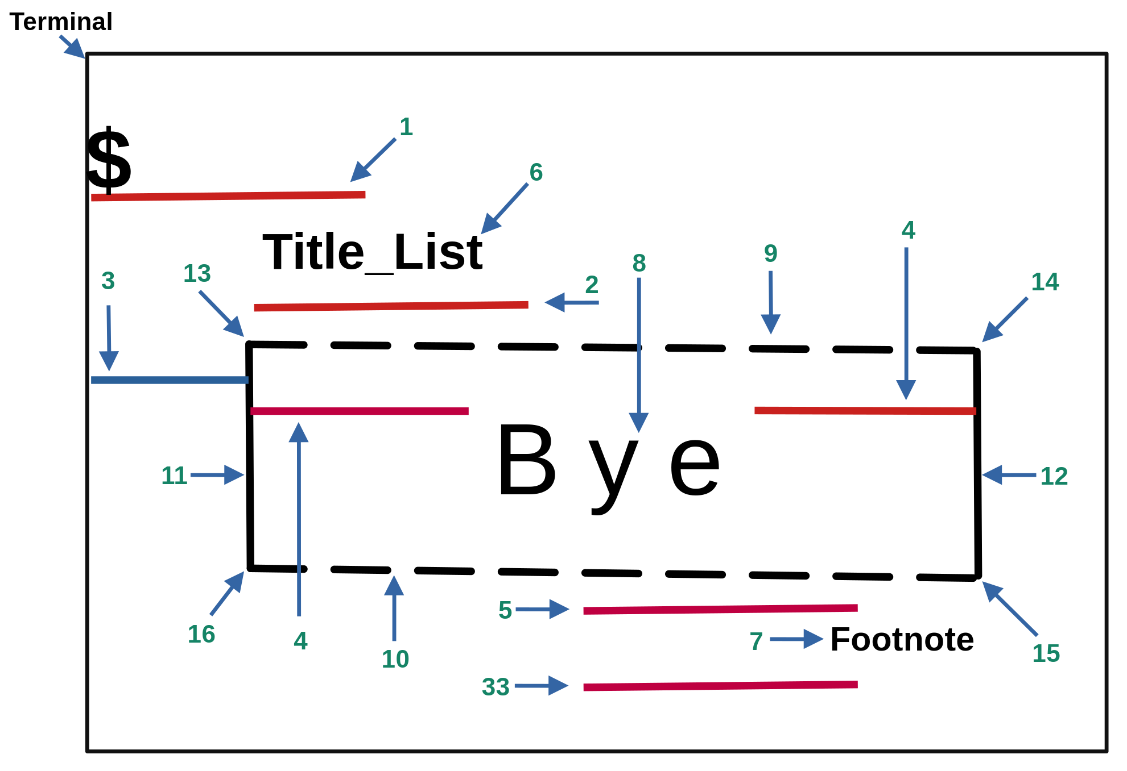

Figure 1

1.- adj_top_margin | 2.- top_space | 3.- adj_indent
4.- adj_space | 5.- bottom_space | 6.- msg_title
7.- msg_footnote | 8.- data | 9.- top_horizontal_line_chr
10.- bottom_horizontal_line_chr | 11.- left_vertical_line_chr | 12.- right_vertical_line_chr
13.- top_left_corner_chr | 14.- top_right_corner_chr | 15.- bottom_right_corner_chr
16.- bottom_left_corner_chr | 33.- adj_bottom_margin

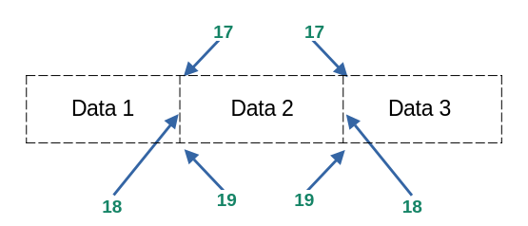

17.- middle_top_corner_chr
Figure 2
18.- middle_vertical_line_chr
19.- middle_bottom_corner_chr

Figure 3
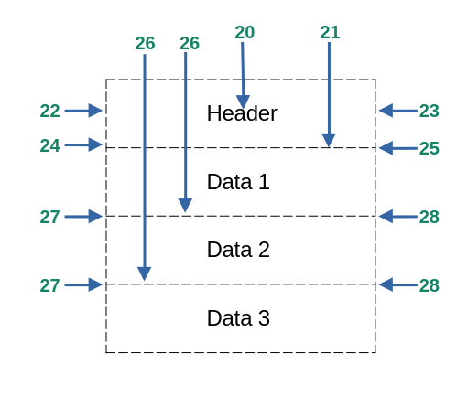
20.- header
21.- horizontal_line_under_header_chr
22.- left_vertical_header_line_chr
23.- right_vertical_header_line_chr
24.- left_corner_under_line_header_chr
25.- right_corner_under_line_header_chr
26.- middle_horizontal_line_chr
27.- left_lateral_corner_chr
28.- right_lateral_corner_chr

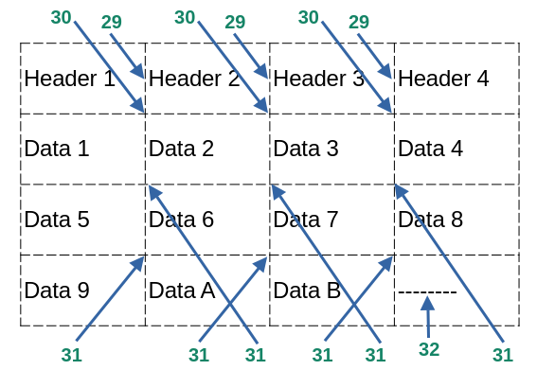

29.- middle_vertical_header_line_chr
30.- middle_corner_under_line_header_chr
31.- middle_inner_corner_chr
32.- set_fill_chr

Figure 4

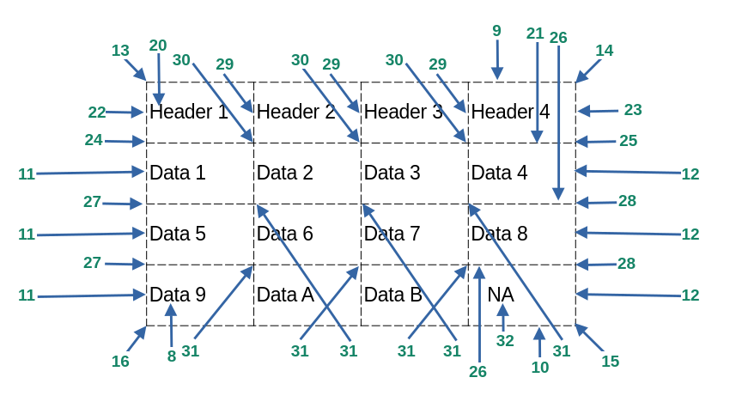
Summarize

Figure 5
Note: 2 and 33 only work if the title and footnote exist.
Figure 1

Figure 2

1.- adj_top_margin | 2.- top_space | 3.- adj_indent
4.- adj_space | 5.- bottom_space | 6.- msg_title
7.- msg_footnote | 8.- data | 9.- top_horizontal_line_chr
10.- bottom_horizontal_line_chr | 11.- left_vertical_line_chr | 12.- right_vertical_line_chr
13.- top_left_corner_chr | 14.- top_right_corner_chr | 15.- bottom_right_corner_chr
16.- bottom_left_corner_chr | 17.- middle_top_corner_chr | 18.- middle_vertical_line_chr
19.- middle_bottom_corner_chr | 20.- header | 21.- horizontal_line_under_header_chr
22.- left_vertical_header_line_chr | 23.- right_vertical_header_line_chr | 24.- left_corner_under_line_header_chr
25.- right_corner_under_line_header_chr | 26.- middle_horizontal_line_chr | 27.- left_lateral_corner_chr
28.- right_lateral_corner_chr | 29.- middle_vertical_header_line_chr | 30.- middle_corner_under_line_header_chr
31.- middle_inner_corner_chr | 32.- set_fill_chr | 33. adj_bottom_margin

Horizontal Line Default Values: bg_all_cell_data/header Default Values:

top_horizontal_line_on = 1 bottom_horizontal_line_on = 1 bg_all_cell_data = True

middle_horizontal_line_on = 0 horizontal_line_under_header_on = 0 bg_all_cell_header = True

Some Other Default Values:

align_title = “justify” msg_title = “” align_data = “justify” update_list = False

align_footnote = “justify” msg_footnote = “” align_header = ”justify” set_layout = Layout.HORIZONTAL

Examples:

Demo 1. Default Values
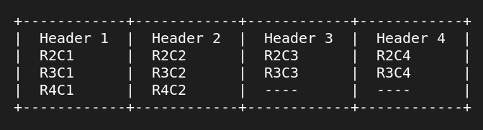
import fancyprint as fp

tlb = fp.FancyFormat()
lst = [["Header 1","Header 2","Header 3","Header 4"],
["R2C1","R2C2","R2C3","R2C4"],
["R3C1","R3C2","R3C3","R3C4"],
["R3C1","R3C2"]]

tlb.print_fancy_format(lst)

Demo 2. A Little bit of Customization

import fancyprint as fp

tlb = fp.FancyFormat()
lst = [["Header 1","Header 2","Header 3","Header 4"],
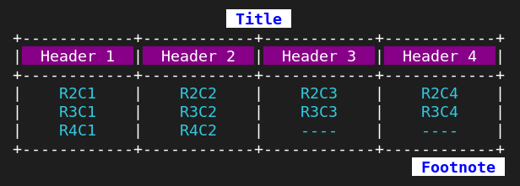
["R2C1","R2C2","R2C3","R2C4"],
["R3C1","R3C2","R3C3","R3C4"],
["R4C1","R4C2"]]

tlb.msg_title = " Title "
tlb.align_title = fp.Align.CENTER
tlb.bold_title = True
tlb.fg_title = 21
tlb.bg_title = 231

tlb.bg_header = 90
tlb.fg_header = 231
tlb.horizontal_line_under_header_on = True

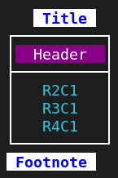
tlb.align_data = fp.Align.CENTER
tlb.fg_data = 14

tlb.msg_footnote = " Footnote "
tlb.align_footnote = fp.Align.RIGHT
tlb.bold_footnote = True
tlb.bg_footnote = 231
tlb.fg_footnote = 21

tlb.print_fancy_format(lst)

lst = [["Header"],["R2C1"],["R3C1"],["R4C1"]]

tlb.print_fancy_format(lst, fp.Line_Style.SINGLE)

Demo 3 → Type of Variables

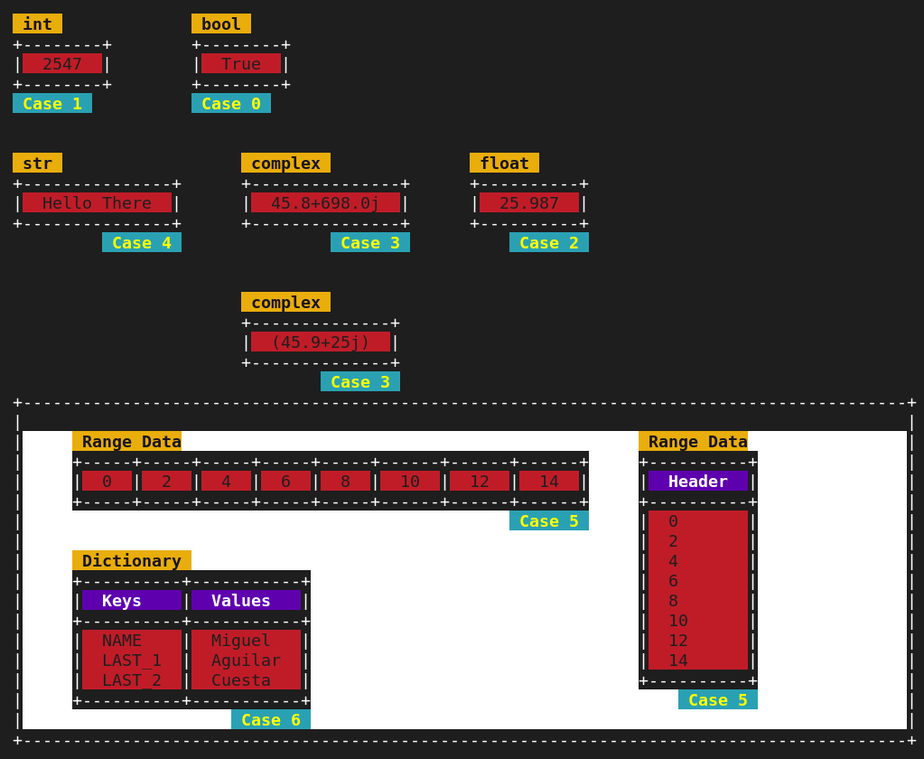

Demo 4. Some More Customization
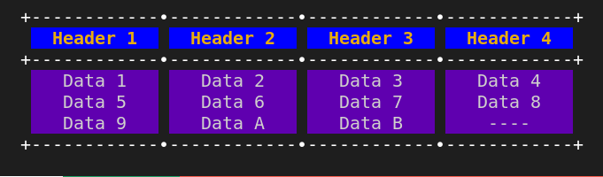

Demo 5. Two List Joined

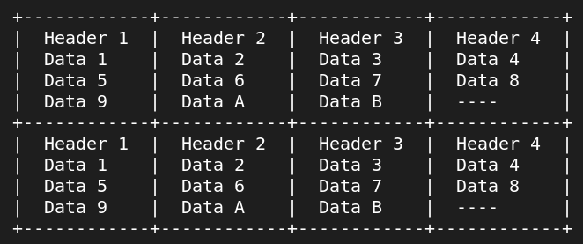

--------------------------------------------------------------------------------------------------------------------------------------------------------------------------
Pen Class

This class contains two methods:

draw_line(size=0, layout=Layout.HORIZONTAL, tail="\N{BLACK DIAMOND}", body="-", head="\N{BLACK DIAMOND}")

draw_rectangle(length=3, width=3, style=Line_Style.DASH)

Rectangle Default Values
top_left_corner_chr = "+" top_horizontal_line_chr = "-" right_vertical_line_chr = "|"
top_right_corner_chr = "+" bottom_horizontal_line_chr ="-" left_vertical_line_chr = "|"
bottom_right_corner_chr = "+"
bottom_left_corner_chr = "+" refill_bg_color = False

Line Default Values General Default Values
bold_draw_line = False adj_indent = 0
bg_draw_line = -1
fg_draw_line = -1

Example: import fancyprint as fp
pen = fp.Pen()
pen.adj_indent = 8
pen.draw_line(size=20, layout=fp.Layout.HORIZONTAL, tail=fp.Unicode.BLACK_LEFT_POINTING_TRIANGLE,
body=fp.Unicode.EM_DASH, head=fp.Unicode.BLAKC_RIGHT_POINT_TRIANGLE)
fp.ins_newline(2)
pen.adj_indent = 14
pen.draw_rectangle(length=8, width=4, style=fp.Line_Style.DOUBLE)

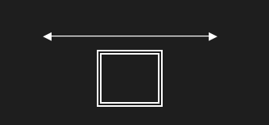
Report bugs at → acma.mex@hotmail.com

FanyPrint module is not a big thing, but I hope you find useful occasionally. Python 3.12.1 or greater is required.

Note: fancyprint module has been tested on RedHat 9, Centos Stream 9, AlmaLinux 9, and Windows 10.

