- Separated Microcontroller Portion from High Power circuitry.
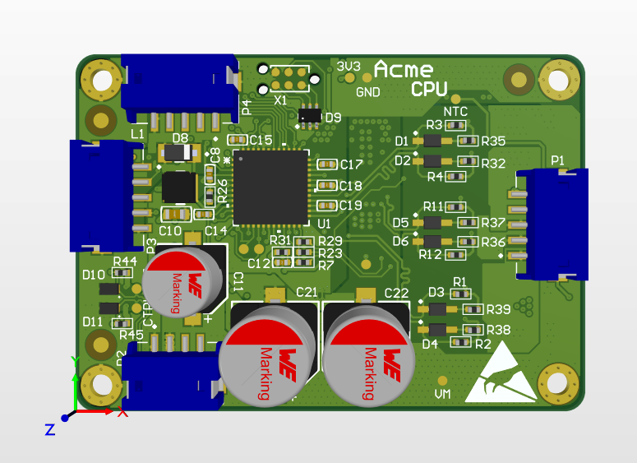
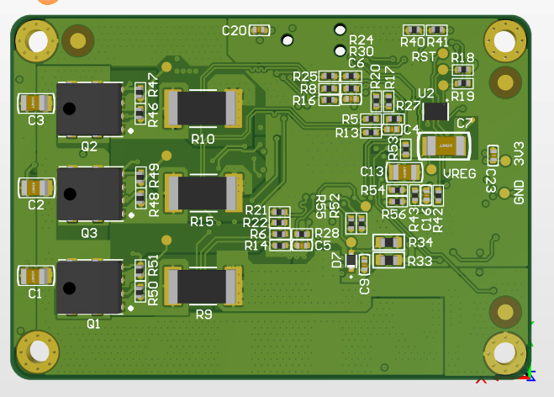

- Placed the Input Connector as close as possible to compensate with the shorter high power path to the H-Bridge Section.
- Minimized the AC loop Area. Used Multilayer return topology to return the Current. Since the Internal Plane layers does not have air proximity, multilayer return path is useful to reduce the resistance (Lowering the heat dissipation due to high current flow).

POWER SOURCE LAYERs
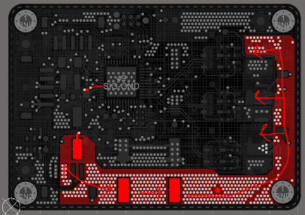
The Motor Power flowing through the 1st Layer (TOP)

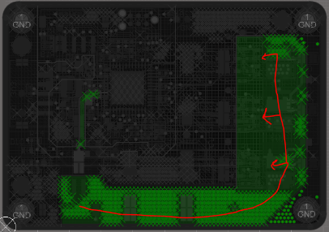

The Motor Power flowing through the 2^{md} Layer

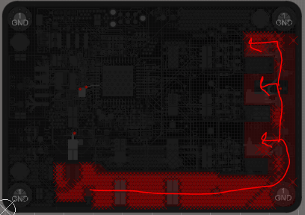

The Motor Power flowing through the 3rd Layer

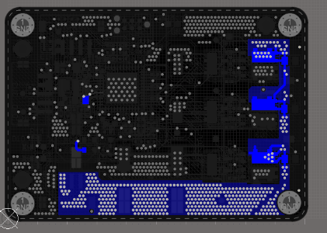
The Motor Power flowing through the 4th Layer (BOTTOM)

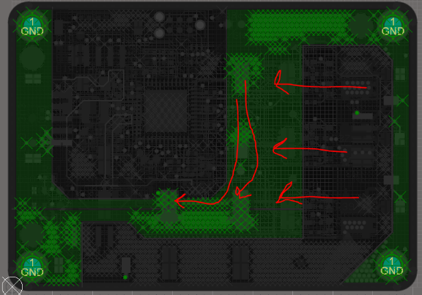
GROUND REURN LAYERs
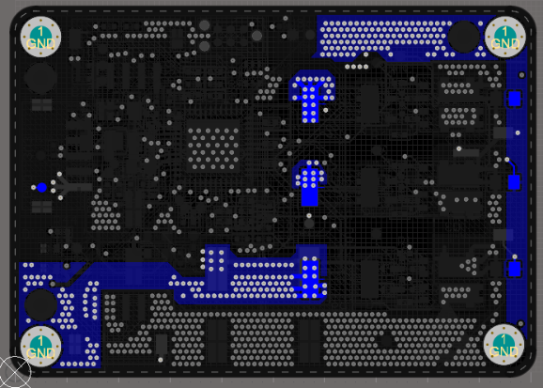
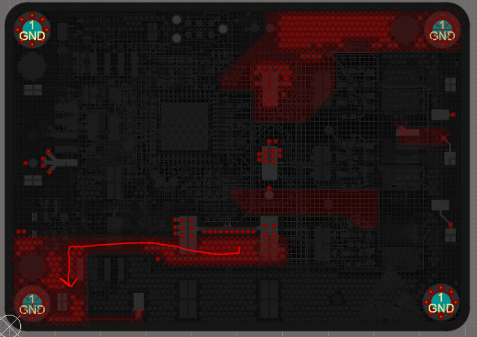

The Motor Current Returning to the Input Filter Caps.

The current is coming to the Input Power port through the
Capacitor using the 3rd Layer.

The current is also coming to the Input Power port through
the Capacitor using the 4th Layer.

- Separation of Ground Paths and isolation are done to reduce unwanted noise injunction. Returned to the Bulk Capacitor. As two Bulk capacitors are used to reduce increase the capacitance, decreasing the height and lowering the ESR value, the separation of ground on start pattern is done.
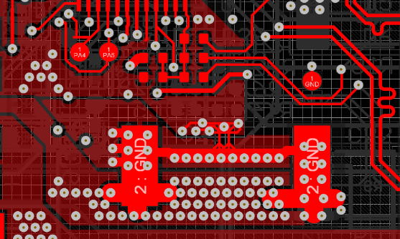
Two net ties are used to separate the MCU Ground from the Power Ground and joined across in between of the Bulk Caps Pads.

Different Ground Signal Return Paths (Primary Layer shown only)–
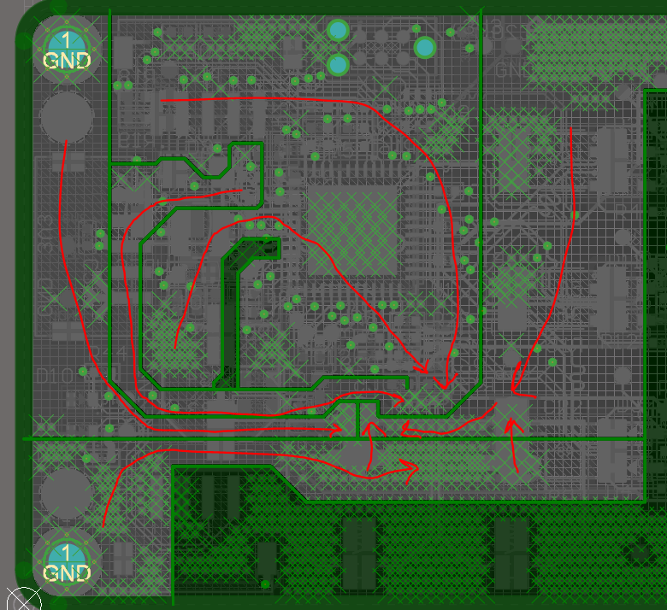

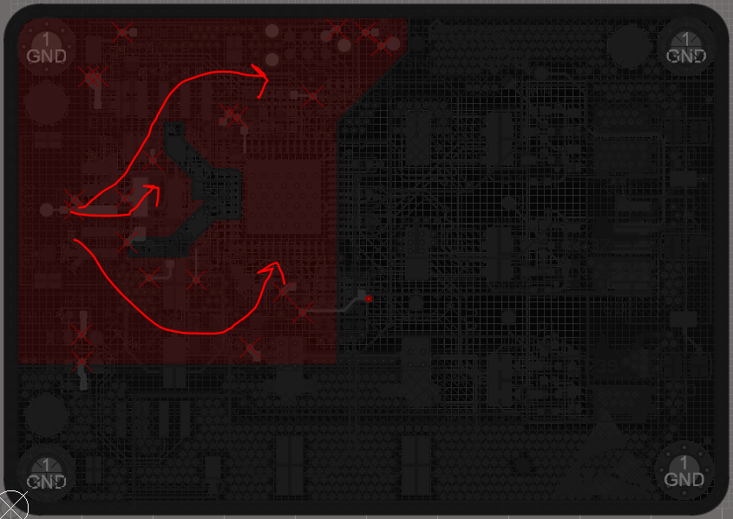
- Separate MCU Power Path Created for 3.3V line which comes from external regulator sources out of the board. Close proximity of the Filter capacitors are placed.

The return path goes like this –
MCU Ground & sense circuit ground-> Bulk Capacitor -> Input Connector.
[Please note: The ground for the Motor Power and 3.3V external Ground are connected to the same source coming from external Power circuit]
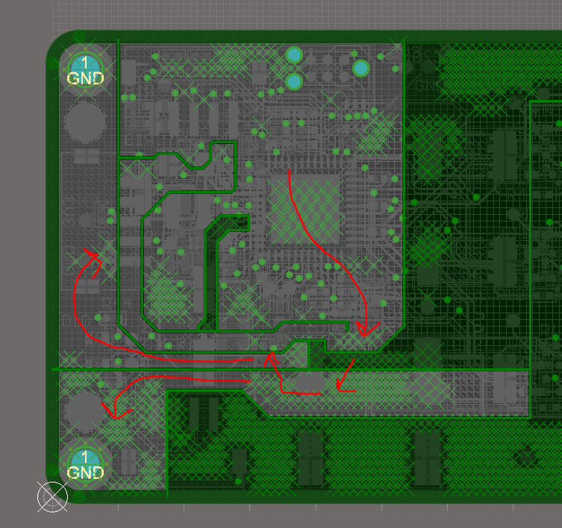

- Array of Vias and Multi-layer Planes are used to carry current.
- Gate resistor and circuitry are placed into close proximity.
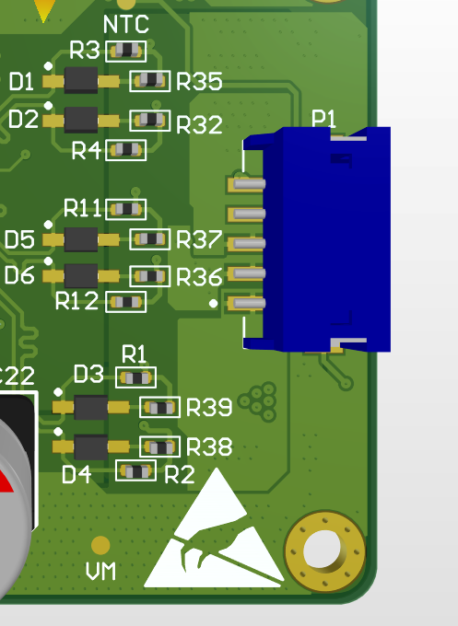
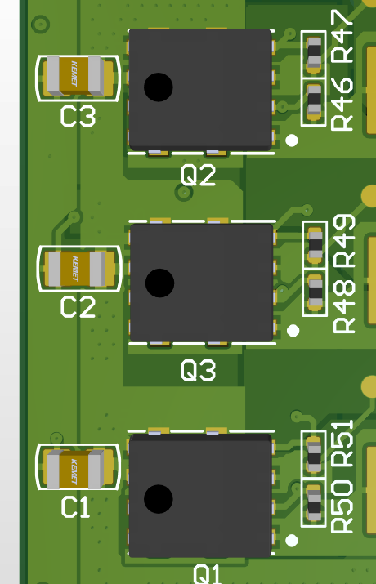
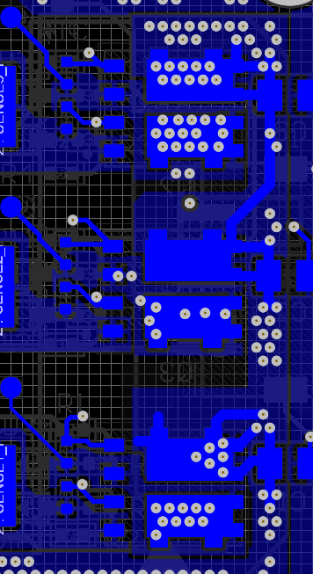
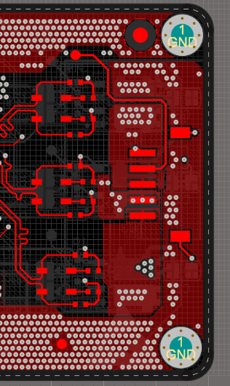

- Kelvin sensing used and differential length tuning is done.
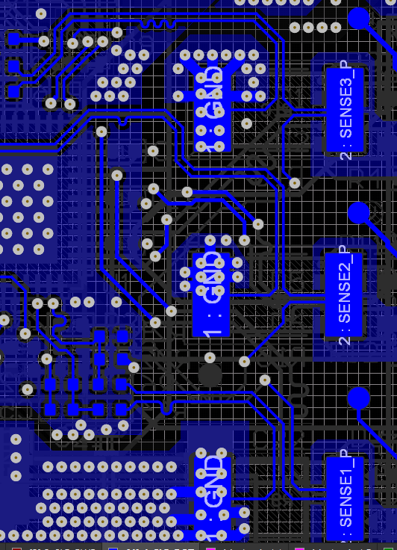

Op-Amp differential inputs are also tuned –
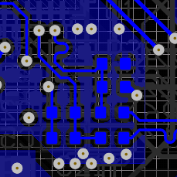
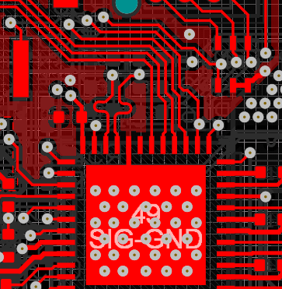

- Gate driver of Three phases – Low Side and High Sides are connected parallel, differential pairs used where length tuning is done.
