Problem D – Ant In a Box

The Problem
An ant climbs into an empty cardboard box looking for food and the box is then closed. The box has dimensions B[x, y, z] and is aligned along the positive X, Y, and Z axes with its corner at the origin. The ant does not discriminate between the different surfaces. It can walk equally well on the top, bottom, or sides of the box. When the box is closed, at time t=0, the ant has a position P[x, y, z] along the interior surface of the box, and a velocity vector V[x, y, z] along which it is traveling. The ant will continue traveling in a straight line along this vector until it passes within half a millimeter of a corner, the box is opened, or it reaches an edge. When it comes closer than 0.5 millimeters to a corner it will stop and wait in that corner until the box is opened. When the ant reaches an edge of the box, it will continue traveling in a straight line along the new surface in the same direction it would if the box were unfolded (in other words at the same angle relative to the edge, but rotated by a right angle along the axis of the edge.) When the box begins to open at time t=T, where will the ant be?
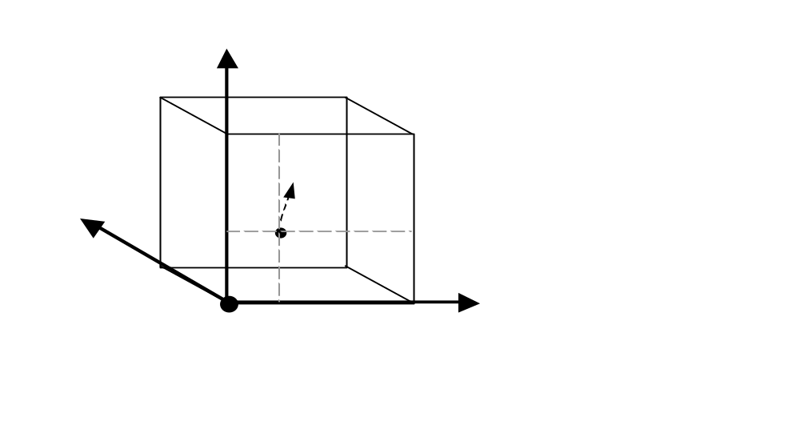

Input / Output Specification
Line 1 contains the number of test cases, N, in the input file. The next N lines each specify one test case consisting of 10 real numbers delimited by single spaces and followed by the end of line in the following order:
Bx By Bz Px Py Pz Vx Vy Vz T
These numbers represent the 3 box dimensions, the 3 position coordinates, the 3 velocity coordinates, and the time at which the box starts to open, respectively. Size and position are in units of meters with precision to the millimeter. Velocity is in units of meters per second, with 3 decimal places. Time is in units of seconds, with precision to the millisecond.
For each test case in the input, output the final position of the ant (x, y, z) in millimeters(not meters) rounded to the nearest whole millimeter.

Sample Input
6
2.000 2.000 2.000 1.000 1.000 2.000 0.000 1.000 0.000 8.000
2.000 2.000 2.000 1.000 1.000 2.000 0.000 1.000 0.000 0.000
2.000 2.000 2.000 1.000 1.000 2.000 1.000 0.000 0.000 5.000
3.000 4.000 5.000 3.000 4.000 5.000 –1.000 –1.000 0.000 10.000
6.000 8.000 10.000 3.000 4.000 0.000 3.000 –4.000 0.000 10.000
6.000 8.000 10.000 3.000 4.000 0.000 1.500 –7.000 0.000 10.000

Sample Output
(1000, 1000, 2000)
(1000, 1000, 2000)
(0, 1000, 0)
(3000, 4000, 5000)
(6000, 0, 0)
(6000, 0, 10000)

