Problem H – Rubik Rotation

The Problem
The Rubik’s Cube, invented in 1974 by Ernö Rubik, is probably the most popular and well-known 3D puzzle ever created. It is a 3×3×3 block whose six sides are each painted one of the solid colors red, green, blue, white, yellow or orange. Each nine block side can be rotated around the center, which allows the colors to be moved around the cube. The sides of a Rubik’s Cube are colored as shown below; this will be the only color distribution for this problem. The colors of the non-visible faces can be determined from the three cubes pictured below which show the effect of two consecutive rotations. The left cube is in the initial configuration, the center cube has had its top rotated clockwise, and the right cube has also had its right side rotated clockwise.
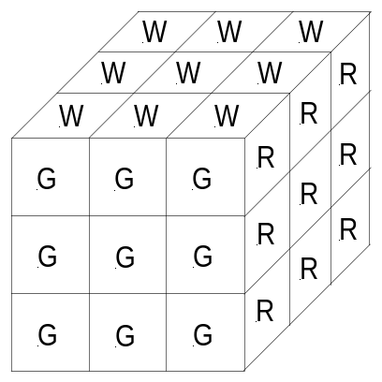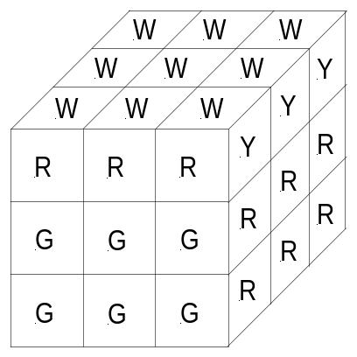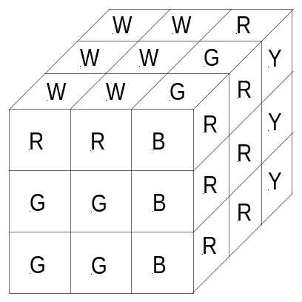
In this problem you will simulate the movement of a Rubik’s Cube. You will be given a sequence of rotations to perform on a cube starting from its initial position with all sides uniformly colored. We will refer to the sides of the cube as top (T), bottom (B), left (L), right (R), front (F), and rear/hidden (H). In the initial position, the front side is colored green and the top is white—the other sides’ colors can be determined from the figures above. All rotations will be 90° clockwise and the perspective will not change.

Input / Output Specification
The input will consist of one or more lines, each beginning with an integer, n. The rest of the line will contain n letters, delimited by single spaces, from the set {T, B, L, R, F, H} corresponding to the clockwise rotation of the top, bottom, left, right, front, and hidden sides. Input will be terminated by n = -1.
For each set of rotations, output the colors from the front of the Rubik’s Cube after the specified rotations have been performed on it. The letters corresponding to the colors should be printed out as shown in the example, in a 3×3 grid, with one space between letters on the same line and a blank line between each separate output.

Sample Input
2 T R
6 R T H B B L
-1

Sample Output
R R B
G G B
G G B

Y R R
W G B
G Y O

