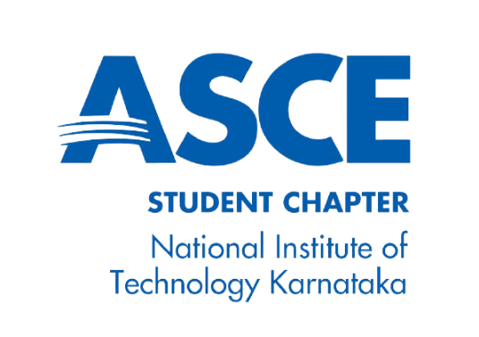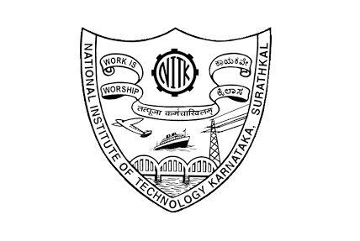

**National Institute of Technology Karnataka**

Start Up Name

Project Members:

**Nirmaan’21**

# Executive Summary

# According to the National Family Health Survey (2015-2016), 58% Indian women use sanitary napkins during their menstrual cycle. Thanks to the initiatives being taken by the government and various NGOs, menstruation is no longer a taboo for a good majority of Indians and soon there will be a time when 100% Indian women will use sanitary napkins, but this poses a serious environmental threat. Conventional pads are loaded with plastic up to 90% which takes 500-800 years to get decomposed. Each pad contains plastic equal to 4 plastic bags. The soiled pads are typically thrown in open areas or water bodies, dumped or discarded in toilets or thrown in incinerators causing land, air and water pollution. This poses a serious threat of ecological deterioration ,requiring immediate action .Many substitutes for sanitary napkins have been introduced including menstrual cups , reusable pads but Indian women have been resistant towards them due to various reasons - not finding them cost effective in the short run ,as on an average the cost of 1 reusable pad equals the cost of 6 plastic pads ,fear of staining, finding them bulkier, not being comfortable with the concept of washing them for reuse, risk of improper disinfection. The plastic pads also contain various chemicals like BPA (bisphenol A), BPS (bisphenol S), SAP (super absorbent polymers), PE(polyethylene) and dioxin. Besides causing rashes, allergies, irritation these chemicals interfere with the reproductive system, complicate embryonic development and can cause problems like ovarian cancer, urinary tract infection. Also, The Bureau of Indian Standards has set out IS5405 for maintaining the quality of sanitary napkins, but this is not being enforced. Many local manufacturers do not adhere to this standard, resulting in poor quality products. Another problem is the lack of employment opportunities and financial independence amongst female home makers and third gender people. About 96% of the third gender people are denied employment, hence they unable to attain financial independence. Besides this, they are also subject to physical, sexual, emotional and economic abuse. Out of India's 160 million women homemakers, almost 77% suffer from domestic violence. Being financially dependent on their husbands, they are compelled to be a victim of physical and mental torture. Therefore, besides safe menstruation, it’s high time to move towards green or sustainable menstruation. A single female generates up to 125 kg of non-biodegradable waste throughout her menstrual life. So almost 63,540 million plastic pads require disposal. Keeping in mind that only 4% of Indian females use substitutes for conventional sanitary napkins like menstrual cups, reusable pads which clearly reflects their preferences, Pehchaan aims to take care of popular choice by providing the conventional sanitary napkins after eliminating the associated risks.

# *Pehchaan* aims to manufacture compostable sanitary napkins with the perennial aquatic weed*- Water Hyacinth as the main constituent, hence preventing the harmful effects of non-biodegradable sanitary napkins.* Consisting of natural raw materials and being completely ecofriendly our product will be compostable and the compost so prepared can be used for making natural manures and fertilizers, this would also prevent the land and air pollution caused by the burning and dumping of plastic pads thereby benefitting the environment to the greatest advantage. Being chemical free, compostable sanitary napkins also eliminate problems associated with plastic sanitary napkins like rashes, allergies, irritation and the risk of interference with the reproductive system. Due to the ongoing pandemic, the unemployment rate amongst women widened even more, increasing to 18%. By employing female home makers and training them for practical work, the implementation of our plan would enrich them with a sense of self-worth and financial independence which would in turn help them fight social evils like domestic violence. New employment opportunities for women would increase their family income, enabling them to gain financial stability. This will also help their families to move out of the vicious circle of poverty. Gradually, this will help them in the education of their children as well. By welcoming the third gender people and accepting them with open arms, providing them employment, our plan will help the society in taking the initial steps towards social inclusivity, by not only treating the third gender people equally and respectfully but "normally “, by providing them employment opportunities that they deserve, helping them attain financial independence. This would also help the economy by generating a new source of income for this section of people. Therefore, adding social and economic value at the same time. Our product being cost effective will provide quality with affordability. Consequently, promoting a culture of menstrual hygiene. Using hybrid distribution we will collaborate with various e commerce platforms (Amazon, Flipkart). For larger economies of scale and to capture a larger market we plan to associate with distributors (wholesalers).Pehchaan would also seek sponsorship through UNICEF and Health Ministry of India .We also plan to popularize our product by campaigning in various schools collaborating with NGOs and launching a social media hash tag called *#PaintTheBloodGreen.*

# Industry Analysis

Problems faced by society

* **Plastic- A peril -**Conventional pads are loaded with plastic up to 90%. Each pad contains plastic equal to 4 plastic bags. The soiled pads are typically thrown in open areas or water bodies, dumped or discarded in toilets or thrown in incinerators causing land, air and water pollution. This poses a serious threat on the environment therefore requiring immediate action.
* **Health Risk-**The plastic pads contain various chemicals like BPA (bisphenol A) ,BPS (bisphenol S), SAP (super absorbent polymers),PE(polyethylene) and dioxin. Besides causing rashes, allergies, irritation these chemicals interfere with the reproductive system ,complicate embryonic development and can cause problems like ovarian cancer, urinary tract infection.
* **Non acceptance of existing alternatives-**Although there are substitutes like reusable pads or menstrual cups, but Indian women have been resistant towards them due to various reasons - not finding them cost effective in the short term ,as on an average the cost of 1 reusable pad equals the cost of 6 plastic pads ,fear of staining, finding them bulkier, not being comfortable with the concept of washing them for reuse, risk of improper disinfection.
* **Lack of good quality-**The Bureau of Indian Standards has set out IS5405 for maintaining the quality of sanitary napkins, but this is not being enforced .Many local manufacturers do not follow this standard, resulting in poor quality products.

Our Solutions

* **Sustainable menstruation**-Besides safe menstruation, it’s high time to move towards green menstruation .A single female generates up to 125 kg of non-biodegradable waste throughout her menstrual life. So almost 63,540 million plastic pads require disposal. To solve this problem, Pehchaan aims to manufacture compostable sanitary napkins with the perennial aquatic weed- Water Hyacinth as the main constituent hence preventing the harmful effects of non-biodegradable sanitary napkins.
* **Promoting Financial Independence**-Due to the ongoing pandemic, the unemployment rate amongst women widened even more, increasing to 18%. As a solution to this we aim to employ more and more female homemakers in order to provide them financial independence and stability. Thus, helping them become self reliant and fight social evils like domestic violence.
* **Complying with Standards**-Believing in quality being the key to success, Pehchaan aims to adhere to the various clauses of IS5405 prescribed by the Bureau of Indian Standards. Thus, ensuring the highest quality product at affordable prices.
* **Adopting the popular choice**-Keeping in mind that only 4% of Indian females use substitutes for conventional sanitary napkins like menstrual cups, reusable pads which clearly reflects their preferences, we aim to take care of their popular choice by providing them the conventional sanitary napkins after eliminating the associated risks.

# Description of Business Venture

List of software used or the tech stack used.

# Production Plan

Describe the steps followed to solve the problem. This should cover the entire work done during the course of the year. Mention the phases of the project and how the initial plan was modified(if applicable) based on the challenges faced

# Marketing Plan

Images, Codes, Videos (drive link to the video-preferably a bitly link)

# Organizational Plan

Describe the final outcome of the project.

# Assessment of Risk

If the project is further pursued in future, what more can be done?

# Financial Plan

What did you learn by doing this project?

# Team Members Details

ABC- [ABC@nitk.edu.in](mailto:ABC@nitk.edu.in)- +91 9874563210 (Project mentor)

ABC- [ABC@nitk.edu.in](mailto:ABC@nitk.edu.in)- +91 9874563210 (Project mentor)

ABC- [ABC@nitk.edu.in](mailto:ABC@nitk.edu.in)- +91 9874563210

ABC- [ABC@nitk.edu.in](mailto:ABC@nitk.edu.in)- +91 9874563210