ESEC/FSE 2007 - Statistics

- No. of submitted papers: 251
- Submissions from 36 countries (US 78; UK 19; Canada, China, Germany: 18; Italy 16; France 10; …)
- Submissions authorship: 205 from academia, 15 from industry, 31 mixed
- No. of accepted full papers: 42 (16.7%)
- Accepted from 11 countries and 9 transnational (US 22, Europe 15, Asia 5)
- Accepted authorship: 35 from academia, 1 from industry, 6 mixed
- No. of accepted poster (short) papers (no explicit call): 18.
- No. of reviews: 645 (up to 25 papers per reviewer)
- No. of PC members: 26 (this changed very frequently)
- No. of external reviewers:100
- No. of submitted WISE papers: 25
- No. of accepted WISE papers: 3

- No. of people involved in the conference activities including reviews( without external): 65
- Number of registrations (self-registration + invited + the supporting staff + combination conference and staff ): 312 (280 + 17 + 10 + 5 )
- Number of participants, (self-registration + invited + the supporting staff + combination conference and staff ): 296 (268 + 13 +10 + 5)
- Number of students: 101 (34%) ; Number of ACM: 92, Non ACM 87
- Countries (US 70, Italy 46, Germany 30, Croatia 26, UK 24….) in total 36 countries
- Conference registration: 224
- Workshop registration + Doctoral symposium: 197
- Only workshop registration: 72 (24%)
- Only Conference: 102 (34%)
- Both workshops and the conference: 122 (41%)
- Male: 241 (81%), Female 55 (19%)

The evaluation form
The results are not representative. Of 296 participants, 68 evaluations have been received; 60% of the evaluators did not stay at the hotel Croatia (so they chosen a cheaper accommodation) and almost 75% are first time at ESEC/FSE – so most of them are students which has impact on their answers.

 | Don't know | Poor | Average | Good | Excellent | Average grade  (1-5)
The conference keynotes were | 1 | 7 | 18 | 25 | 11 | 3.54
The SOTA presentations were | 10 | 6 | 21 | 17 | 6 | 3.34
The quality of papers were | 2 | 0 | 10 | 35 | 15 | 4.08
The paper presentations were | 0 | 0 | 16 | 32 | 14 | 3.97
 | Don't know | Poor | Average | Good | Excellent | Average grade (1-5)
The conference venue (hotel) was | 0 | 2 | 3 | 28 | 33 | 4.36
Session rooms were | 0 | 1 | 12 | 41 | 11 | 3.94
Conditions for interactions were | 0 | 0 | 5 | 35 | 26 | 4.32
The conference place (Cavtat) was | 0 | 2 | 2 | 20 | 42 | 4.52
Lunches & coffee breaks were | 0 | 4 | 15 | 21 | 26 | 3.98
Welcome the excursion & reception were | 2 | 7 | 17 | 18 | 18 | 3.67
The conference dinner was | 5 | 2 | 9 | 22 | 22 | 4.13
Croatia Hotel accommodation was | 27 | 1 | 7 | 12 | 12 | 4.06
Accommodation (other than H. Croatia) was | 30 | 0 | 4 | 25 | 4 | 4.00
The support staff was | 2 | 0 | 1 | 14 | 48 | 4.75
Conference registration services were | 1 | 0 | 1 | 19 | 45 | 4.68
Information material/brochures were | 2 | 0 | 5 | 28 | 30 | 4.40
In general, the organisation was | 0 | 0 | 2 | 27 | 37 | 4.53
 | Yes | No
Are your first time on ESEC/FSE conference ? | 45 | 18
 | Yes | Probably yes | probably no | No
Will you come to the conference next year? | 20 | 35 | 7 | 0

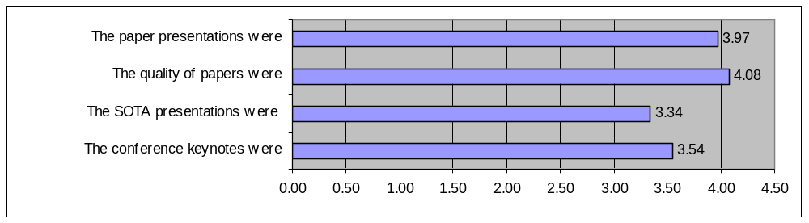

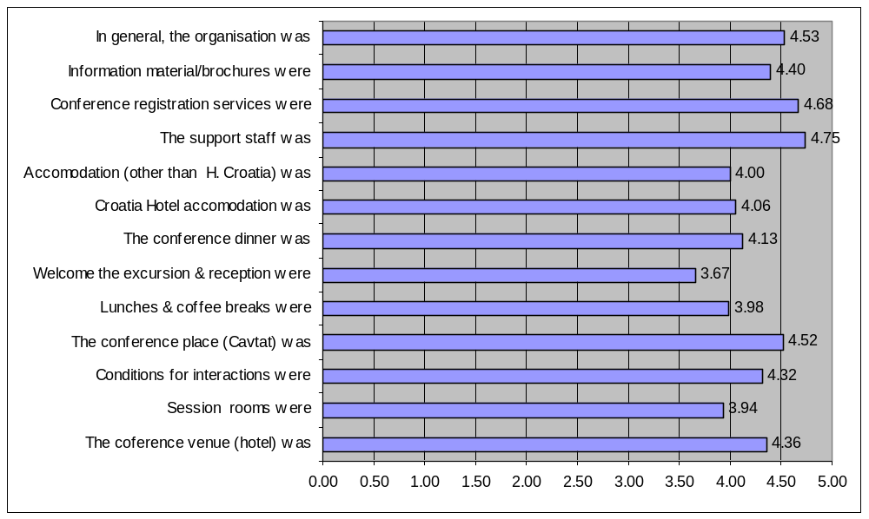
ESEC/FSE 2007 Evaluation form – Comments from the evaluation

- Posters are good to have, but not if to many on the same topic (like testing this year). The layout of room with columns in the middle was bad
- Except of E. Weyukers talk, all keynotes and SOTA presentation were very bad. I recommend to improve this as usually keynotes are very inspiring
- SOTAS were not supposed to be tutorials as it was written in the booklet
- Let posters be announced after sessions with similar content
- I like posters (i.e. Easier to ask questions than presentation) but here posters are only for work not good enough to qualify for regular papers (and that explains why there were many poor posters). Why not ask best-valued papers to make posters, too?
- Strong technical program, well-balanced program structure, nice place, well-organized: I enjoyed it. Session 1 and 2 had a strong overlap in potential audience. It was not good idea to schedule these in parallel.
- The first keynote talk missed the whole point
- SOTA presentation were too technical.
- Poor interest for poster sessions, consider the following ideas: separate session, connect posters to regular presentation session, so that attendees interested in a specific topic are made aware of related posters. Perhaps one slide per poster presented by session chair at the end of each session. Put posters so attendees need to pass them to get coffee/food.
- SOTA presentation should be shorter
- first keynote was not that good, second was great
- Earlier notice on poster requirements
- Excellent location, the keynotes and SOTA-s would have been better if they were more narrowly focused and had more technical detail
- Better keynote speakers, more interesting SE people who also do cutting edge research
- Maybe better choice of keynotes and SOTA speakers
- Great location but hard to get to, especially for non-europeans
- Keynote speakers must have better slides and more coherent presentations to be interesting. I'm still not convinced that ontology has anything to offer for me. The keynote had same insight, but too few for the length of the talk. Slides were poor.
- Staab's keynote was awful, as was the EU speaker
- Find some way to keep everyone at the symposium to the very end. Excellent job Ivica and Antonia
- Elaine Weyuker and Walt Saccachi was excellent. The others less so.

ESEC/FSE 2007 Evaluation form – Venue and organization

- Excellent organization, only problem was the dimension of the reception in Sponza. A bit to crowded and hard to see.
- There were not desks in the session room
- Hotel staff not always kind as expected for a 5 star hotel.
- Sometimes, air condition was too much.
- Didn't make use of support staff or read the brochures
- The hotel staff in the restaurant was pretty unfriendly and incompetent
- The 5k and 10k run event was a great idea and fun
- The workshop room was very nice, but it was quite small (we needed additional chairs) and we were soon without fresh air. Hotel Castelletto, I can recommend it. www.dubrovnikexperience.com
- a booklet with abstracts would have been useful
- Too large room for doctoral symposium (13 people in this big conference room)
- Hotel restaurant staff absolutely unfriendly
- Wireless access did not work on Monday and Tuesday, worked excellently from Wednesday on
- Hotel staff not so kind
- Cavtat was nice, but Dubrovnik would have been even better.
- Too young hostesses, poor choice of wine
- It was hard to find restrooms in hotel Croatia. A bit disappointing not to go to Dubrovnik by boat, but the bus ride was very nice. Hotel Croatia lobby smell strange sometimes. All of these were outside the control of the conference
- The main problem with the facilities was the internet access for the first few days. The conference dinner was too loud and that made conversation difficult
- Finally, I have to say that it felt very welcome. Student volunteers were very motivated, helpful and friendly. The staff everywhere was nice and welcoming. Top organization of the conference. Rooms were not over-air-conditioned - very much appreciated. Gordious location, great social events. Run was excellent, lot of fun, please do it again. Would be nice to have coffee at lunch and water outside coffee break.
- Bad wine at reception and dinner. Hostesses could be older!
- Session rooms needed microphones because the rooms were "cavenious"
- Very helpful stuff at the reception
- Some means for encouraging attendees to enter the session room on time. Especially after breaks would be good. Some ideas for that: clean out the refreshments earlier, have some kind of bell ringing, just ask it at organizers opportunities (during messages, etc.) Thank you!
- Extra power plugs in the room would be fantastic
- Very well organized. High quality program. Relaxed environment, parallel tracks.
- se.run() was a great idea and a nice event
- We should have water during the sessions
- There should be better vegetarian food options
- The SE run was great idea but please include some free time in schedule afterwards (or perhaps a poster session). I needed some time to recover from race

