

Session: 1161

Creating a Smart Gateway
for IoT with Raspberry Pi

Lab Instructions

Authors:
Andrea C. Martinez, IBM, acm@us.ibm.com
Pradeep Natarajan, IBM, pnatara@us.ibm.com

February 2016 edition
NOTICES
This information was developed for products and services offered in the USA.
IBM may not offer the products, services, or features discussed in this document in other countries. Consult your local IBM representative for information on the products and services currently available in your area. Any reference to an IBM product, program, or service is not intended to state or imply that only that IBM product, program, or service may be used. Any functionally equivalent product, program, or service that does not infringe any IBM intellectual property right may be used instead. However, it is the user's responsibility to evaluate and verify the operation of any non-IBM product, program, or service.
IBM may have patents or pending patent applications covering subject matter described in this document. The furnishing of this document does not grant you any license to these patents. You can send license inquiries, in writing, to:
IBM Director of Licensing
IBM Corporation
North Castle Drive, MD-NC119
Armonk, NY 10504-1785
United States of America
The following paragraph does not apply to the United Kingdom or any other country where such provisions are inconsistent with local law: INTERNATIONAL BUSINESS MACHINES CORPORATION PROVIDES THIS PUBLICATION "AS IS" WITHOUT WARRANTY OF ANY KIND, EITHER EXPRESS OR IMPLIED, INCLUDING, BUT NOT LIMITED TO, THE IMPLIED WARRANTIES OF NON-INFRINGEMENT, MERCHANTABILITY OR FITNESS FOR A PARTICULAR PURPOSE. Some states do not allow disclaimer of express or implied warranties in certain transactions, therefore, this statement may not apply to you.
This information could include technical inaccuracies or typographical errors. Changes are periodically made to the information herein; these changes will be incorporated in new editions of the publication. IBM may make improvements and/or changes in the product(s) and/or the program(s) described in this publication at any time without notice.
Any references in this information to non-IBM websites are provided for convenience only and do not in any manner serve as an endorsement of those websites. The materials at those websites are not part of the materials for this IBM product and use of those websites is at your own risk.
IBM may use or distribute any of the information you supply in any way it believes appropriate without incurring any obligation to you.
Information concerning non-IBM products was obtained from the suppliers of those products, their published announcements or other publicly available sources. IBM has not tested those products and cannot confirm the accuracy of performance, compatibility or any other claims related to non-IBM products. Questions on the capabilities of non-IBM products should be addressed to the suppliers of those products.
This information contains examples of data and reports used in daily business operations. To illustrate them as completely as possible, the examples include the names of individuals, companies, brands, and products. All of these names are fictitious and any similarity to the names and addresses used by an actual business enterprise is entirely coincidental.
TRADEMARKS
IBM, the IBM logo, and ibm.com are trademarks or registered trademarks of International Business Machines Corp., registered in many jurisdictions worldwide. Other product and service names might be trademarks of IBM or other companies. A current list of IBM trademarks is available on the web at “Copyright and trademark information” at www.ibm.com/legal/copytrade.shtml.
Adobe, the Adobe logo, PostScript, and the PostScript logo are either registered trademarks or trademarks of Adobe Systems Incorporated in the United States, and/or other countries.
Cell Broadband Engine is a trademark of Sony Computer Entertainment, Inc. in the United States, other countries, or both and is used under license therefrom.
Intel, Intel logo, Intel Inside, Intel Inside logo, Intel Centrino, Intel Centrino logo, Celeron, Intel Xeon, Intel SpeedStep, Itanium, and Pentium are trademarks or registered trademarks of Intel Corporation or its subsidiaries in the United States and other countries.
IT Infrastructure Library is a Registered Trade Mark of AXELOS Limited.
ITIL is a Registered Trade Mark of AXELOS Limited.
Java and all Java-based trademarks and logos are trademarks or registered trademarks of Oracle and/or its affiliates.
Linear Tape-Open, LTO, the LTO Logo, Ultrium, and the Ultrium logo are trademarks of HP, IBM Corp. and Quantum in the U.S. and other countries.
Linux is a registered trademark of Linus Torvalds in the United States, other countries, or both.
Microsoft, Windows, Windows NT, and the Windows logo are trademarks of Microsoft Corporation in the United States, other countries, or both.
UNIX is a registered trademark of The Open Group in the United States and other countries.
© Copyright International Business Machines Corporation 2015.
This document may not be reproduced in whole or in part without the prior written permission of IBM.
US Government Users Restricted Rights - Use, duplication or disclosure restricted by GSA ADP Schedule Contract with IBM Corp.

Resource guide
IBM Technical Client Training has enhanced its training capabilities, and extended reach into new cities and countries, by partnering with five highly qualified IBM Business Partners who provide high quality, authorized training for IBM Clients, IBM Business Partners, and IBM employees. IBM continues to provide authorized training curriculum and content, and also maintains overall ownership of the IBM Training ecosystem.
The delivery of public, private and customized training to IBM Clients and IBM Business Partners is now done by the IBM Global Training Providers (GTPs):
- Arrow
- Avnet
- Global Knowledge
- Ingram Micro
- LearnQuest
See ibm.com/training for information on the classes that the GTPs offer.
Completing this InterConnect lab is a great first step in building your IBM skills. IBM offers several resources to keep your skills on the cutting edge. Resources available to you range from product documentation to support websites and social media websites, including the following examples:
- IBM Training website
- Bookmark the IBM Training website for easy access to the full listing of IBM training curricula. The website also features training paths to help you select your next course and available certifications.
- For more information, see http://www.ibm.com/training
- IBM Certification
- Demonstrate your mastery of IBM products to your employer or clients through IBM Professional Certification. Certifications are available for developers, administrators, and business analysts.
- For more information, see http://www.ibm.com/certify

A Gateway for the Internet of Things
With the explosion of sensors, embedded systems, and small form factor devices pervading our homes, work places, retail stores, and venues, the massive amount of data and communication between “things” will only continue to climb. The notion of a device gateway is not altogether new, but its importance is renewed to help aggregate, enrich, filter, scrub and perform any necessary transformations on the explosion of embedded things. There may be scenarios where a device gateway is required to avoid the “chatter” of things communicating directly to the Internet.
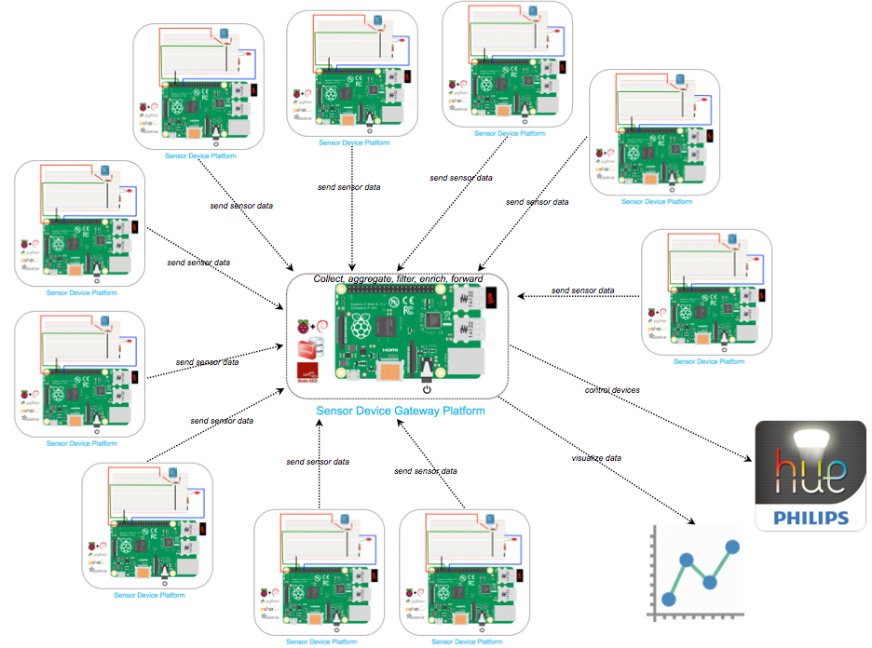
When deploying a fleets of instrumented “things” a “Sensor Device Gateway” is useful for collecting sensor data on a local network, storing, aggregating, filtering, enriching data then forwarding data payloads on to a backend analytics engine…or controlling another device. This lab will demonstrate some of these concepts with real sensors, devices, and small form factor devices.

Part 0: Before you Begin

1. Take Inventory of your Lab Hardware
You have been provided the following:
1 lab workstation – pre-loaded with a RedHat Enterprise Linux 6 image
1 Raspberry Pi 2 Model B+ – preloaded with a Raspbian “Jessie” Linux image
1 Breadboard (instrumented with DHT11 sensor and necessary electronic components)

2. Your Lab Workstation will be used to connect to the Raspberry Pi (RPi)
From the Lab Workstation, enable the second network card (eth1) for Internet access. In the Virtual Machine Settings, set Network Adapter 2 to “NAT”. Start the virtual machine if it is not started. Open a terminal window and type the command:
ifup eth1
Check that the DHCP server assigned an IP address:
ifconfig eth1
Open Firefox browser and make sure you are able to access the Internet.
Two modes of communication will be used, ssh and a web browser. Your RPi has been already configured to connect to the lab network. The RPi IP address has been documented below. Be sure to use this IP where the lab instructions reference <raspberry_ip>
Raspberry Pi IP address: _____ . _____ . _____ . _____

Part 1: Setup the “Sensor Device Platform”
This “sensor device platform” is a mixture of electronic components (DHT11, resistors, jumper wires, breadboard), software packages to read the sensor data (Python scripts and GPIO operating system packages), hardware (Raspberry Pi), and network connectivity. The RPi has been pre-configured and pre-installed with the software necessary to sense, package and transmit data sensed by the DHT11. The breadboard has been pre-wired with the necessary electronic components to allow the DHT11 to sense temperature/humidity and an LED. You will control the breadboard behavior through the other platform components described in this lab.

1.1 Connect the Breadboard to the RPi
Using the provided jumper wires, connect the breadboard to the RPi General Purpose Input/Output (GPIO) port. The “sensor device platform” should look like this:
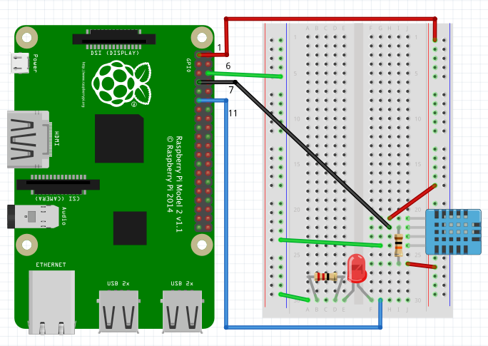
Figure 1: The "Sensor Device" Platform

1.1 Connect the Breadboard to the RPi
 | Step | Description
_______ | 1.1.1 | Connect a jumper wire from the breadboard voltage “power rail” to pin #1 (GPIO1) on the RPi. This is constant 3.5 voltage that will power the DHT11
_______ | 1.1.2 | Connect a second jumper wire from the DHT11 “data” pin to pin #7 (GPIO4) on the RPi.
_______ | 1.1.3 | Connect another jumper wire from the ground “power rail” to pin #6 (Ground)
_______ | 1.1.4 | Connect the last jumper wire from the LED to pin #11 (GPIO 17)
Double check your jumper wire connections. Feel free to validate the jumper wire setup with your lab instructors (miswiring can cause shortages to the DHT11 or the LED).

1.2 Send Data from the “Sensor Device Platform”
There is a Python program in the pi home directory (/home/pi) called readsensor.py. This program will read data from the DHT11 sensor and publish that data to a Mosquito message broker. Mosquitto uses the MQTT protocol to broker message exchanges on “topics”. Topic names are completely configurable. Change the MQTT topic to something unique.
1.2 Send Data from the “Sensor Device” Platform
 | Step | Description
_______ | 1.2.1 | Connect to the Raspberry Pi 2 (RPi) From the Lab Workstation, open a Terminal window  ssh pi@<raspberry_ip>  Type the password, raspberry
_______ | 1.2.2 | Edit /home/pi/readsensor.py by opening the Python script in an editor (like vi):  vi ~/readsensor.py
_______ | 1.2.3 | In the program, the “topic” is temp, as seen in the following line:  mqttClient.publish(“temp”, data, qos=0)  Replace “temp” with a new topic name of your choosing.  Use the cursor keys to move down to the line and word that needs to be modified.  Press Esc to go to “edit” mode in vi  Then x to delete each character in the word “temp”  Press Esc then i to go to “insert” mode  Type the name of your topic you want DHT11 sensor data to be published  Press Esc then :wq to write changes and quit vi
_______ | 1.2.4 | Now run the program by doing the following:  ./start.sh
At this point, the Python script (readsensor.py) on the RPi will read data from the sensor and send it to the Mosquitto message broker via MQTT. The sensor data is also being printed to your ssh console).
Temp= 71.6 Humidity= 44.0 %
Temp= 73.4 Humidity= 43.0 %
Temp= 71.6 Humidity= 44.0 %
Next, you will take this data and make it actionable. The next part of the lab will construct a workflow to process the temperature and humidity data in the device gateway using Node-RED and perform an action based on the sensor data received.

Part 2: Setup the “Sensor Device Gateway Platform”
To take the sensor data and make it actionable we will construct a Node-RED workflow to do something based on the temperature data. The RPi in this lab will also be used as a “sensor device gateway platform” for device data. It just so happens the same RPi is being used as a “sensor device platform” for the DHT11 (this was completed in Part 1). The RPi has been pre-installed with all the software necessary to receive data and perform all “sensor device gateway platform” functions.

2.1 Create a Node-RED workflow to read and store Sensor Data in Informix
This section will use Node-RED to convert the DHT11 temperature and humidity readings (generated from the readsensor.py Python script) into a well-formed JSON string, then append a timestamp to each data payload. Finally, the JSON document (which now contains DHT11 data and a timestamp) is inserted into an Informix database.

2.1 Create a Node-RED workflow to read and store Sensor Data in Informix
 | Step | Description
_______ | 2.1.1 | On the Lab Workstation, open a web browser and type the following in the address bar:  http://<raspberry_ip>:1880  This is the Node-RED workflow editor. Click on the “Debug” tab to the extreme right.  Do you see your temperature and humidity readings scrolling down? This is all the sensor data being sent by your DHT11 and received by your device gateway.
_______ | 2.1.2 | Subscribe to the Message Broker and Read Data  Copy an MQTT Input Node from the Node-RED palette onto the workspace. There is a tab called “Hands On Lab” that you may use.  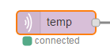  Double click on the node to configure it. Click on the pencil next to the “Server” field and set the server and port to:  localhost:1883  Next, set the topic to your unique topic that you used in the Python program readsensor.py (Step 1.2.3).  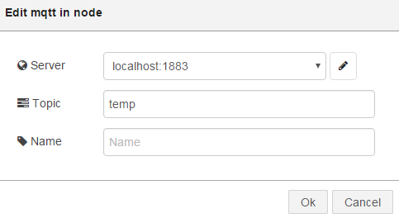  The “Name” field is optional. If you don’t fill this value in, the name of the “Topic” is used for the name of the node.
_______ | 2.1.3 | Setup a “debug” node  Connect the two nodes. Click on the enable button on the far right of the debug node shown below and then click Deploy in the upper right corner of Node-RED  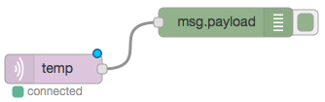
_______ | 2.1.4 | You should now begin to see temperature/humidity readings in the Debug tab on the right panel.  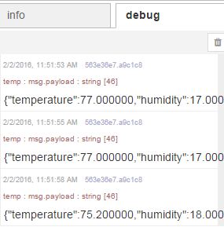  It is important that you click Deploy in the upper right corner in Node-RED after you modify a flow and want to use it.  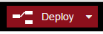
_______ | 2.1.5 | Transform data (Ready for Database/Graph)  Add a json node and add a function node to your existig workflow.  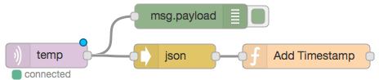  Double Click the Function node and transform the data into a properly formatted json document ready to be graphed and inserted into the database.  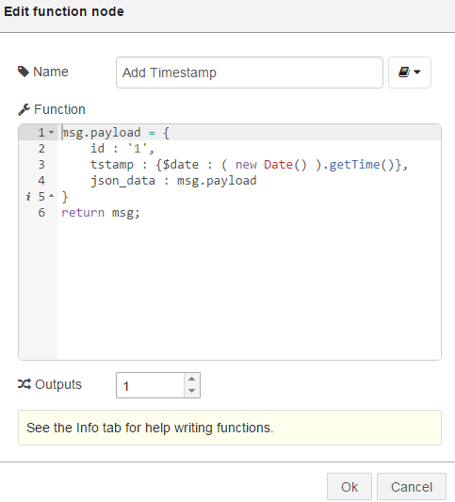  Note, the “Add Timestamp” function node appends a timestamp onto the DHT11 temperature and humidity readings.
_______ | 2.1.6 | Insert DHT11 Sensor Data into the Informix Database  Add the timeseries output node to the end of the Node-RED flow  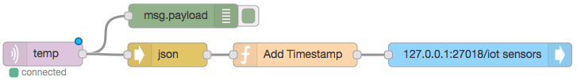  Configure the Timeseries output Node by double clicking on it. Set the server to 127.0.0.1:27018/iot  27018 is the port that Informix is Listening on for REST calls  iot is the name of the database  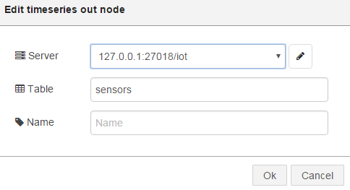  Click on the Deploy button to activate the changes in the Node-RED workflow.
After successful completion of this step data will be flowing from the DHT11 sensor (through the Python script), into the Node-RED flow and getting inserted into the Informix database located on the RPi “sensor device gateway platform”.

2.2 Create Node-RED Flow to read Data From the Database and Control the Phillips Hue Light Bulb
Next, a new Node-RED workflow will be used to aggregate sensor data from Informix (accomplished in the previous section), and use averaging logic on temperature data to control a Phillips Hue light bulb.
2.2 Create Node-RED Flow to read data from Database and Control the Phillips Hue Light Bulb
 | Step | Description
_______ | 2.2.1 | Add an inject input node onto the workspace  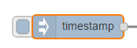  Double click on the node to configure it. Configure as shown below.  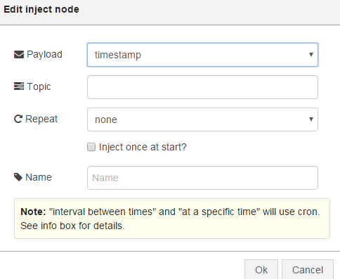
_______ | 2.2.2 | Add an Informix Timeseries Input node  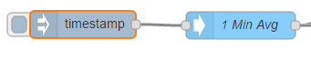  This timeseries node will be used to aggregate the temperature data that has been stored in the Informix database over a 1 minute interval.  Double Click to configure the node. Configure the node as shown below.  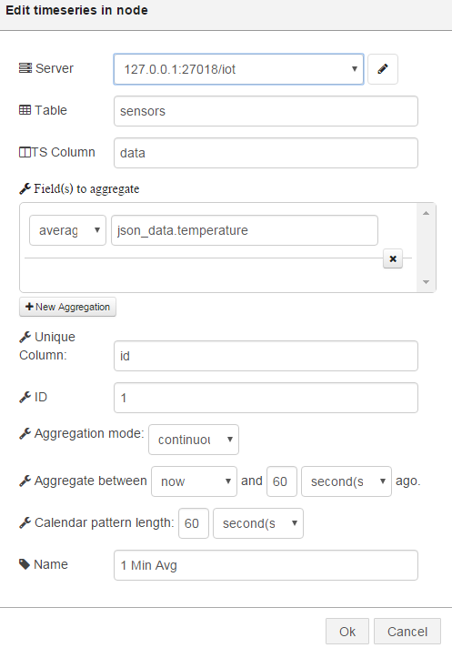
_______ | 2.2.3 | To cause the query of data to occur, click on the left button on the inject node. Add a debug node to verify the flow is working.  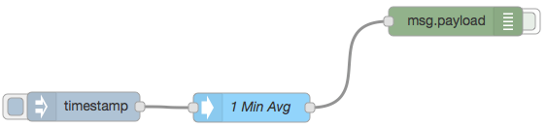  Deploy the flow. You should see minute averages in the debug panel.
_______ | 2.2.4 | Transform the aggregated data  Add a function node and configure as seen below.  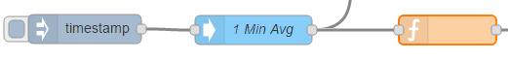  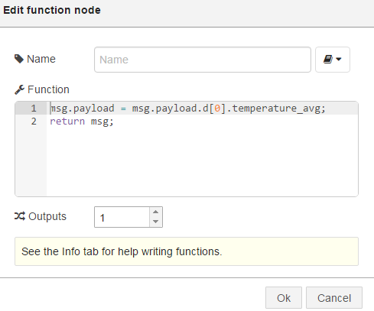
_______ | 2.2.5 | Set Min/Max Thresholds and Control the Phillips Hue  Add a temp-hue node and configure. This will set the High and Low thresholds for actions to the Phillips Hue light bulb  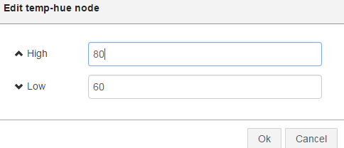  If the avg temperature over the last minute (as reported by the timeseries query Node) is close to the High threshold, the Hue light bulb color will be set to red for hot. If the average temperature is close to the low threshold then blue, and when in between it is calcuated accordingly.  The temperature in the room is fairly constant, so to change the color of the Hue, you can set the high/low thresholds to different values.
_______ | 2.2.6 | Add an http request node and configure  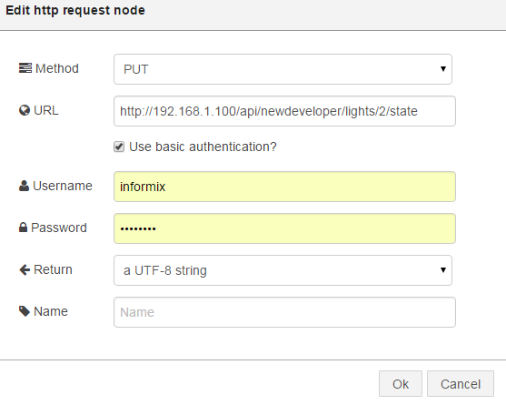  Deploy the workflow.
You can now control the Phillips Hue light bulbs causing different colors to occur based on your values in the temp-hue high/low thresholds.

3. Visualizing Data in the “Sensor Device Gateway Platform”
Going back to Part 1 of the lab, with the initial Node-RED workflow, sensor data payloads will also be piped into the data visualization Node, so that sensor data can be pulled out for graphing on a dashboard. The graphing dashboard will also be constructed in Node-RED.
3.1 Add Local Visualization to Node-RED Flow
 | Step | Description
_______ | 3.1.1 | Add Data visualization node to the Sensor Data Flow (from Part 1)  Add an iot-datasource Node into the flow and configure as shown below  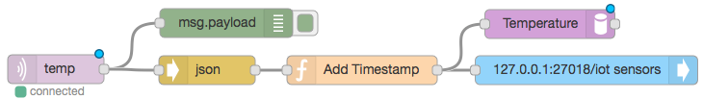  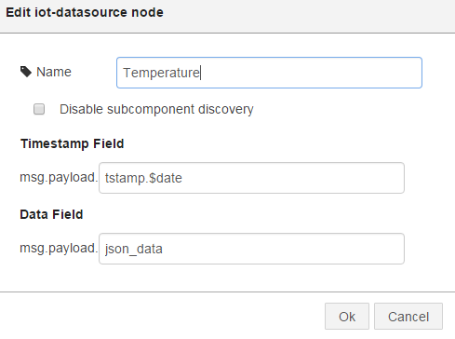  Deploy the workflow.
_______ | 3.1.2 | Add Graph to Dashboard  There is a visualization dashboard that has been built into the IOT gateway kit. You can access that at URL:  http://<raspberry_ip>:1880/dash  In the upper right corner click on Create new Dashboard    Enter a dashboard name:  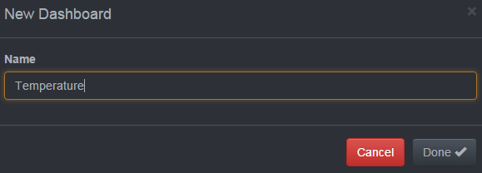
_______ | 3.1.3 | Add a new Chart by clicking on Create new Chart    Configure the new chart as shown below. Give it a name. Choose the Line/Area Chart plugin.  Click on add Datasource and you should see a datasource based on the name of the iot-datasource node that was added in your flow in previous steps.  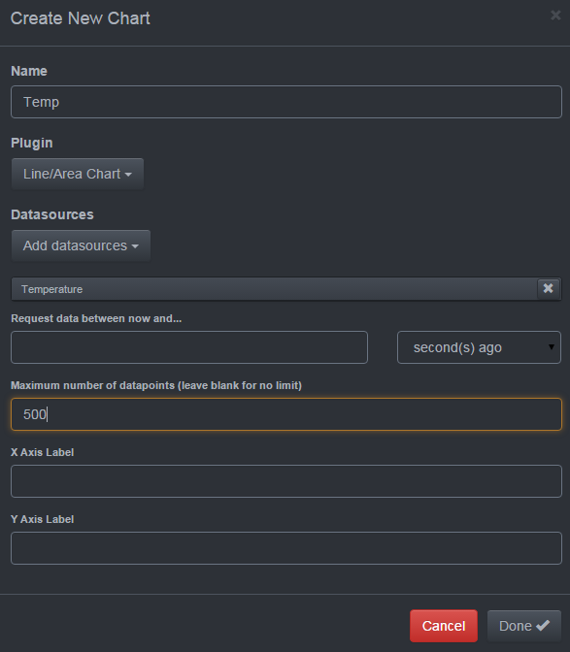  Set the Max data points to 500 and click done. After this is done, you should be able to visualize the real time data being read from the temperature sensor.
At this point, you should see a linear graph with data points that correspond to the DHT11 sensor data being stored on the “Sensor Device Gateway”.
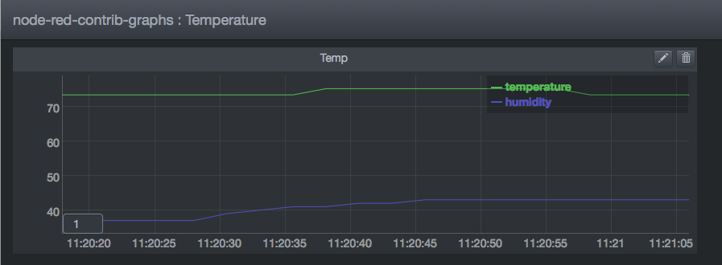

4. Create Flow to Turn on/off Phillips Hue
Next, a new Node-RED workflow will be created to directly control the Phillips Hue light bulb. This is a simple example of how nodes can be used to manually control devices that are connected to the Internet of Things.

4.1 Create Node-RED Flow to Turn On/Off Phillips Hue
 | Step | Description
_______ | 4.1.1 | Inject On/Off into a new workflow  Add 2 inject Nodes, one node to turn the bulb “On” and the second to turn the node “Off”  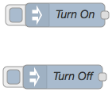  Configure one node to pass a json for “on” value and the other to pass a json for the “off” value.  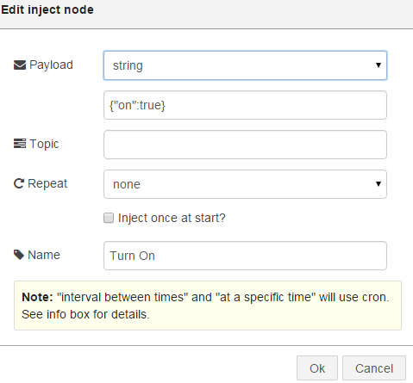
_______ | 4.1.2 | Inject On/Off into a workflow  Add http request node and configure as shown below.  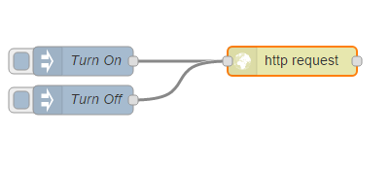  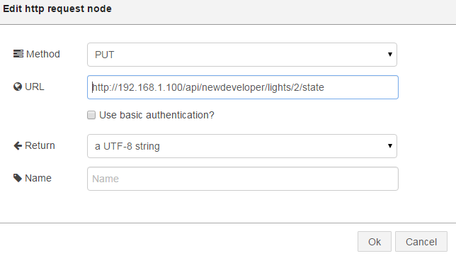  Deploy the workflow.
At this point, you can use this flow to turn the light on and off. Phillips has a documented specification that explains how REST API calls can be used to control their devices. REST calls can be made over HTTP, and thus the HTTP request nodes in Node-RED are extremely useful for integrated with any REST enabled device or software.

Appendix

1. Hands on Lab Answers
Connect to the Raspberry Pi 2 (RPi) From the Lab Workstation, open a Terminal window
ssh pi@<raspberry_ip>
Type the password, raspberry
Copy the Node-RED answer flow into the clipboard by displaying the answer flow in your ssh session on your Lab Workstation:
cat ~/hola.flow
Use your cursor to highlight the text and copy into the clipboard.
On the Lab Workstation, open a web browser and type the following in the address bar:
http://<raspberry_ip>:1880
Navigate to the “Hands on Lab – Answers” tab. In the Upper right hand corner, select Import > “Clipboard”.
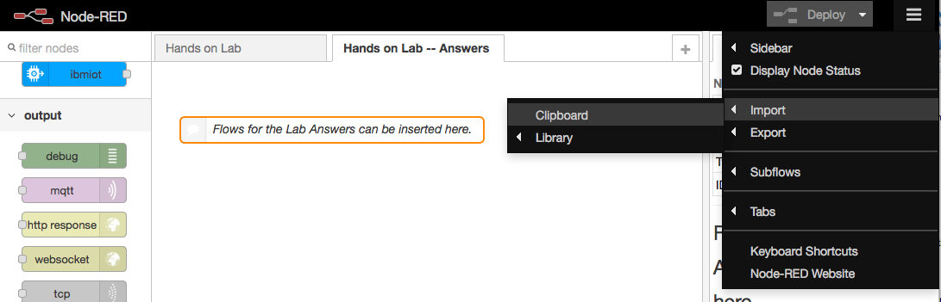
Figure 2 -- Importing Node-RED workflow for lab answers
Paste the contents of the clipboard into the window. In the Upper right hand corner, select Import > “Clipboard”. Click Deploy.

2. Readout of readsensor.py
import paho.mqtt.client as mqtt
import Adafruit_DHT
import time

mqttClient = mqtt.Client()
mqttClient.connect( "localhost", 1883 )
while True:
humidity, temperature = Adafruit_DHT.read( Adafruit_DHT.DHT11, 4 )
if not humidity is None and not temperature is None:
temperature = temperature * 9.0 / 5.0 + 32
data = '{"temperature":%f,"humidity":%f}' % ( temperature, humidity )
mqttClient.publish( "temp", data, qos=0 )
print "Temp=",temperature," Humidity=",humidity,"%"
time.sleep( 2 )

When/if needed there is an Informix user on the RPi. User: informix Password: informix

