**TO TEST ON LOCAL  
(workspace setup)**

Table of Contents

Purpose 3

Audience 3

Pre-requisites/Assumptions 3

JDK 8 4

Maven 5

IntelliJ 6

DBeaver 8

Git for windows 9

MySQL 9

Running the sample application 10

# Purpose

This document will serve as the reference guide on what are the required tools to setup local work environment for test flight API.

# DISCLAIMER

All software used for the development of this API are all open source.

# JDK 8

Java 8 was the version used. You can download JDK 8 in the following link: <https://www.oracle.com/ph/java/technologies/javase/javase8-archive-downloads.html>

Select the 64-bit installer:



Once the installer is downloaded and JDK 8 is installed, update the environment variables to include the bin folder of JDK 8.

Add new entry in the system variables for the JDK 8 installation folder:

Update the PATH entry to include the newly created JAVA_HOME:

To verify that the path is configured correctly, open a new terminal, and type the following:

*java -version*

# Maven

Maven will be used for software project management tool; this will be used mainly for dependency management *(and build steps in the future).*

Maven version ***3.6.3*** will be used for this test API, you can download maven at this link:

<https://archive.apache.org/dist/maven/maven-3/3.6.3/binaries/>

Download the zip file and extract it to any preferred location:

Once extracted, please update the environment variables to include maven.

Add new entry in the system variables:

Update the PATH entry to include the newly created MAVEN_HOME:

To verify that the path is configured correctly, open a new terminal, and type the following:

*mvn --version*

# IntelliJ

IDE used for the development of this spring boot application is JetBrains – IntelliJ IDE (Community edition)

You can download IntelliJ in the following link: <https://www.jetbrains.com/idea/download/#section=windows>

# MySQL

MySQL Server was used on the local machine to host the database for this test flight API.

You can download MySQL server in this link: <https://downloads.mysql.com/archives/installer/>

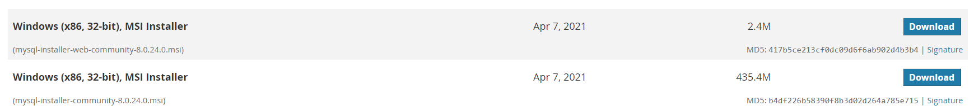

The database script that creates the sample schema, tables, and records were included on the git repository link provided on the email.

PORT to use: 3306

User: root

Password: <any preference>

# DBeaver

DBeaver was used for the database IDE.

You can download DBeaver community edition in this link: <https://dbeaver.io/download/>

Once download and installed, can now select what database we want to connect to:

*Right click on the connections then select Create 🡪 Connection*

Connection created – Localhost (mySQL)

