The Backup Folder Location
Once you’ve selected you source location folder, you’ll need to select the backup location. To do so, click the Backup Location ellipsis button.
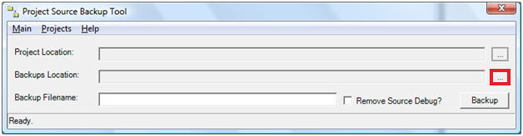
Figure 4: The Backup Location button of the Project Source Backup Tool.
This will bring up the Browse for Folder dialog again, only this time the ‘New Folder’ button will also be enabled allowing you to select a folder, or create a new one for your backup.
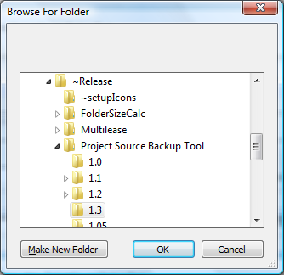
Figure 3: The Browse for Folder dialog.

