Finally you can specify whether or not to remove the source Debug and Release folder locations prior to backup. The backup Debug and Release folders are cleared after the compression routine anyway; they are not removed as this is not possible at this time, so instead I chose to clear all the files from those folders, to save space in the zipfile. To delete these folders from your Source, simple check the ‘Remove Debug’ checkbox as shown below
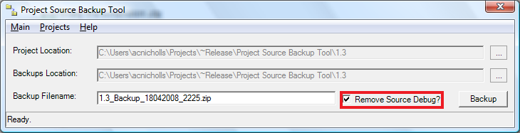
Figure 6: The Backup Filename textbox of the Project Source Backup Tool.
To start the backup process, simply click the ‘Backup’ button. A few dialog screens will pop-up on your screen informing you of the progress, this is normal, just let it happen. When finished Project Source Backup Tool will ask if you would like to exit, selecting ‘No’ will clear the interface and allow you to backup another project.

