The Filename
The last step is to name your zipfile. You’ll notice that one you finish selecting the Backup Location, the File Name textbox automatically fills in for you.
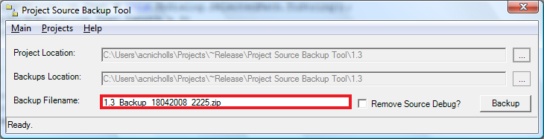
Figure 5: The Backup Filename textbox of the Project Source Backup Tool.
The naming convention for the backup is as follows,
first the name of the final folder for the Project location,
then underscore
then the date in the mmddyyyy format
then underscore
then the time in HHmm format
and finally the extension .zip
If you wish to change the filename simply select the text and type your preference into the box. Please be sure to not use Windows(tm) illegal characters such as #,|,<,>,:, etc.
If you wish to keep the naming format, but want to rename to include the current date/time, simply hold your cursor over the textbox, and double-click the left mouse button. The filename will instantly change to reflect the current date and time, following the above format. You can then make any changes you deem necessary.

